Isobutane in Egypt

Gas suppliers

**wataneyag**

http://www.wataneyag.com/en/products/

**Camping gaz**

https://www.campingaz.com/MiddleEast/t-contactform.aspx

Egypt

MISR INTERCOMMERCE

Address: Multitrade Building, Street # 17, Tajamouh Khames Service Area, El Hay El Awal, Postal Code 11477, New Cairo

Tel: +20 2 26 18 27 41

Email: contactus@bouri.net

Website: [www.bouri.net](http://www.bouri.net)

<http://www.bouri.net/en/ProductByBrand.aspx?CategoryId=394&Brand=1&page=0&bn=0&ct=0&sct=0&prcf=0&prct=0&fl=0>

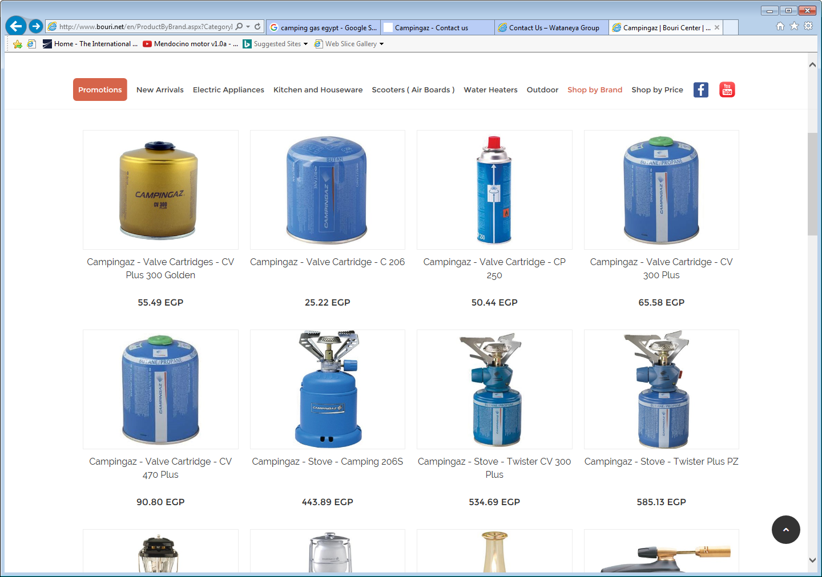

<https://egypt.souq.com/eg-en/camping-gaz/camping-goods-323/a-t/s/>

