R600a 23 Jan 2015

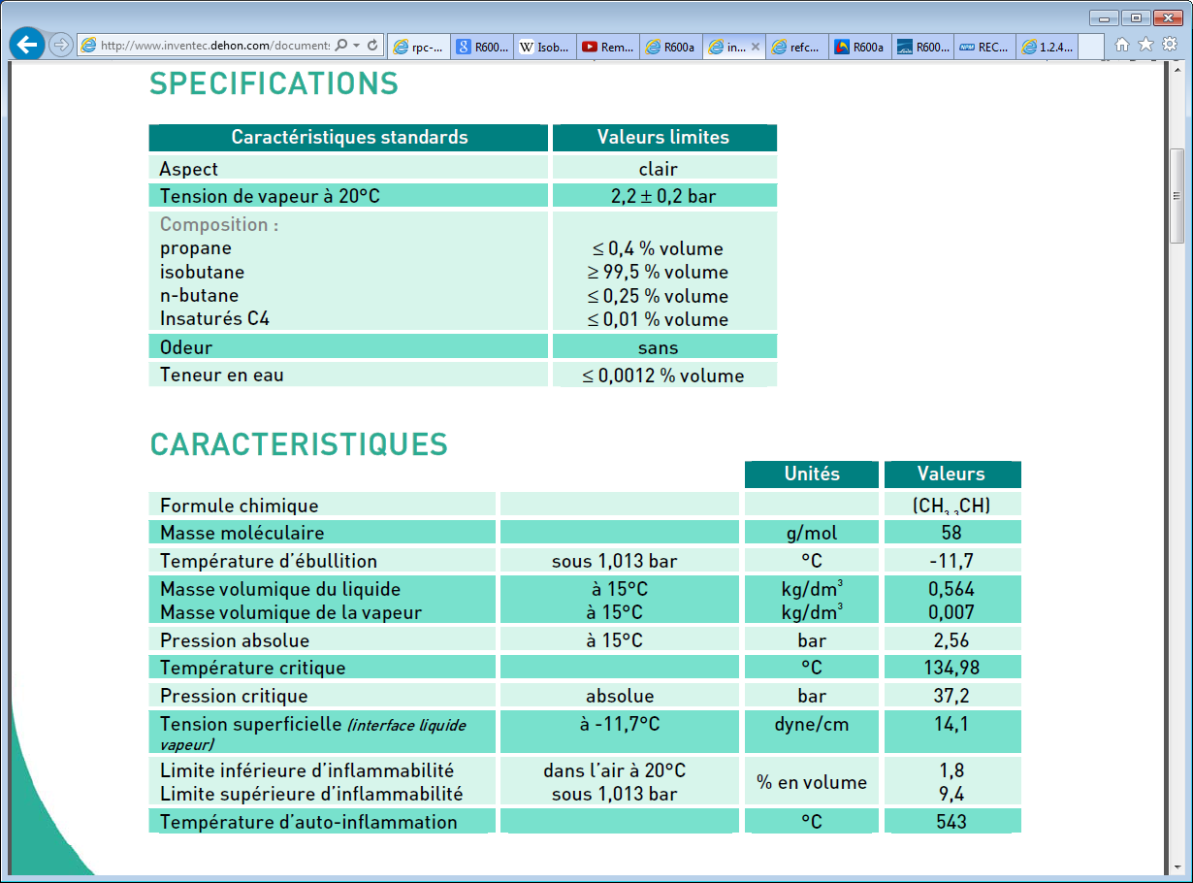

Fammability problems

A simplistic view.

7g of gas/liquid will occupy 1litre @ 15degCR600a

1kg of gas/liquid will occupy 143 litres

13kg of gas/liquid will occupy 1857 litres almost 2m3

With an LEL of 1.8%.

A room of 102m3 (40m2 = 5mx8m) will be fully filled with a flammable mixture.

Any ignition source will ignite the entire room and give a deflagration or detonation

Flammability

<http://www.draeger.com/sites/assets/PublishingImages/Segments/ES/Oil-Gas-Industry/Plant-Safety-Operations/explosion_protection_br_9046262_en.pdf>

<http://en.wikipedia.org/wiki/Flammability_limit>

<http://www.bartec.de/homepage/eng/downloads/produkte/exschutz/exprotection.pdf>

<http://www.gasesmag.com/features/2012/September/Chilworth_September_2012.pdf>

ATEX

<http://www.cmp-products.com/what-is-atex-and-why-atex-was-introduced>

Jonathan.Gulley@cern.ch 160890

Refs

<http://fr.wikipedia.org/wiki/Isobutane>

<http://www.inventec.dehon.com/fr/chimie-fine/intermediaires-de-synthese/19/r600a/223.html>

<http://www.linde-gas.com/en/products_and_supply/refrigerants/natural_refrigerants/R600a_isobutane/index.html>

<http://www.npm.fr/p/freon-gaz-refrigerants/recharge-isobutane-r600a-420g/54270>

<http://www.secop.com/products/compressor-basics/ac-compressors/1-secop-hermetic-reciprocating-compressors/12-refrigerants/124-flammable-refrigerants-r290-and-r600a.html>

<http://www.gasesmag.com/>