*Starting a RPC lab in the Physics Dept in Helwan University, Egypt.*

Ian Crotty July 2011

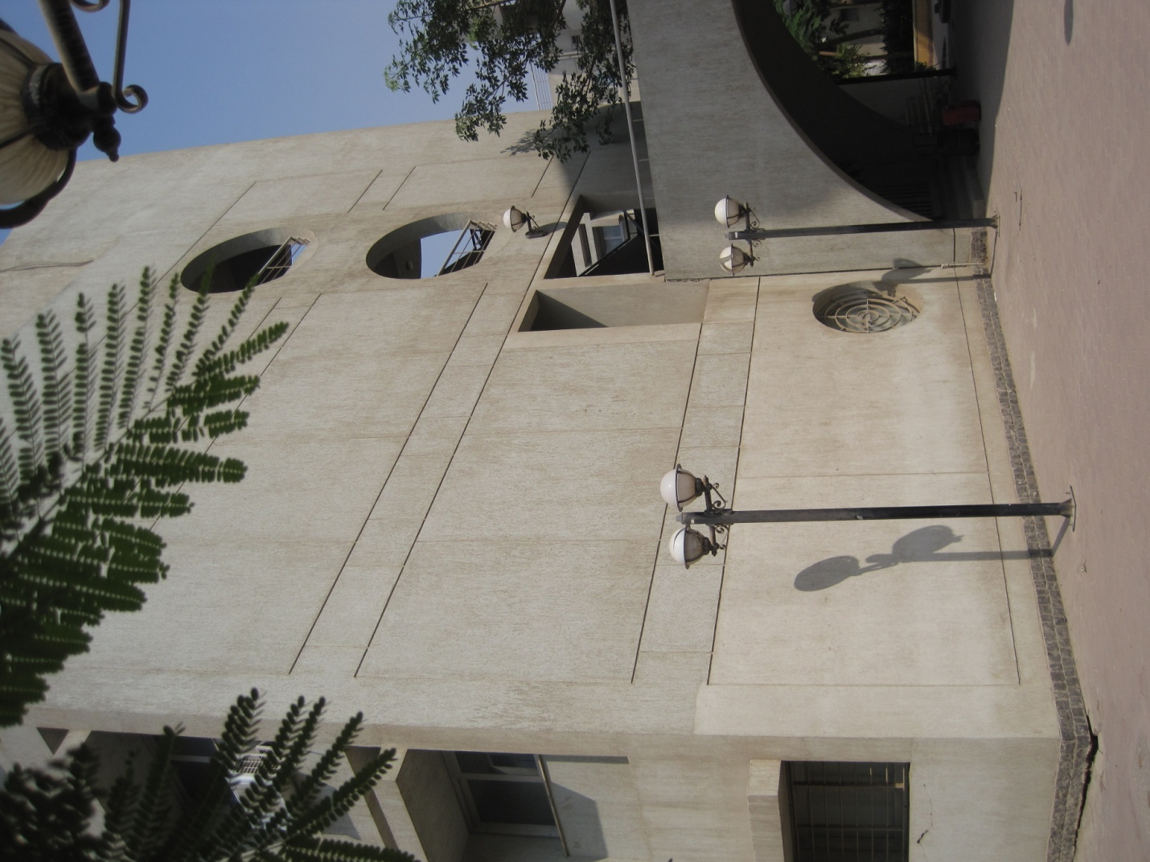

**The labs x2**

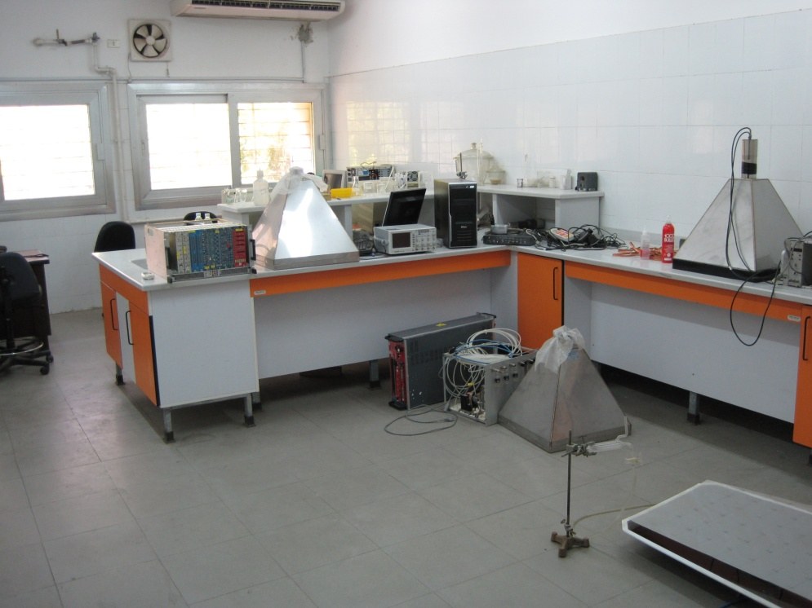

The Air-conditioned lab

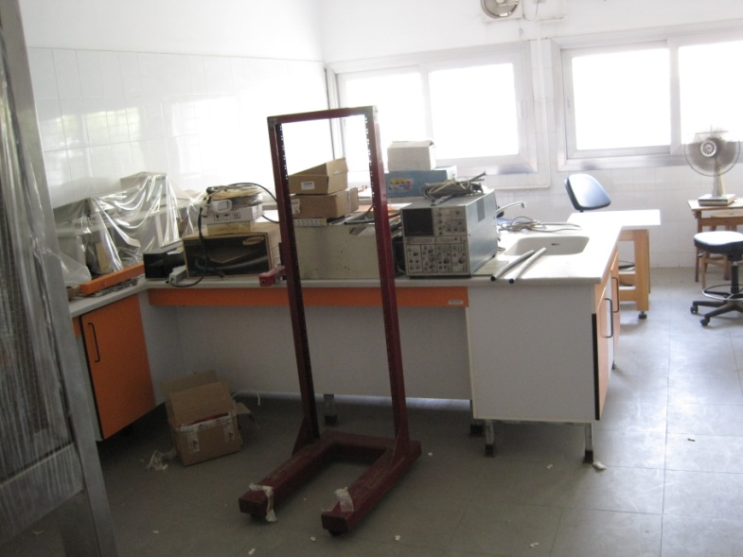

The lab with no AC

**Ambient temp and humidity.**

An instrument was found and made to work. The measured values with the AC running for some hours was <20deg C and ~70%. It would be a good idea to verify these measurements. The amount of water dripping from the Ac into a bucket was >20litres/day for a room of some 60m2 and occupied by 5-6 people.

**Gas**

2 Channel Mixer calibrated for R134a and Isobutane

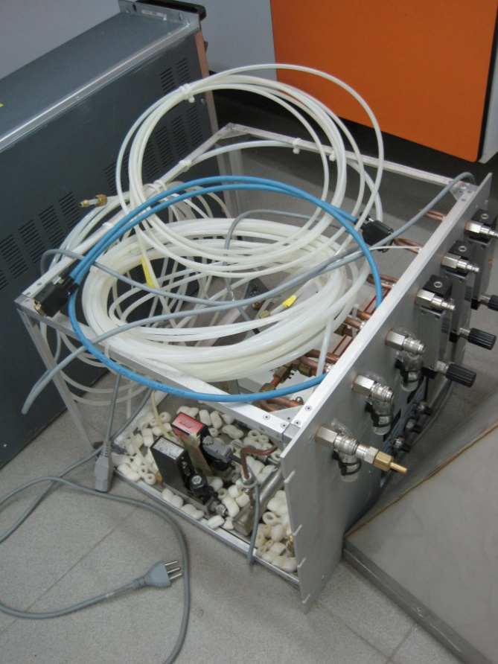

**Freon**

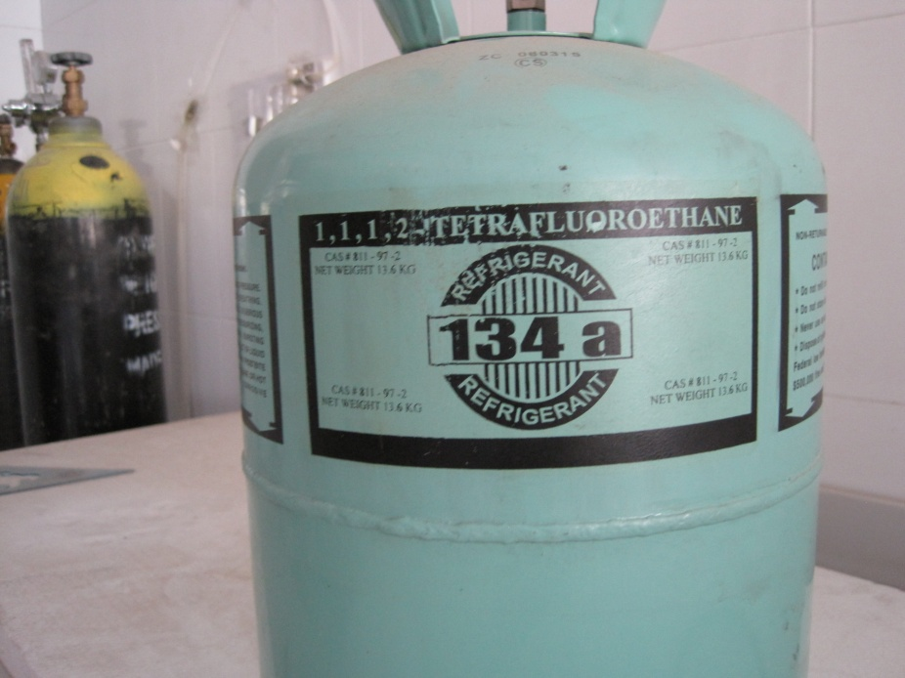

13kg of R134a

**Isobutane**

It seems that isobutane is not available in Egypt and but should be imported. Butane is also no longer available as a product called Biogas has replaced it. Biogas seems to be made from 50 -70% Methane and 30 – 50% Co2 with quite some other elements in the 1-10% range. The main constituents are both quenchers. What are the alternatives

**Campingaz**

Is composed of 70% Butane and 30% propane. It was found in small containers with a screw top. Again both are quenchers.

**Safety**

**Electrical**

The differential protection (30mA)from CERN sores was equipped with an Egyptian type plug ( German) and is used for all devices , rack scope etc. A dedicated large section Cu ground strap was connected, by a qualified electrician, to the electrical earth of the building inside the distribution box of the lab. This was then also connected to the rack and with an extension to the chamber. It should also be connected to the Comic frame. This installation is safe assuming the earth of the building has been well done.

**Gas**

The proposal is to put the flammable gas bottle and or mixer outside the building with a cut off valve inside the lab. The exhaust will also be vented out of the building. An alarm will be found and installed to indicate the presence of flammable gas if any in the lab. A procedure to deal with such eventualities must be drawn up and instructions for use made to those allowed to use the installation.

**HV/LV**

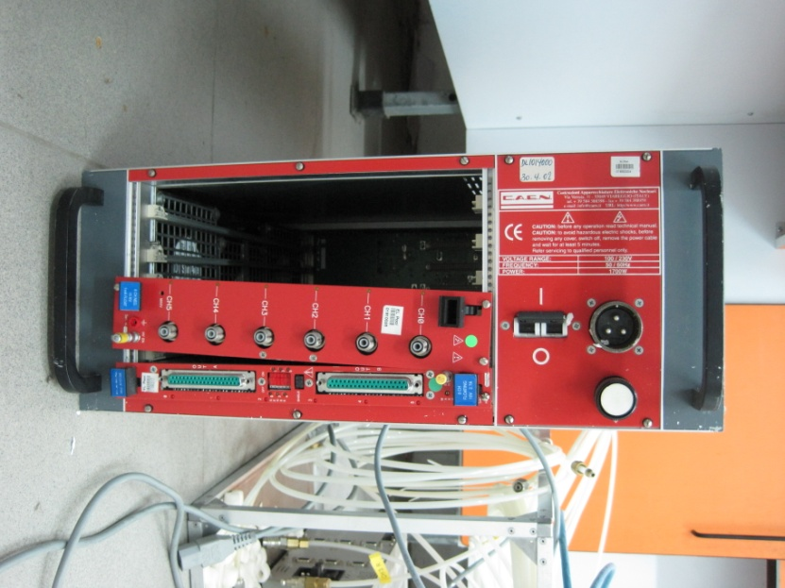

Unfortunately some of the support rails in the crate did not withstand the transport accelerations .

See appendix for additional pictures of the damage. The unit was opened and other rails chosen to mount the LV and H modules. Both were tested and found to be operational. A HV 3 pin dummy plug was made up by the students so that the HV cable could be tested to 12KV. This was done noting the values of current both stable and during the ramp using different ramp rates, resulting in a discussion of capacitance and leakage currents. The LV PS & cable was also tested .

**Cosmic stand frame incorporating a Farady cage for the chamber**.

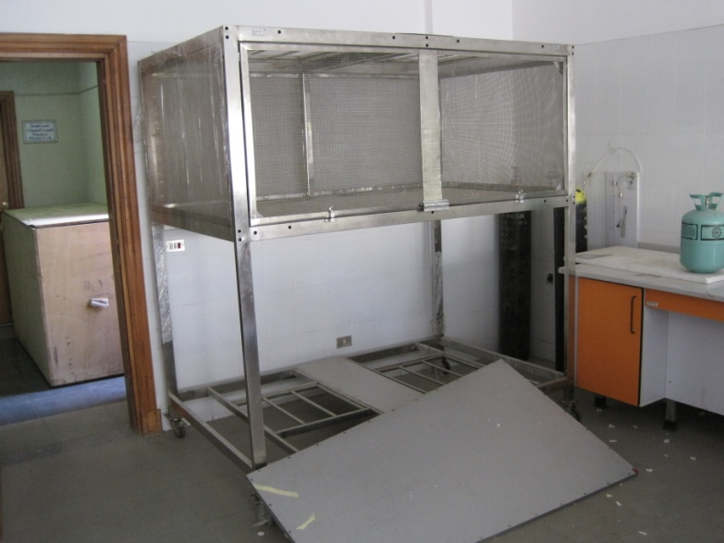

This was dismounted and put in the AC lab. It has positions for 4 scintillators, 2 on top and 2 at the bottom. They are separated in height by approx 1.8m and in a horizontal plane by ~30cm. Improvements in acceptance can be made by reducing these distances. At present only 2 are equipped with PMTs. One of these was tested and found to be working well.

**Scintillators x4**

Stainless steel light guides mounted on top of the plastic scintillator ( ~70cm x 70cm x 5cm) which is at the bottom of the pyramide.

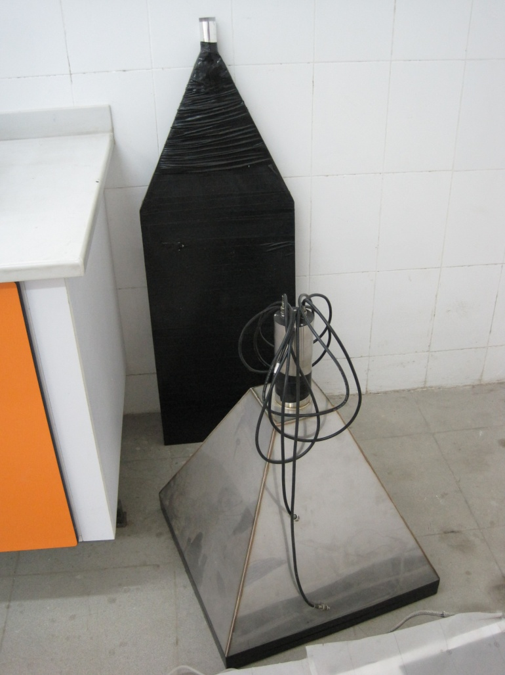

Behind the pyramidal version is a scintillator with side light guide and unfortunately no PMT fittings nor PMT. This can have the standard 2inch fittings mounted and the PMT base screwed on.

One of the scintillators/PMT asemblies was powered up, on the last morning, and the pulses observed with an oscilloscope, Insteck GDS 2204 with 200Mhz bandwidth and 1 Gs/s. It would not go below 5microsecs/div.

<http://www.tequipment.net/InstekGDS-2204.html> See Appendix.

The pulse was not visible at the first attempt but became rather clean after x10 amplification.The discriminator was connected and a pulse was seen on the scope. This needs further investigation.

**Chamber and gap storage**

Componets of a chamber sent some time ago were also in the lab. It is open with the gaps removed. One gap was put back in to help protect it. One gap had been opened to see the construction and oiled surfaces.

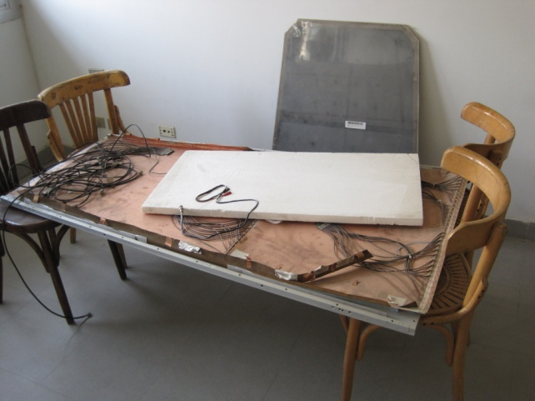

Base of opened chamber

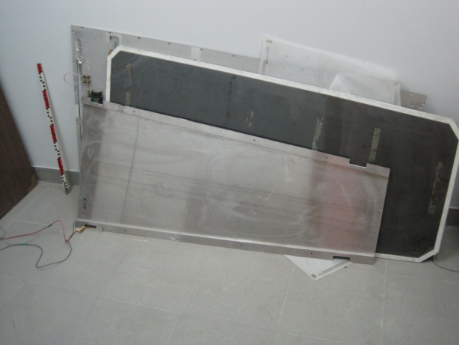

One bottom gap and the top cover equipped with 3 FEBs.

**NIM failure**

While attempting to obtain a NIM pulse from the discriminator , after amplification , it was found that the Egyptian NIM carte had the + &- 6V missing. Fortunately there are 2 other NIM bins from CERN, one of which was verified.

**Actions**

The reassembly of the cosmic stand in the AC lab.

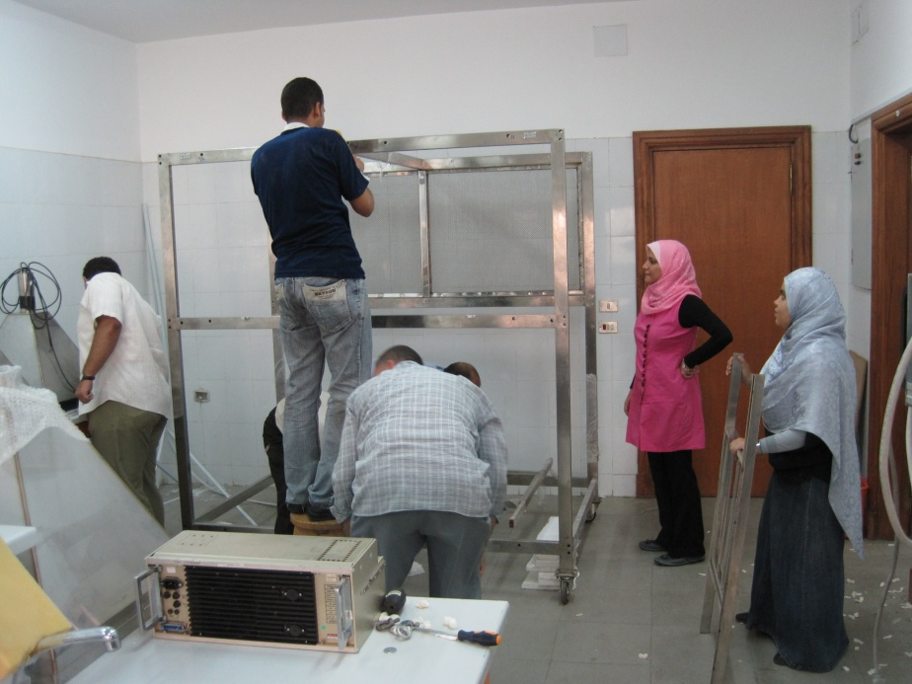

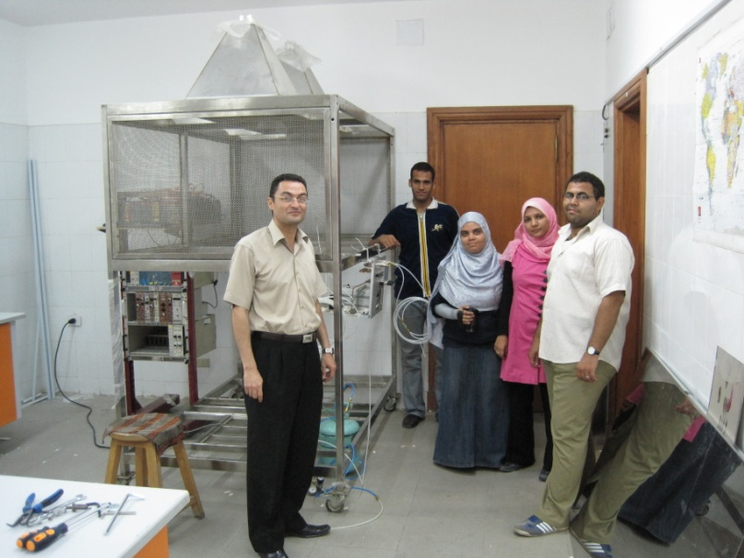

The team standing next to the cosmic stand with temporarily mounted gas mixture crate and 3 NIM crates and CAEN HV/LV crate installed in the shortened CERN rack.

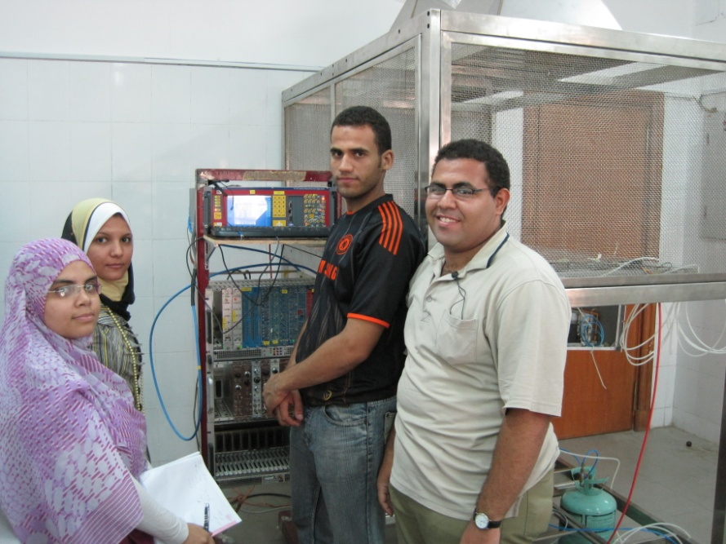

Gas and High voltage on !

Students:

From left to right; Shereen, Walla, Waleed and Ahmed

The voltage and current were plotted in the ohmic region up to 7kV to illustrate what will be done once the correct mixture is available. Currents < 1-2 microA were noted. The data is with the students.

**Future plans**

The present objective will be to obtain an efficiency plot using what is available. Either importing isobutene or using those gases available. The quencher gas problem must be solved, this in its self is an interesting project.

Currents can be measured with respect to temperature and relative humidity, both are especially high.

Cluster size can be investigated, studying streamers.

Alternative chamber concepts can be investigated, eg Multigap that function with pure Freon.

With more electronics even more could be done.

**Documentation and procedure.**

All actions should be noted and procedures established, to ensure the safety of the those involved and the survival of the equipment.

**Appendix**

**Lab. Equipement;**

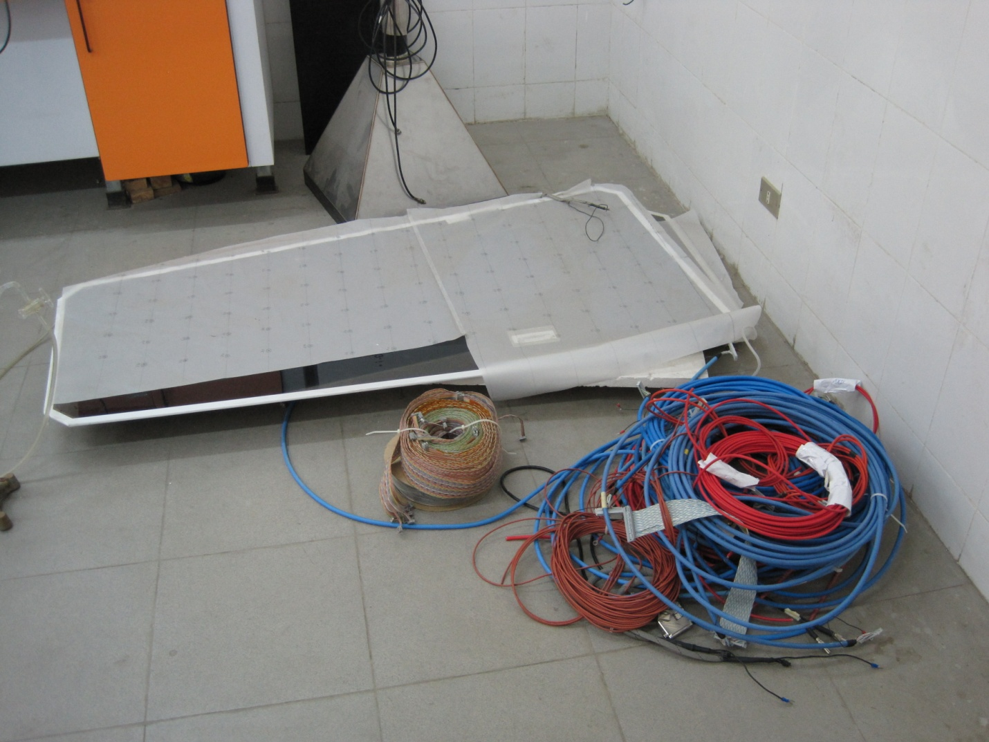

Some cable and gaps unpacked from the recent delivery.

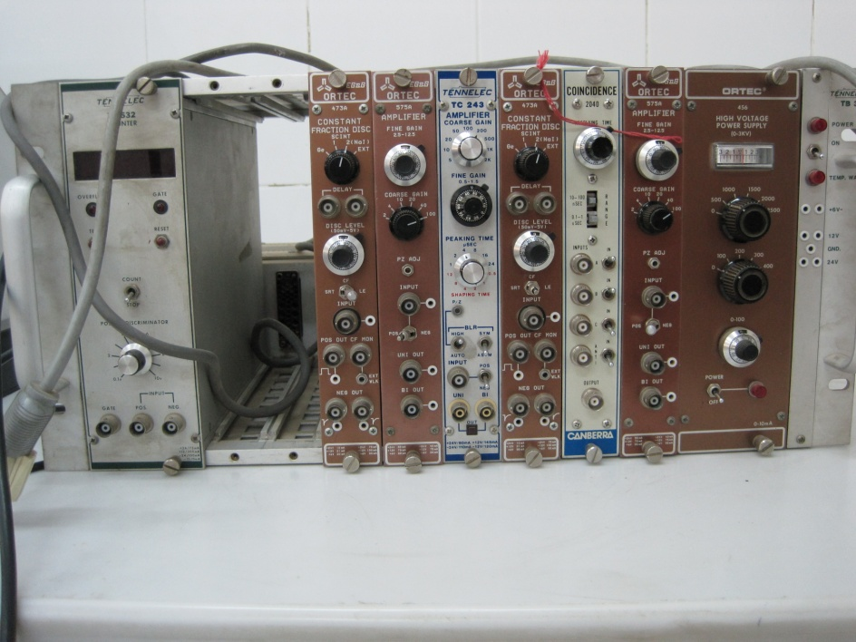

The Electronics used with the scintillators & PMTs

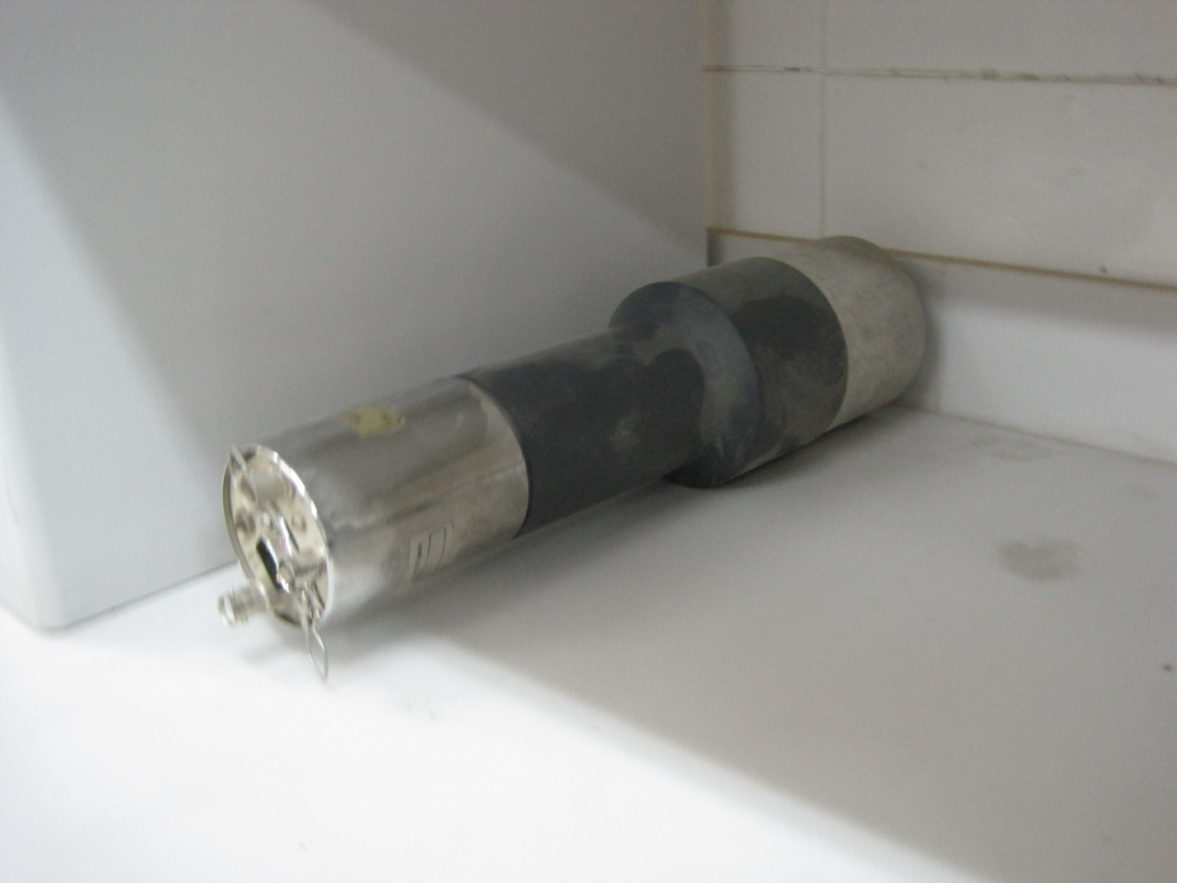

PMT & NaI

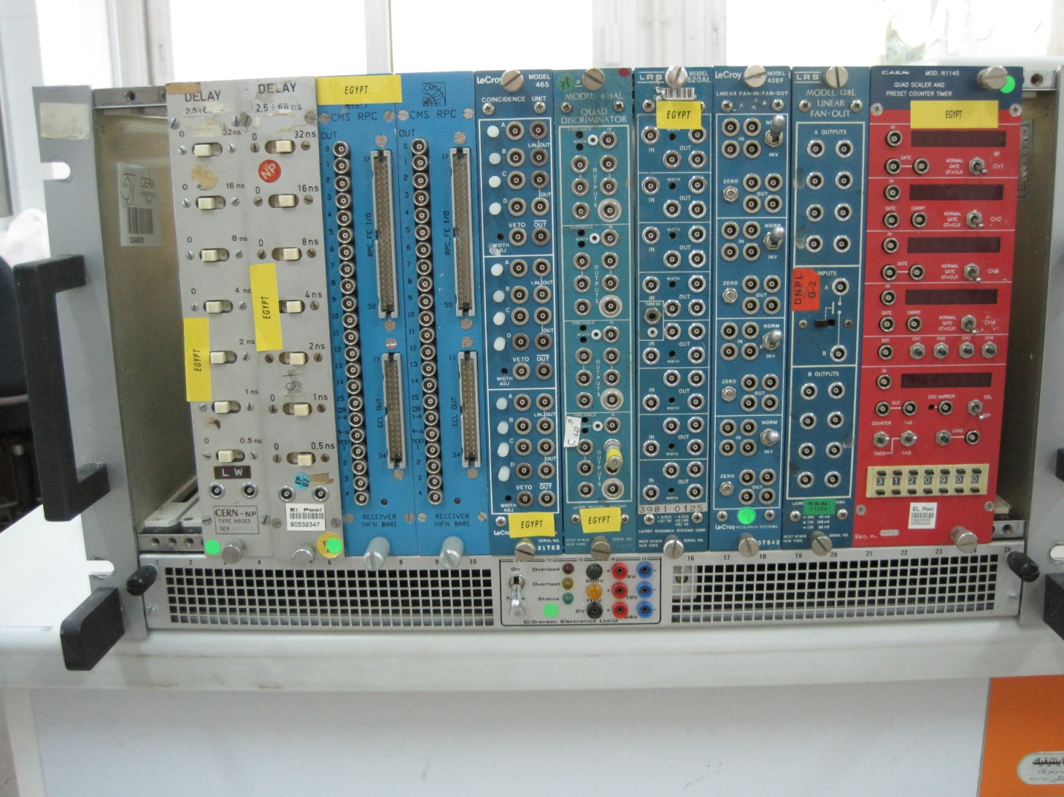

Electronics from CERN.

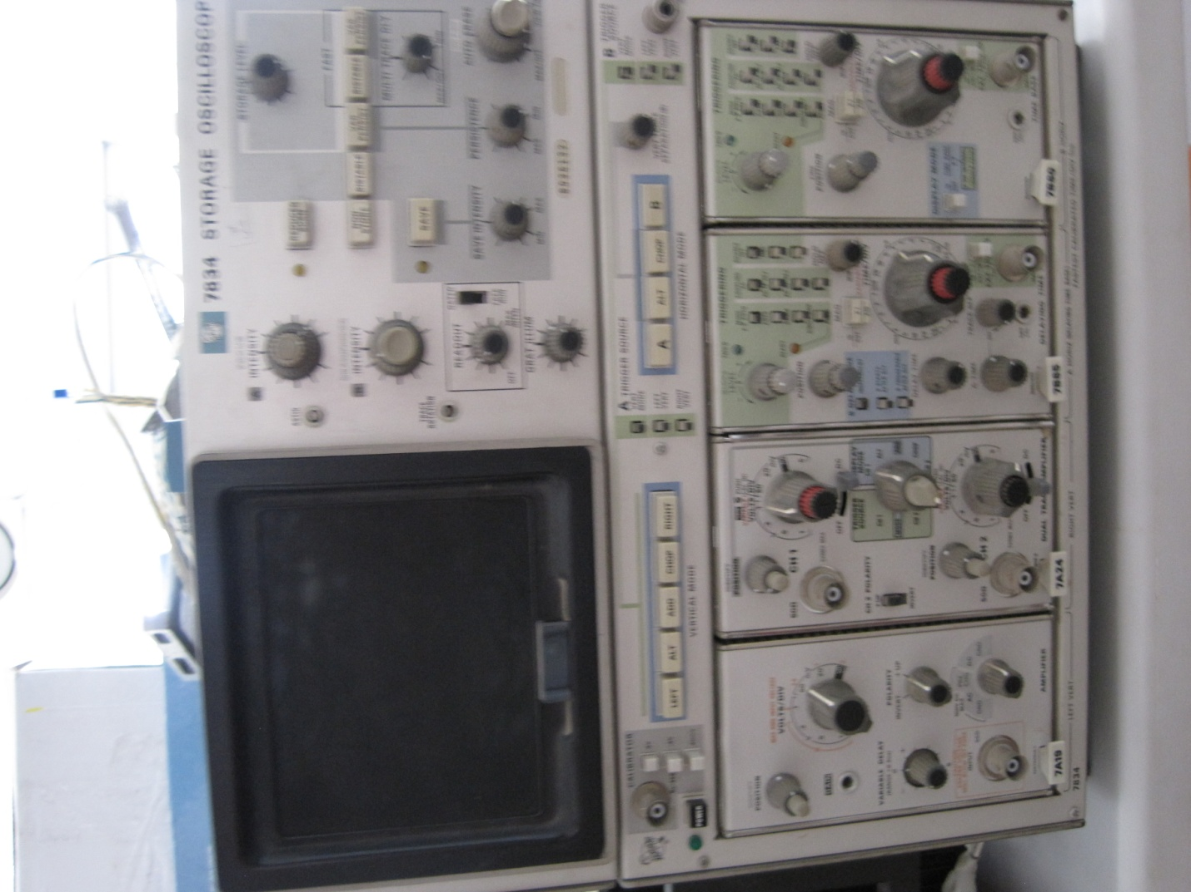

An old storage scope.

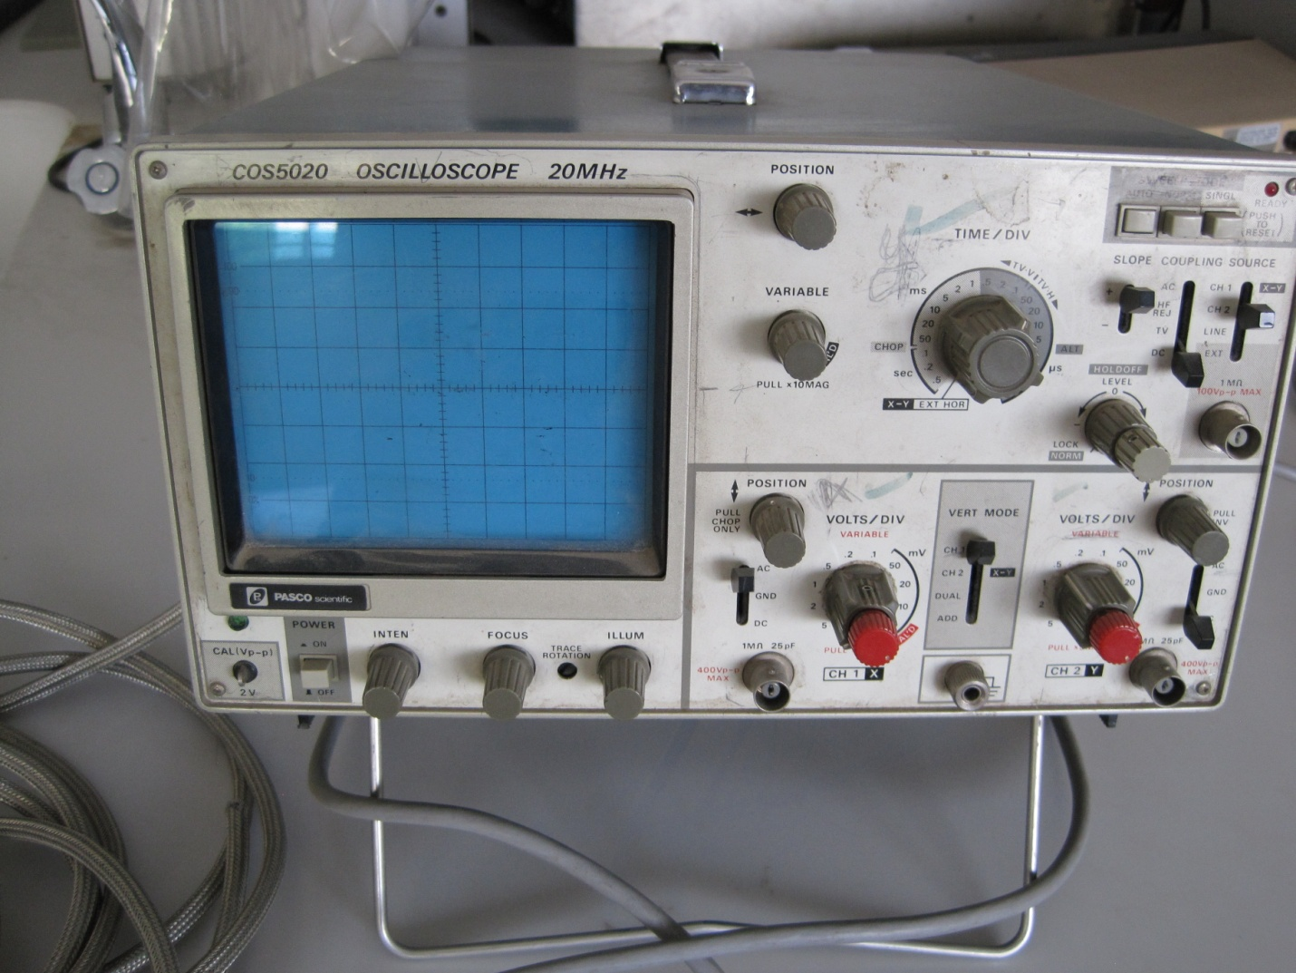

An analogue scope

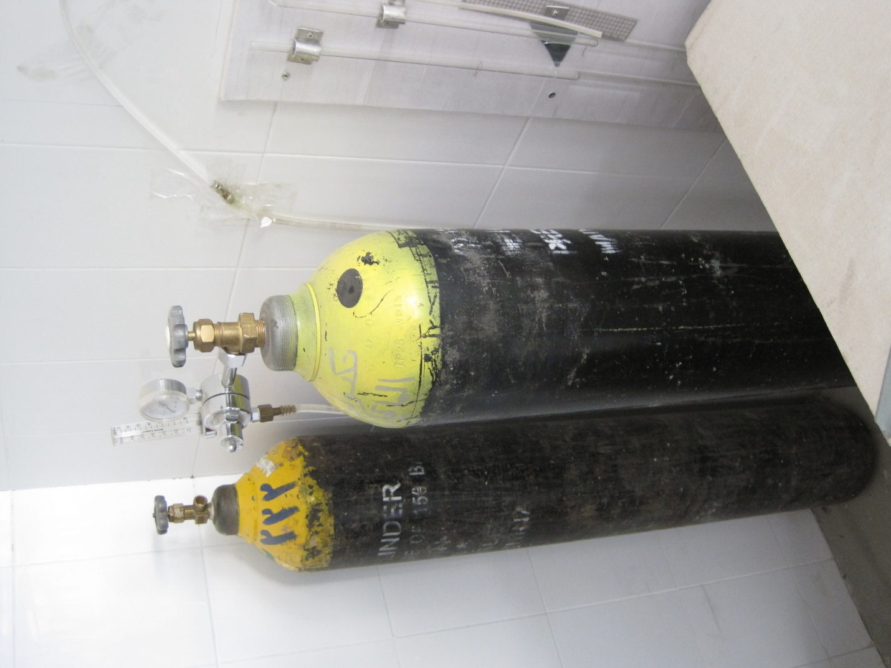

Ar and a mixture of Ar and CO2, perhaps available for welding.

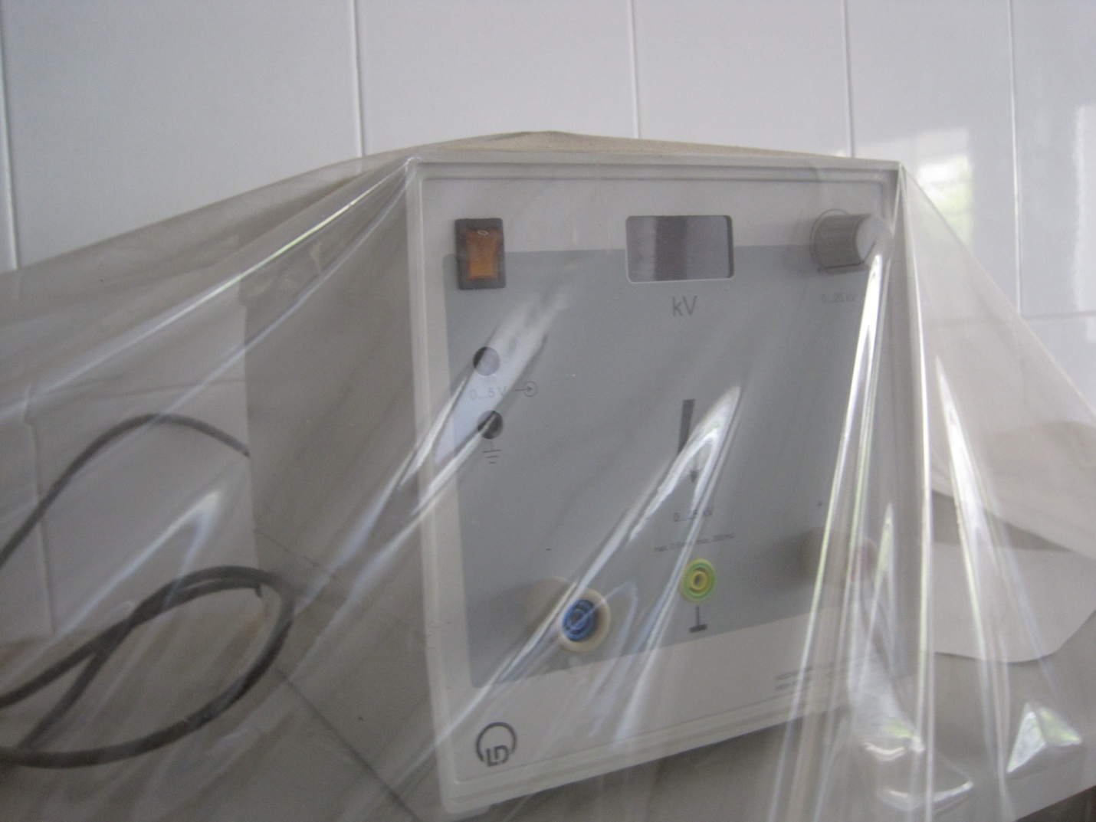

25 kV 1mA PS .

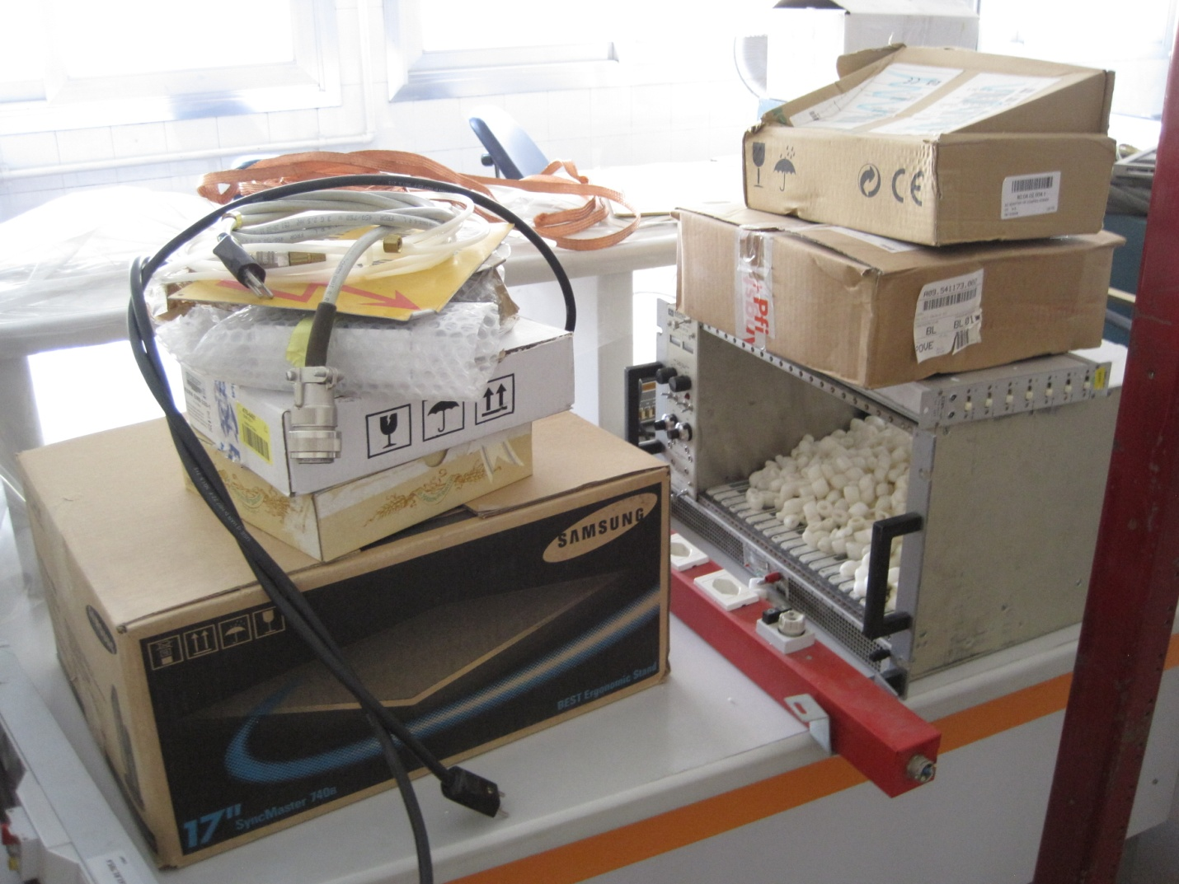

Material from CERN

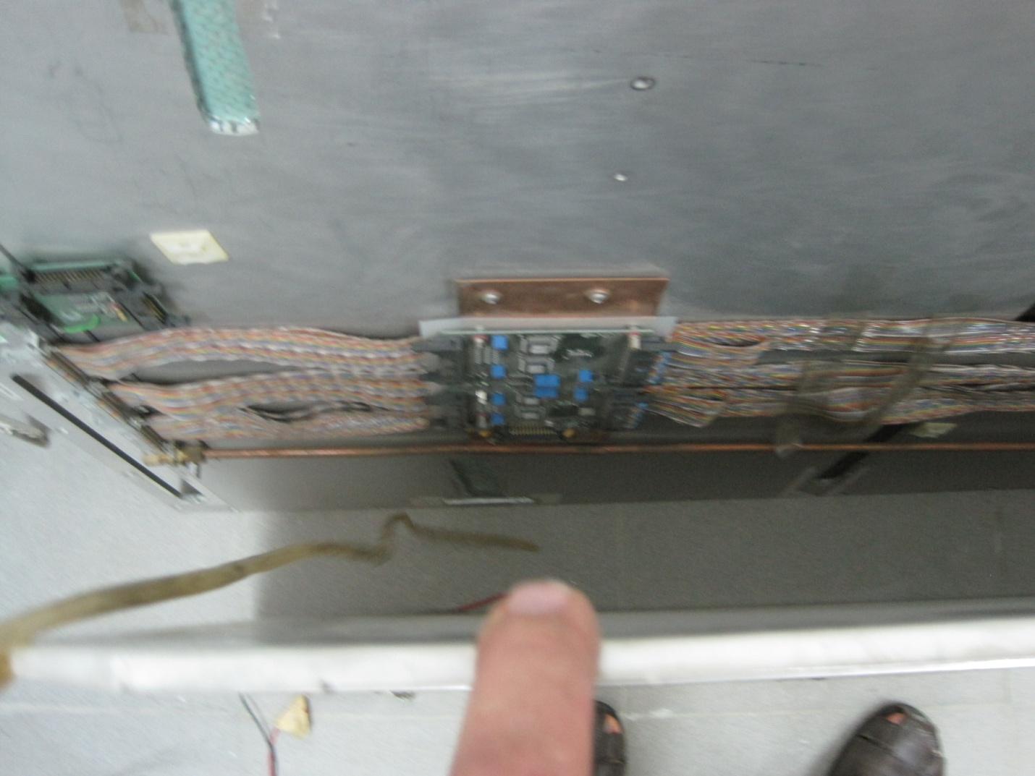

The spare FEBs

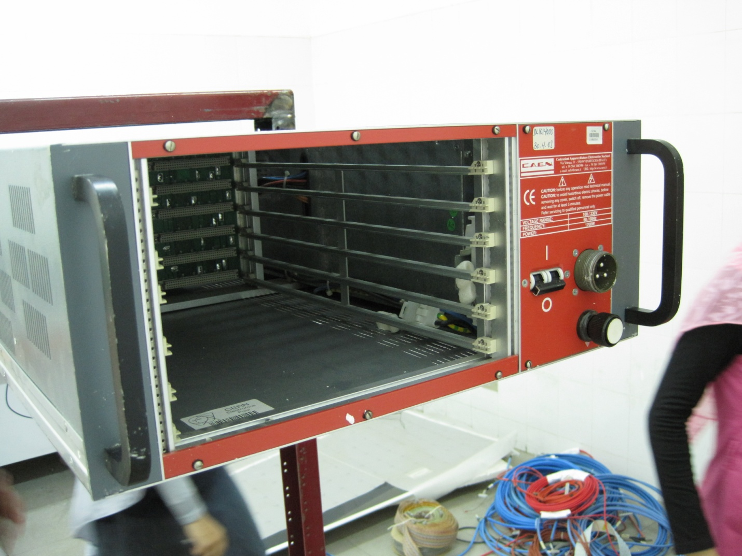

Damaged CAEN Rails

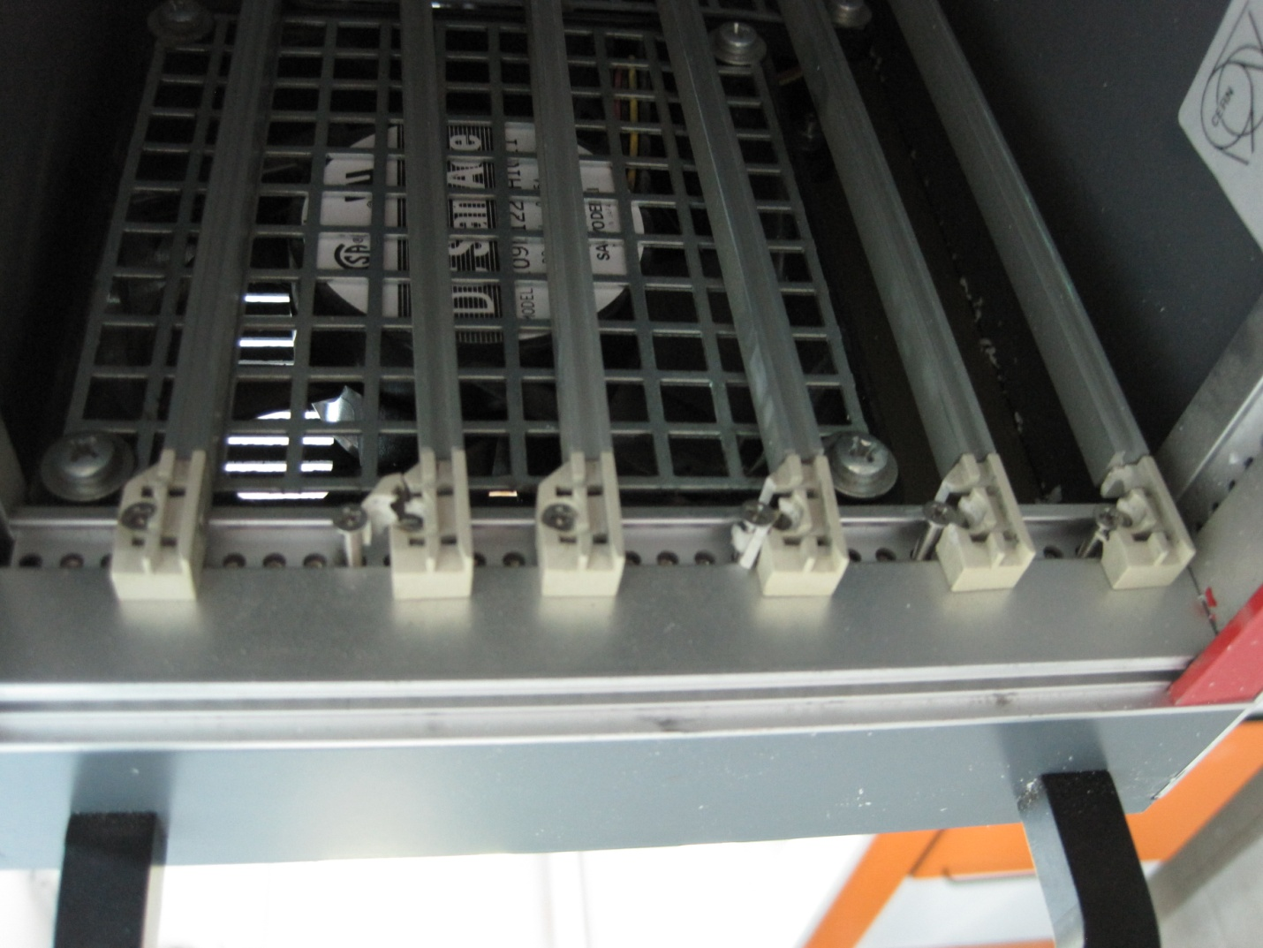

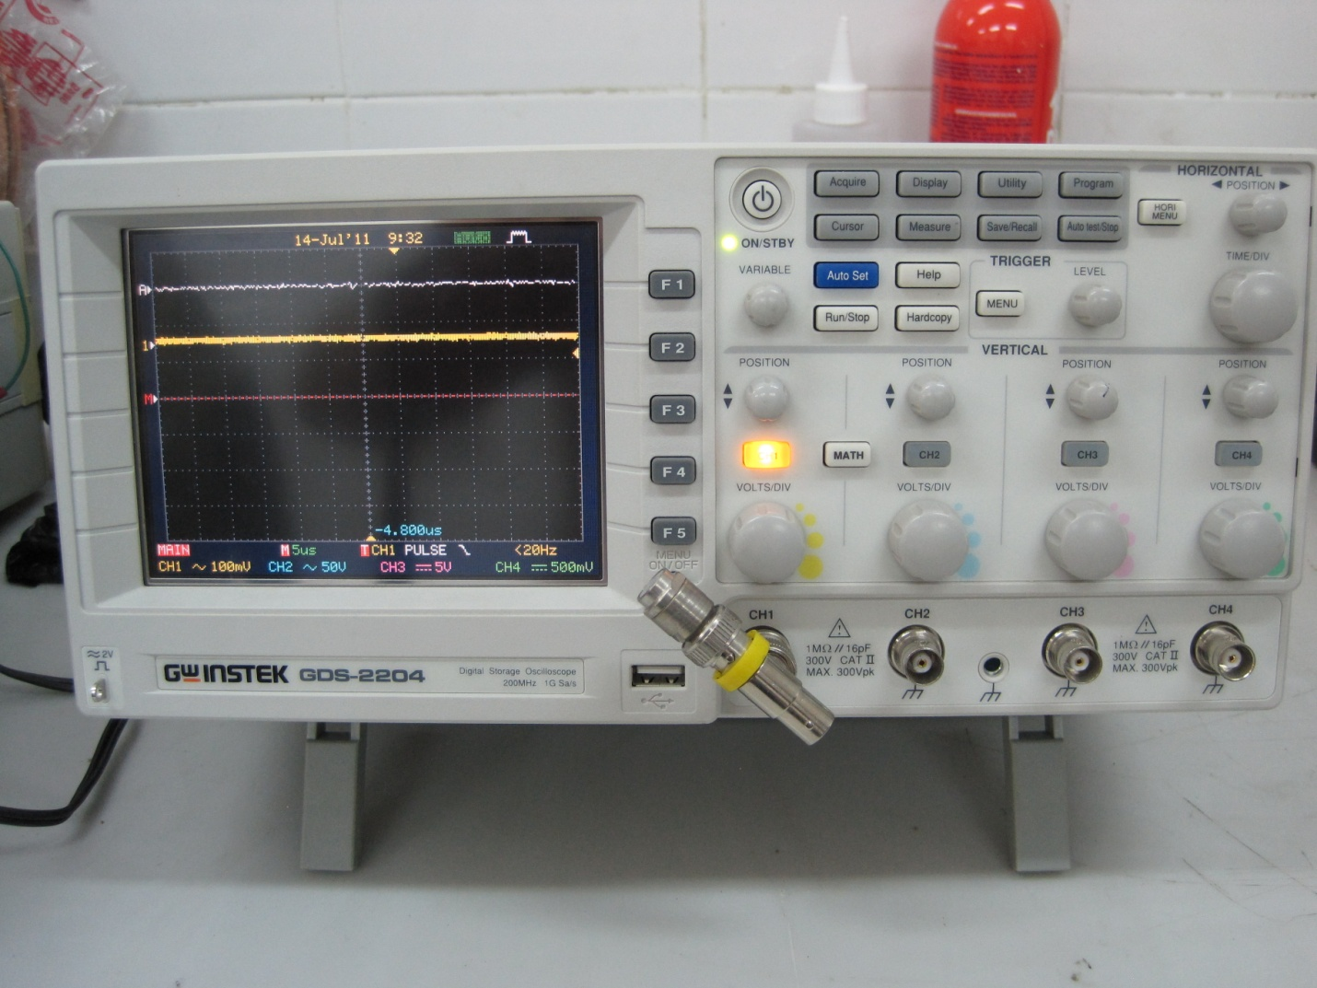

The good digital scope

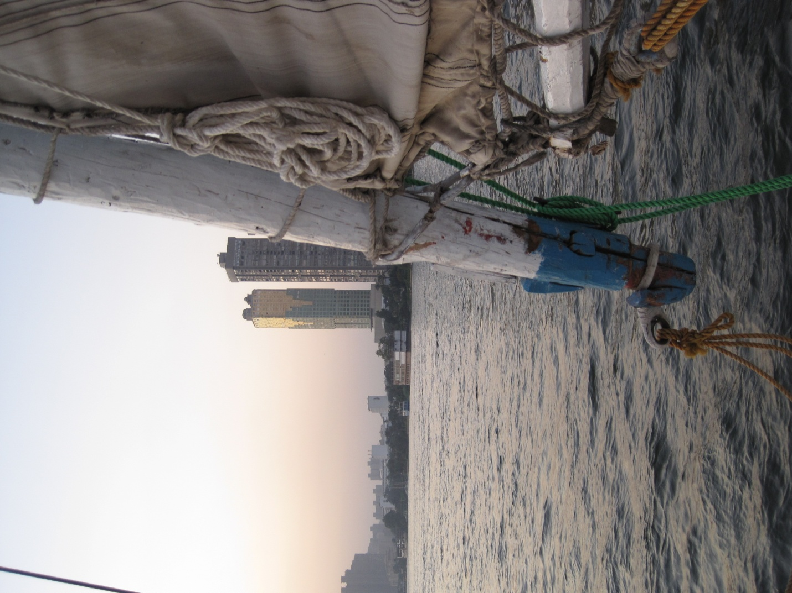The clash of old and new

Thanks to all those involved especially Dr. Ayman Mohamed Mahrous