Books of use in building detectors and Scientific projects

Techniques for Nuclear and Particle Physics Experiments: A How-to Approach

William R. Leo

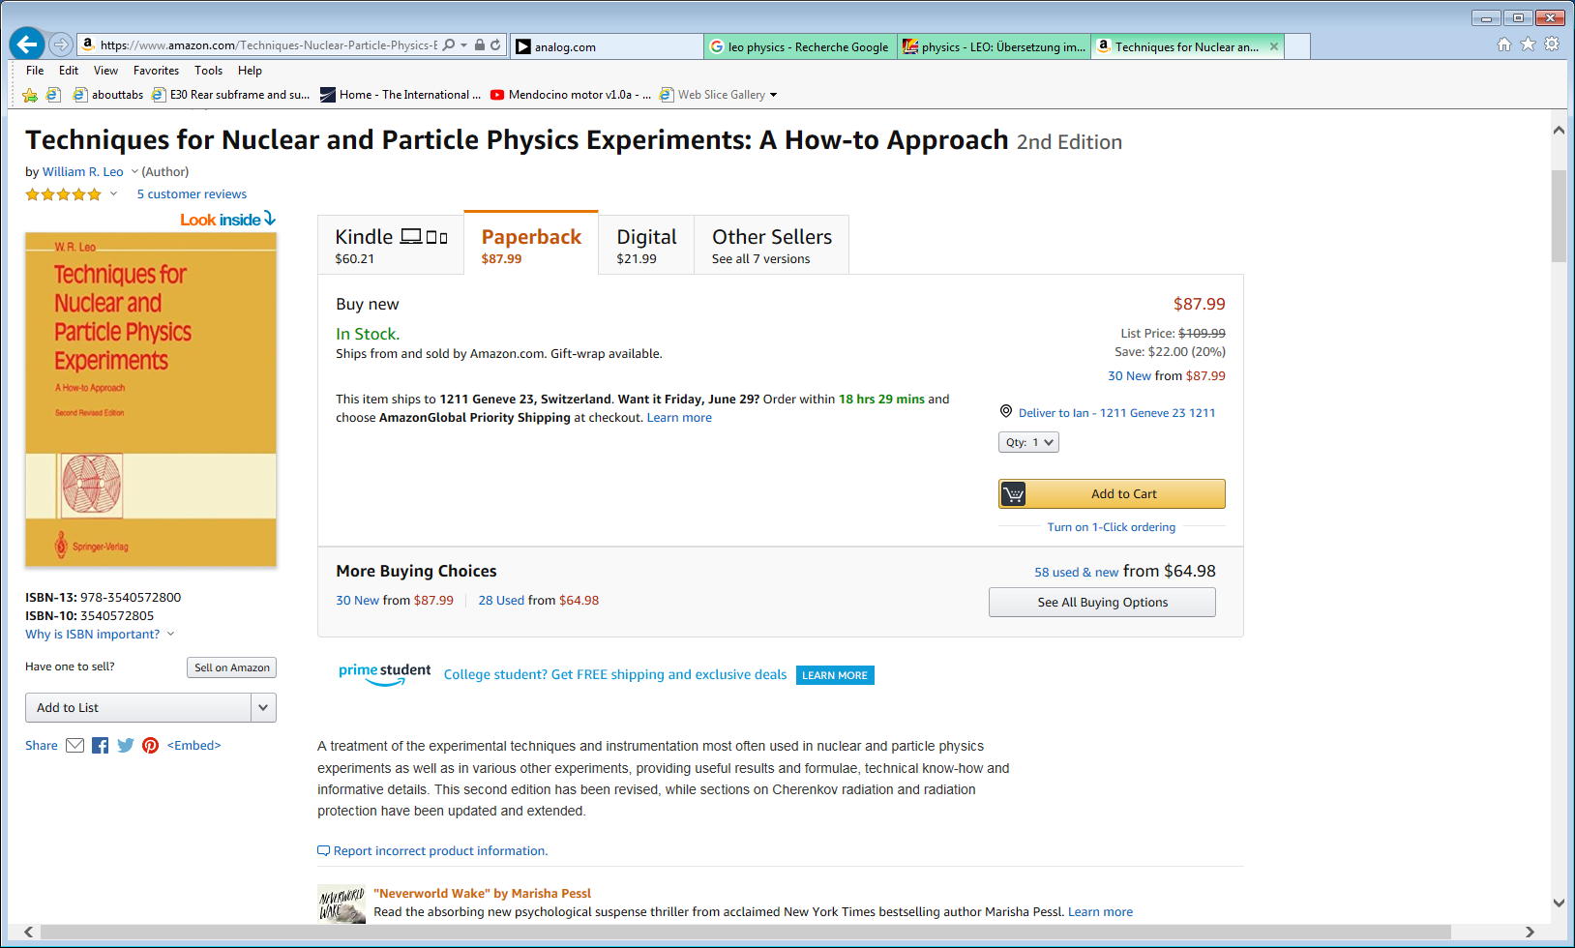

http://iopscience.iop.org/article/10.1070/PU1988v031n11ABEH005654/pdf

https://cds.cern.ch/record/302344/files/0387572805_TOC.pdf

http://tesla.phys.columbia.edu:8080/eka/William_R_Leo_Techniques_for_nuclear_and_partic.pdf

Building Scientific Apparatus

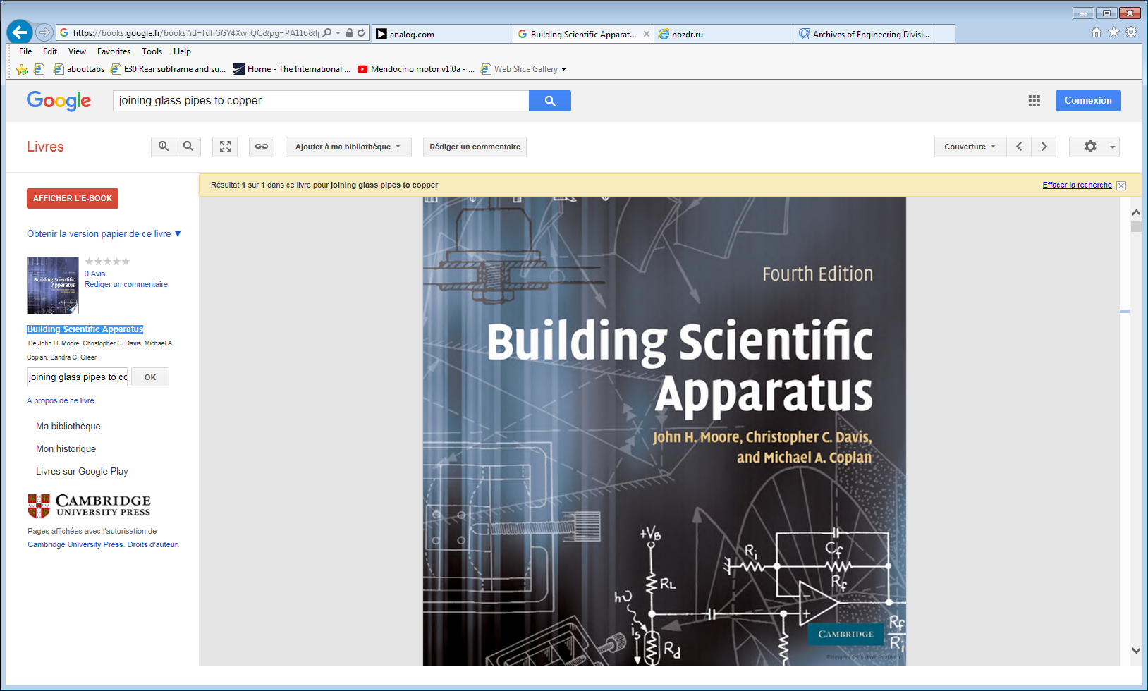

<ftp://nozdr.ru/biblio/kolxo3/E/Moore%20J.H.,%20Davis%20C.C.,%20Coplan%20M.A.%20Building%20Scientific%20Apparatus%20(CUP,%202009)(ISBN%200521878586)(O)(644s)_E_.pdf>

Radiation Detection and Measurement (Anglais) Relié – 24 septembre 2010

Glenn F. Knoll (Auteur)

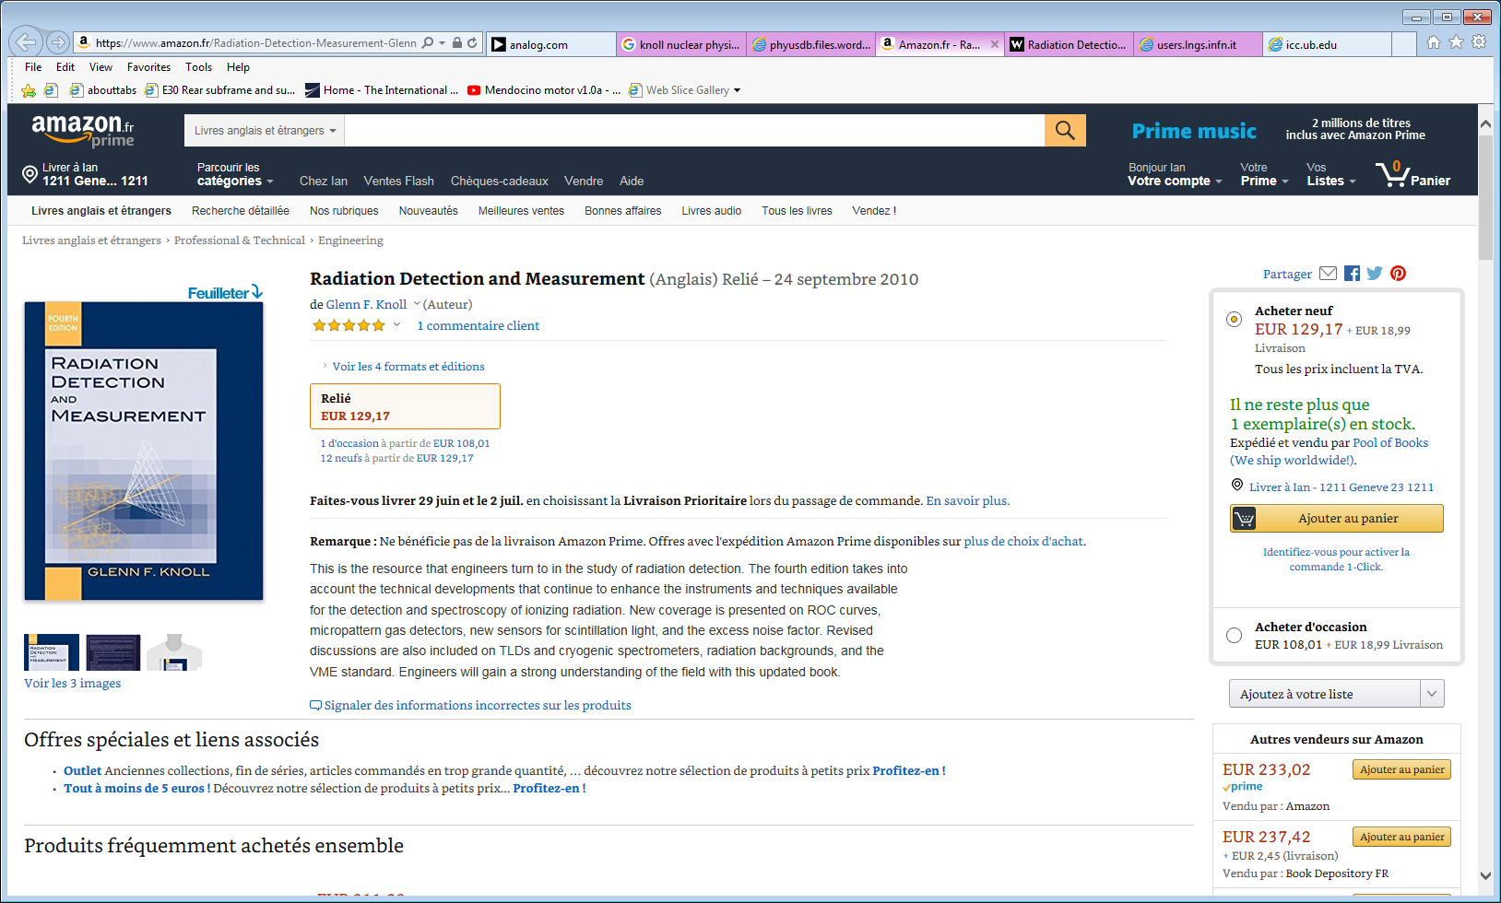

4th edition

https://phyusdb.files.wordpress.com/2013/03/radiationdetectionandmeasurementbyknoll.pdf

3rd edition

<http://users.lngs.infn.it/~dimarco/Radiation%20Detection%20and%20Measurement,%203rd%20ed%20-%20Glenn%20F.pdf>

Sauli

<https://scholar.google.com/citations?user=FzgPZiYAAAAJ&hl=en>

<https://www.researchgate.net/scientific-contributions/62257554_F_Sauli>

Gaseous Radiation Detectors

Fundamentals and Applications

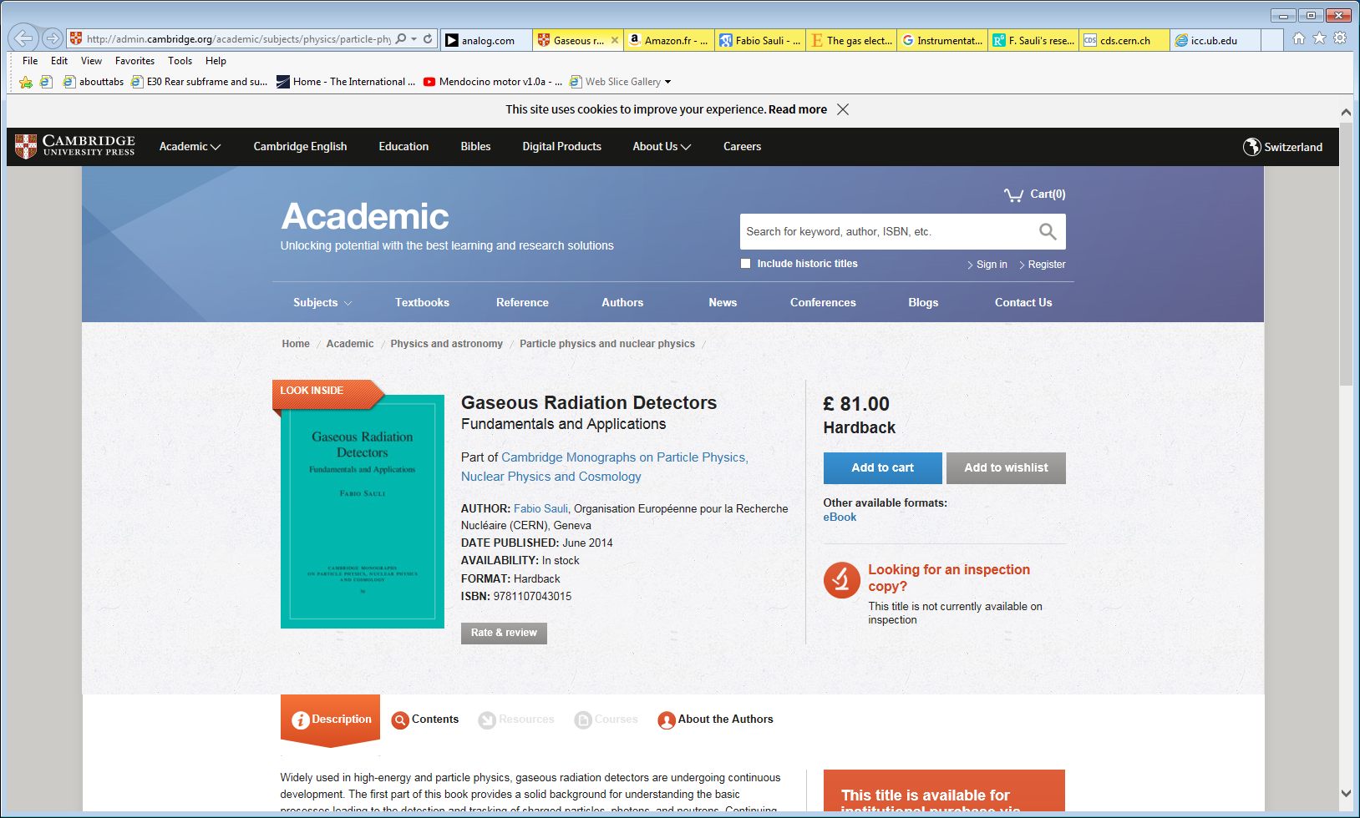

GEM and Sauli

https://www.sciencedirect.com/science/article/pii/S0168900215008980

Companys supplying lab experiments

http://lambdasys.com/products/category/3