Industrial visits in Mexico primarily in search of RPC Chamber mechanics namely Honeycomb panels (HCP). A log.
Ian Visit Feb 2018

PUEBLA
13 Feb lab visit & 14 Feb 2018 HCP visit.
See brief report on lab visit made on the spot here;
https://indico.cern.ch/event/707135/
http://rpc-cms-re4-upscope.web.cern.ch/rpc-cms-re4-upscope/RPC/Chamber%20Institutes/Mexico/LabIndustryFeb2018/ LabsIndustrialContactsMexicoFeb2018.pptx

LLerandi
HCP supplier with machining ability, Gerardo LLerandi the owner listened to our requests and agreed on a strategy to proceed. Namely we provide the specification of a model panel that will be used by us to verify the quality of the inserts, facings and cut-outs and in addition we will perform non-destructive stiffness tests and destructive analysis to investigate the build quality. This model panel will allow them to cost the production of the necessary volume for RE3/1 and RE4/1. They have large facilities that does not make our small order very attractive, they produce truck bodies, however once I introduced CERN and its international activities the owner showed far greater interest. One major snag is that the production facility is in Chihuahua that is 4.3 hrs by plane to the north or 17 hrs on the road.
http://grupollerandi.com/servicios/materiales-compuestos
They have a water jet cutting facility that can handle 6m x 2.4m panels. Aluminium profiles can be made to measure in Mexico.
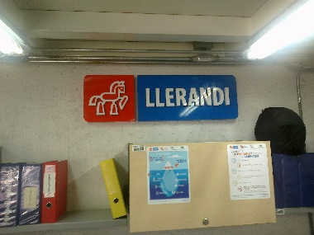
The conclusion is that this appears to be an excellent opportunity that should be followed up but in addition continued efforts must be made to find other suppliers so that quality and pricing can be compared, if possible closer to Mexico city.
INFRA gas supply
They are part of a national company with links to Carba gas or Airliquid.A visit was made with the same colleagues as for the HCP company above. They can supply all three gasses that are required for RPC operation. They claim that prices for educational institutions are cheaper than for industry, “they are even free” !! However thay say you must recover the gas ! off course they can suppy the rig to do that !
In the future they will be able to supply ecological friendly gases such as the HFO series, R449a, R1234yf, R513a, R290 (Propane), R600 (Butane), R600a (2-méthylpropane) etc
A list of all the components for the gas system must be established including clean copper gas pipe.
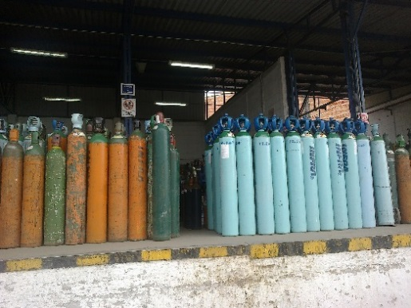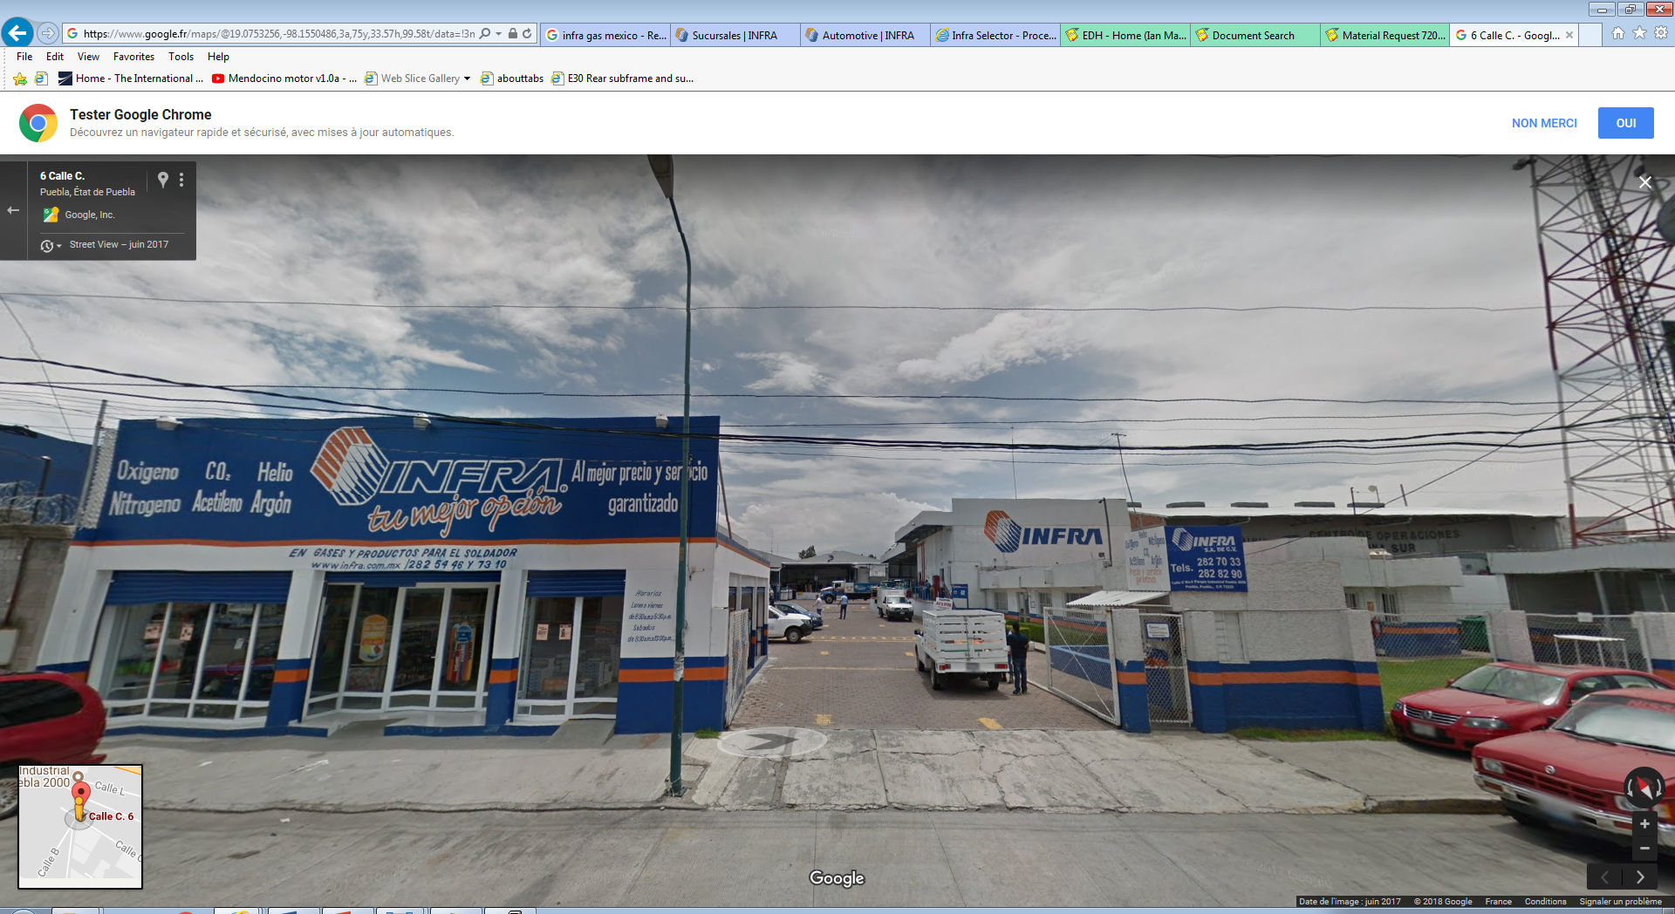

MFC
A brief specification was written for the MFCs, namely;
Total flow 25 [l/hr]
giving 23.8[l/hr] R134a and 1.3 [l/hr] isobutene
SF6 was not included in order to keep the costs down.
6mm input and output ( not ¼ inch which is 6.3mm !)
Input P 2Bar out put 10-100mBar.

Mails were written together with Alejandro requesting quotes for price and delay to ;
Allborg (USA) , Matheson (USA) and Parker (USA) in Mexico city. I have not heard any news.

Gas pipe/union supplier
Guillermo Tejeda Munoz from Alice in BUAP supplied addresses of suppliers of pipe and Legris unions in Puebla. He is making his own gas inlets, HV power supply, Cosmic pinao(operational), glass RPC

Pipes
http://www.maco.com.mx/maco.html
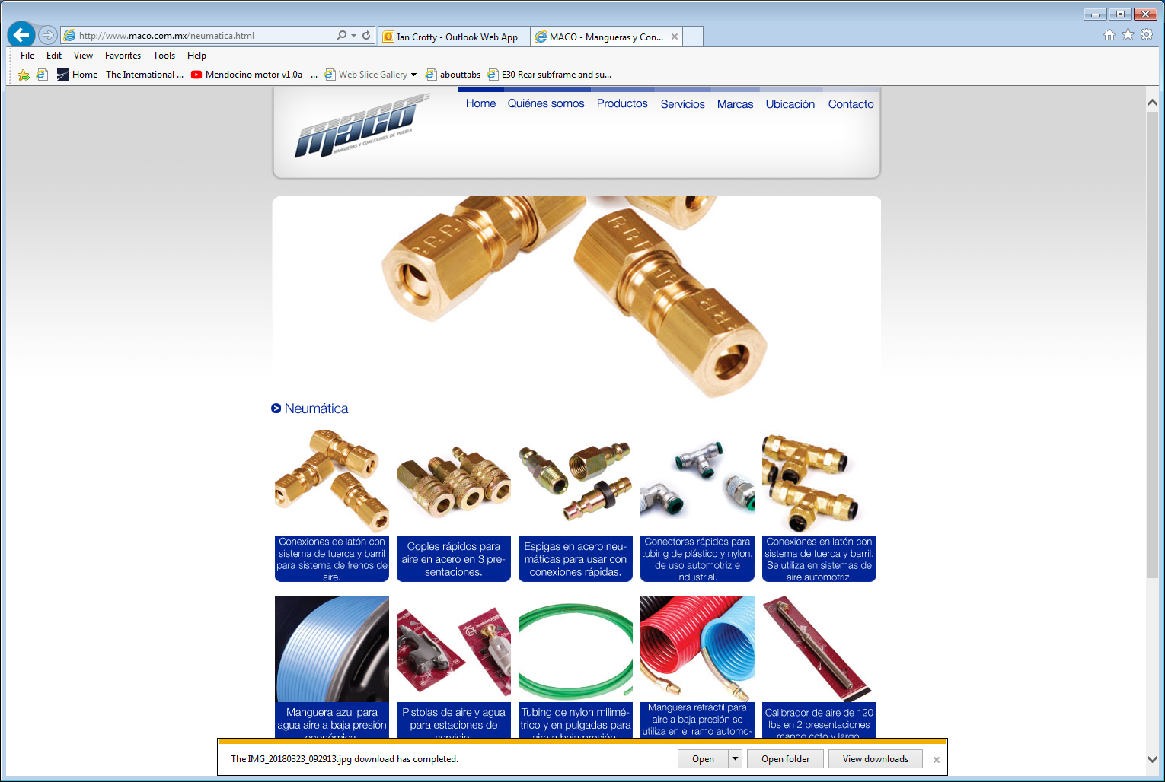

Unions from Parker store
https://www.google.com.mx/maps/place/Parker+Store/@19.0562591,-98.219167,19z/data=!4m5!3m4!1s0x85cfc12b084a819b:0x5432f8d2c910ca59!8m2!3d19.0562591!4d-98.2186934?hl=es-419

A visit was also made to ATLAS BUAP silicon sensor lab with a complete gas installation. Very impressive.
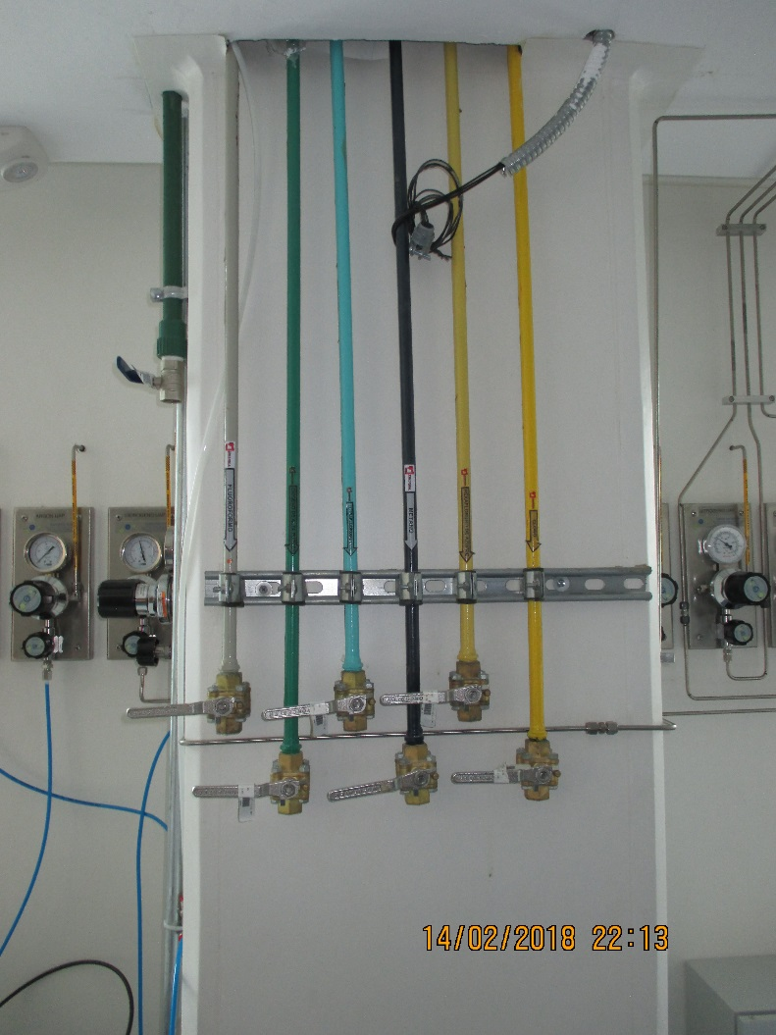
For no clearly explained reason SF6 was not allowed in the building…….

In addition there is in TUCULA there is a military application for faraday cages by Parker.

MEXICO CITY
26 Feb. Hotel was Royal Pedregal.
Here the visit to two “labs” is included as one is an excellent link to numerous industrial suppliers/contacts.
ICN - UNAM Institute de Ciencias Nucleares. Mr. A Ortiz is in charge at this location. Here is the ALICE lab with a gas rack and gas supply.
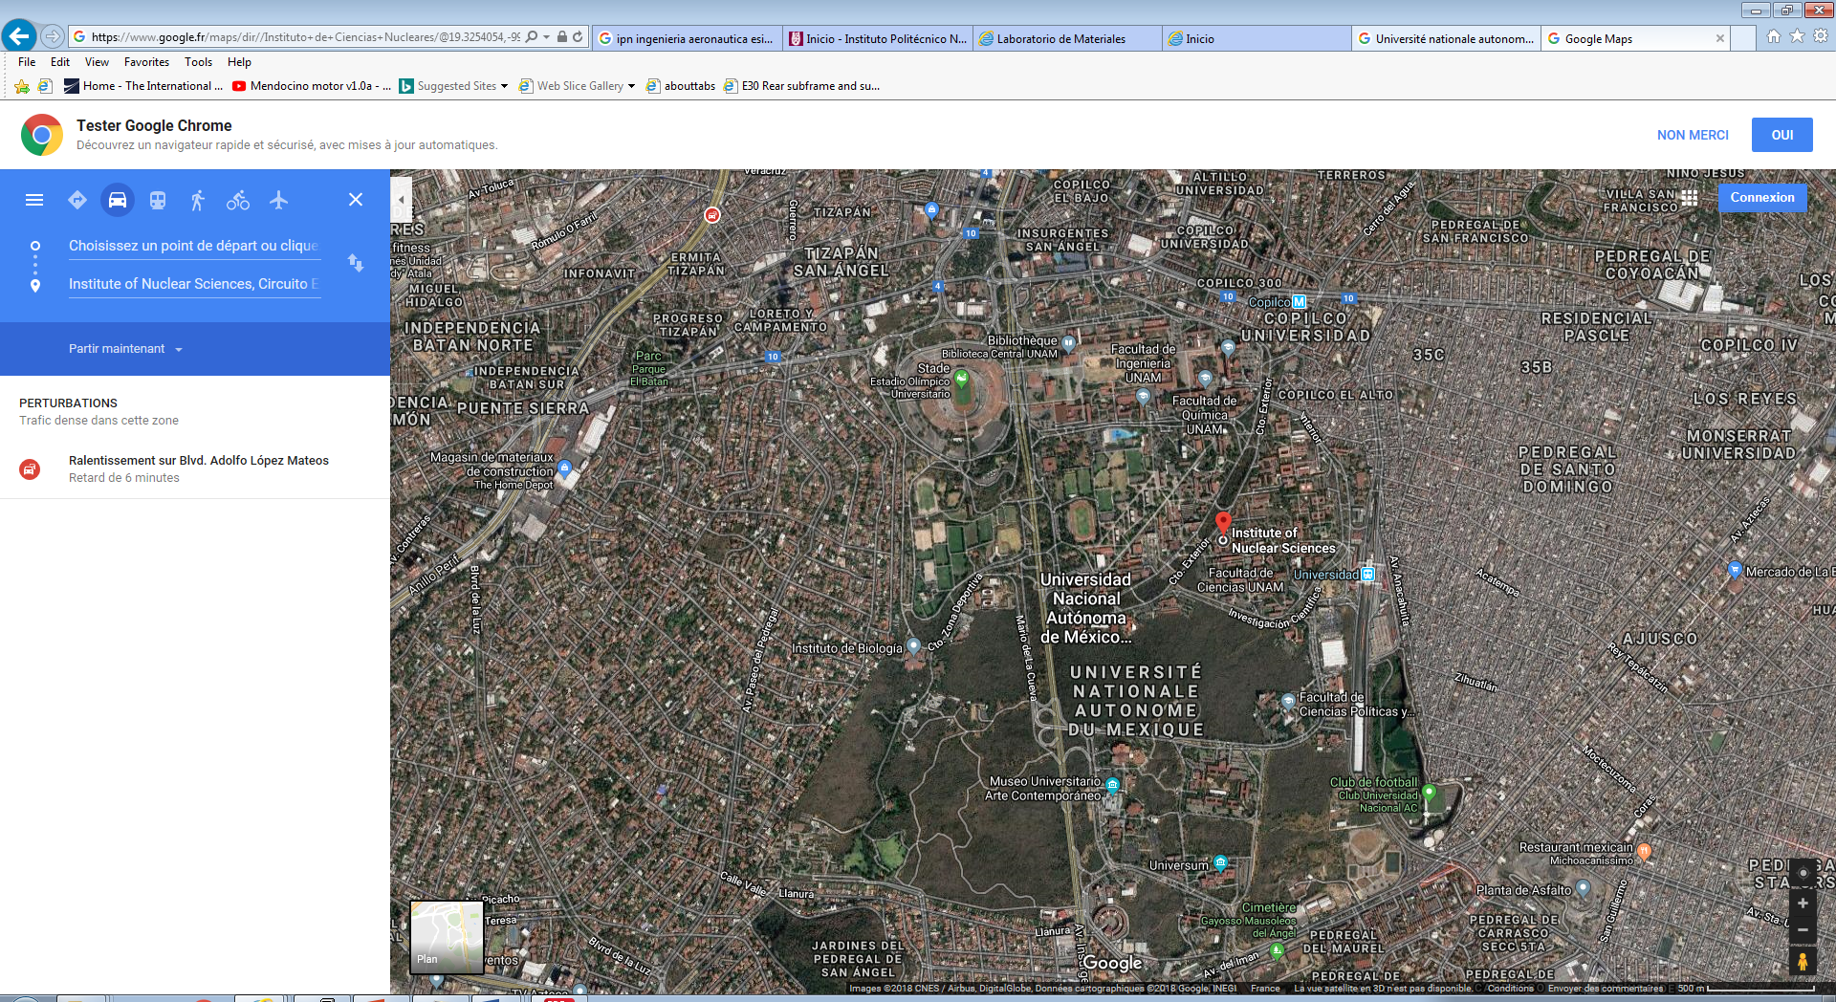

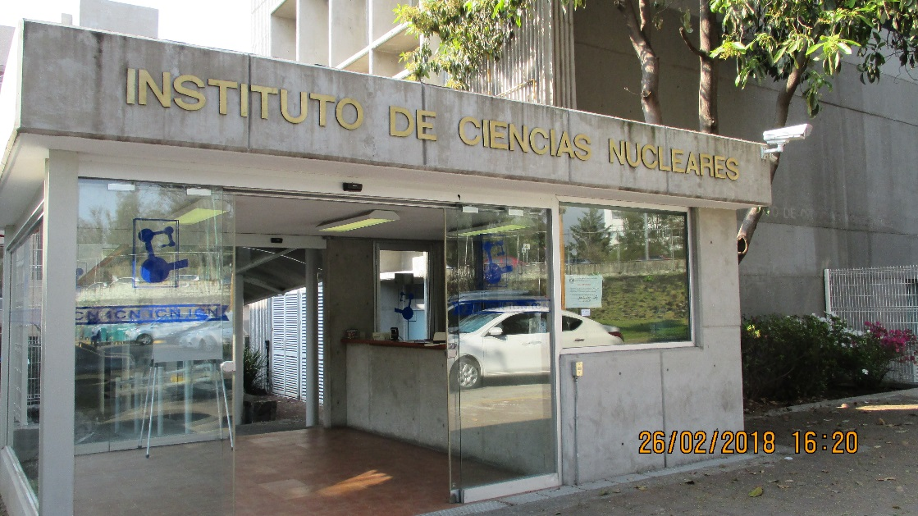
An additional make of MFCs was seen as operational, if they are they are MFM or MFC was not clear as they were in line with rotameters and I did not see the controller module in operation. Photos. Complete installation with gas bottle storage outside. Only SF6 and R134a are used. No flammable gas.
UNAM is a very large University of some 300 k students.
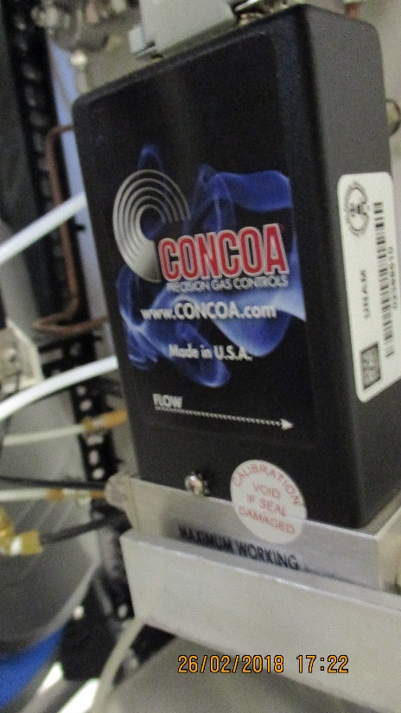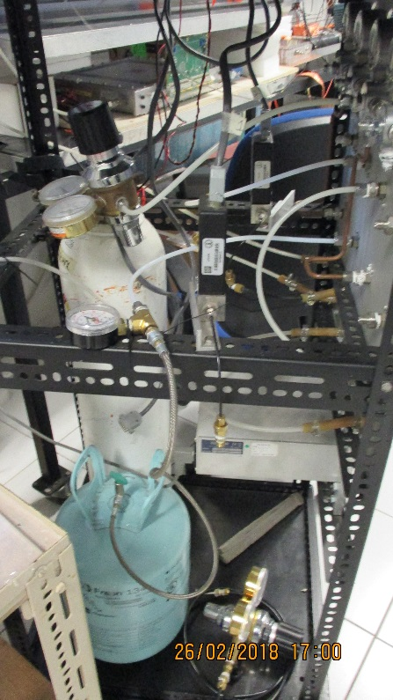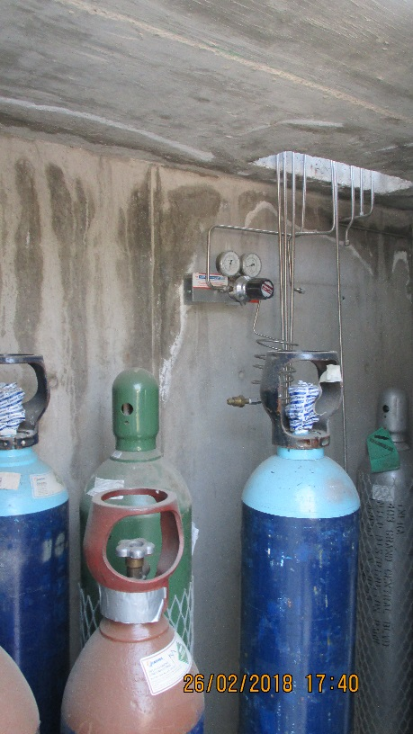
The MFCs are made in the USA;
http://www.concoa.com/massflowcontroller.html

Mateo’s suggestion, visit the Aeronautical Institute in the north of Mexico city
ESIME IPN
In the north of the city, next to CINVESTAV his actual institute.
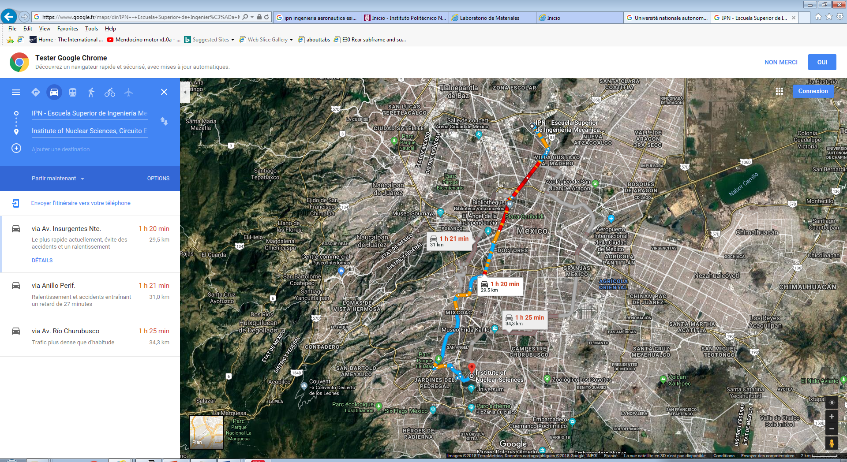
http://www.esimetic.ipn.mx/Paginas/Inicio.aspx
Av. Ticomán No. 600, Col. San José Ticomán, Delegación Gustavo A. Madero, Ciudad de México, México, C.P. 07340,
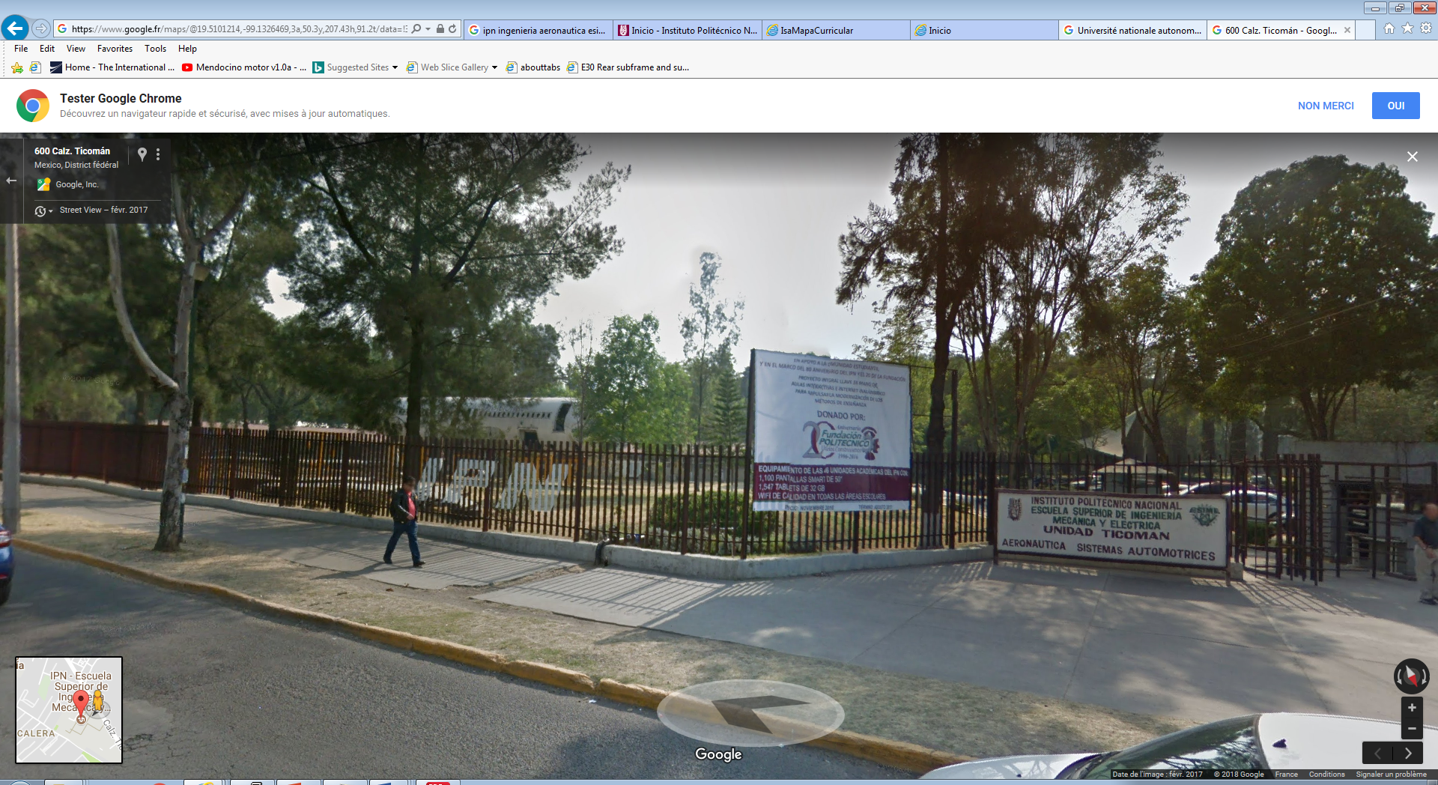

People to meet and those met.

Requested to meet Marcelino, a colleague friend of Mateo.
Requested to meet the head of the Composite Dept , , Ing. F. Tomas Estrada Rosales, tel 0052 55 87 2899 6000 ext 56057
We did meet the head of the workshop, Fernando Martinez Poot, tel 0052 55 87 2899 IPN - TICOMAN
We learn that many students from this institute go to work for AeroMexico after their studies. This company should be contacted.
We talked to Ing. Alexander Hilario Hernandez MORENO ( hihernandezm@ipn.mx )about damage due to machining.
Suggested industrial contacts were;
Dyna, Volvo, Scania MROs (Maintenance , Repair and Operations).
Personally I think these companies will deal with the “tractor unit” of the truck rather than the producer of the trailor body which is where HCP will be used. This type of supplier contact was made in Puebla/Chihuahua, see previous section.

Bombardier, Transportation that has recently installed in the city, Ciavdad, Sahagun, Mexico City. To be contacted.
Then we were sent to the Industrial liaison office (UPIS) headed by Mr. Julio Cesar Million Diuz, tel. 0052 57 29 6000 ext 56155.
He is very resourceful and supplied contacts and a catalogue of aviation suppliers. Mateo scanned this doc here;
https://rpc-cms-re4-upscope.web.cern.ch/rpc-cms-re4-upscope/RPC/Chamber%20Institutes/Mexico/LabIndustryFeb2018/CatalogueAeronauticalSuppliersMEX/doc20180227222634.pdf
He has offered to help with this search for companies.
Mateo has gone through the Catalogue and has identified these companies;
- GROB AIRCRAFT AG page 50
- EQUIPOS ESPECIALIZADOS DEL ATLANTICO S.A. de C.V page 45
- ESPECIALISTAS EN TURBOPARTES S.A. de C.V. page 45
The latter was suggested by Mr. Million from UPIS.
Mateo has sent a mail to Mr. Million giving his version of the HCP specification. To be followed up by visits to these companies with the samples that were taken from 904 by Salvador. The letter is translated at the end of this log.

They have hands on experience with many (>10 ) airframes littered around the site
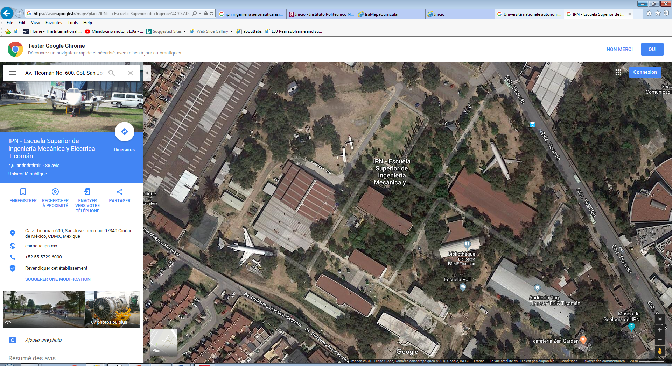

Rodolfo Estrada has an additional list of x3 HCP sources. As quoted by Salvador.

Rodolfo mentioned the https://www.quiminet.com/ site in his presentation of 13 03 2018 upgrade meet. This is the data base for industrial suppliers in Spanish ( for mexico ??) that I used to make the list in my slides from Upgrade meet in 30 Jan 2108. The first on the list is the one visited in Puebla with BUAP colleagues.

Conclusion
There is an important distinction to be made between large scale HCP production for truck bodies, building construction and the aerospace industry even below 10km altitude. The latter is a small scale high price specialised production of complex forms whereas the former is large scale producer of flat panels and is far cheaper priced
It takes hours and hours sitting in taxis to go anywhere in MEX.
There appears to be in Mexico in Mexico city and in the north extensive levels of industry of all sorts.
The above is effectively 3-4 days activity. More can be done with a plan and contacts made before the visit.
This just a start, many suppliers will have to be checked for the quality and price.

I owe Mateo approx. 600 peso for x4 Taxi rides.

Mateo Garia email; mramirez@fis.cinvestav.mx

This document is available here;
http://rpc-cms-re4-upscope.web.cern.ch/rpc-cms-re4-upscope/RPC/Chamber%20Institutes/Mexico/LabIndustryFeb2018/IndustrialVisitsMexicoPueblaAndMEX.pdf

The mail Mateo sent to Cesar for the HCP spec.

Letter from Mateo dated 27 Feb 2018 (mramirez@fis.cinvestav.mx)

Original followed by translation ( google)
Como le hemos mencionado, planeamos construir detectores de partículas
para una colaboración internacinal, el Experimento CMS del Gran
Colisionador de Hadrones (LHC), y requerimos de Paneles-sandwich de
Aluminio tipo panal de abeja (Composited Aluminum Honeycomb panel) para
hacer parte de la mecánica.

Estos paneles tendrán forma trapezoidal con dimensiones de 1.7 m de largo,
1.3 m de base mayor, y 0.9 m en la base menor. Grosor de 6 mm.
Entiendo que el sandwich es Aluminio-pegamento-honeycomb
core-pegamento-aluminio.
Por otro lado, entendí que la problemática está en el tamaño de estos
paneles y que por ende, es más fácil llevar nuestra solicitud a las
empresas.

Detalles respecto al proceso de fabricación pueden discutirse con cada
empresa, ya que no somos expertos en el tema, por ejemplo el pegado con
compresión y calor.

Este correo es para recordarle nuestra solicitud de Contactos en la
industria que nos pueda proveer honeycomb panel, compuesto en sanwich, y
cercano al proceso de producción. Algunas industrias que nos recomendaron
fueron Volvo, Dyna, Bombardier, Mexicana.
También estamos abiertos a más opciones tal y como nos ha hecho llegar con
el catálogo.

Por otro lado, si en sus contactos hay alguien que puede agregar elementos
como tuercas/taquetes para fijar tornillos, sin dañar el panel, nos sería
de gran ayuda.

De antemano muchísimas gracias
y esperamos su pronta respuesta.

Saludos.

Mateo Ramírez García.
A nombre de CMS RPC Collaboration

Translation
Mateo letter

As we mentioned, we plan to build particle detectors
for an international collaboration, the CMS Experiment of the Great
Hadron Collider (LHC), and we require Panels-Sandwich
Honeycomb aluminum (Composited Aluminum Honeycomb panel) for
Be part of the mechanics.
These panels will have trapezoidal shape with dimensions of 1.7 m long,
1.3 m of major base, and 0.9 m in the minor base. Thickness of 6 mm.
I understand that the sandwich is Aluminum-glue-honeycomb
core-glue-aluminum.
On the other hand, I understood that the problem is in the size of these
panels and, therefore, it is easier to take our request to the
Business.
Details regarding the manufacturing process can be discussed with each
company, since we are not experts in the subject, for example the stuck with
compression and heat.
This email is to remind you of our Contact request in the
industry that can provide us honeycomb panel, composed in sanwich, and
close to the production process. Some industries that recommended us
They were Volvo, Dyna, Bombardier, Mexicana.
We are also open to more options just as he has sent us with
the catalog.
On the other hand, if in your contacts there is someone who can add elements
As nuts / studs to fix screws, without damaging the panel, we would be
of great help.

Many thanks in advance
and we await your prompt response.
Greetings.

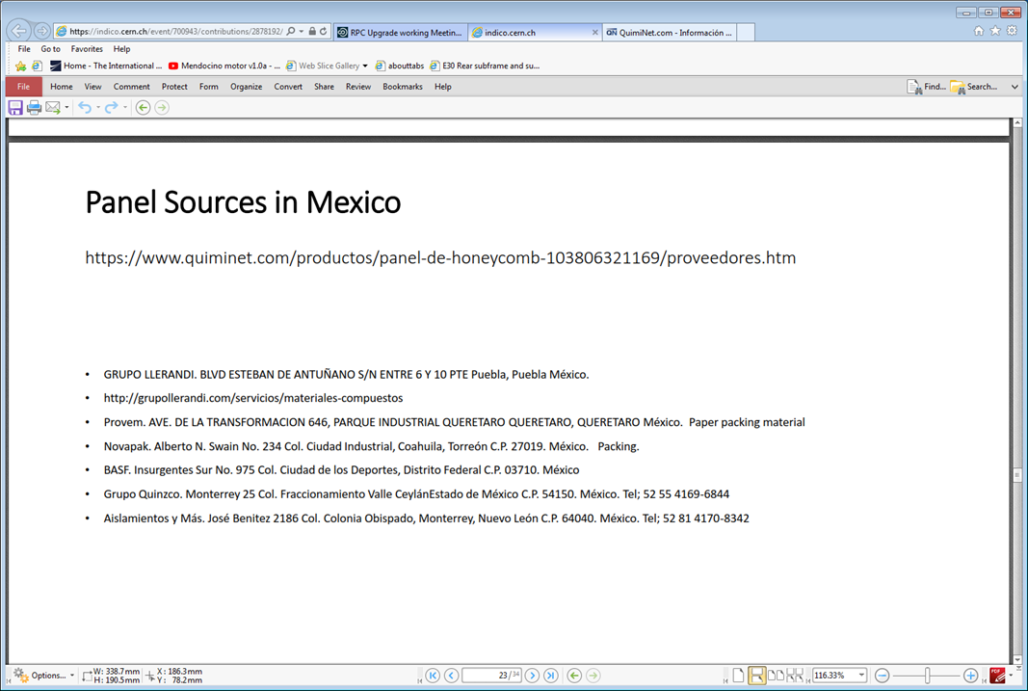

Aeromexico MRO
https://world.aeromexico.com/en/about-us/knowing-aeromexico/maintenance/?site=us
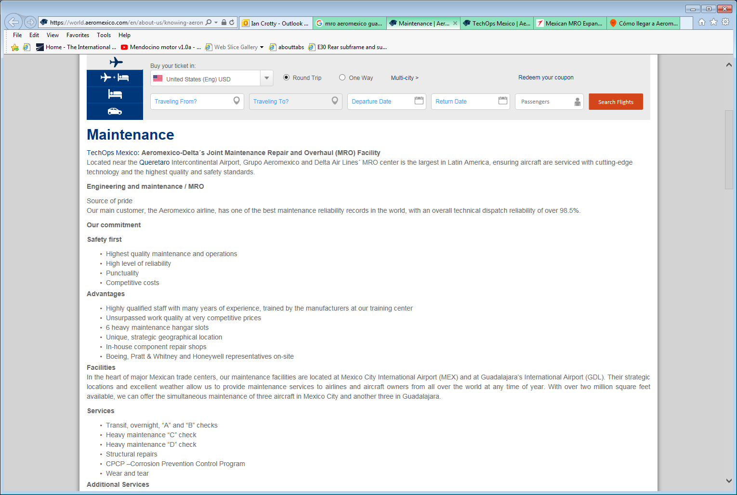
Contact us in Mexico at:
Aeromexico
Avenida Fuerza Aerea Mexicana No 416
Col. Federal
C.P. 15700
Telephone: (5255) 9132-6377 or 9132-6678
Fax: (5255) 9132-6490
Email: contractservices@aeromexico.com

