Characterization of the Cylindrical Humidifier for Gases Used in
CMS RPCs in the VAL4-309 laboratory of the Eco-campus (BUAP)
Mart´ınez Tapia Felipe de Jesus
February 1, 2024
Summary
This report presents the detailed characterization of the cylindrical humidifier used in the laboratory for the
research on Resistive Plate Chambers (RPC's) at CERN. The device in question exhibits dimensions
specific, including a height of (29.80±0.05) cm, a diameter of (15.80±0.05) cm, and differentiated heights for
the dry and humidified gas inlet and outlet tubes, respectively. Furthermore, a reference is established
critical for the optimal water level through a glass tube, whose red line is at a height of
(0.90 ± 0.05)cm. The relevance of the height from the base of the humidifier to the laboratory floor is highlighted,
set at (42.70 ± 0.05) cm for the purpose of addressing considerations regarding atmospheric pressure.

1. Humidifier Specifications
The humidifier features the following key dimensions:
Total height: (29.80 ± 0.05) cm.
Diameter: (15.80 ± 0.05) cm.
Height of dry gas inlet tube: (2.00 ± 0.05) cm.
Height of humidified gas outlet tube: (2.30 ± 0.05) cm.
Length of the humidified gas inlet tube inside the humidifier: (29.30 ± 0.05) cm.
Length of the humidified gas outlet tube inside the humidifier: (2.40 ± 0.05) cm.

2. Optimum Water Level Reference
To maintain an optimal water level, a glass tube with a red line located at a height of
(3.70 ± 0.05)cm with respect to the base of this tube. This reference provides a visual indicator of the water level
demineralized that the humidifier will contain.

3. Height from the Base to the Laboratory Floor
The position of the humidifier relative to the laboratory floor is a crucial factor in addressing variations
with respect to the atmospheric pressure and the pressure that will be inside the humidifier. The current height from
the base of the device to the ground is (42.70 ± 0.05) cm.

3.1. Heat Transfer and Evaporation
Humidification is achieved through heat exchange between dry gas and water. The dry gas, upon entering
through the inlet tube, it undergoes an evaporation process upon contact with the surface of the water
present inside the device. This heat transfer phenomenon results in the incorporation of
water vapor to the gas, thus increasing its moisture content.

3.2. Relative Humidity and Parameter Control
The relative humidity of the resulting gas is a critical indicator of the humidification process. The capacity of
control physical parameters, such as temperature (I'm still thinking about how to delve deeper into this part) and
gas velocity, plays an essential role in obtaining specific levels of relative humidity, optimizing
thus the conditions for experimental research.
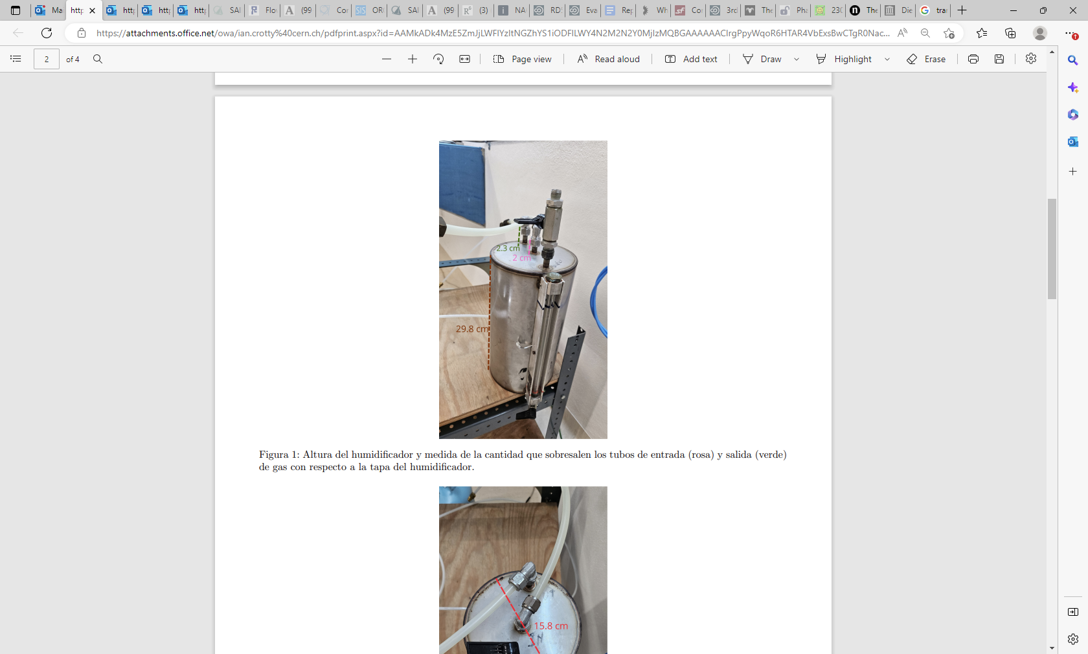

Figure 1: Height of the humidifier and measurement of the amount the inlet (pink) and outlet (green) tubes protrude
of gas with respect to the lid of the humidifier
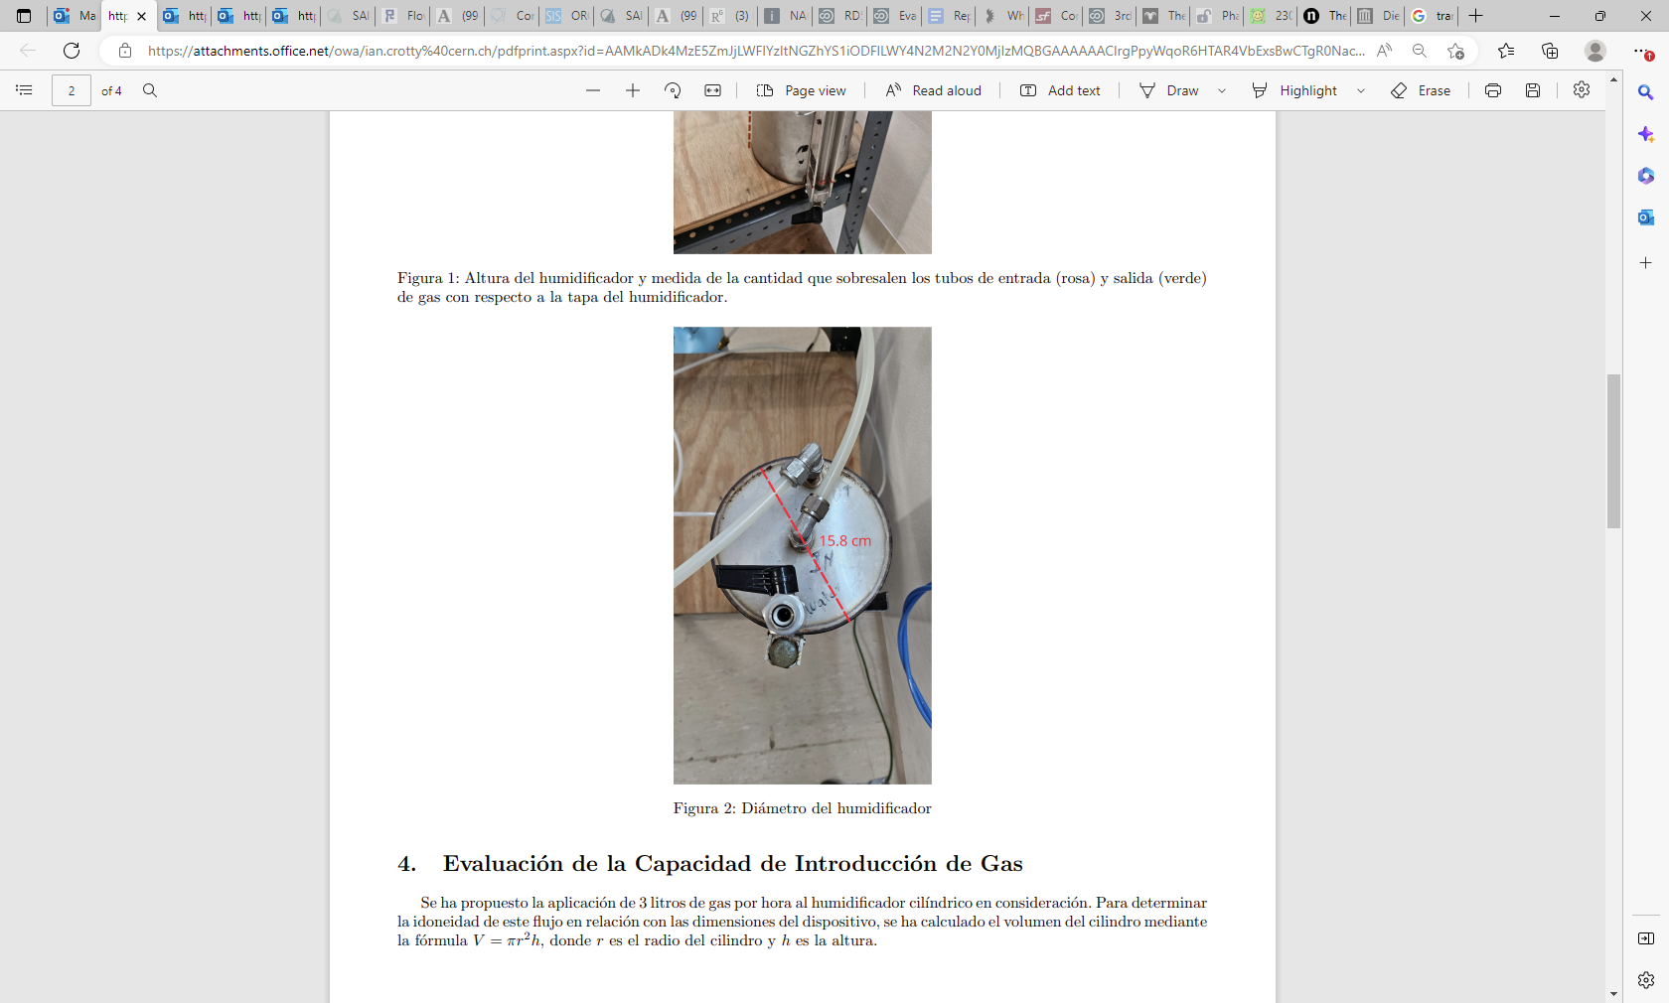

4. Evaluation of Gas Introduction Capacity
The application of 3 liters of gas per hour to the cylindrical humidifier under consideration has been proposed. To determine
the suitability of this flow in relation to the dimensions of the device, the volume of the cylinder has been calculated by
the formula V = πr2h, where r is the radius of the cylinder and h is the height.

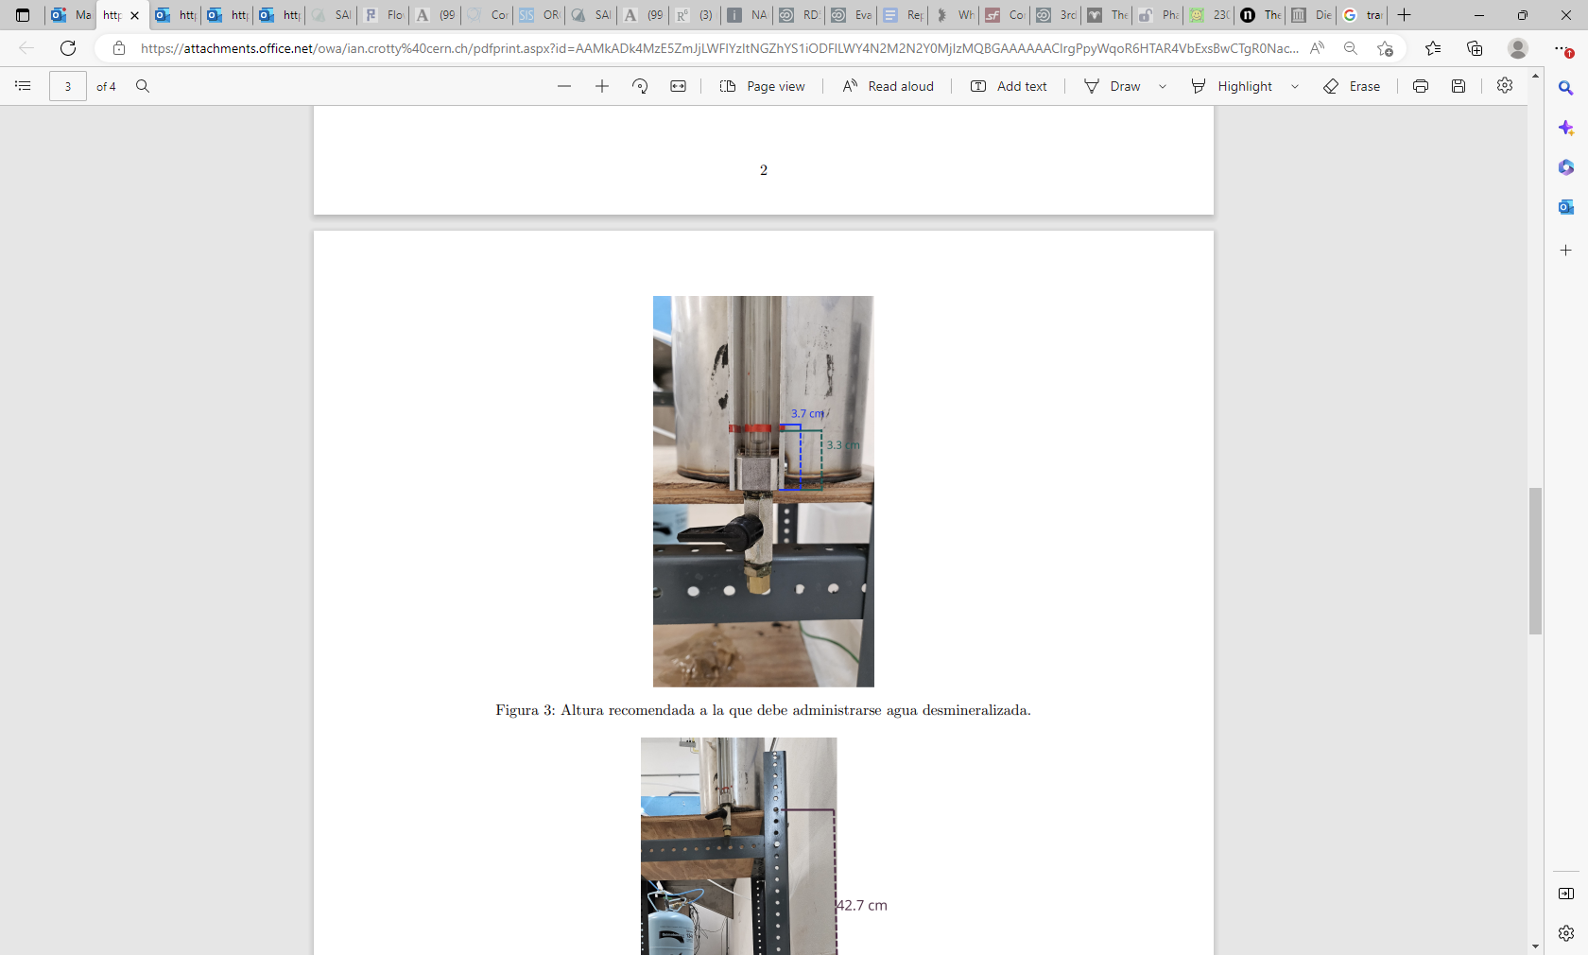
Figure 3: Recommended height at which demineralized water should be administered.
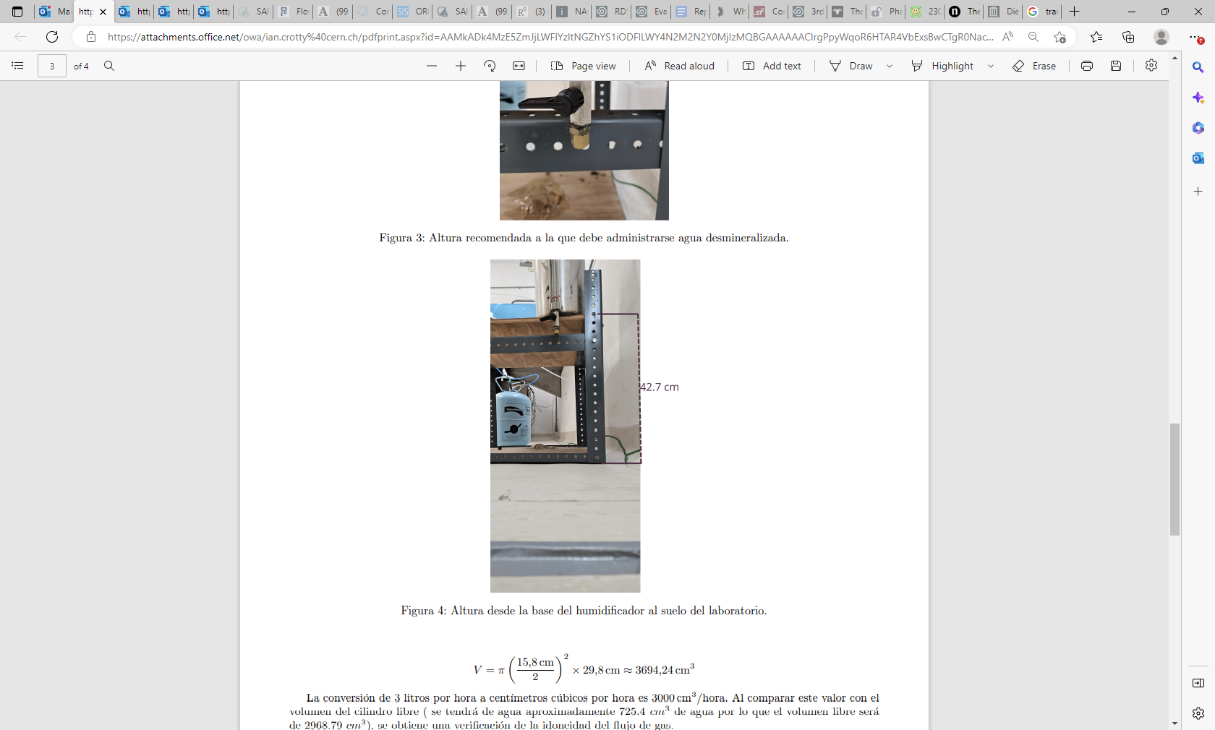
Figure 4: Height from the base of the humidifier to the laboratory floor.
V = π (15.8/2)^2 x 29.8cm ~3694.24cm3

The conversion of 3 liters per hour to cubic centimeters per hour is 3000 cm3/hour. When comparing this value with the
volume of the free cylinder (there will be approximately 725.4 cm3 of water, so the free volume will be
of 2968.79 cm3
), a verification of the suitability of the gas flow is obtained.
Verification: .791
The verification result indicates that the proposed flow exceeds the volume of the cylinder, which suggests that the
3
Application of 3 liters of gas per hour is not ideal in relation to the dimensions of the cylindrical humidifier. HE
recommends checking and adjusting the gas flow to ensure compatibility with the device.

5. Necessary pressure of the gas so that it can leave the humidifier.
The water inside the humidifier will be exerting pressure on the walls that contain it called pressure.
hydrostatic that must be overcome by the gas that is introduced so that it can leave. The hydrostatic pressure is
calculated with:
P = ρgh + p0 Where:
P = hydrostatic pressure
ρ = density of the liquid g = gravity h = height of the liquid whose pressure is to be measured p 0 = atmospheric pressure
Assuming that the container has one liter of water (1000cm3
), 'this will have a height of 5.1cm contained within
of the humidifier. Furthermore, it is known that the density of water is 997kg/m3.
Thus, knowing the atmospheric pressure,
The pressure that the gas needs to overcome in order to leave the water is: P = (997Kg/m3
)(9.8m/s2
)(0.051m)+p0
= 498.3P a = 0.004983bar = 4.983millibar
It was found that the pressure that the gas needs when entering is approximately 5 millibars so that it can leave.
of the water

