Ipedance Calc for the Oman Proto chamber

Different calculators

<http://www.ideaconsulting.com/strip.htm>

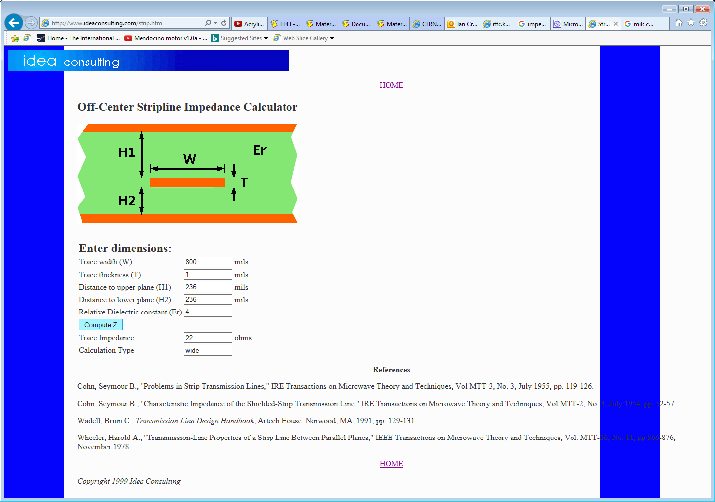

For 20mm wide strips that are 6mm from the ground gives 22 [Ohms]

<http://chemandy.com/calculators/microstrip-transmission-line-calculator-hartley27.htm>

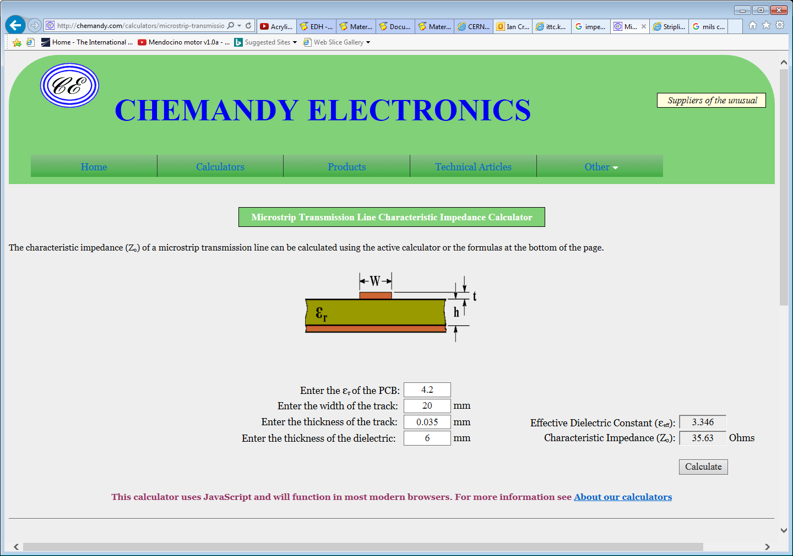

<https://www.eeweb.com/toolbox/microstrip-impedance>

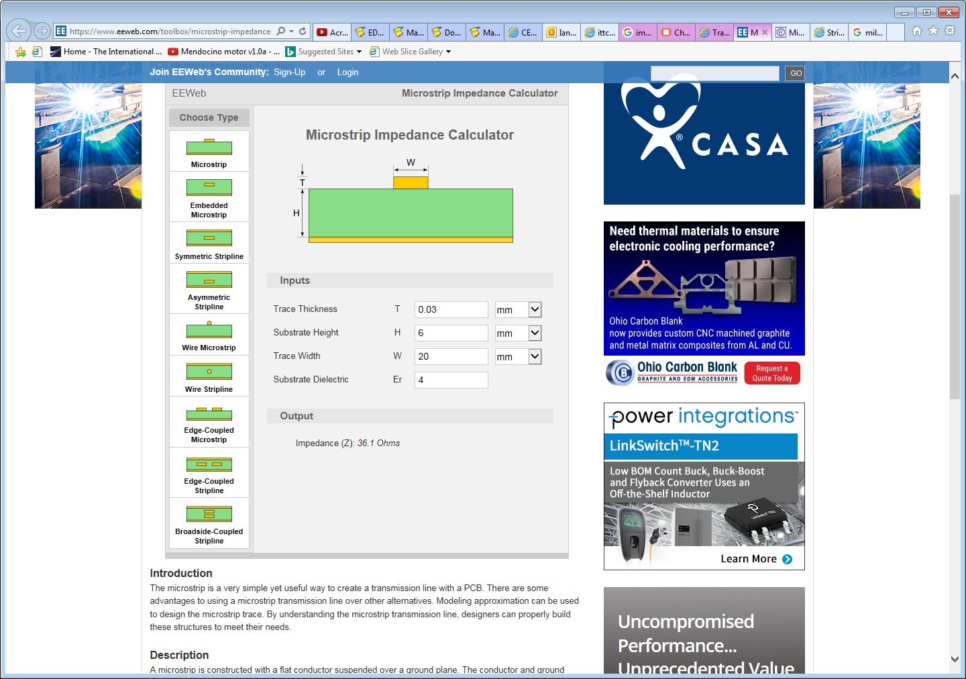

<http://www.eeweb.com/toolbox/twisted-pair>

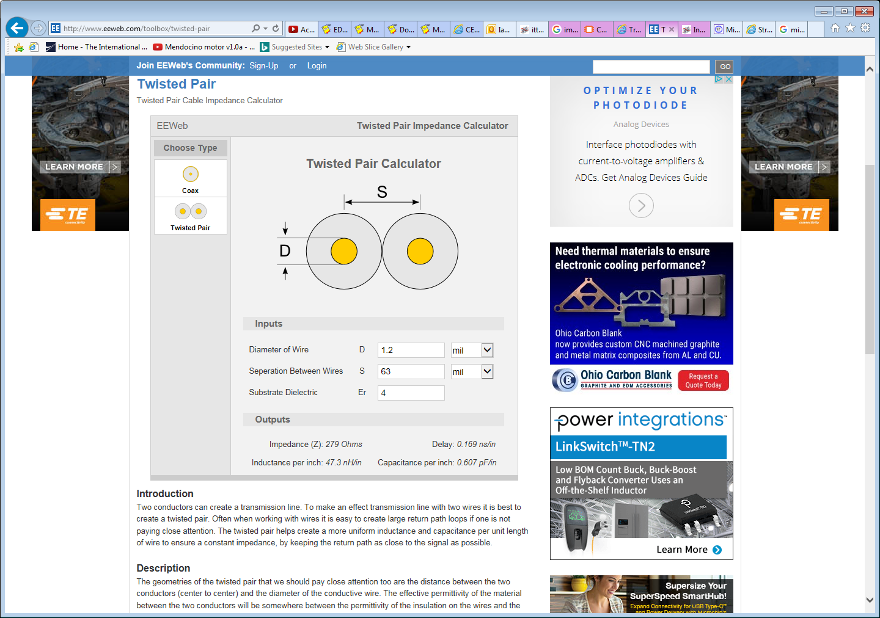

References

<http://alignment.hep.brandeis.edu/Lab/XLine/XLine.html>

<https://www.allaboutcircuits.com/textbook/alternating-current/chpt-14/characteristic-impedance/>

<http://www.ittc.ku.edu/~jstiles/723/handouts/Transmission_Line_Input_Impedance.pdf>

<https://www.eeweb.com/toolbox/microstrip-impedance>

<http://www.ittc.ku.edu/~jstiles/723/handouts/3%20%20Transmission%20Lines%20and%20Waveguides.pdf>

<http://www.ittc.ku.edu/~jstiles/723/handouts/>