Shipping to Oman University

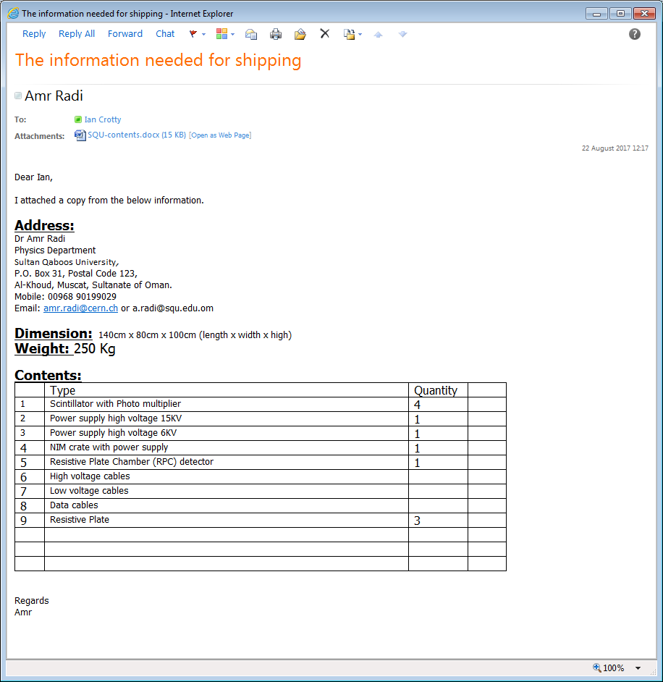

EDH ………………..

Shipping by sea as is cheaper.