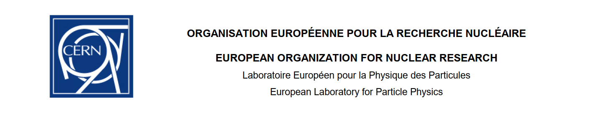

Certificate of activities performed by Students from Sultan Qaboos University, Oman.

Hajir Sulaiman  Al Siyabi, Juhaina Khamis Al Busaidi, Shams  Hilal Al Zakwani, Marwa Saleh  Al Busaidi, Noor Abdullah  Al Raiisi and Mohammed Salim Al Maashani.

The students performed numerous diverse hardware activities related to RPCs and electronics during their stay at CERN in July 2018.

They were introduced to the principle of “gas collection over water” and an apparatus put together with the simplest of equipment with the intention of measuring gas flow rate. This method was used to compare and calibrate analogue rotameters that were calibrated for Nitrogen against the flow of different gases, Argon and Tetrafluoroethane (R134a) that are used in RPCs. The idea being to be able to use this technology, which is readily available at CERN, to mix the different gases for the operation of a RPC in their home institute.

Modifications of the apparatus were performed to avoid oscillations using different length pipes entering the inverted graduated flask. Errors due to timing, operation of the flow regulation valve, parallax error and team organisation were discussed and refined to improve reproducibility. To understand the validity of such a simplistic apparatus an industrial quality instrument was accessed in the CERN Gas group. All data was collate and plotted. All activities were performed by the students. Flow rates looked at 0.1 to 10litres/hour.

The notion of surface resistivity was introduced and two simple methods of measurement were investigated, namely a forced contact of a copper taped “bridge” to form a square over the surface coating, graphite, to be measured. Secondly, by applying Cu tape to the substrate, in this case classical RPC electrode material, Bakelite (HPL), in two parallel strips forming a square of 10cm x 10cm. The graphite was then applied using spray and rolling methods with and without dilution. Measurements were made with a DMM instrument directly reading the surface resistance in units of Ohms per square (a strange unit). Values of 30 – 300kOhms/sq. were found. Many attempts were made by the students to achieve values above 120kOhms/sq., a value normally used in RPC electrode preparation. The notion of ‘hands on” was applied throughout this activity, applying the coating, spray technique, optimisation of values, discussion of parameters involved, heat and humidity, etc. .Methods to reduce the impact of the human element were discussed. The importance of health and safety standards in the laboratory were explained.

All these trials were carried out by all the students that produced a good level of enthusiasm and participation.

A visit was organised to another laboratory where Multi gap RPCs for ALICE are produced to understand how they dealt with the question of resistive coating application.

A few days before their departure I was approached by the young women of the group to procure and produce a RPC that they would take back to Oman . Appreciating this proactive stance we contacted the local glass supplier at Gex and left immediately to procure some small glass sheets 30 x 40cm that were cut on the spot and paid for out of the students’ pocket ! Glass is the alternative electrode material for RPCs favoured by many as electrically more stable and less noisy. On our return the complete procedure to produce a working “Gas Gap” was implemented by the same students. The necessary cleaning of the glass followed by the application of the non-stick spray to the marble work surface was done. The spacers and gas inlets, the latter produced by cannibalising pens acquired from the CMS secretariat, were produced and carefully assembled with an epoxy adhesive. Being transparent, the quality of the job was visible. The only remaining action to obtain a working RPC gas gap is to apply the graphite coating similar to the activity previously accomplished.

The ”Cosmic Watch” project initiated by their supervisor Dr. Amr requires the assembly and soldering of SMD components onto dedicated pcbs. The CERN SMD lab was visited, where the students were guided through the necessary equipment and soldering tools to carry out this task by a qualified technician from the lab. All had a trial and managed to solder these extremely small elements to a trial pcb. Specific viewing tools were a digital microscope and large screen with dedicated soldering irons and solder dispenser.

Of course more could have been achieved but given the limited time the students had available while at CERN I would consider this hands-on experience enabled them to understand that the origin of the data from an RPC is at this scale rather simple. In addition, the components of a RPC are rather basic but require sufficient attention to detail to produce a working instrument. Both of these points aims to avoid the phenomena of “a black box” as they would have a more global view of the system from data generation to analysis.

If this activity can be continued, it would be of great advantage to students in Oman to also gain experience in the operation of a RPC in their own lab.

Ian Crotty

Senior Engineer for the RPC CMS