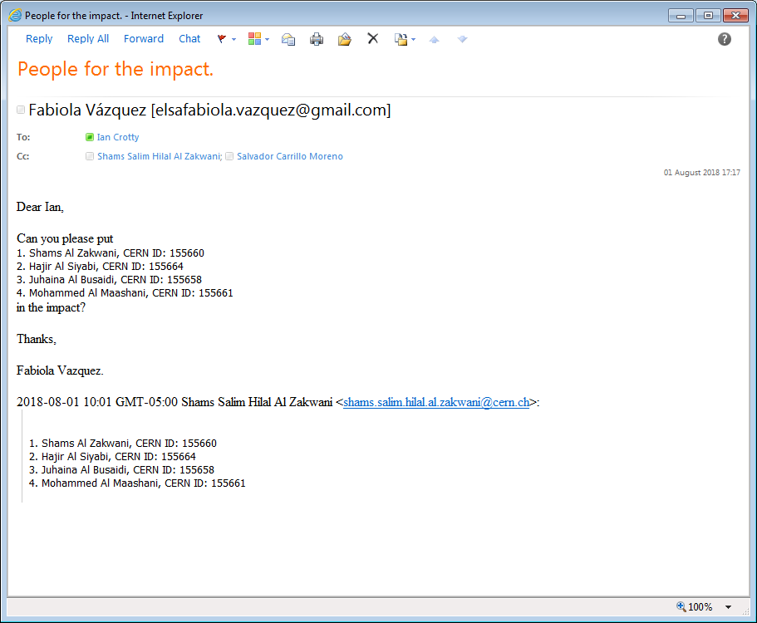

* Salvador Carrillo Moreno‎;
* https://mmm.cern.ch/owa/14.3.409.0/themes/resources/clear1x1.gifU097854@student.squ.edu.om‎
* https://mmm.cern.ch/owa/14.3.409.0/themes/resources/clear1x1.gifHager2090@gmail.com
* https://mmm.cern.ch/owa/14.3.409.0/themes/resources/clear1x1.gifmarwa.busaidi@gmail.com‎; https://mmm.cern.ch/owa/14.3.409.0/themes/resources/clear1x1.gif
* nooralraisi333@gmail.com‎;
* https://mmm.cern.ch/owa/14.3.409.0/themes/resources/clear1x1.gif https://mmm.cern.ch/owa/14.3.409.0/themes/resources/clear1x1.gifRoumyana Mileva Hadjiiska
* [U097854@student.squ.edu.om](mailto:U097854@student.squ.edu.om);
* ,;

[marwa.busaidi@gmail.com](mailto:marwa.busaidi@gmail.com);

* nooralraisi333@gmail.com;Categories:

