Pro Forma Invoice

October 5, 2012

Sent by : Prof. Sung Keun Park  Department of Physics,  Korea University 5-ga Anam-dong  Sungbuk-gu, Seoul, Korea  (Zip code : 136-713)  Tel : +82-2-3290-3099    Email: paul0985@gmail.com | Sent to : Ian Crotty (+41 22 767 8185)  Jean-Paul Chatelain (+41 76 487 0903)  Jean-Francois Pernot (+41 76 487 0022)  Goods Reception (Meyrin site, +41 22 767 4691)  Dept. PH, CERN 1211, Geneve 23, Switzerland  Tel: +41 22 767 8185  Email: ian.crotty@cern.ch (Ian Crotty)

1. Full descriptions
Materials: 116 High Pressurized Laminate (HPL) plates
The 116 HPLs were tested in Korea Detector Laboratory (KODEL), Korea University, to manufacture Resistive Plate Chambers (RPCs) at CERN, Geneva, Switzerland for the second phase CMS/LHC experiment. The 116 HPLs were converted to 58 gas gaps (core components for RPC detectors) and tested with electric potentials ranging from 0 to 10.0 kV at KODEL to assure the detector qualification for the CMS/LHC experiment. The 116 HPLs in a form of gas gaps DO NOT have commercial values because they will not be used for any commercial or industrial application purpose. Furthermore, they do not contain any harmful, toxic, explosive, or radioactive material. The 116 HPLs are to be finally returned to CERN only for pure the scientific activity.
2. Country of origin: Italy
3. Quantity: 116 HPLs and a shipping box
4. Declared value: 3200.0 Euros
5. Net weight of HPLs: 400 kg
6. Total weight including a shipping box weight: 800 kg.
7. Size of shipping box: 239 cm (length) x 107 cm (width) x 161 cm (height)
8. Reasons for export: Pure scientific activity

I declare that the above information is true and correct to the best of my knowledge.

October 5, 2012
Prof. Sung Keun Park,
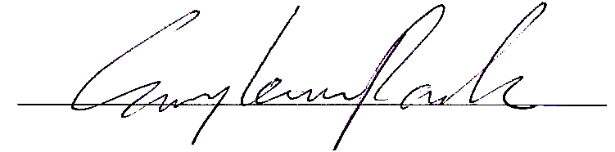

Director of the Korea Detector Laboratory,
Professor of Dept. of Physics,
Korea University, Seoul, Korea

