ISPM

<https://www.ippc.int/en/countries/all/ispm15/>

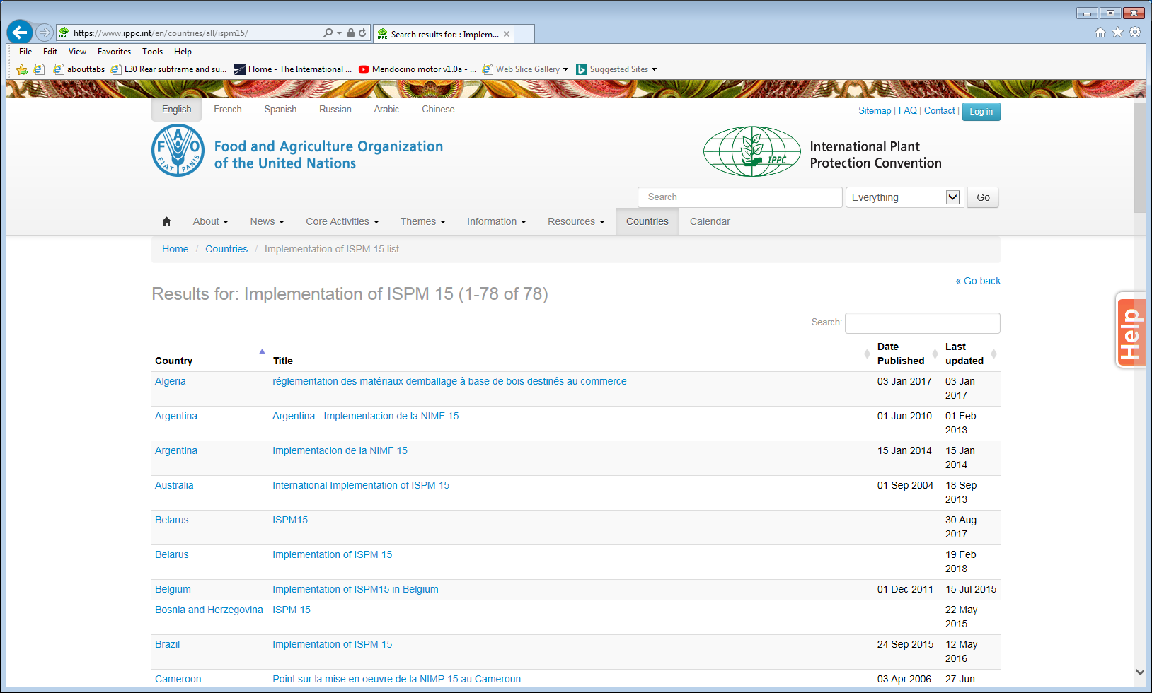

Some doc

<https://www.ippc.int/static/media/files/mediakit/IPPCOverviewBrochure2012-03-en.pdf>

