|  |  |  |
| --- | --- | --- |
| Report | | |
| **Modification and Analysis of the CMS ME11 Clamp.** | | |
|  | | |
| DOCUMENT PREPARED BY: | DOCUMENT CHECKED BY: | DOCUMENT APPROVED BY: |
| Ali Karaki | Cristina Penades Huesca |  |

DISTRIBUTION LIST:

TABLE OF CONTENTS

1. Introduction 3

2. Original clamp 4

2.1. Design 4

2.2. Load cases 5

2.3. Ansys numerical model 5

2.4. Simulation results 7

2.5. Bolts calculations 8

3. Modified clamp-1 9

3.1. Design 9

3.2. Simulation results 9

3.3. Bolts Calculations 10

4. Modified Clamp-2 11

4.1. Design 11

4.2. Simulation results 12

4.3. Comparison between using the clamp at 3 and 9 o’clock 12

5. Load Test 14

6. Conclusion 15

# Introduction

The following report presents a study on modifying the ME11 clamp design to accommodate larger service trays and ensure compatibility with service channel types A and C. The motivation for this modification arises from the need to accommodate increased services that will be installed on the service trays during LS3. The radial trays and nose trays have been enlarged while respecting the envelope R2725mm to accommodate the larger service trays. The report discusses various options for modification, including design constraints, calculations, and numerical simulations, to ensure that the modified clamp design is efficient and functional.

Two types of clamps are used [1] o insert/extract the ME11 chambers. The forward clamps clamped to tray type A and the backward clamps for the tray type C. Only the backward clamps will be modified, and this will be discussed in this document.

Figure 1-Service channels on YE1 Nose.

[1] <https://edms.cern.ch/project/CERN-0000235429>

# Original clamp

## Design

The ME11 clamp is composed of four elements that wrap around the ME11 bracket and are clamped together. The first plate, denoted as plate 0 and colored orange, is fixed to plate 1 through two M12 screws. Plate 1 and plate 3 are connected through a hinged joint, allowing them to pivot around an axle. Similarly, plate 2 and plate 3 are connected through a similar hinged joint. The clamp force is generated by tightening the M12 screws between plate 2 and plate 0. Additionally, there are two prism-shaped triangular bars installed on plate 1 and plate 2 to accommodate the chamfer on the ME11 bracket.

In Figure 2, the clamp and the ME11 bracket are displayed, where the bracket is highlighted in red, and the plates are represented in blue and made from Aluminium alloy 6082. The structural steel components are colored orange. The screws used in the clamp are made from stainless steel A4. The material properties of each component used in the clamp design are listed in the table 1 below.

Figure 2- ME11 bracket and clamp.

Table 1-Material properties.

|  |  |  |  |
| --- | --- | --- | --- |
|  | Density  [Kg/m3] | Young’s Modulus  [GPa] | Yield Strength  [MPa] |
| Structural steel | 7850 | 200 | 240 |
| Aluminium alloy 6082 | 2770 | 71 | 260 |
| Stainless steel A4-70 | 8000 | 200 | 450 |

## Load cases

To install or remove a CSC chamber, a total of three clamps are utilized to secure the extraction tool to the YE1 nose. The ME11 extraction tool is then fixed to the three clamps and suspended by a crane. The **weight of the chamber is 150Kg**, **while the weight of the lifting tool is 350Kg**, which is considered distributed equally among the three clamps. (Note that the tool will always be suspended by the overhead crane, but to be conservative, it is assumed that the crane is not contributing at all). To adopt even further conservative approach, considering the difficulty in estimating the precise load distribution among the three clamps, a safety factor of 1.5 is applied. Consequently, **the total load on one clamp is calculated as ((150kg+350kg)/3) *1.5=2500N** to ensure a safe and reliable design. This process is replicated for all 18 chambers around the YE1 nose. Nevertheless, the most critical scenario occurs at 3 and 9 o'clock positions where the clamp experiences a complete shear load. Therefore, this specific case will be analyzed in the study.

## Ansys numerical model

**Symmetry**: The clamp design exhibits a single plane of symmetry, specifically, the XY plane as illustrated in figure 3. To streamline the model and minimize computation time, the geometry has been simplified through the application of symmetry, effectively restricting any displacement in the direction perpendicular to the symmetry plane.

Figure 3-Symmetry plane.

**Mesh:** The geometry has been discretized into 4604 elements and 11941 nodes utilizing the "Solid187" element type, as shown in figure 4.

Figure 4- Mesh.

**Contacts:** The simulation includes several frictional contacts with a friction coefficient of 0.7. Between Plate 0 and Plate 1, a frictional contact is applied. Similarly, a frictional contact is applied between the ME11 bracket and Plates 1, 2, and 3, as well as the ribs. Another frictional contact is applied between Plate 2 and Plate 0. The simulation also includes revolute joints on both axles, which allow free rotation around the pin. In the model, the ribs are considered bonded to Plate 1 and Plate 2. All the contact details are shown in Figure 4.

Figure 5- Contacts applied.

**Bolts modelling:** The bolts in the model are represented as beam lines with a fixed joint at the top vertex corresponding to the head of the bolt to the washer footprint, and at the edge corresponding to the threaded part of the bolt to the female threaded hole around. To achieve 70% of the yield strength of the bolts between plate 0 and plate 1, the required pretension is calculated as F=0.7*Sy*As, where Sy=450 MPa, and As (the cross sectional area of a M12 bolt using the minor diameter) =84.3 mm2, therefore F=26000N. However, for the bolts between plate 0 and plate 2, since there is a gap between the two plates, applying more pretension causes more deformation in plate 2. Therefore, only 10KN of pretension is applied in this case. It's important to note that the purpose of this ANSYS model is to estimate the deformation of the clamp and stress on the plates, while the stress on the bolts will be calculated manually in another section of the document.

**Boundary conditions:** In the simulation, the ME11 bracket is considered fixed, so a fixed support is applied to it. The simulation is divided into two steps:In step 1, the pretension force is applied to the bolts and then locked in place for step 2.In step 2, an external force of 1250N is applied to Plate 0 in a downward direction. Only half of the force is applied due to symmetry considerations. The standard Earth gravity is also included in the simulation.  
Figure 5 shows the boundary conditions applied.

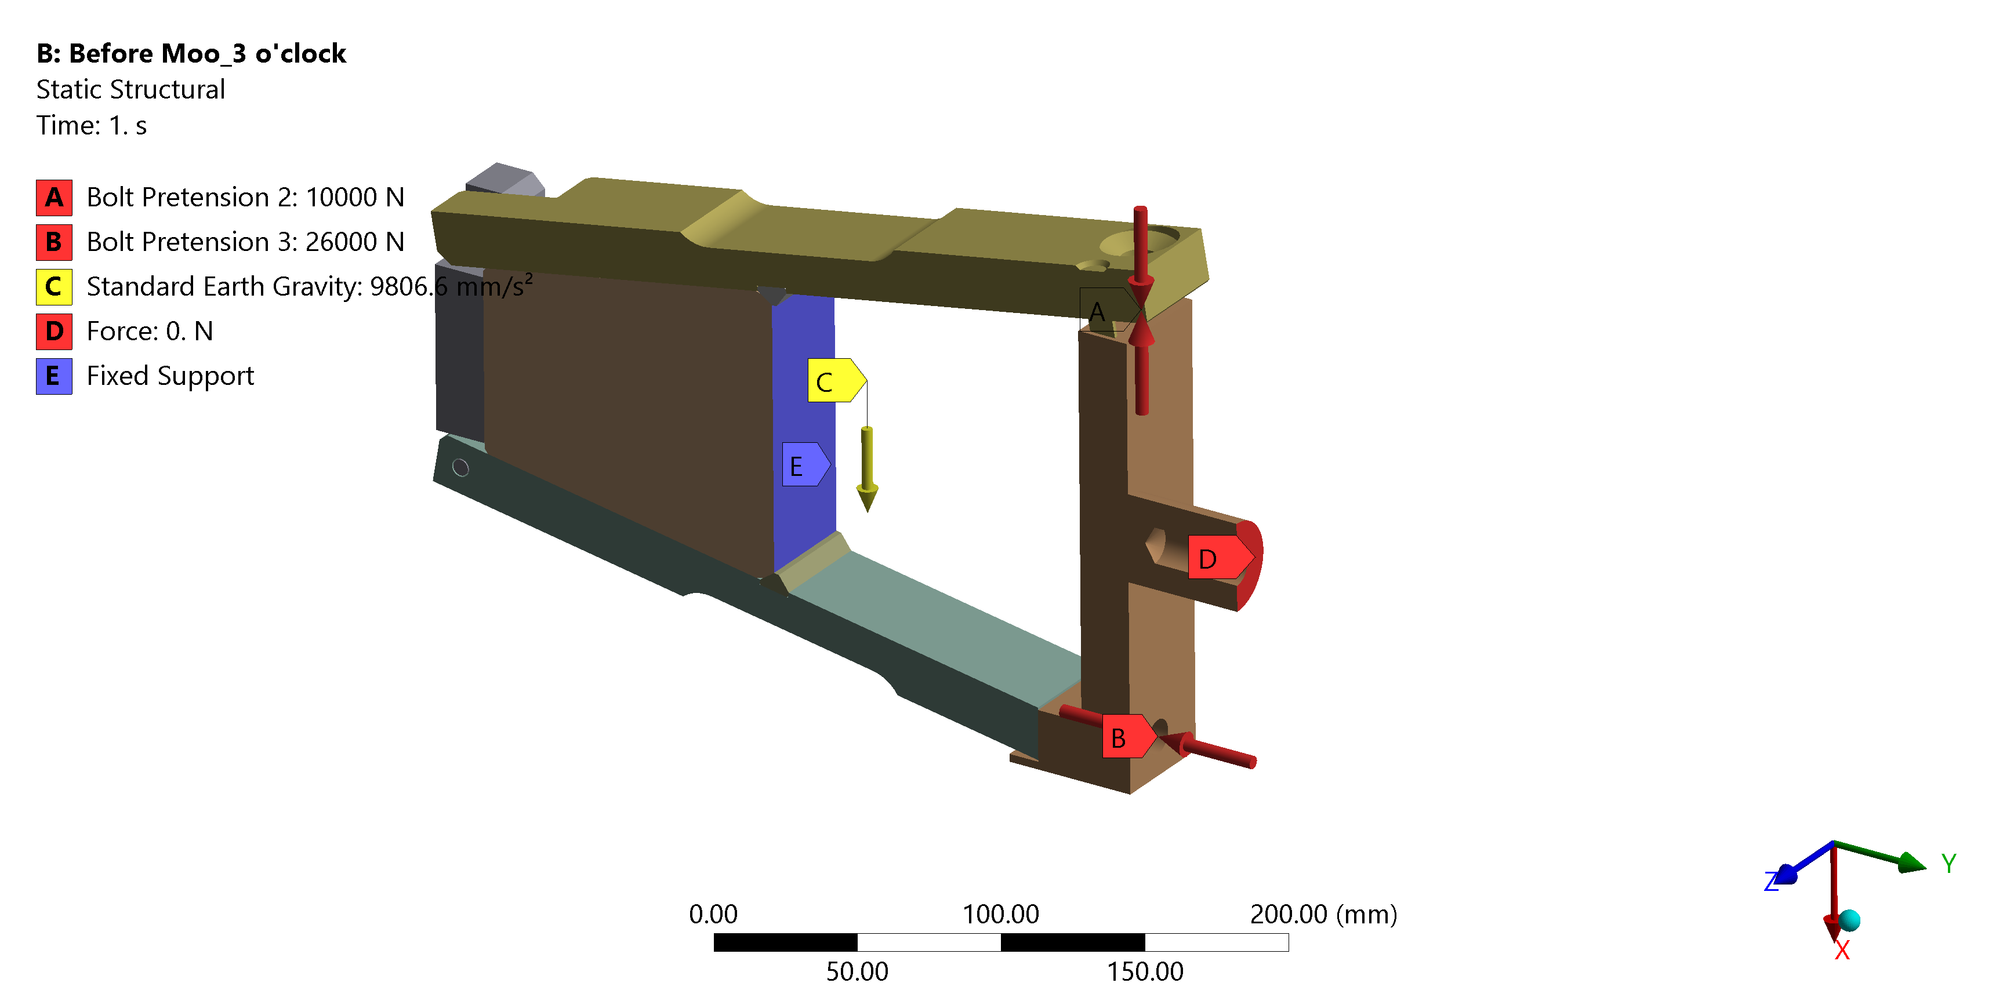

Figure 6-Boundary conditions

## Simulation results

The simulation results indicate that Plate 2 deforms by 1 mm during the tightening of the bolts, which is attributed to the gap between Plate 0 and Plate 2. When an external load of 2500N is applied, the clamp undergoes further deformation and deforms by 2.66 mm. The deformation of both Plate 2 during bolt tightening and the clamp under external load are shown in Figure 6.

Figure 7-Deormation results in both steps.

Regarding stress levels, the simulation results show that the maximum equivalent Von-Mises stress is 475 MPa. However, this stress is localized at the contact point between Plate 0 and Plate 2, where it is compressive and caused by the bolt pretension. Therefore, it can be ignored.

The second most stressed area is on Plate 2, where bending stress is observed. Upon closer inspection, the maximum stress in this area is 103 MPa. This stress level is well beyond the elastic limit of the aluminium alloy used in the model (260 MPa). The results are shown in Figure 7.

Figure 8- Equivalent Von-Mises stress on the clamp.

## Reaction forces

To verify force conservation within the model, the reaction forces on the bracket, which serves as the only fixed point, will be compared against the applied forces. This comparison will help ensure the accuracy and validity of the model.

The forces exerted on the model include:

-Force due to the weight of the extraction tool and the chamber: **2500 N/2** (due to symmetry)

-Standard earth gravity: Accounting for the weight of the clamp, bolts, and bracket, Ansys estimates it to be approximately 6.09 kg, equivalent to **59 N**.  
  
Therefore, the sum of the applied forces is:1250+59= **1309N**

The observed reaction force on the fixed support is **1332 N**, which is higher than the expected value. This discrepancy is likely attributed to the influence of bolt pretension and frictional contactswithin the model. Thesefactors introduce additional forces resulting from the relative motion between the contacting surfaces.

Figure 9- Reaction force in the vertical direction on the fixed support.

To confirm the impact of bolt pretension and frictional contacts on the reaction force, a new model is constructed. In this revised model, the bolts are removed, and the frictional contacts between plates 0, 1, and 2 are replaced with bonded contacts. All other boundary conditions are maintained identical.

The measured reaction force on the fixed support is **1303 N** in the current model, which is lower than the previous model, aligning with the expected result. The remaining difference of 6 N is likely attributed to the sliding and other frictional contact occurring between the bracket and the clamp. This marginal discrepancy is considered acceptable, indicating that the forces are conserved within the model.

Figure 10- Reaction forces after removing the bolts from the model.

## Bolts calculations

The bolts that join plate 2 to plate 0 experience solely tensile load, whereas the bolts linking plate 0 to plate 1 endure shear load, which is considered the most critical scenario. Therefore, the calculation will be performed on those bolts.

First, we need to calculate the axial force (tension or compression) in the bolt due to the preload:

Axial force in bolt = Preload = 26000 N

Next, we need to calculate the shear stress on the bolt due to the external load:

Shear stress on bolt = Applied shear load / Area of bolt cross-section

To calculate the area of the bolt cross-section, we need to know the diameter of the bolt. It is an M12 bolt with a standard pitch of 1.75 mm. The minor diameter of an M12 bolt is approximately 10.2 mm. Therefore, the area of the bolt cross-section can be calculated as follows:

Area of bolt cross-section = π/4 * (10.2 mm)^2 = 81.66 mm^2

Now we can calculate the shear stress on the bolt:

Shear stress on bolt = 1250 N / 81.66 mm^2 = 15.31 MPa

Finally, we can calculate the overall stress on the bolt using the von Mises stress criterion, which takes into account both the axial and shear stresses:

Overall stress on bolt = √(axial stress^2 + 3 * shear stress^2)

Therefore:

Overall stress on bolt = √(26000 N / 81.66 mm^2)^2 + 3 * (15.31 MPa)^2 = 281.8 MPa

The yield strength of a SS bolt A4-70 is 450 MPa, therefore the stress level is well below the limit.

# Modified clamp-1

## Design

The proposal is to increase the size of the cable tray on top of the ME11 bracket by removing 5 mm from the inside of plate 1 and plate 2 of the clamps. However, this will result in plate 0 needing to be extended by 5 mm to maintain the same gap between it and plate 2. As a consequence of reducing the thickness of plate 1, it will no longer be possible to drill and tap M12 holes. To address this, the proposal is to replace the existing 2 M12 bolts with 4 M6 bolts. The effects of these changes will be simulated and analyzed in this section.

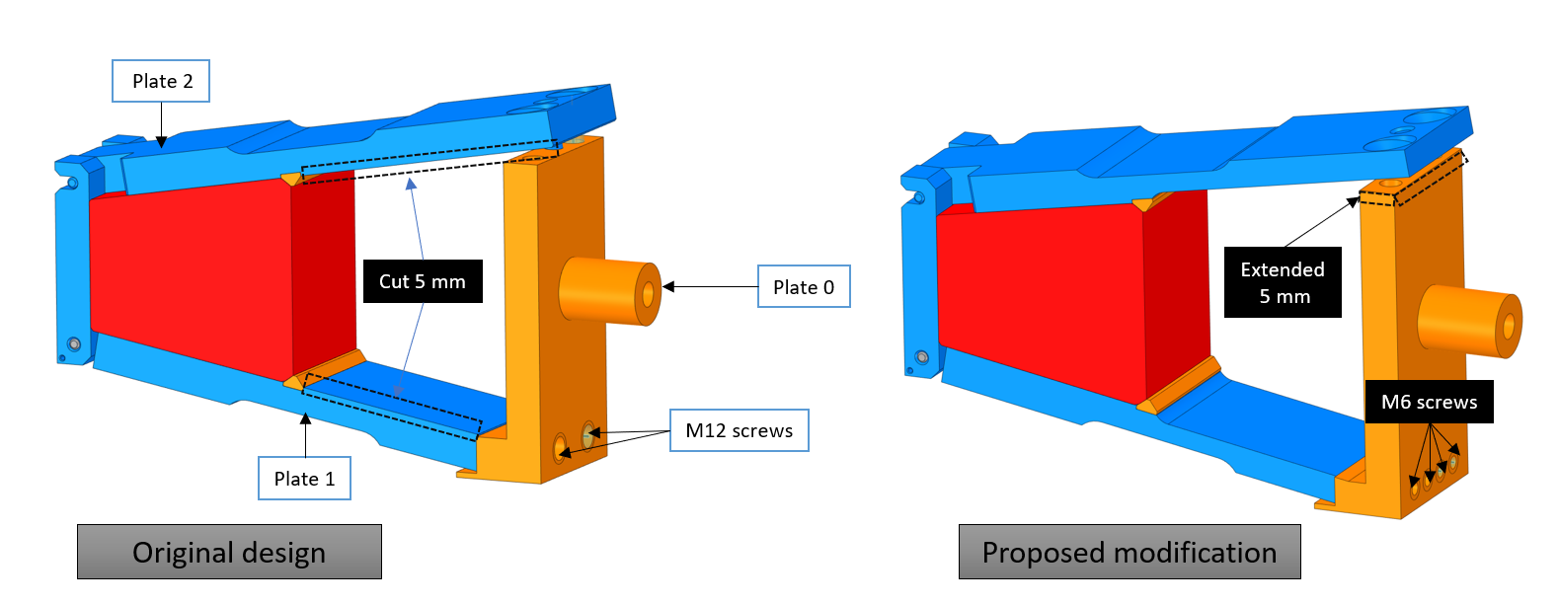

Figure 11-Proposed modification compared to the original design.

## Simulation results

For the modified clamp, the same mesh, load case, and boundary conditions will be applied as those used for the original design.

As anticipated, the deformation increased slightly and reached a value of 2.8 mm after the load was applied. Figure 9 shows the deformation results.

Figure 12-Deformation after the modification on both steps.

The equivalent Von-Mises stress in the most critical area on plate 2 reaches 150 MPa approximately which is stell beyond the elastic limit of the material.

Figure 13-Equivalent Von-Mises Stress on the modified clamp.

## Bolts Calculations

As in the previous chapter, only the bolts subjected to shear will be analyzed, as this represents the worst-case scenario. In this situation, there are 4 M6 bolts sharing a load of 2500 N, resulting in a shear load of 625 N per bolt. First, we need to calculate the axial force (tension or compression) in the bolt due to the preload:

Axial force in bolt = Preload = 6000 N (Pretension to 70 % of the material limit)

Next, we need to calculate the shear stress on the bolt due to the external load:

Shear stress on bolt = Applied shear load / Area of bolt cross-section

To calculate the area of the bolt cross-section, we need to know the diameter of the bolt. It is an M6 bolt with a standard pitch of 1 mm. The minor diameter (the diameter at the bottom of the threads) of an M6 bolt is approximately 5.3 mm. Therefore, the area of the bolt cross-section can be calculated as follows:

Area of bolt cross-section = π/4 * (5.3 mm)^2 = 22.03 mm^2

Now we can calculate the shear stress on the bolt:

Shear stress on bolt = 625 N / 22.03 mm^2 = 28.38 MPa

Finally, we can calculate the overall stress on the bolt using the von Mises stress criterion, which takes into account both the axial and shear stresses:

Overall stress on bolt = √(axial stress^2 + 3 * shear stress^2)

Therefore:

Overall stress on bolt = √(6000 N / 22.03 mm^2)^2 + 3 * (28.38 MPa)^2 = 284.7 MPa

The yield strength of a SS bolt A4-70 is 450 MPa, therefore the stress level is well below the limit.

# Modified Clamp-2

## Design

As mentioned in the introduction, the primary objective is to expand the capacity of the cable trays keeping the same outer envelope and connection to the installation tool and maintaining the same level of performance of the clamp under identical load conditions. During the earlier modification analysis, a slight increase in deformation was observed, which was attributed to a reduction in the stiffness of plate 2 after removing 5 mm from its interior. To offset this effect, a proposal was made to extend the clamp by 5 mm on each side in the Z direction, and to investigate its impact on the deformation. Below is an illustration of the modified clamp, where the extension in the Z direction is highlighted in yellow.

Figure 14- Modified clamp extended in Z.

## Simulation results

By maintaining the same simulation configuration, the results indicate that adding 10 mm in the Z direction for plates 1 and 2 caused a minor decrease in deformation. Consequently, the behavior of the clamp is now comparable to that of the original design, with a deformation value of 2.67 mm.

Figure 15- Deformation results after adding 10 mm in Z.

Due to the enlarged contact surface between the clamp and ME11 bracket, the stress level has decreased, with a maximum value of 138 MPa observed on plate 2.

Figure 16- Equivalent Von-Mises stress after adding 1 mm in Z.

## Comparison between using the clamp at 3 and 9 o’clock

As the clamp is intended to be used at both 3 o'clock and 9 o'clock positions for extracting the chambers, it is important to assess its behavior in both scenarios. To accomplish this, the simulation was rerun with the same boundary conditions, but with the direction of the external load inverted.

If the clamp is used in the opposite orientation, both the deformation and stress level are lower. The maximum deformation recorded is 1.45 mm, and the stress level on plate 2 has decreased to less than 100 MPa. Both outcomes are presented in figures 14 and 15, respectively.

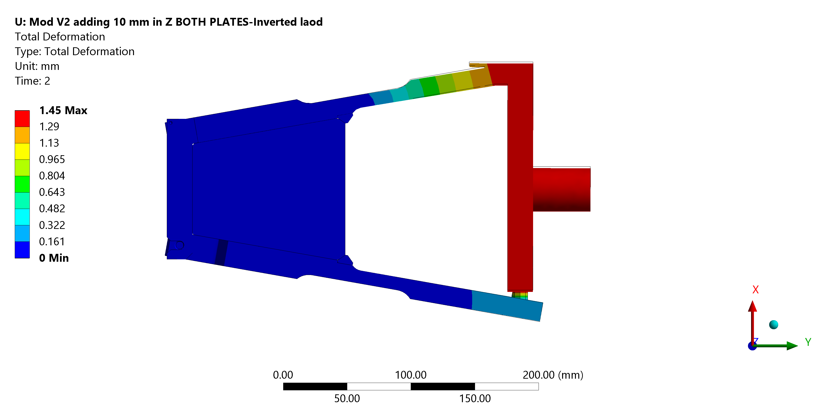

Figure 17- Deformation when the clamp is used at 9 oclock.

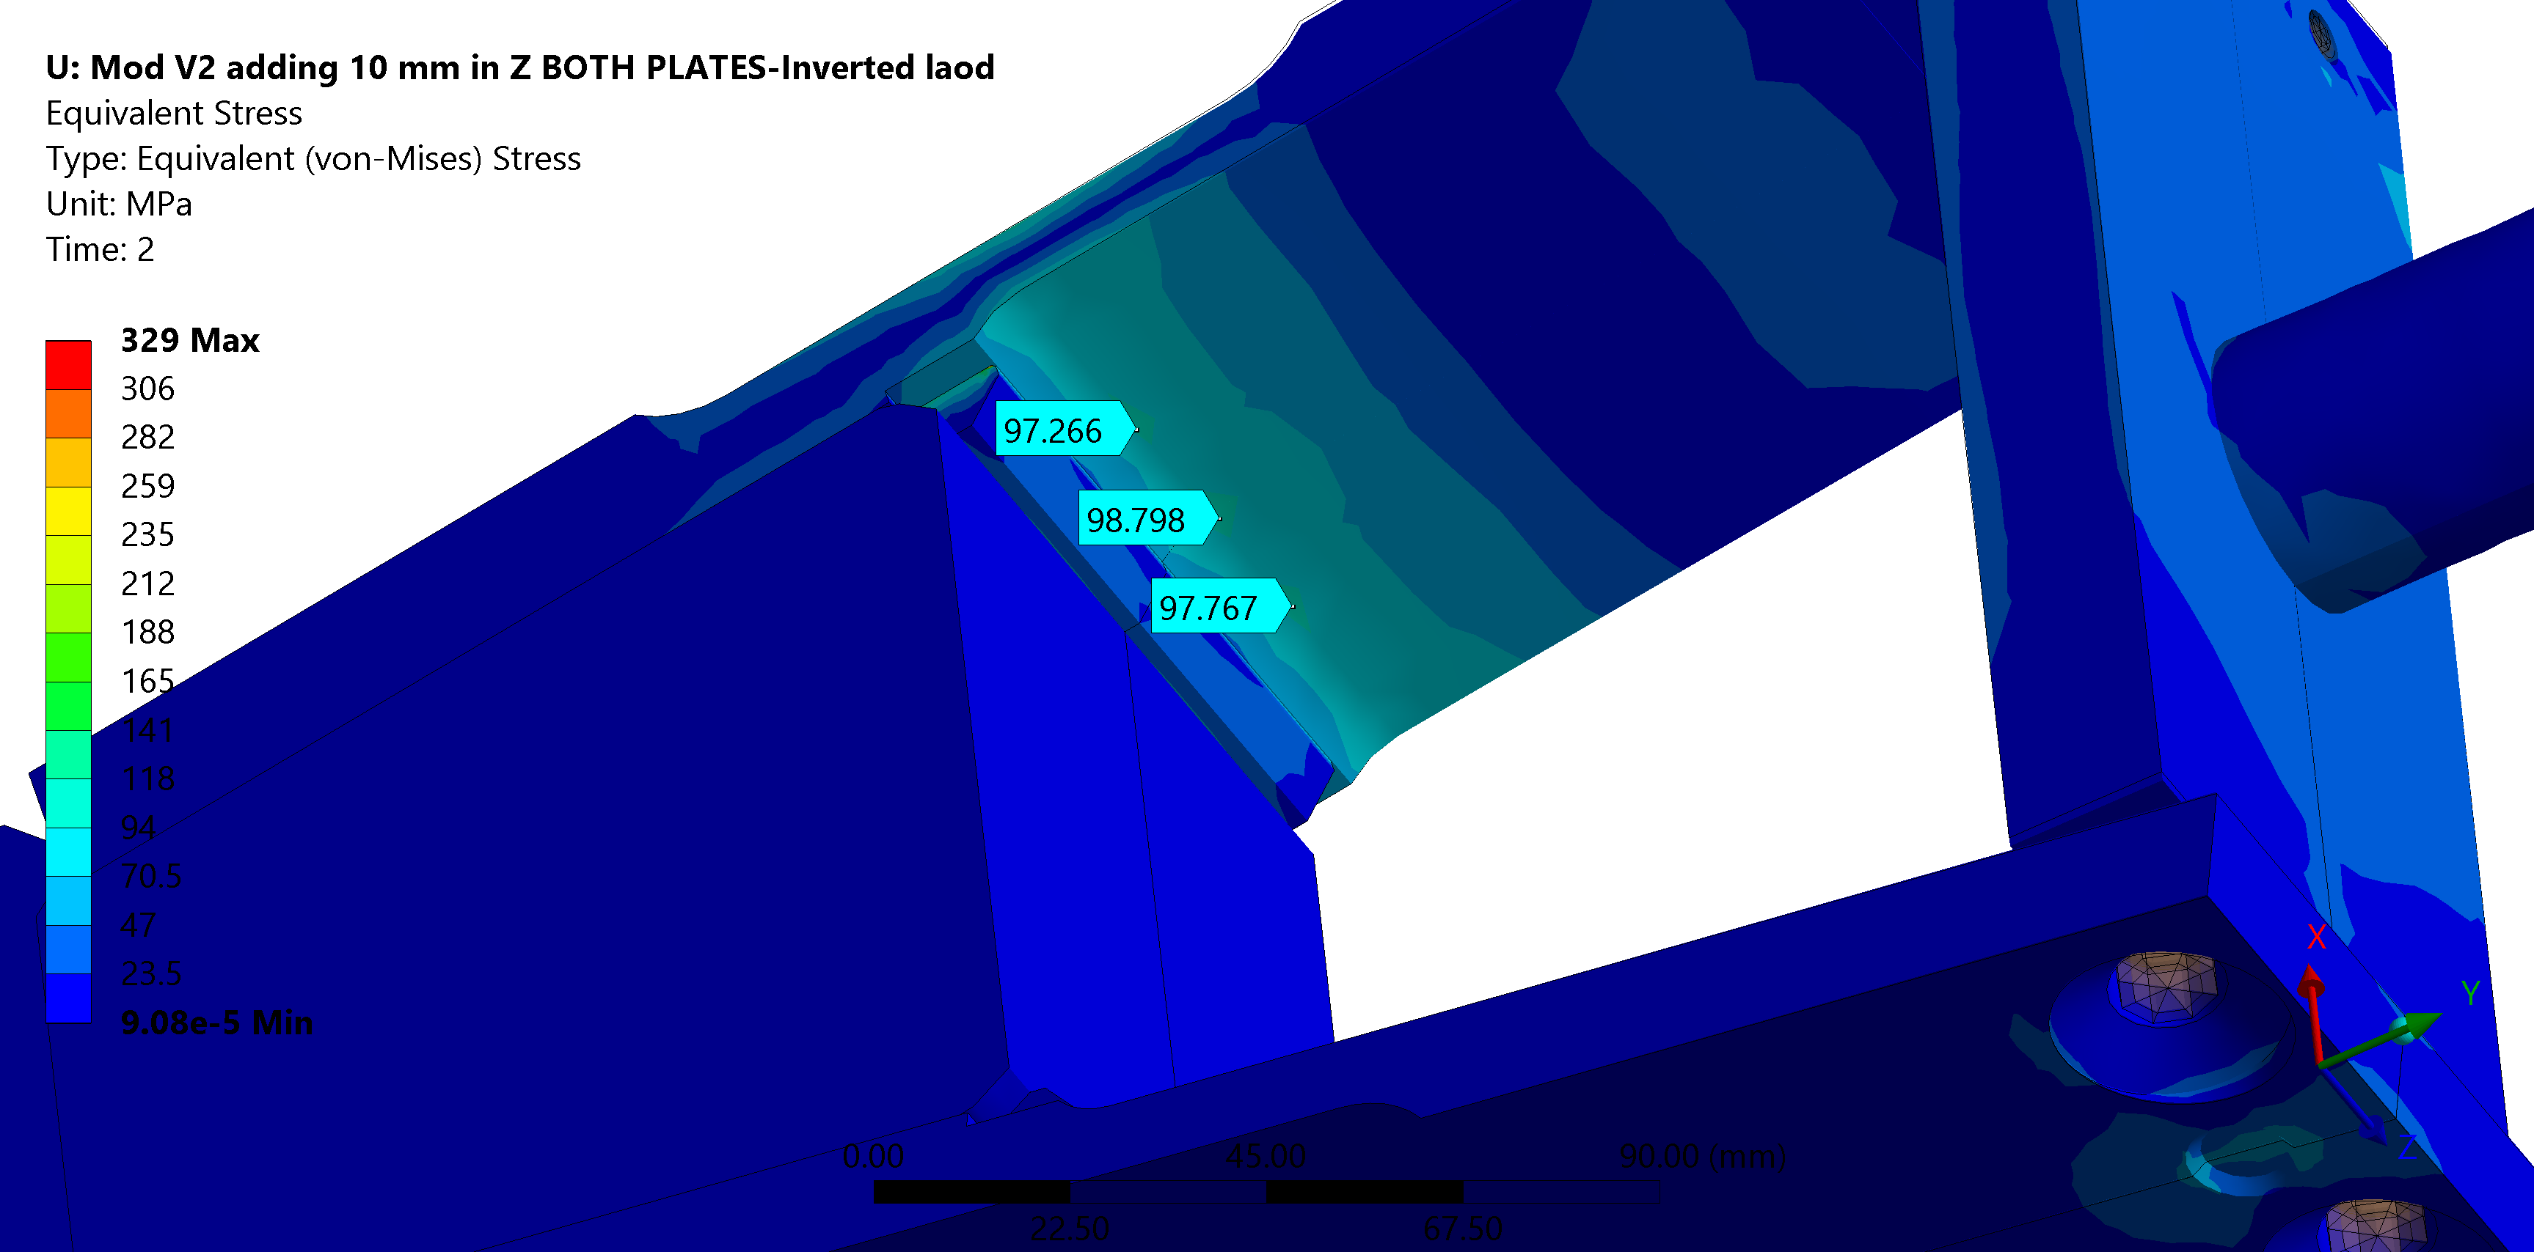

Figure 18-Equivalent Von-Mises stress when used at 9 o'clock.

# Load Test

To ensure the robustness of the design and compliance with safety standards, a load test will be conducted, applying a load of 250 kg in accordance with the calculated stress. However, due to the complexity of the system, the exact load distribution on each clamp during operation is uncertain. Consequently, any deformation observed during the test may not accurately reflect real-world conditions. Nonetheless, since the new clamp shares the same theoretical behaviour as the original clamp, it is assumed to exhibit similar performance under actual load conditions, provided the applied load remains unchanged.  
  
A machined Aluminium block will serve as a representative bracket and will be securely attached to a rigid support. The load will be applied using a screw-jack, and the magnitude of the applied load will be measured using a load cell. To facilitate this process, a cap with a flat surface will be affixed to the pin of the clamp. Furthermore, an interface component featuring three dowel pins will be utilized between the jack and the clamp to accommodate the placement of the load-cell.  
  
Figures 17 and 18 depict the load test setup as described earlier.

Figure 19- Load Test Set-up 1

Figure 20- Load Test Set-up 2

# Conclusion

To be added after the load test