RPC Air conditioned enclosure in building 904

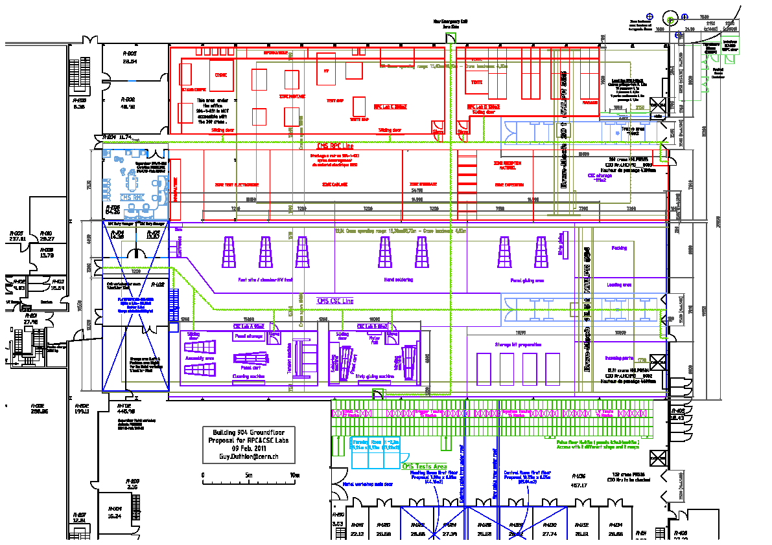

Yellow represents the 2 rooms

x2 room 29.5 x 9.5m = 280m2

7.5 x 15.5m = 116m2

Thermal coefficient (Walls) U=0.5 [W/m2.K] Internal height ≥ 3.5m

Thermal coefficient (Windows) U = 1 – 1.4 [W/m2.K] External height ≤ 4.3m

Roof load 150kg False ceiling height ≥ 0.3m

X2 Airlocks (SAS) Pressure inside 10Pa

Ian Crotty 29 March 2011