**Resistive Plate Chambers pre-assembly, assembly, testing procedure and**

**Work flow**



**Prepared by**

Pakistani RPCs group

National Centre for Physics Qauid-e-Azam University Islamabad

**Table of contents:**

1. Pre-assembly.
   1. Components preparation.

1.1.1. Electrical components.

1.1.2. Mechanical components

1.1.3. Pre-assembly tests

1. Space requirement.
2. Pre-assembly procedure.
   1. Storage of assembly materials.
   2. Side support angles bars, services and top & bottom panels’ preparation.

3.2.1. Panel preparation steps.

* 1. Gas gaps, FEBs testing procedure.

3.3.1. Gas gaps testing.

3.3.2. FEBs testing.

* 1. Mylar and copper sheets cutting.
  2. Gas pipes bending, coaxial and flat ribbon cables preparation.

3.5.1. Gas pipes bending.

3.5.2. Coaxial and flat ribbon cables preparation.

4- RPCs assembly procedure.

5- RPCs testing and database.

* 1. Components list to prepare the RPCs test setup.
  2. Testing procedure.
  3. Good chambers performance parameters.
  4. Data base for chambers test results.

6- Packing and shipment.

1. **Pre-assembly:**

**1.1. Components preparation.**

**1.1.1. Electrical components.**

* Cutting, trimming of the coaxial cables.
* Ferrule mounting and crimping.
* Soldering of the coaxial cables to the adopter board.
* Soldering of the coaxial cables with copper sheet.
* Preparation of the gas pipes.
* Preparation of the flat ribbon cables.
  + 1. **Mechanical components.**
* Retrofitting of the honeycomb panel.
* Preparation of the aluminum supporting bars.
* Preparation of the copper plate for FEBs coolant.
* Cutting of copper and Mylar sheets.
* Preparation and fixing of the Mylar sheets at the top inner side of the HCP.
* Preparation of the patch panels (wider and narrow end).
* Shielding cover.
* Perspex sheet.
* Mounting of the flat ribbon cables on the wider end patch panel.

**1.1.3. Pre-assembly tests.**

* Spacer test.
* Gas gap leak test.
* HV vs Dark current test.
* Maintain data base for all test results.

1. **Space requirement.**

The required number of rooms at production site should be five:

* Storage Room
* Mechanical Shop
* Assembly Room
* Testing Room
* Office

1. **Pre-assembly procedure.**

**3.1. Storage of assembly materials.**

The assembly materials like panels, gas gaps, Mylar sheets, flat ribbon cables, copper braid, copper sheet, coaxial cables, FEB, adopter boards, Distribution boards etc. are stored in the storage room. A few other items like cable connectors, gas connectors, prepared flat ribbon cable connectors, screws and nuts, prepared adopter board and soldered coaxial cables are stored in the assembly room, where these can easily be found during chamber assembly.

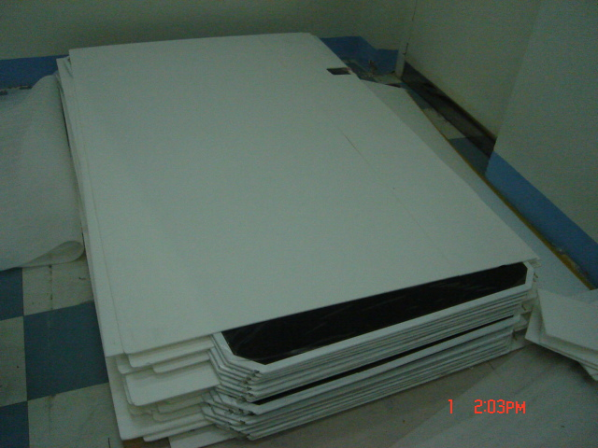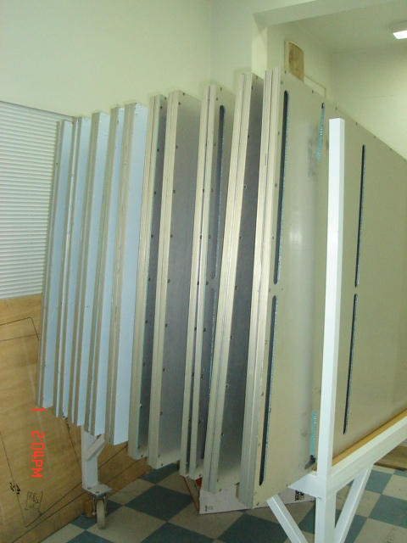

Figure 3.1: a) gas gaps storage; b) panels storage

**3.2. Side support bars, services and top & bottom panels preparation:**

The side support angles, patch panel and panels are prepared in the mechanical shop, where all the related mechanical facilities are available. The gas gaps were not sent according to the drawings so the panels have to be modified accordingly. All the modification process is done in the mechanical shop and then modified panels are stored in the storage room in the panel storing racks. Before storing these panels in the racks, each panel is cleaned and makes it ready for the assembly. The procedure of panel preparation is as under:

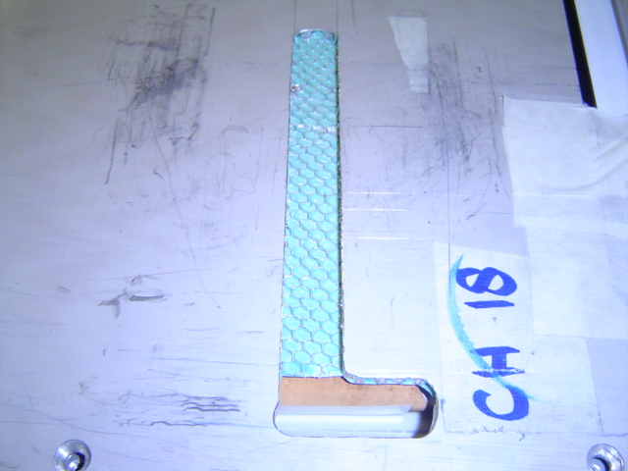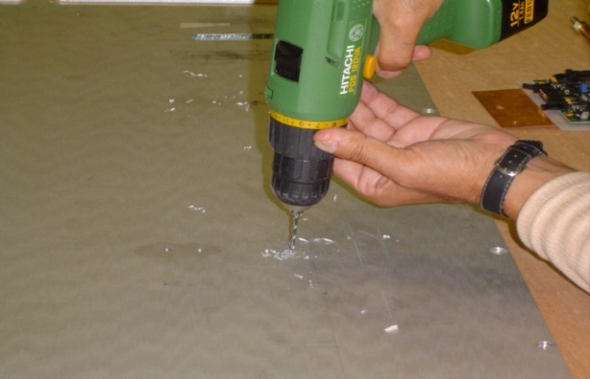

Figure 3.2: a) holes in panels; b) retrofitting of the honey comb panel for gas pipes

* + 1. **Panel preparation steps:**
* Remove the plastic insulation sheets from the top and bottom ends of the panel
* Take the dimensions of panel randomly from any four locations
* Remove the top panel
* Remove one by one side Al bars and blow dry air inside the holes to remove Al sand at the thread locations
* Clean any oil marks and Glue patches on the bars and panels with the cleaning chemical
* Mark the positions of gap’s HV connection slots, gas inlets holes and its routes, HV cables hole and its route, and holes for shield box in the panels
* Make HV connection slots in bottom and top panels
* Make the gas inlets holes 20mmx50mm and increase its route to 200 mm in length
* Make the hole for HV cables and increase its route to 200 mm in length
* New threads M5 in top panel at 158mm perpendicular to the side of the panel for the shield box
* Screw the bottom panel with all four Al bars and tight it to 10Nm-12Nm torque
* Foil the top panel at all slots and remove sharp edges and counter sink at all hole positions
* Clean the panel with cleaning chemical
* Refresh the mounting threads in the side Al bars
* Close the panel and store it for the assembly

The side support angles are available in 14mmx16mm specification and now they can easily be made.

**3.3. Gas gaps, FEBs testing:**

Detail is as follows

**3.3.1. Gas gaps testing:**

The gas gaps are tested for the initial quality tests and then shifted for the assembly of chambers. The quality tests for the gaps are as under:

1. Gas gaps removal from package and initial dimensions and visual test like measure the bending, thickness, high voltage and ground connections, inlets and outlets of gaps and PET film condition of each gas gap.
2. Data entry of each gap in the data book, note the gas gap’s ID number and Resistivity code of each gap.
3. Gas gaps that pass initial visual test are stored under humidity and temperature control.
4. Each Gap put on under 20-mbar pressure tests for the leakage test and spacer test.
5. The rejection for the leakage test fail was more than 2 cm reduced pressure column on the manometer.
6. Those passed leakage test were checked for the spacer test with the help of spacer template sheet, each spacer was pressed twice (5 N force at least) and visualize the column of manometer. If there is sudden jumps of about 1.5 -3 cm then that spacer was supposed of be broken.
7. All the information was recorded in the data book with the spacer location and pressure readings.
8. Passed leakage and spacer test were placed under High Voltage and Dark Current test with the RPC gas mixture under 2 mbar pressures at 5 l/h for 8- 10 hours, the gaps with less than 3 μA current were accepted for the assembly while others are rejected.
9. All the tests are performed under humidity and temperature control and note the temperature and humidity readings on Hygrometer.

**3.3.2. FEBs testing:**

The FEB boards are tested with the help of software program and all the data for each FEB board is stored in soft and hard copy.

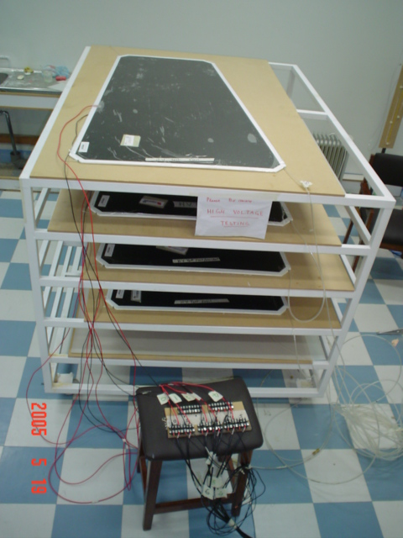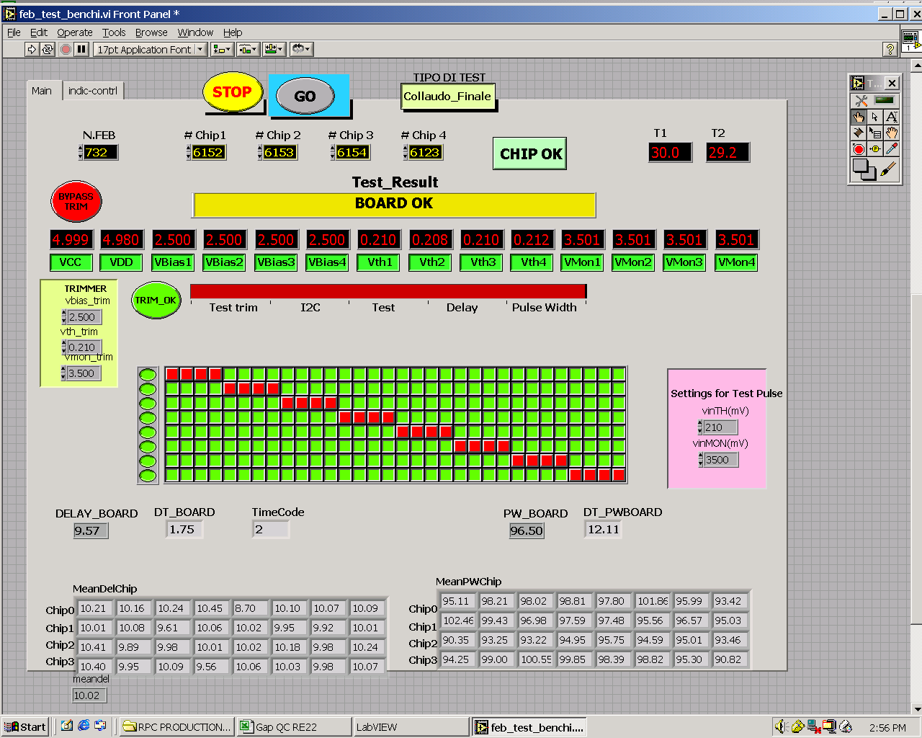

Figure. 3.3.2: a) gaps under testing; b) FEBs testing tool front panel.

**3.4. Mylar and copper sheets cutting:**

Copper and Mylar sheets are cut with the help of scissor and knife. The top panel Mylar is slotted with the help of punch knife. All the cut sheets are stored in the assembly room for the assembly. Each sheet is cleaned before storing in the assembly room.

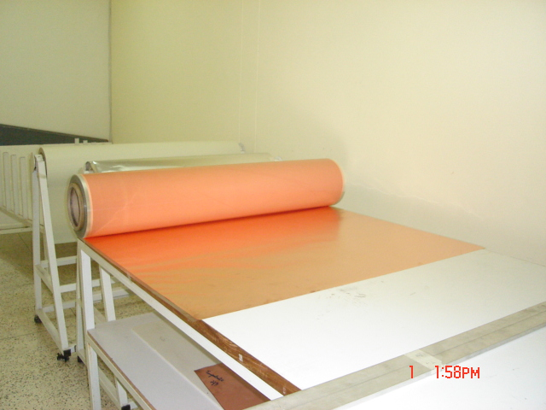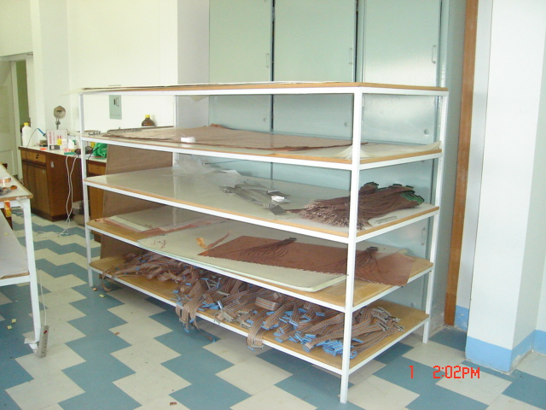

Fig: 3.4: a) copper sheet roll on cutting table; b) coaxial and flat ribbon cables storage.

**3.5. Gas pipes bending, coaxial and flat ribbon cables preparation:**

**3.5.1. Gas pipes bending:**

* The gas pipes are bent with the help of jigs for the complete shape of the gas pipe. The gas pipes are heated with a controlled heating plate and then put in the cold water. The time duration for heating of each shape may vary and monitored closely during the process.
* The gas pipes must not have any kinks and no overheating.

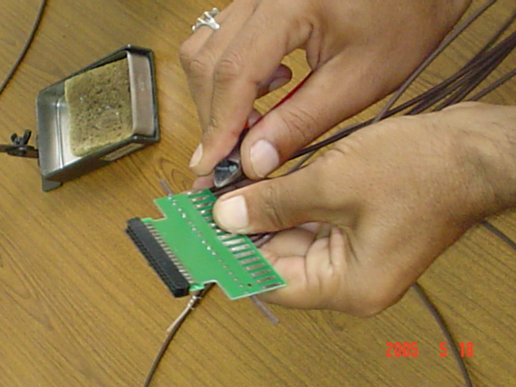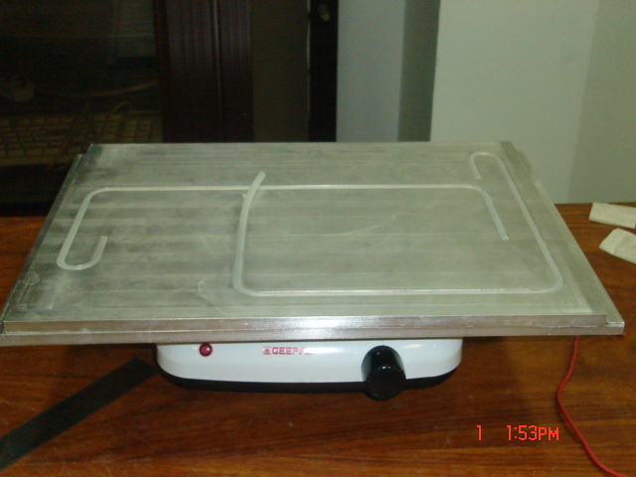

Figure 3.5.1: a) cables soldering with adopter board; b) gas pipes bending tool.

**3.5.2. Coaxial and flat ribbon cables preparation:**

* The coaxial cables are prepared manually and then soldered with the adopter boards.
* The tools used for the preparation of coaxial cables are wire strippers and wire cutters.
* The lengths of conductor and braid ends are selected with the help of jig screwed to the wire stripper.
* Each cable is tested for the insulation with the ground braid and central conductor.
* The flat cables are cut with the ribbon cable cutter and the length of each cable is measured before attaching connectors to the ends.
* The flat ribbon cables are prepared with the help of vice.
* Each flat ribbon cable is tested before storage.
* The flat cable for the FEB supply is also cut, prepared and tested with the ribbon cable tester.

1. **RPCs assembly procedure.**

Detail procedure is as follow.

* Open the top panel and blow dry air to clean any dust inside
* Screw the side support angles not fully tight
* Aligned the bottom Mylar sheet 5mm larger in size in width, that slight part is underneath the side support angles and double stick it to the panel
* Tight the screws of side supports
* Place Faraday Cage envelop on the Mylar sheet and double stick it to the bottom Mylar
* Double stick a Mylar sheet (full gap size) on the envelope
* Cut the Mylar and copper sheet at the HV slot and insulate it with the insulation tape
* Insert copper braid on HV and 0V cables on all three gaps with the shrinkable sleeves
* Remove the top insulation sheet from the full gap both sides
* Note ID numbers of all three gaps on the chamber assembly book
* Place the full gap on the Mylar sheet
* Insert the gas pipes on the full gap by the heating
* Insert gas block pieces at the other two ends
* Double stick copper strip sheet with the full gap
* Double stick Mylar cut pieces with the copper strip sheet
* Place three protection strips underneath the strip sheet at soldering points
* Remove the insulation from the cut gaps
* Place the narrow cut gap on the sandwich
* Double stick a cut piece of Mylar sheet with the narrow gap
* Connect the gas pipe and two U tubes on the inlets of narrow gap
* Insert one gas block piece
* Place copper sheet on the gas gap
* Place the soldering protection strips at the soldering points underneath the copper sheet
* Solder the coaxial cables at ferrule end and conductor end with the copper sheet and copper strip
* Place the wide gas gap
* Connect the gas pipe and U tubes, connect them with the other ends of Narrow gap
* Insert gas block piece at one inlet of top wide gap
* Double the Mylar with the wide gas gap
* Place copper sheet on the gap
* Place soldering protection strip underneath the copper sheet
* Solder the coaxial cables at ferrule end and conductor end
* Remove the six soldering protection strips
* Solder the top and bottom copper sheets with soldering protection strip underneath the copper sheets
* Double stick the Mylar sheet with slots for the coaxial cables with top panel
* Cut the Mylar at the HV connection and insulate it with insulation tape
* Remove the soldering protection strips
* Close the panel and tight the screws to 10Nm-15Nm torque.
* Assembled chambers are then stored for the initial quality tests.

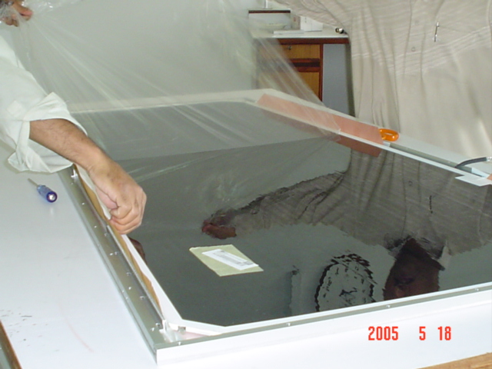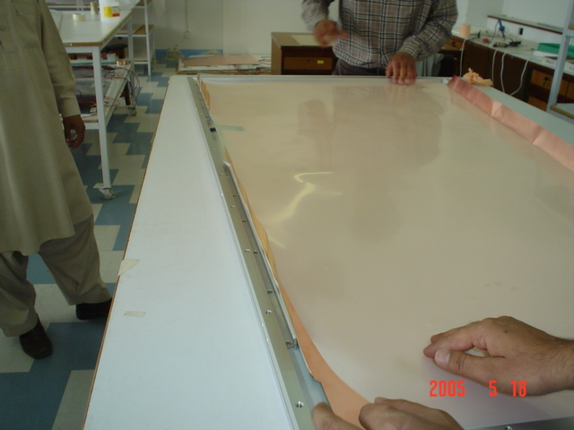

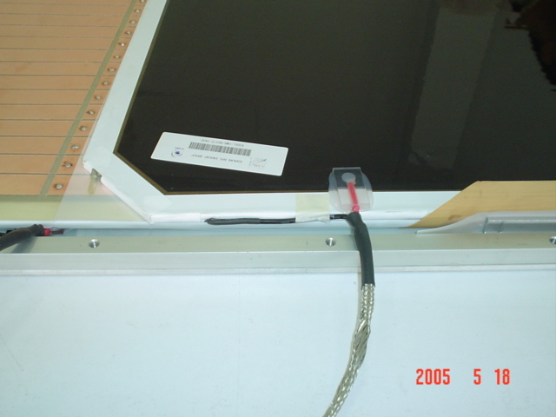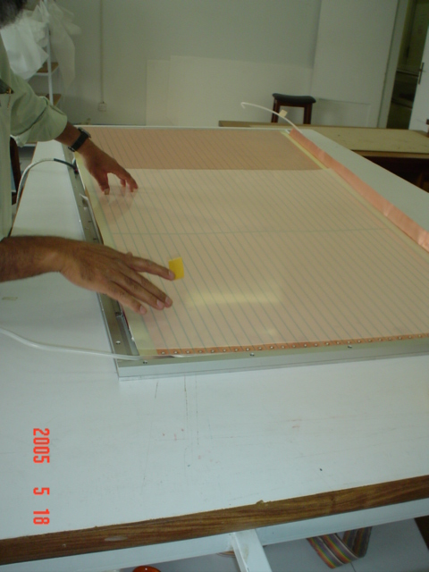Figure 4: a) Mylar on copper sheet at the bottom panel; b) gas gaps insulation removal.

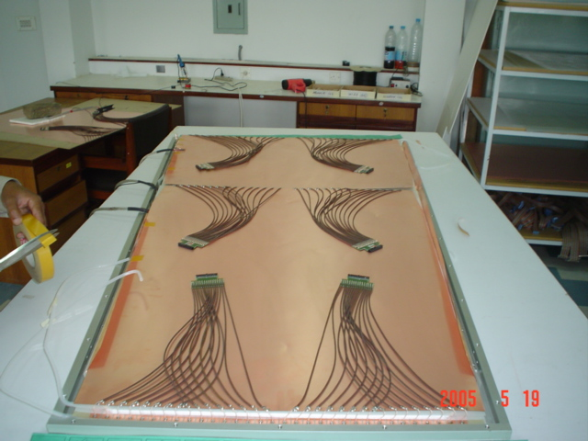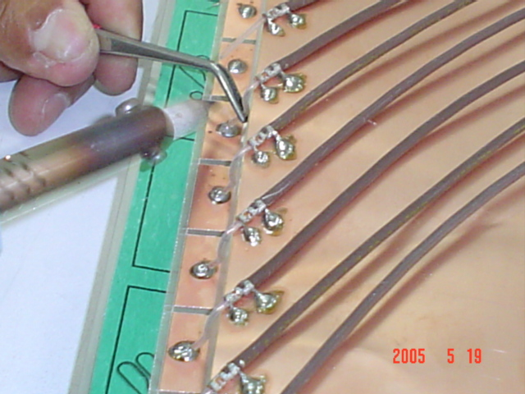Figure 4: c) strip sheet covering with Mylar for insulation; d) top narrow gap at the strip sheet.

Figure 4: e) soldering of coaxial cables with strips; f) gas pipes connection, copper sheets with adopter boards at faraday cage.

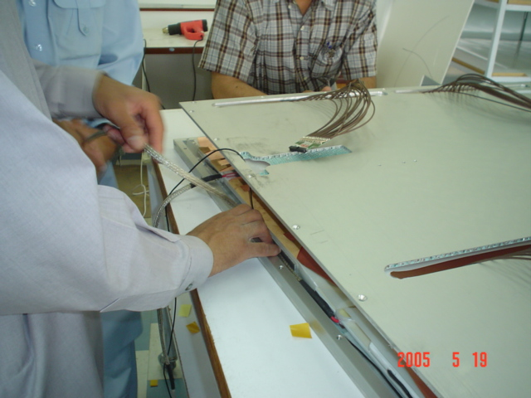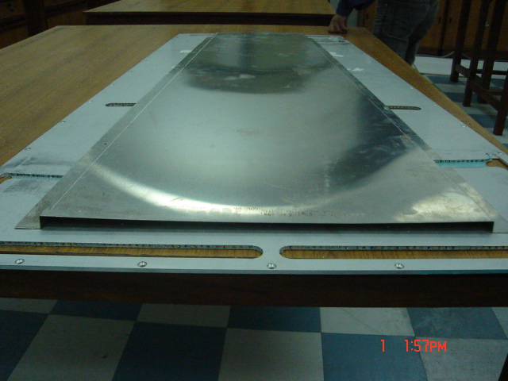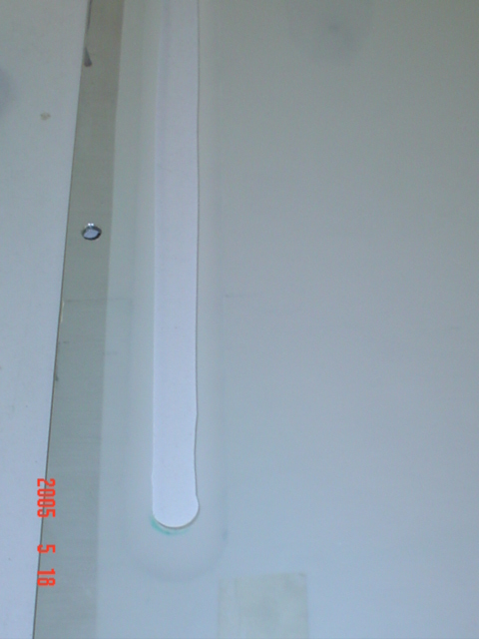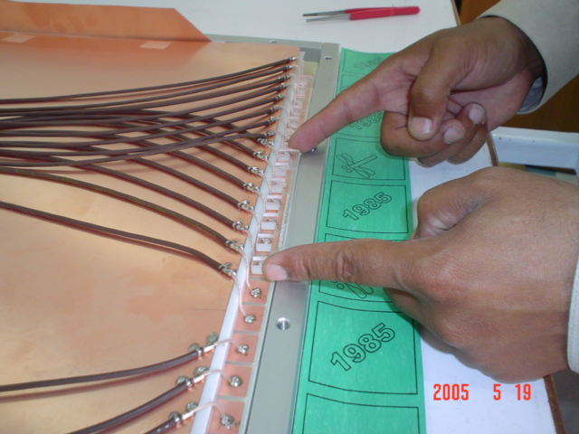Figure 4: g) spacers for solder and gap protection; h) gas gaps nozzle blocker

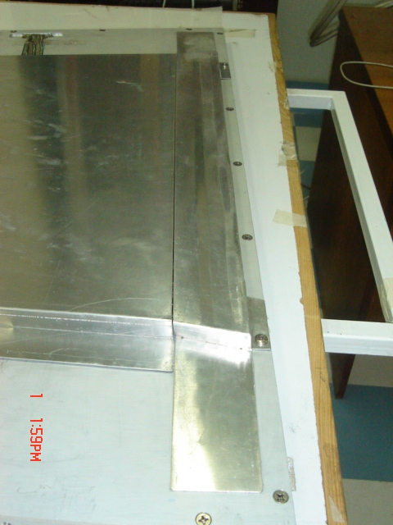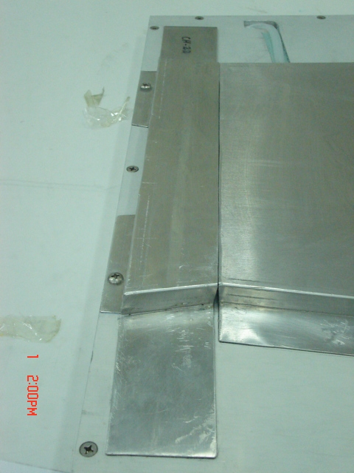Figure 4: i) high voltage cables routing; j) shielding cover at the top honey comb panel

Figure 4: k) wider side small shielding cover; l) narrow side small shielding cover

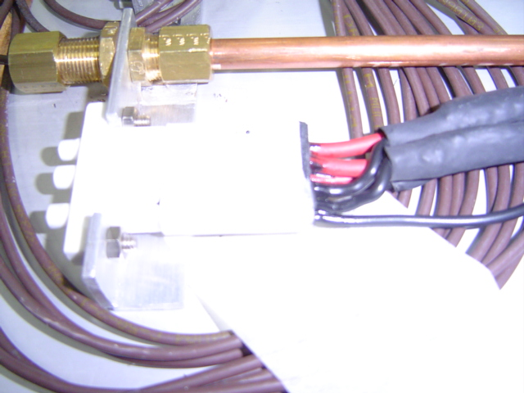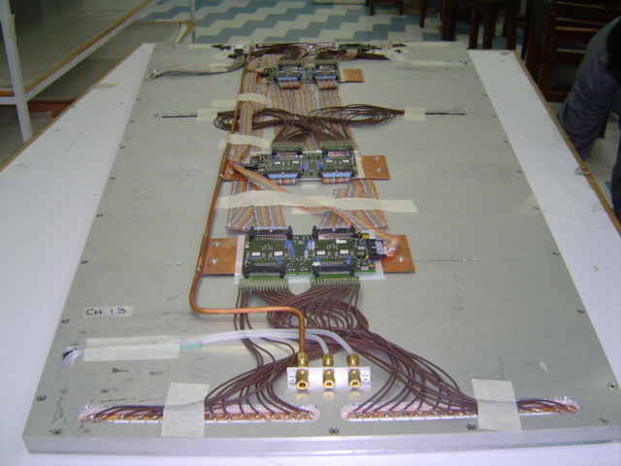Figure 4: m) top view of the RPC without shielding cover; n) high voltage and coolant connectors at the services panel.

**5. Testing of the chambers:**

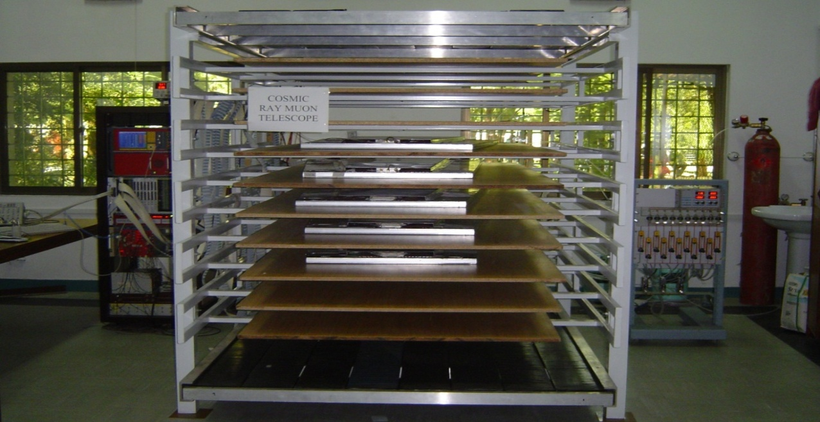

Figure 5: RPCs testing setup.

**5.1. Components list to prepare the RPCs test setup:**

* Cosmic Ray Muon Telescope.
* Scientillators
* Gas systems (distributor + gas cylinders + mass flow controllers+ pipes).
* Mainframe SY1527.
* Low voltage power supply
* TDCs
* Trigger unit.
* VME crate controller.
* Signal cables, High voltage cables.
* Temperature and humidity measuring devices.
* Air conditioner, humidifier and de-humiditifier.
  1. **Procedure to test:**

The chambers testing procedure is following

* Bring 10 chambers one by one in the cosmic stand.
* Make the gas connections and start to flush the gas mixture in the chambers for ~ 10 volume changes.
* Mean time makes the HV, LV and signal cables connections.
* Apply the high voltage at all chambers in the cosmic stand. Start the volts from 1000 volts and increase slowly with 1kV interval till 8kV.After each 1kV interval note the current. In case of some abnormal behavior slowly decease the volts and check gas flow, connectors etc… if no problem the keep the chambers at 8kV for ~ one day for conditioning with flushing uniform flow of gas mixture.
* Then apply the LV and see the current and volts in each channel. In case of abnormal check it. If not then keep it ON.
* Switch ON the scientillators and trigger unit.
* Start the DAQ.
* Normally we take 20000 events at following HV intervals 8.6, 8.8, 9.0, 9.2, 9.3, 9.4, 9.5 and at 9.6kV.
* 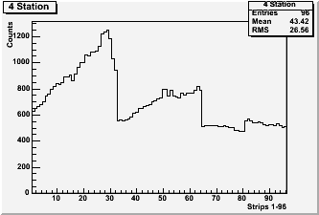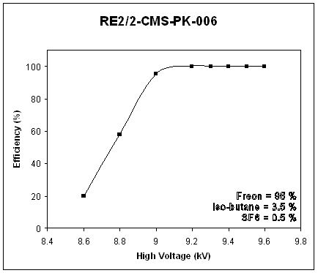After that analyze the data of each run and see the efficiency, cluster size, strip occupancy and dark current and got the following plots.

Figure 5.2: a) strip occupancy histogram; b) efficiency plot

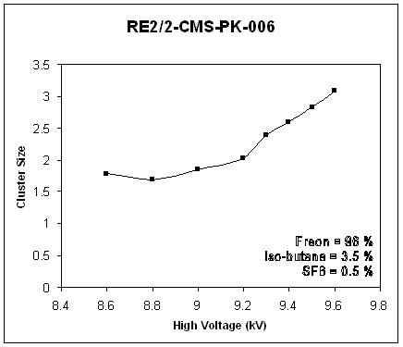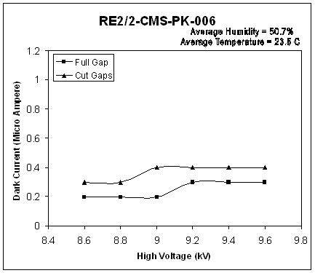

Figure 5.2: c) dark current; d) cluster size

* 1. **Good chambers performance parameters.**

At 9.6kV chamber should have

1. Efficiency > 95%.

2. Cluster Size < 3.

3. Dark current < 4uA per chambers.

4. Out of 96 strips two dead are acceptable. If more than that should change the FEB and investigate the reason.

**5.4. Data base for chambers test results:**

To keep the record of chambers performance in more systematic way a data base has been built. The data in this data base is chamber by chamber. When you open the data base it looks like that.

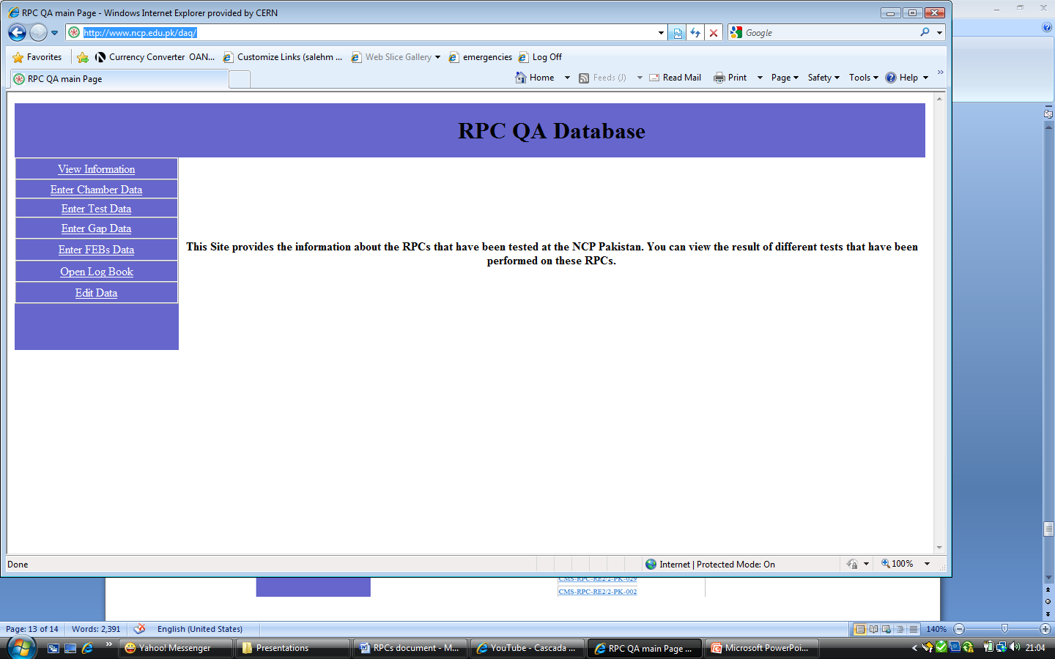

By clicking the view information a list of chambers which are in this data base is appeared as below.

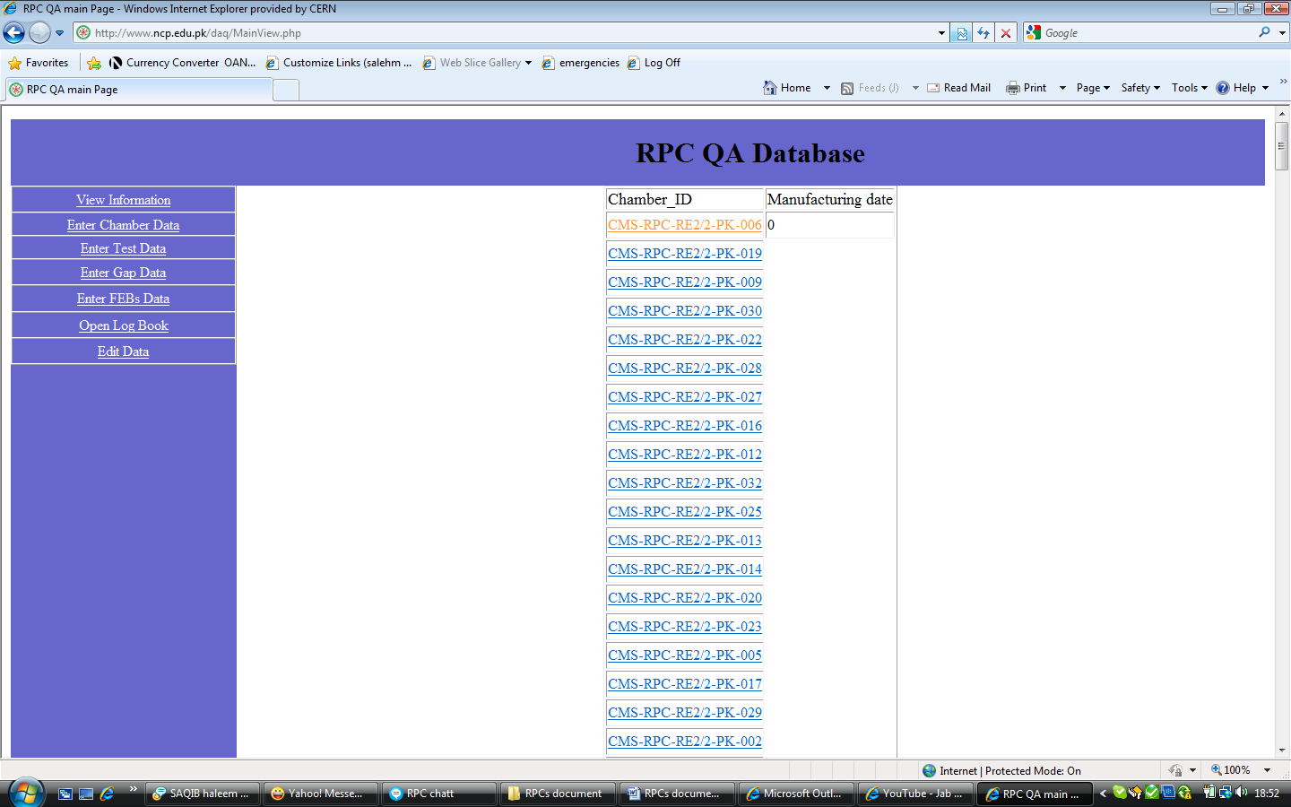

Just by clicking at any chamber gaps numbers and FEBs which are used inside this chamber appears like that

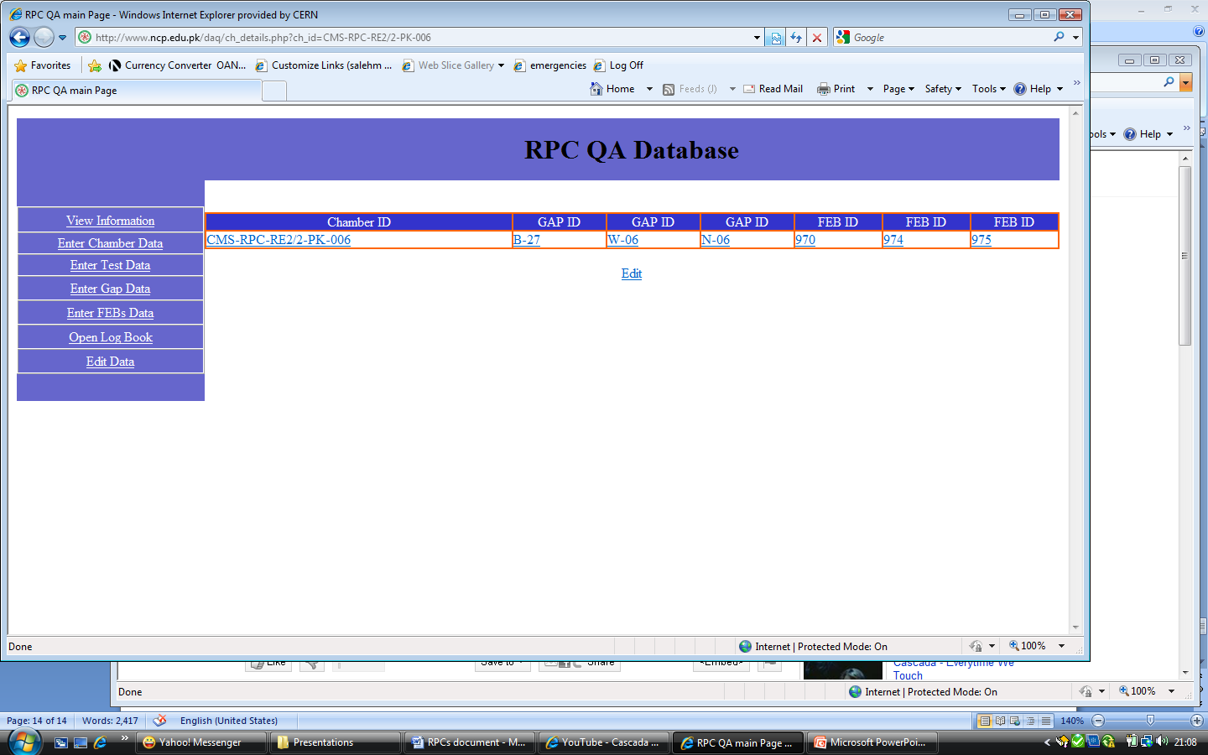

Now by clicking at the chamber number in this place the information of run by run appear

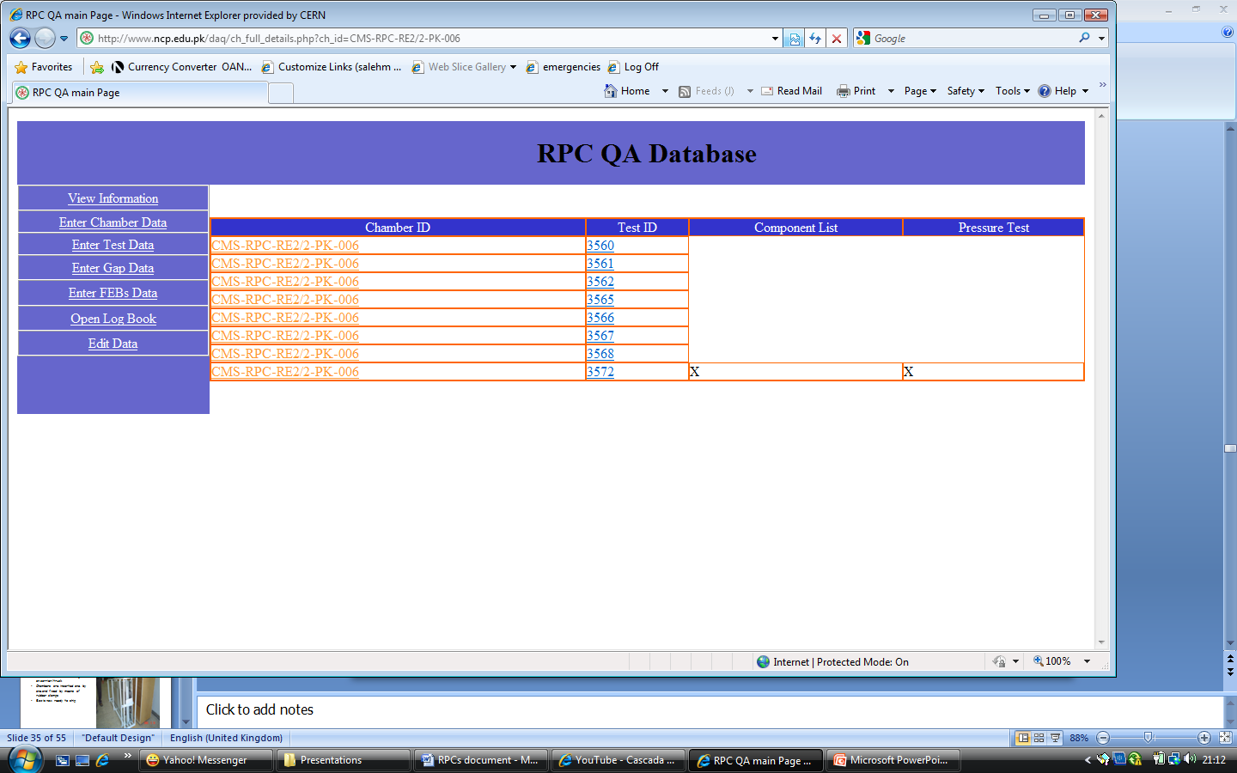

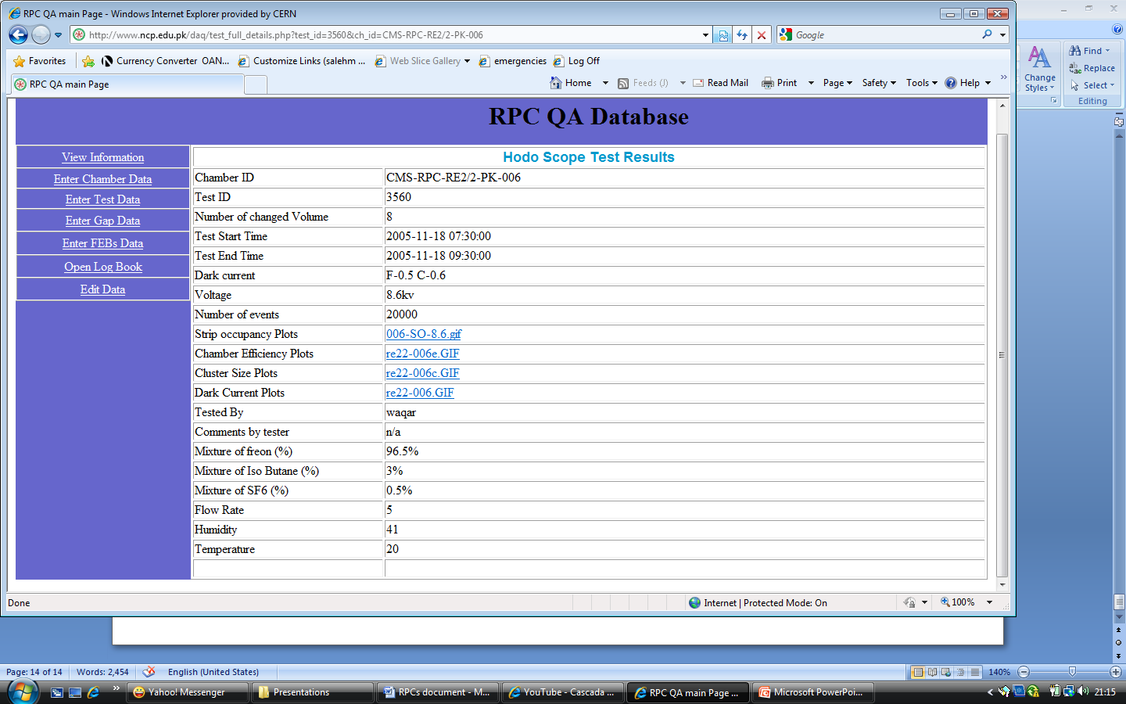Each run numbers gives the details as follows

The blue lines click will give the plots of strip occupancy, efficiency, cluster size and dark current. As given in Fig.8 (a, b, c and d).

**6. Packing and shipment:**

* Passed (HV and Dark Current test) chambers are packed in the shipping racks and are sent to NCP for cosmic ray test.
* Those pass the cosmic ray test are packed again and will be sent to CERN for the installation.

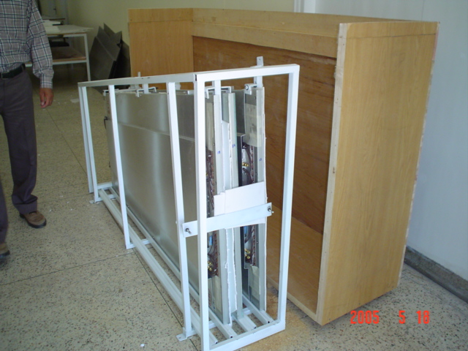

Figure 6: a) chambers in iron rack and wooden box which used for shipment.

These chambers received in the CERN, again tested in ISR test setup. Then RPCs transported to the Point5 where Compact Muon Solenoid (CMS) is assembled for installation.