Emails from P. Vitulo concerning Oil condensation on HPL surface.

Date: Thu, 30 Aug 2012 10:53:40 +0200

From: Vitulo Paolo <paolo.vitulo@unipv.it>

To: Ian Crotty <crotty@mail.cern.ch>

Subject: Fwd: Re: Skype conference on New HPL surfaces

Parts/Attachments:

1 OK ~545 lines Text (charset: windows-1252)

2 Shown ~474 lines Text (charset: windows-1252)

----------------------------------------

---------- Forwarded message ----------

From: Vitulo Paolo <paolo.vitulo@unipv.it>

Date: 2012/8/9

Subject: Re: Re: Skype conference on New HPL surfaces

To: kslee0421 <kslee0421@korea.ac.kr>

Cc: Salvatore Buontempo <Salvatore.Buontempo@cern.ch>, "paul0985@gmail.com"

<paul0985@gmail.com>, Giuseppe Iaselli <giuseppe.iaselli@ba.infn.it>,

Salvatore Buontempo [salvatore.buontempo@gmail.com](mailto:salvatore.buontempo@gmail.com)

Dear Kyongsei,

thanks for the detailed message. Here my comments and answers:

Mail Address:

Paolo Vitulo

Dipartimento di Fisica

via Bassi, 6

27100 PAVIAÂ Â  - IT -

As concernings your points:

1) I agree that sending an old HPL sample and a NEW one would semplify our

understandings.

However the sample and the pattern on it should be representative ofÂ  many

of them.

We all should be aware not to give a too stringent QA for the cleaning tool

for several reasons, among which

the fact that the pattern can be different from panel to panel since , as we

discussed , the quantity of the

spryed MEK could affect it etc. Beside this, and to be more precise, it is

CMS that has to do the QA, ie CMS should

provide a tool for a quantitative estimation of the pattern made by the

machine. Â

2) This is a very important step. We have to know what is affecting the

surface after acetone attack. And it is more important

because it seems a behaviour common to all kind of HPLs (old, new, Korean,

Italian).

3) I agree that the scratching of the surface helps the strength of the glue

attachment.

I'm not so sure this will help for the linseed oil. According to me you can

have drops formation also in presence of dust.

Some dust particles infact can form condensation nuclei and oil can condense

around them.Â

A test with a very clean and a very dirt glass could maybe give the answer.

About Minho's test I do not understand well: I see also a sample of

plexiglass ( for reference ? ). A part that, from the pictures, I see the

same behaviour of the linseed oil for all the samplesÂ  (plexiglass included)

that is formation ofÂ  (what I think is ) oil polimerization spots.Â  These

spots could be formed by dust particles in the air for exemple and could

invalidate the results.

In addition thisÂ  I propose another test:

1) assembling and oiling ofÂ  mini-gaps (10 cm x 10 cm):

a) one mini-gap assembled with one electrode ofÂ  OLD HPL and one of NEW HP

b) one mini-gap assembled with both electrodes ofÂ  OLD HPL

c) one mini-gap assembled with both electrodes ofÂ  NEW HPL

c) one mini-gap assembled with one electrode of NEW HPL and one of Korean

HPL

d) .....

e) ....

and so on with all the combinations....included the combination in which one

electrode is made of plexiglass.

Then the oiling procedure shoul follow as close as possible the procedure

used for the real gaps.

Here I have an important question: after the oil draining from a gap what do

you do ?Â  I mean you flow the gap with some gas or you leave the gap drying

in the air ?Â Â

After the oiling procedure and the oil drying my proposed test foreseen the

opening of all the mini-gaps for inspection.

Sorry for the length of this mail....

Best regards

Paolo

2012/8/9 kslee0421 <kslee0421@korea.ac.kr>

Dear Paulo,

Could let me know your addressÂ inÂ INFN toÂ send some sampleÂ by me ?

As disccussed in the skype meeting yesterday,Â

1. KODELÂ willÂ request to GT a specification of surface

treatmentÂ forÂ the next HPL.

SungÂ insisted yesterday, the surface treatment for the HPL

should be the

same as theÂ old HPL used for the previous Barrel and RE RPC

production.

So, I would like to sendÂ some old HPL samples to you.Â On the

old HPL sheets,

Â Â  the scratchÂ stripe patterns areÂ relatively much clearer than

the new HPL.

Â Â  Sending the old HPL samples to youÂ seems to be the best way.

2.Â Chemical analysis for the greasy thingÂ from the HPL

surfacesÂ when applied

Â Â  acetone acid. I have calledÂ NationalÂ Basic Scence Centers in

Korea today.

Â Â  One of them is inside Korea University. So far, the analysis

seems to be ver

Â Â  tough becauseÂ of the small amount. They saidÂ the amount of

sampleÂ should be

Â Â  at least 10 g.Â In National centerÂ in Pusan, there seem to be

some differentÂ test

Â Â  facilities. But still the small amount is the problem. But I

and Sung will keep

Â Â  searchingÂ the experts to figure it out for a while.

I d oil inside the

gaps might be related withÂ a fact that how well the linseed oil

can chemically

attachedÂ to the melamine surfaces. My conjecture is as the

follow:

Polishing the HPL surfaceÂ would beÂ needed not just toÂ enhance

the glue strength

of spacers to the HPL.Â After the HPL surfaces were treated by

the GTÂ cleaning tool, Â

microscopic scratches formed wouldÂ enhance the chamicalon't know you agree with me. But, the condensation of linseed

microscopic scratches formed wouldÂ enhance the chamical

attachment of linseed

oil to the HPL surfaces. Â Â Â Â Â Â

Minho, a KODEL engineer, has performed a series of tests of oil

Condensation

for oldÂ samples (with relatively clear scratched strips) and new

HPL samples

(one of the 40 sheets delivered in the last May, the strips are

not so clear).

He found from the test that the condensation of the linseed oil

mixtureÂ on the Â

polished side of old HPL is generally muchÂ less than the

unpolished sideÂ of the

old HPL or a polished side of new HPL. Please see the attached

figure.

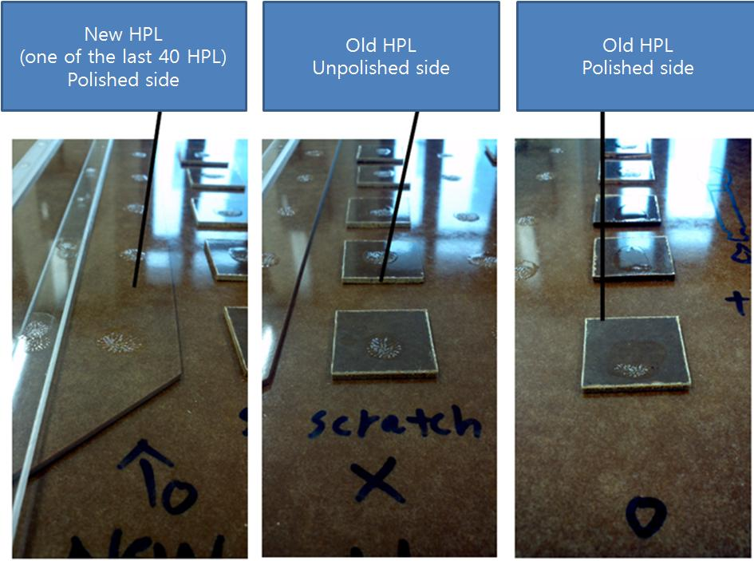

TheÂ same treatment of HPL surfaces as we did for the previous

Barrel and RE RPCs

seems to beÂ neccessory to avoid this oil condensation problem. Â

With Best Regards,

Kyongsei Â Â Â Â

Â

With Best Regards,

Kyongsei