ANNEX 1
Gap production specification document

- Introduction

A total of 660 Gas Volumes (GV) are needed for the RPC low η restoration. For continuity with the existing CMS forward RPC system, the production will occur at the KODEL laboratory (Korea University, Seoul) using the same technology as developed in past for the CMS production. The HPL panels needed for the gap assembly will be procured in Europe, cut to the proper size, surface cleaned and shipped to KODEL. Procurement of other basic components, as described in section 2, will be pursued directly by KODEL. In the following table 1 the list of gap typologies and associated dimensions is given.

Table 1: list of gap types and dimensions

Gap Name | Quantity | Dimension | Engineer drawing
 |  | ∆RxW x w[mm]
RE4/2 “bottom” | 110 | 1663x920x630 | Appendix 1a
RE4/2 “top wide” | 110 | 613x918x811 | Appendix 1a
RE4/2 “top narrow” | 110 | 1010x809x632 | Appendix 1a
RE4/3 “bottom” | 110 | 1930x1265x927 | Appendix 1b
RE4/3 “top wide” | 110 | 526x1262x1170 | Appendix 1b
RE4/3 “top narrow” | 110 | 1364x1169x930 | Appendix 1b

In appendix 1 of the present document engineering drawings for each gap type gives construction details for spacer positions and electrical and gas connections.

Quality assurance will be performed at the Korean site following the official technical spec document discussed in session 4 of this document. For each batch of gaps, a QA documentation will be provides before the shipment and discussed for approval. Only gap passing the selection criteria should be shipped at the chamber production sites. Final acceptance test will be executed in the chamber production sites by local manpower. Only accepted material will be accounted as part of the total 660 delivery.

2. Procurement and preparation of basic components

2.1 List of components
The following basic components should be procured under responsibility of KODEL
- Graphite paint
Model name: 3005B
Produced by: Hyesung Company, Korea
Drying time: 120 hour
Viscosity from manufacturer. K.Y Lee

- Insulating films
Material specification: Polyetilenterephatale
Model name: GHS-71B
Produced by: Sun Kyung Chemical (SKC), Korea
Thickness: 190 μm
Dielectric rigidity (@25 0C-50 Hz) 150 KV/mm (ASTM D149)
Dielectric constant (@25 0C-50 Hz) 3.3 (ASTM D150)
Volume resistivity (@25 0C-DC) 1018  (ASTM D257)
Surface resistivity (@25 0C-50 Hz) 1014  (ASTM D257)
Isolation class: B (DIN 57 530)
Melting temperature: 260 ⁰C K.Y.Lee to check
- Hot melt adhesive
Model name: EVA TANEL-100
Produced by: Koron Plastic INC, Korea
Working temperature: 170-180 ⁰C

- Spacer edge frame and coins
Material name: Polycarbonate
Base material produced by SKC, Korea
Production method: Injection molding
Thickness: 2.000+/-0.015 mm

- Gas inlet/outlet
Material name: Polycarbonate
Base material produced by SKC, Korea
Production method: Injection molding
Outer diameter of gas pipes: 4.3 mm
Inner diameter of gas pipes: 3.0 mm
Thickness of parts maintaining gap thickness: 2.000+/-0.020 mm

- Epoxy adhesive
Name: Scotch Weld DP 460
Produced by: 3M, USA
Work life (@ 23 0C): 60-90 min
Min. polymerization time (@ 23 0C):4-6 hours
Max shear stress with polycarbonate: 2.8-3.4 Mpa (after 24 hours)
10% (after 5 hours)
25% (after 6 hours)
90% (after 7 hours)

- Linseed Oil
Model name: Galloil Olio Cotto
Produced by: SprintChimica, Torino, Italy

- Insulating blocks for high voltage
Base material: polycarbonate
Dimension: 20x30 x5 (thickness) mm³
Manufactured by a CNC machine
Adhesive required to attach the block: EVA TANEL-100

- HV cable
Model name: LL33906 22AWG
Produced by: LG Cable and system, Korea
Maximum HV allowed: 20 kV
Maximum temperature allowed: 105 ºC
Radius: 3.0 mm
Type: double insulated with a 2.0-mm polyamide core

2.2 Component certification and preparation
- Graphite paint
For each batch of graphite paint purchased from Hyesung company, sample surface electrodes are manufactured by a silkscreen method to confirm that surface resistivity comply with specifications. An array of fifty 10-cm wide and 10-cm long sample surface electrodes made of copper tape on few full size HPL sheets is prepared as shown in Fig. 1. The regions between adjacent electrodes are properly insulated by using thin polystyrene tape. A graphite layer is coated on the electrodes surface by silkscreen procedure identical to the one employed for the regular production. The surface resistivity value should be within the range 80 kΩ/□ < σ < 200 kΩ/□. A careful mapping of the distribution over the entire surface ( also the edges) should be ensured;

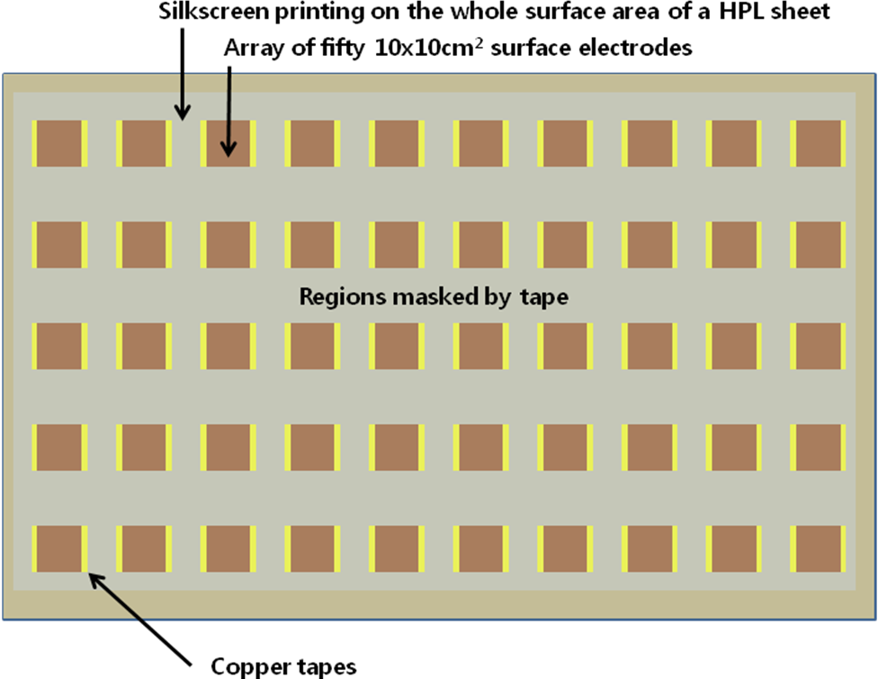
Figure 1
- Insulating films
PET film is used for a proper insulation of the graphite. The thickness of the purchased product is carefully checked and the surface quality (scratches) is visually inspected by eyes;

- Hot melt adhesive
The viscosity of the hot-melt adhesive is preliminarily checked by about 10 cycles operation on dummy HPL sheets. The temperature of the hot melt adhesive yielding an optimal condition for extrusion, which critically depends on room temperature, ranges from 170 to 180 ºC;

- Spacer edge frame and coins
The thicknesses of spacer edge frames and coins are measured and checked by a micrometer;

- Gas inlet/outlet profile
Inlet of gas pipes are carefully checked to ensure gas-flow impedance. The gas pipes and the corner gap-supporting blocks are visually inspected by eyes. The thickness of the parts maintaining gap thickness is checked;

- Epoxy adhesive
For the gap production, the maximum usable time to use epoxy after the purchase is three months. Only 50-cc capacity packaging in the 3M dispenser are accepted;

- Linseed Oil
The viscosity of the Heptane & Linseed oil mixture is verified using the Cup (Ford, Zahn etc) technique. In addition the polymerization is verified by pouring a sample of the mixture down a sloping HPL sample and allowing the drying for XX hrs. The resultant film is then exposed to chloroform liquid to verify the polymerization;

- Insulating blocks for high voltage
Visual inspection is required to check mechanical defects;

- HV cable
Visual inspection is required to check mechanical defects.

3. Production procedure

3.1 Preparation of electrodes
The HPL electrodes are coated with graphite paint by a silkscreen method. The width of graphite-free area along the periphery of the HPL sheet should be 22 mm. 120 hours are then required for a complete drying of the coating. The final values of the surface resistivity of the graphite layers after the proper polymerization should range between 80 and 200kΩ/□. The surface resistivity of each HPL plate is measured at two middle positions and at four corner positions. The mean values of the surface resistivity are recorded in the quality-control data sheet.
Each graphite-coated HPL sheet is isolated by a 190 μm PET film glued with EVA type hot-melt adhesive. The hot-melt adhesive is heated above the melting point (170 ~ 180 ºC), and then pumped from a tank to an extrusion head which is also kept at constant and well controlled temperature. The thickness of the hot-melt layer should not exceed 100 μm. A barcode label shall be put on the PET film near to the edge but away from the foreseen electrical and gas connections.

3.2 Gas volume assembly
Two electrodes, prepared as described in previous step, are glued together using polycarbonate spacer and edge frames to form a gas volume (GV). An epoxy adhesive is used. Information about pattern of the spacers, edge frame and gas inlet/outlet components are available in Annex 1.
At each step, the following operation are performed in parallel for all spacers: 1) deposition of drops of adhesive, 2) deposition of spacers, 3) deposition of a second drops of adhesive on top of the deposed spacers. The edge frame is glued with the same procedure. A thin bead of glue is applied all along the edge. The frame segments are put in position, one in each side of the plate, and a second string of glue is put on top of the frame. The second panel is then overlapped to the first one. During the curing time the gas volume is kept under a constant pressure distributed uniformly along the entire surface with + 40 hPa at a constant temperature of 20ºC for 24 hours.
Before the gluing a careful examination of HPL surface should be performed to select only appropriate panels. Degreasing procedure using isopropylic alcohol and lint free cleaning paper, should be applied, if needed. The gluing must take place at room temperature with relative humidity below the 50%. Excessive level of humidity could end up in poor glue curing.

The two components of the adhesive are mixed together only inside the dispensers, i.e. very short time before the application. Relevant parameters for this step are: 1) glue workable time after components are mixing should not exceed 60 min; 2) typical time between components mixing and pressure application should less than 20 min.
Every new batch of glue and HPL a spacer is glued on a small test plate and cured during the 8 hours under standard conditions. After that time, the spacer is gradually stressed for 10 min under controlled conditions up the breaking point. The test is successful if the breaking occurs with a normal stressing force of over 8 Kg. In case of failure action should be taken. Final sealing of the GV is done filling with hot-melt glue the 3-mm section that remain around the edges of the frame. The excess of melt is cut out after it has cooled down to room temperature.

3.3 Gas Volume varnishing
A batch of 20 GV, sandwich between two rigid panels, is placed in vertical position with the long side inclined at about 5.7º with respect the horizontal plane. The gas inlets are connected with plastic flexible pipes to a steel cylinder containing which can be moved along the vertical direction. Varnish composition should be linseed oil/heptane (40/60). The surface of the liquid inside the cylinder lies initially below the lower GV inlets. The cylinder is then lifted at constant speed so the varnish level visible through the transparent pipes. The varnish circuit is sealed and, during the filling, the pressure inside the GV is kept negative with respect to the atmosphere to compensate the varnish static pressure. The cylinder is subsequently lowered at very low speed up to the complete emptying of the gas volume. Depletion rate in this phase should be 3 cm/min. At the end, the GV are connected to airflow (~25 volume/hour, T_{air} = 30ºC) for 96 hours up to complete polymerization of the varnish.
Every 5 varnishing cycle, a single GV is open and inspected to ensure the quality of the procedure. GV internal surface should be checked for complete polymerization of the oil coating, for absence of anomalous oil drops around the spacer and for other imperfections. Moreover the thickness of the oil coating should be evaluated not to be more then 30 +/- 10 μm. In case one of the above mentioned criteria is not met, action should be taken. At the end of this step one barcode label specifying the GV ID should be placed near to the edge of each gap but away from foreseen electrical and gas connections.

4. Quality assurance
The data of the QA test results for each individual gas gap should be properly recorded in a dedicated data file in a format attached in the end of the document and be stored together with the excel data files provided by the gap manufacturer.

4.1 “Gas leakage” test
The gas tightness is controlled by measuring the stability of an applied overpressure of 20 mb during a time of 600 seconds, done after the spacer test so allowing thermal equilibrium to be established, using a pressure sensor (Sensor Technics CTE7000) 0-40 mbar and a 20 bit ADC Picolog recorder. According to the gap type, the maximum pressure drop as reported in table 2 will be allowed. GV showing larger pressure drop will be rejected.

Table 2: Maximum pressure drop

Gap Type | RE4/3 “top narrow” | RE4/3 “top wide” | RE4/3 “bottom” | RE4/2 “top narrow” | RE4/2 “top wide” | RE4/2 “bottom”
Maximum pressure drop | 0.15 mbar | 0.2mbar | 0.3 mbar | 0.15 | 0.2 | 0.3

An additional measurement of the leak rate has to be carried out at 3 mbar, to be used as a reference value for the final commissioning phase at P5. This test is meant only for recording the leak value at these conditions, similar to what the gaps will have in CMS detector.

4.2 “Spacer strength” test
The GV are subjected to an overpressure of 20 mbar to check the spacers tightness. A mask made of 0.2-mm thick PET film, where the shape of the spacers and the positions are properly drawn, is positioned on the gap. A 20 hPa pressure is applied to the gap. Each spacer is pressed and the variation of the pressure is reordered. The gas gap is qualified when no spacer causes a shift larger than 1 mbar. All the data will be recorder following the DB specs as defined by CMS.

4.3 Electrical tests
All the GV passing the previous test will then be eligible to be connected to the HV power supply for further certification. To this aim two additional steps are needed:
- the full perimeter of the GV should be protected against electrical leakage using proper HV insulating tape;
- HV connections should be performed (using proper cable) on the small copper pads inserted below the insulating PET film. The soldering should be protected using hot melt and insulating HV tape.

The electrical cables should be diameter 3 mm, color red, 20 KV cable for the High Voltage and 0.5 mm² conductor cross section, color black, 800 V cable for the ground. Both cables will have a length of 1.5m. A Jupiter connection should be connected using heat shrink (diameter of 10 mm) and a copper braid acting as a shield.

A gas mixture 95% C₂H₂F₄ + 5% i-C₄H₁₀ will be used. The gap should be fluxed to allow at least 10 volume change before any voltage is applied. All the HV values should be normalized at 1010 hPa and 20ºC. If P is the actual pressure and P₀ ₌ 1010 hPa, T is the actual temperature and T₀ = 293 °k, the correct HV_{applied} to be applied to the gas gaps can be obtained the following equation:

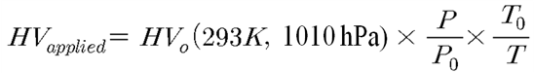
HV_{applied} should be properly calculated and adjusted time by time according to the actual values of P and T before the test.
The following test will be performed:
- “Dark current” test (I)
The current I at different HV₀ should be measured and plotted (HV₀ = 0.1, 1.0, 2.0, 3.0, 4.0, 5.0, 6.0, 7.0, 7.5, 8.0, 8.5, 9.0, 9.1, 9.2, 9.3, 9.4, 9.5, 9.6, 9.7, 9.8, 9.9, 10.0, 10.1 KV, 23 points in total).
Each voltage step shall be applied for duration of 30 minutes before the measurement of the current. Pressure, T and Humidity have to be monitored. If the current at HV₀ = 10 kV is higher than I_{max} the GV is rejected. According to the GV type the I_{max} values as given in table 3 will be applied.

Table 3: Maximum value of the current I at HV₀ = 10 kV
Gap Type | RE4/3 “top narrow” | RE4/3 “top wide” | RE4/3 “bottom” | RE4/2 “top narrow” | RE4/2 “top wide” | RE4/2 “bottom”
I_{max} (μA) | 2 | 3.5 | 5 | 2 | 2 | 3.5

- “Dark current” test (II)
Leave the GV under HV₀ = 10 kV for a period of 168 hours with a gas flow of 5 l/hour. Pressure and temperature should be monitored to correct for variation. The gap will be rejected if at the end of this period any of the following events was registered:
- I_{10 kV} > I_{max} ( as reported in table 3);
- current increase higher than 50%;
- an OVC or a trip occurred.

- “Dark current” test (III)
The current I at the following HV₀ values (HV₀ =1.0, 2.0, 3.0, 4.0, 4.5, 5.0, 5.5, 6.0, 6.5, 7.0 kV, 10 points in total) is measured and plotted. Each step has 5 minutes duration. The slop should be computed and recorded. All the gaps giving I_{6 KV} > 1.5 μA will be rejected.

All the results should be recorded in the database according to the specifications.

5. Storage
The builder needs to have an efficient system for storage and tracking of the raw materials and the finished parts, in order to avoid damage and contamination of the surface in the parts and mixed-up in the raw materials. It is important to avoid that the HPL plates and GV are subject to a bending moment due to the gravity, this occurs maintaining the structures horizontally. Not vertical position must be avoided at any time or fully supported because can procure a permanent deformation on the HPL plate and GV. Storage should be such that the gaps will never be stressed in bending. Humidity and Temperature of the storage area should be recorded and kept between 18 and 25 degrees Celsius with a relative Humidity between 35% and 50 % .

6. Final control and shipment
Transportation boxes will be provided by the supplier according to technical specs defined by CMS RPC. HPL will be shipped on similar boxes that can be used as reference. A final visual inspection of the gaps before their packaging should be done to spot:
- Broken gas pipes for gas inlets and outlets
- Damages on edges and gas corner pieces
- Damages on cable connections
- Damages on HV protection blocks (acrylic blocks)
- Uniformity of graphite layers both HV and GND
- Uniformity of EVA coating for PET insulation films

Supplier will be fully responsible for transport of the GV to CMS RPC assembly sites (India, Belgium and CERN). Quality control data for each shipment batch will be provided to CMS in official RPC Database, before the real shipping. This step will allow for a remote pre-acceptance from CMS RPC team.

7. Acceptance
In the three reception sites (India, Belgium and CERN) the final acceptance tests will be performed by repeating the quality assurance tests as described in present document. Only GV fulfilling all the requested quality assurance values will be accepted.
In case of rejection, the quality assurance measurement results will be shared with the supplier and final decision will be taken by the CMS RPC collaboration.

8. Schedule
The start of the production will be defined by the first delivery of the HPL sheets. The total HPL material will be delivered in not more than 6 deliveries, within 6 months from the first one. KODEL will deliver 660 certified and accepted gaps within a maximum delay of twelve months. The gap will be shipped in different batches to the 3 assembly sites (India, CERN, Belgium) according their needs.

Appendix 1a: Gap dimension and engineering details for RE4/2

Appendix 1b: Gap dimensions and engineering details for RE4/3

