Cleaning of HPL sample from Korea, 16 Feb 2012.

Cleaned x2 Acetone

& x1 IPA

Cleaned IPA

Original

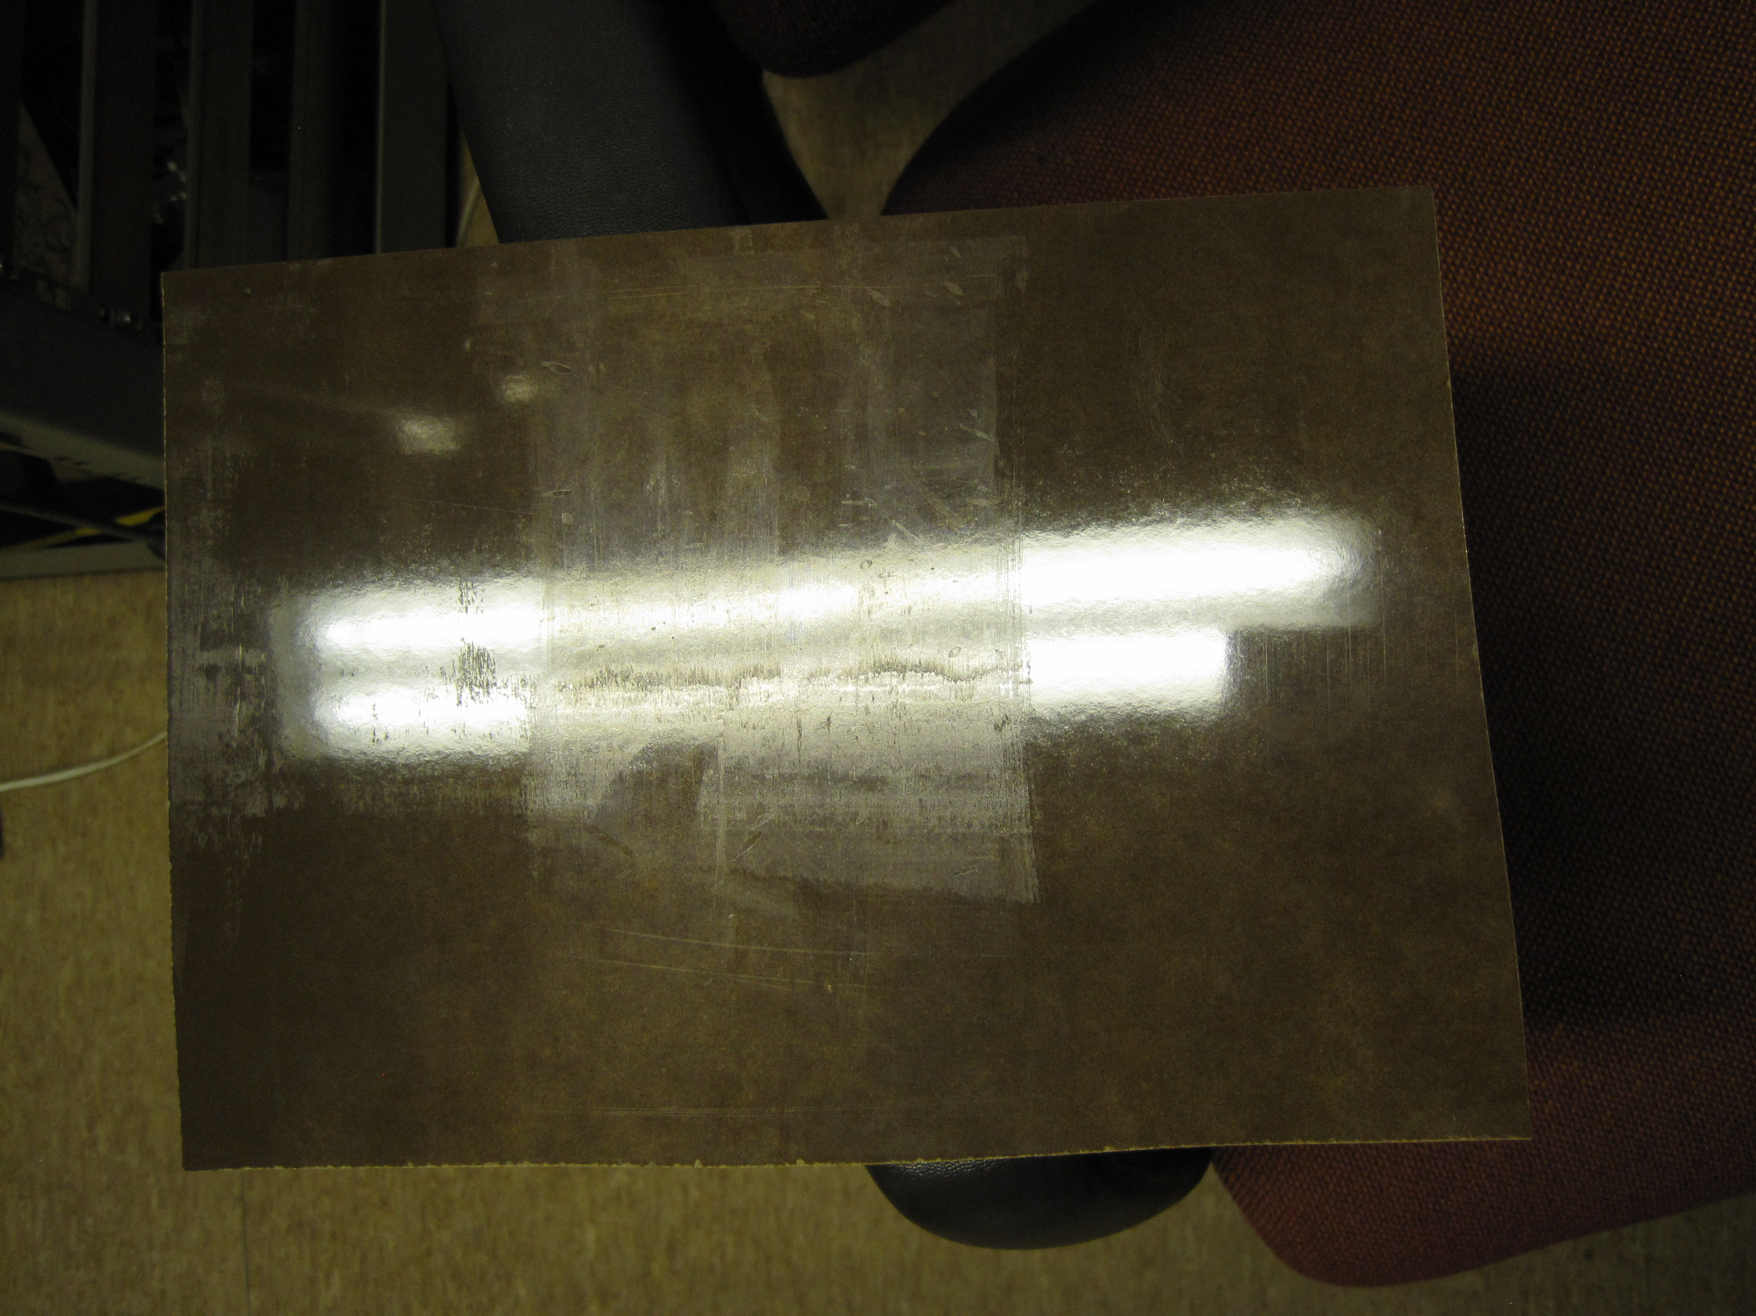

Ian Crotty 17 Feb 2012