# CMS RPC Upscope Bakelite Specification

CERN, April 2011

1. **Basic material**

High Pressure Laminate using Phenol impregnated kraft paper as the bulk and Melamine resin impregnated ‘decorative’ papers on the outer surfaces.

1. **Pieces**

Starting with 660 sheets of HPL we request to produce 1980 cut pieces with size, shape and precision as described in point #4 below. In addition from each sheet a ”sample” 300 x 300mm will be cut to be kept in Pavia to track changes in resistivity over the following years.

1. **Volume (Electrical) Resistivity**
   * + The volume resistivity must be between 1- 6 x1010 [Ω.cm] @ 20°C.
     + StDev.ρ/Av.ρ ≤ 0.5
2. **Size, shape and cut precision**

Starting from HPL sheets of 3.2 x 1.6 m with thickness 2 mm +/- 0.1 mm we ask to cut half of them according to pattern W29 and half according to pattern W30, as described in the attached drawings with tolerance +0, -0.5 mm.

1. **Quality Controls & Resistivity measurement database**

First QC level. In HPL sheet production site, for each sheet 8 resistivity measurements will be performed and recorded in a resistivity database delivered at the end of each production batch. Three measurements will be done along the 3.2m sides at 20 cm distance from edge and at positions 80cm, 160 cm and 240 cm form a corner. One measurement will be done at the center of each 1.6m side at 20 cm from the edge. Only panels respecting the resistivity specs in point n.3 here above in all 8 measurements will be shipped to Pavia University site for second QC step.

Second QC level. Second resistivity qualification measurement will be done on the 9 point measurement jig in Pavia University laboratory. Only panels respecting the resistivity specs in point n.3 here above in all 9 measurements will be shipped to Cutting facility site for the cutting procedure. Rejected panels will be collected in a separate batch and shipped back to the supplier.

Third QC level. The third and final level of measurement will be made in Pavia University laboratory within 3 months with respect to the initial delivery to Pavia, using a 30x30cm2 sample kept aside from the panel after the cutting procedure. This latter stage defines the panels that will be charged to the client (final acceptance test for resistivity value and stability in time).

1. **QC Sheet thickness**

Each HPL sheet will be checked to comply with thickness specs described in point n.4 here above and recorded in HPL sheet database.

1. **QC Surface finish**

The surface of the HPL sheet must be ‘brilliant’ ( as described by the manufactures use of the polished stainless steel “pressing plates” termed “lucido”) without blemishes and deformations. The surface roughness is in the Ra = 0.1μm range. We expect a sampling measurement rate of 2% on the overall production (1 measurement on 1 panel from each batch of 50 panels) and recorded in HPL sheet data base.

1. **Gluing polycarbonate**

The HPL sheet must be compatible with gluing of polycarbonate components on its surface.

1. **Linseed oil treatment**

The HPL sheet must be compatible with the uniform wetting of the full surface of the sheet with diluted linseed oil

1. **Graphite treatment**

The HPL sheet must be compatible with uniform deposit of graphite on its surface.

1. **Storage and Transport**

All the transports of HPL sheets will be ensured by supplier.

Uncut panels:

The HPL sheet shall be stored on reinforced palettes under cover of rain and direct sunlight. The palettes will have neither additional load placed on top nor be placed on other palettes of smaller dimensions causing the client’s HPL sheet to bend. The HPL sheet will remain flat at all times. For any reason for delay in shipping the client has the right to reject deformed sheets.

Cut panels:

The examples of packing boxes for cut panels already built (in Italy) and used are to be continued throughout the production run (see attached drawing in annex …). Cut HPL sheets must packed in the following way:

1. HPL sheets should be packed vertically in the boxes interleaved with kraft paper sheets,
2. HPL batch should be covered internally with plastic sheets,
3. two bags of silica gel should inserted in the box to secure the proper relative humidity during box transportation.

1. **Label and traceability**

Each HPL sheet is supposed to arrive to Pavia University laboratory with one unique label, clearly indicating the batch, slot position and production date. After second resistivity QC level, Pavia University lab will provide 4 identical labels per sheet, positioned on it to secure the correct labeling of each piece after the cutting procedure. They will be used to identify the cut sheets in the resistivity measurement data base.

1. **Acceptance procedure**

There will be a first technical validation of the HPL cut sheets in the cutting site, done by the client. Only validated sheets will be shipped to final General Tecnica firm site in Colli (Frosinone, Italy).

Final acceptance test consists of two actions:

1. Cut HPL sheets delivered in General Tecnica site will be inspected and validated by the client at arrival.
2. Stability after 3 months of each panel in term of resistivity measurement on the sample (30x30 cm) cut from original panel and stored in Pavia University laboratory. All measurements done within 3 months should comply with technical specs in point n.3 here above.

The rejects from each QC and acceptance steps are taken back by the supplier.

**Cutting Patterns W29 and W30**

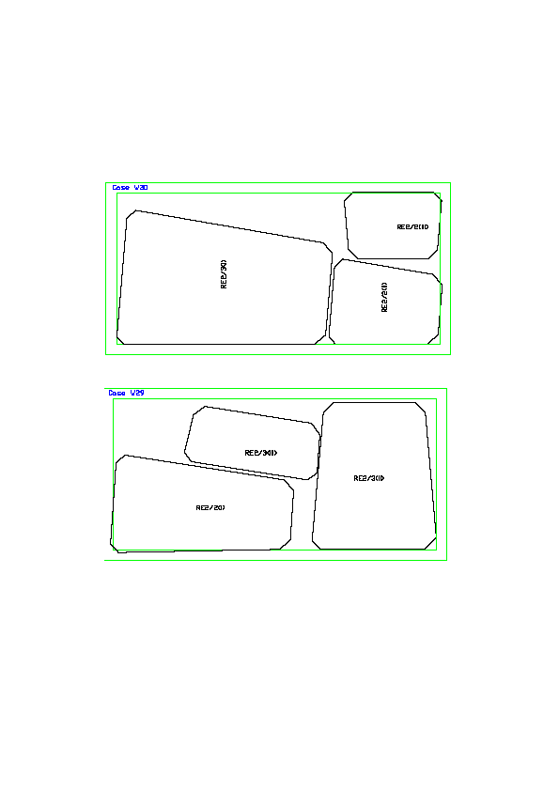

**Dimensions of bakelite pieces (not gap) for RE*2 and RE*3 chambers (as verified by Luc and Ian in the ISR 16 March 2010).**

**Dimensions of HPL (not gap) for RE*/2 and RE*/3 type chambers. These are dimensions as verified by Luc and Ian in the ISR 16 March 2010.**

<http://project-cms-rpc-endcap.web.cern.ch/project-cms-rpc-endcap/rpc/Production/Oil%20&%20Bakelite/Cutting/20210203/RPChpl030920REtype2.pdf>

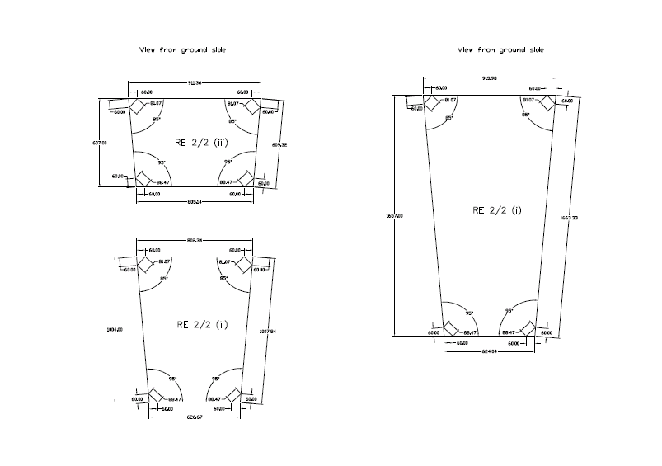

http://project-cms-rpc-endcap.web.cern.ch/project-cms-rpc-endcap/rpc/Production/Oil%20&%20Bakelite/Cutting/20210203/RPChpl030920REtype3.pdf

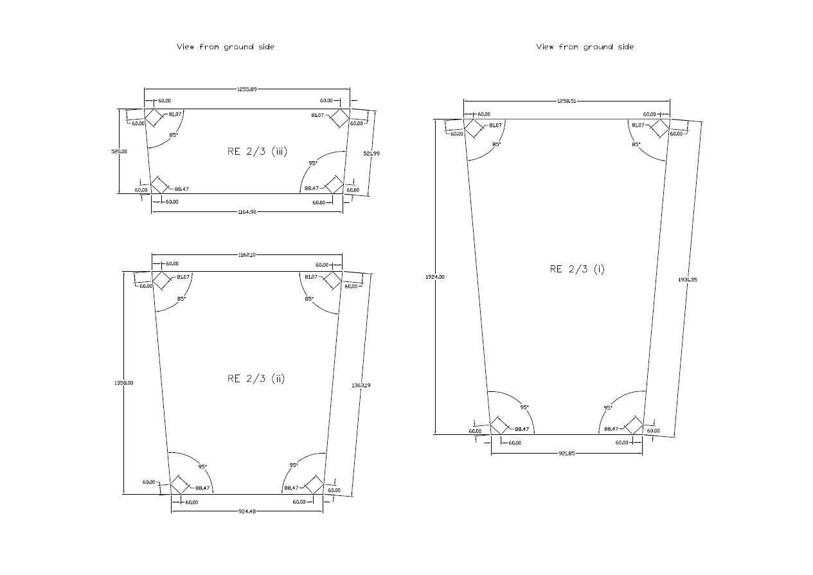

**Transport box internal details**

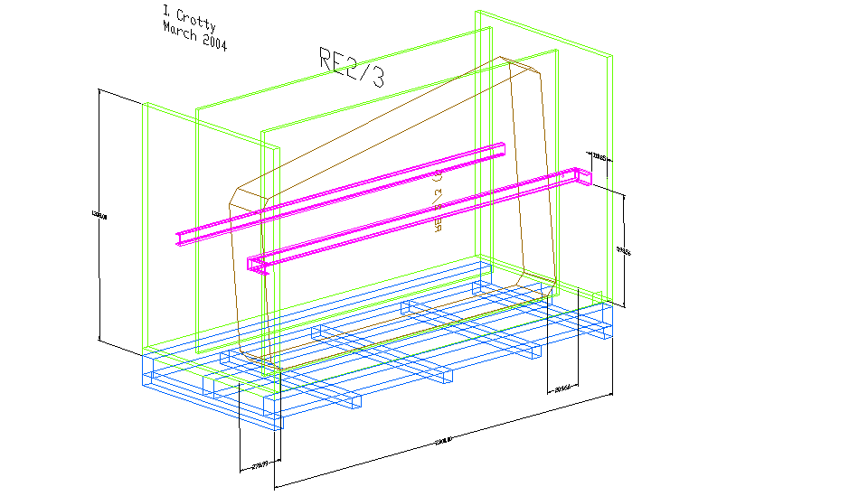

With additional two levels of compression bars which are pre-stressed as shown below. There will be only one size of box to give added flexibilityas the boxes move between the different institutes.

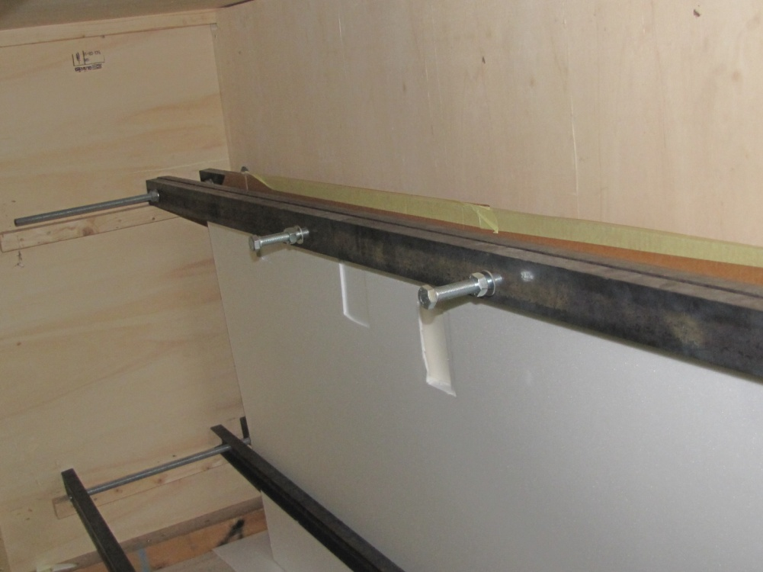

S. Buontempo and I. Crotty 13 April 2011