CMS RPC Upscope Bakelite Specification

CERN, 19 April 2011
- Basic material
High Pressure Laminate using Phenol impregnated kraft paper as the bulk and Melamine resin impregnated ‘overlay’ papers on the outer surfaces.

- Pieces
Starting with 660 sheets of HPL we request to produce 1980 cut pieces with size, shape and precision as described in point #4 below. In addition from each sheet a ”sample” 300 x 300mm will be cut to be kept in Pavia to track changes.

- Volume (Electrical) Resistivity
    - The volume resistivity must be between 1- 6 x10¹⁰ [Ω.cm] @ 20°C.
    - StDev.ρ/Av.ρ ≤ 0.5
    - A log of the Temperature & Humidity before, during and after each measurement should be kept and put into the data base.
- Size, shape and cut precision
Starting from HPL sheets of 3.2 x 1.6 m with thickness 2 mm +/- 0.1 mm we ask to cut half of them according to pattern W29 and half according to pattern W30, as described in the attached drawings with tolerance +0, -0.5 mm. Annex 1, 2 & 3.

- Quality Controls & Resistivity measurement database
First QC level. In HPL production site, for each sheet, 8 resistivity measurements will be performed and recorded in a resistivity database delivered at the end of each production batch. Three measurements will be done along the 3.2m sides at 20 cm distance from edge and at positions 80cm, 160 cm and 240 cm form a corner. One measurement will be done at the center of each 1.6m side at 20 cm from the edge. Only panels respecting the resistivity specs in point n.3 here above in all 8 measurements will be shipped to Pavia University site for second QC step.

Second QC level. After 3 weeks the second resistivity measurement will be done on the 9 point measurement jig in Pavia University laboratory. Only panels respecting the resistivity specs in point n.3 here above in all 9 measurements will be shipped to cutting facility site for the cutting procedure. Rejected panels will be collected in a separate batch and shipped back to the supplier. This stage defines the panels that will be charged to the client (final acceptance test for resistivity value and stability in time).

- QC Sheet thickness
Each HPL sheet will be checked to comply with thickness specs described in point n.4 here above and recorded in HPL sheet database.

- QC Surface finish
The surface of the HPL sheet must be ‘brilliant’ ( as described by the manufactures use of the polished stainless steel “pressing plates” termed “lucido”) without blemishes and deformations. The surface roughness should be in the R_{a} = 0.1μm range. We expect a sampling measurement rate of 2% on the overall production (1 measurement on 1 panel from each batch of 50 panels) and recorded in HPL sheet data base.
- Storage and Transport
All the transports of HPL sheets will be ensured by supplier.
Uncut panels: The HPL sheet shall be stored on reinforced palettes under cover of rain and direct sunlight. The palettes will have neither additional load placed on top nor be placed on other palettes of smaller dimensions causing the client’s HPL sheet to bend. The HPL sheet will remain flat at all times. For any reason for delay in shipping the client has the right to reject deformed sheets.
Cut panels: the examples of packing boxes for cut panels already built (in Italy) and used are to be continued throughout the production run (see annex 4). Cut HPL sheets must be packed in the following way:
- HPL sheets should be packed vertically in the boxes interleaved with kraft paper sheets,
- Each HPL pack should be covered within the box with plastic sheets,
- Two bags of silica gel shall be inserted in the box to secure the proper relative humidity during box transportation.

- Label and traceability
Each HPL sheet is supposed to arrive to Pavia University laboratory with one unique label, clearly indicating the batch, slot position and production date. After second resistivity QC level, Pavia University lab will provide 5 identical barcode labels per sheet, one of which is attached in Pavia. The remaining will be positioned on the sheet to secure the correct labeling of each piece after the cutting procedure. They will be used to identify the cut sheets in the resistivity measurement data base. The Barcode labels will be placed at the Riva facility. They will be put on the edge of the cut sheet outside the graphite area
- Cleaning procedure in GT
The cleaning should be done in GT. Each sheet will be inspected on both faces and if the top face without the barcode label is damaged then the sheet will be inverted and the bar code repositioned.
On the least good face. The MEK will be inspected and changed at regular intervals to ensure optimum performance. The condition of the rotary brush will be verified to ensure that sufficient pressure is applied to the HPL. The cleaned panels will be packed into the packing boxes taking care to ensure they are vertical and clamped ensuring that they remain flat at all times. After the cleaning procedure the HPL sheets must be compatible with gluing of polycarbonate components on its surface, with the uniform wetting of diluted linseed oil and with uniform deposit of graphite on its surface.
- Acceptance procedure

There will be a first technical validation of the HPL cut sheets in the cutting site, done by the client. Only validated sheets will be shipped to the General Tecnica site in Colli (Frosinone, Italy). Final acceptance test consists of an inspected and validated by the client after the cleaning , with MEK, in the General Tecnica site. The rejects from each QC and acceptance steps are taken back by the supplier.

ANNEX 1
Cutting Patterns W29 and W30

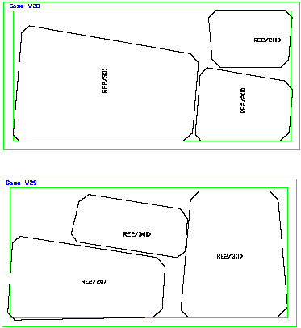

ANNEX2

Dimensions of HPL (not gap) for RE*/2 .

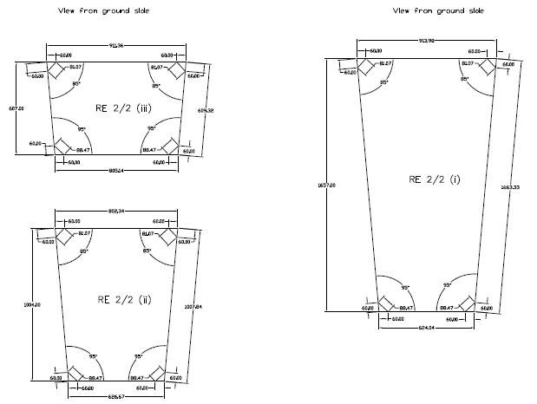

ANNEX3
Dimensions of HPL (not gap) for RE*/3 type chambers.

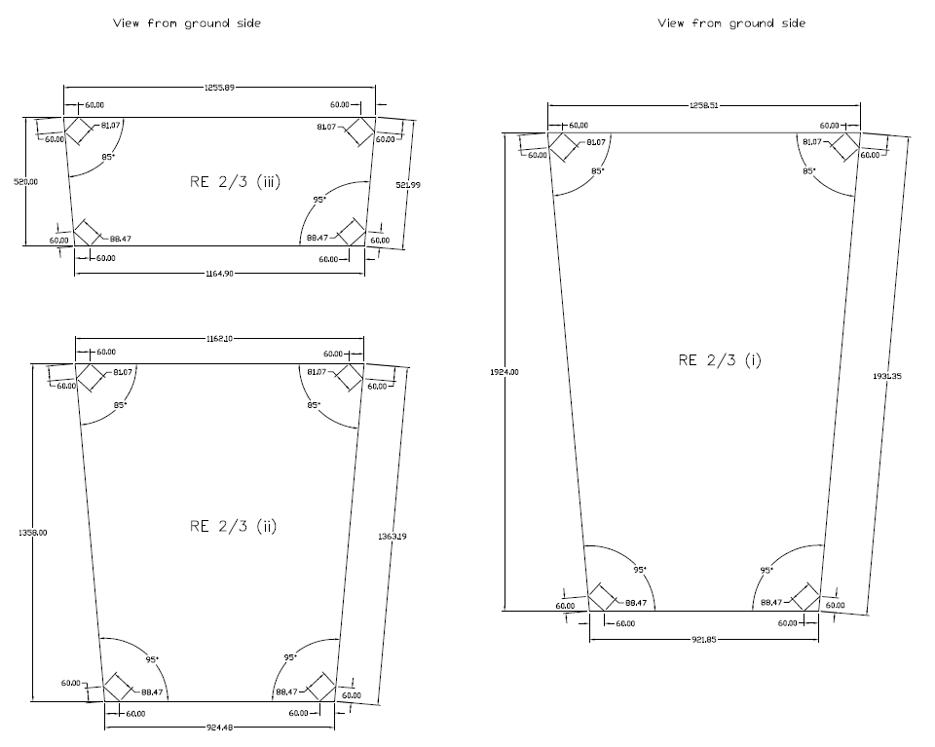

ANNEX 4
Transport box internal details

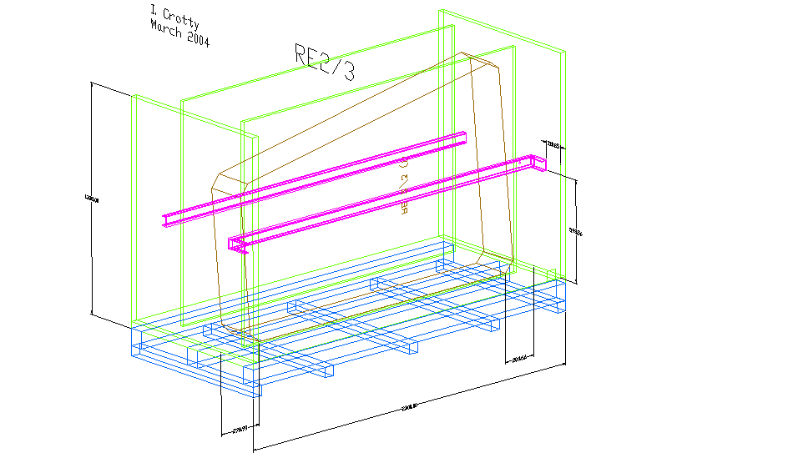

With additional two levels of compression bars which are pre-stressed as shown below. There will be only one size of box to give added flexibility as the boxes move between the different institutes.
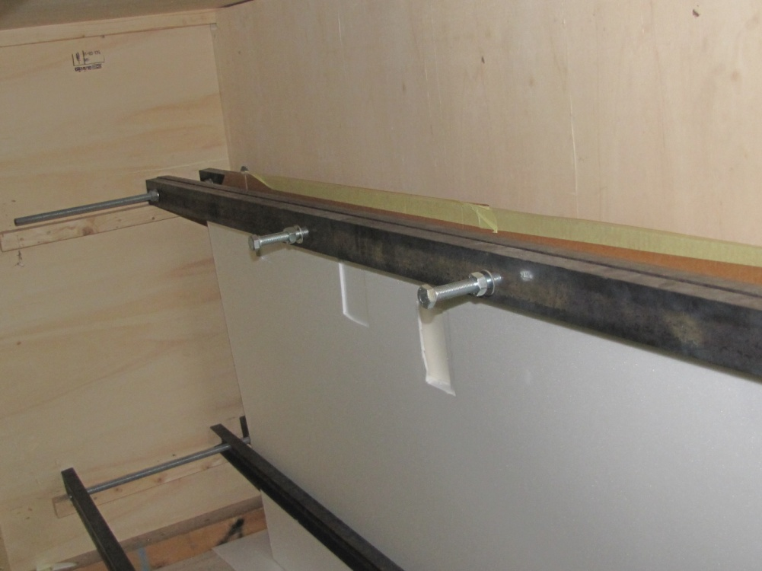
S. Buontempo and I. Crotty 13 April 2011

