# CMS RPC Upscope Bakelite Specification

CERN, May 2nd 2011 (revised CERN, may 2nd 2011)

1. **Basic material**

High Pressure Laminate using Phenol impregnated *kraft* paper as the bulk and Melamine resin impregnated ‘overlay’ papers on the outer surfaces.

1. **Pieces**

Starting with 660 sheets of HPL we request to produce 1980 cut pieces with size, shape and precision as described in point #3 below. In addition from each sheet a ”sample” 300 x 300mm will be cut to be kept to track changes.

1. **Technical Specs**

3.1. Volume (Electrical) Resistivity:

3.1.1. The average volume resistivity must be between 1- 6 x1010 [Ω.cm] @ 20°C;

3.1.2. StDev.ρ/Average.ρ ≤ 0.5

3.1.3 All measurements have to be in the above range

3.2. Size shape and cut precision:

3.2.1. Sheet Dimension: 3200 x 1600 mm;

3.2.2. Sheet Thickness: 2 mm +/- 0.1 mm;

3.2.3. Shape (ANNEX 1): production must be cut half according to pattern W29 and half according to pattern W30;

3.2.4. Cutting precision: tolerance between patterns W29, W30 (ANNEX 2, 3) and cut sheet must be within +0, -0.5 mm..

1. **Quality Controls & Resistivity measurement database**

4.1. HPL Production Phase - the Supplier will measure and record into the CMS data base:

* + 1. in the day of the production the volatile percentage of the different impregnated papers used;
    2. in the day of the production the working environment temperature and humidity;
    3. during the heating phase the press thermal cycle.

4.2. First Quality Control Phase – HPL production site. the Supplier will measure and record into the CMS data base:

* + 1. environment Temperature and relative Humidity;
    2. Temperature of the HPL surface measured in the pile middle position of each batch;
    3. For each sheet, 8 resistivity measurements: 3 measurements (for two sides) will be done along the 3200 mm sides at 200 mm distance from edge and at positions 800 mm, 1600 mm and 2400 mm form a corner.; 1 measurement (for two sides) will be done at the center of 1600 mm side at 200 mm from the edge;
    4. For each sample of HPL sheets, thickness will be checked to comply with thickness specs described in point n.3 here above;
    5. Only panels respecting the specs in point n.3 here above will be shipped to Pavia INFN & University site for second QC step.
  1. Second Quality Control Phase – Pavia INFN & University laboratory
     1. After 3 weeks a second resistivity measurement will be done on the 9 points measurement jig;
     2. Only panels respecting the resistivity specs in point n.3 here above will be shipped to the cutting facility site for the cutting procedure;
     3. Rejected panels will be collected in a separate batch and shipped back to the supplier. This stage defines the panels that will be charged to the client (final acceptance test for resistivity value and stability in time).

1. **QC Surface finish: HPL production site**

The surface of the HPL sheet must be ‘brilliant’ (as described by the manufactures use of the polished stainless steel “pressing plates” termed “lucido”) without blemishes and deformations. The surface roughness should be in the Ra = 0.1μm range. We expect a sampling measurement rate of 2% on the overall production (1 measurement on 1 panel from each batch of 50 panels) and recorded in HPL sheet data base. This task will be accomplished by the Supplier.

1. **Storage and Transport**

All the transports of HPL sheets will be ensured by supplier.

Uncut panels: the HPL sheet shall be stored in all the sites on reinforced palettes under cover of rain and direct sunlight. The palettes will have neither additional load placed on neither top nor be placed on other palettes of smaller dimensions causing the client’s HPL sheet to bend. The HPL sheet will remain flat at all times. For any reason for delay in shipping the client has the right to reject deformed sheets.

Cut panels: the examples of packing boxes for cut panels already built (in Italy) and used are to be continued throughout the production run (see attached drawing in ANNEX 4). Cut HPL sheets must packed in the following way:

6.1. HPL sheets should be packed vertically in the boxes interleaved with *kraft* paper sheets,

* 1. HPL batch should be covered internally with plastic sheets,
  2. two bags of silica gel should inserted in the box to secure the proper relative humidity during box transportation.

1. **Label and traceability**

Each HPL sheet is supposed to arrive to Pavia INFN & University laboratory with one unique label, clearly indicating the batch, slot position and production date. After second resistivity QC level, Pavia INFN & University lab will provide 5 identical barcode labels per sheet (in the actual format and dimension to be overposed on a low adhesive paper strip) one of which is attached in Pavia. The remaining will be positioned on the sheet to secure the correct labeling of each piece after the cutting procedure. They will be used to identify the cut sheets in the resistivity measurement data base. The Barcode labels will be placed at the cutting facility. They will be put on HPL sheet in a specific location indicated by the client.

1. **Cleaning procedure in GT**

Surface treatment should be applied to each panel on the side where the spacers will be glued, according to the technical specification in the following;

* Rotating brush with speed of 1000rpm
* Panel speed 2.4m/min
* Solvent Methyl Ethyl Ketone (MEK)

Each sheet will be inspected on both faces and if the top face without the barcode label is damaged then the sheet will be inverted and the bar code repositioned. on the least good face. The MEK (Methyl Ethyl Ketone) will be inspected and changed at regular intervals to ensure optimum performance. The condition of the rotary brush will be verified to ensure that sufficient pressure is applied to the HPL. The cleaned panels will be packed into the packing boxes taking care to ensure they are vertical and clamped so ensuring they are flat at all times. After the cleaning procedure the HPL sheets must be compatible with gluing of polycarbonate components on its surface, with the uniform wetting of diluted linseed oil and with uniform deposit of graphite on its surface.

1. **Acceptance procedure**

There will be a first technical validation of the HPL cut sheets in the cutting site, done by the client. Only validated sheets will be shipped to the final General Tecnica firm site in Colli (Frosinone, Italy). Final acceptance test consists of an inspected and validated by the client after the cleaning, with MEK, in General Tecnica site. The rejects from each QC and acceptance steps are taken back by the supplier.

**ANNEX1**

**Cutting Patterns W29 and W30**

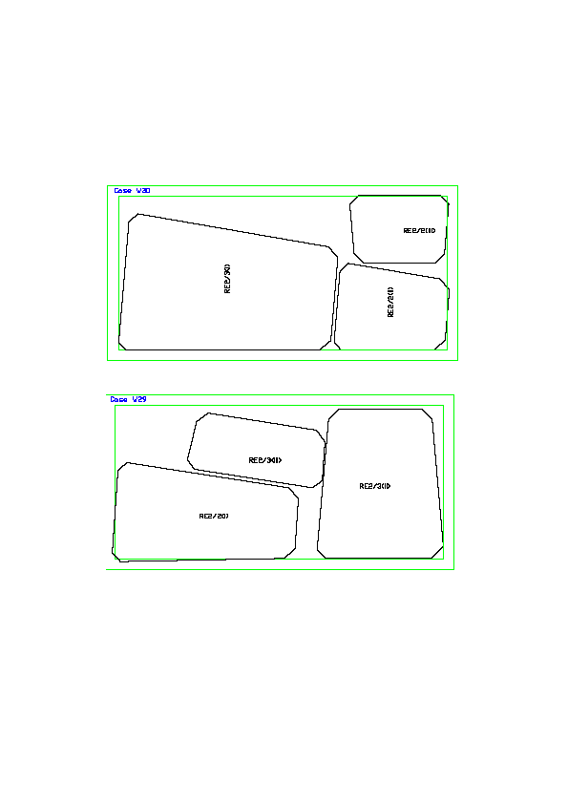

**ANNEX2**

**Dimensions of HPL (not gap) for RE*/2 .**

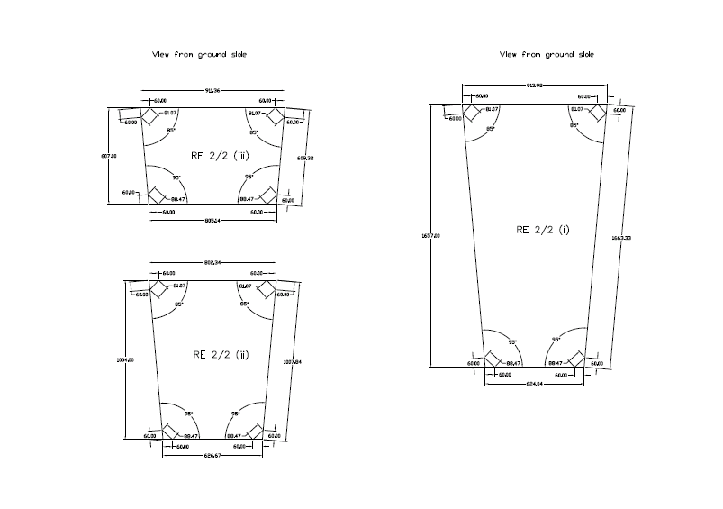

**ANNEX3**

**Dimensions of HPL (not gap) for RE*/3 type chambers.**

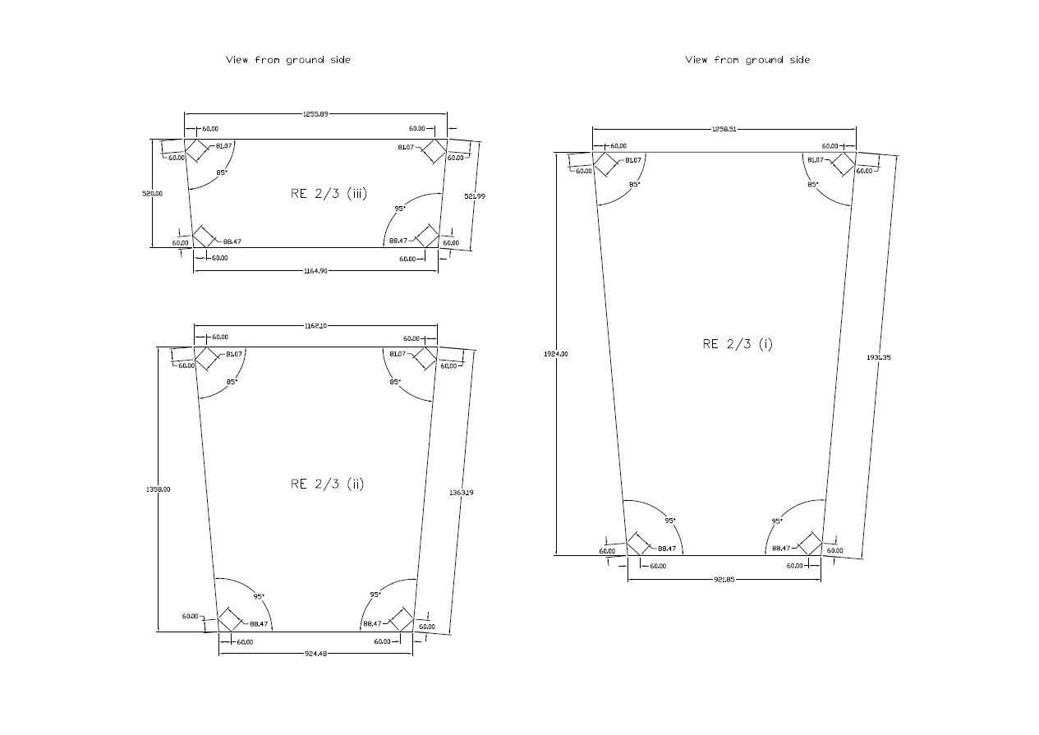

**ANNEX 4**

**Transport box internal details**

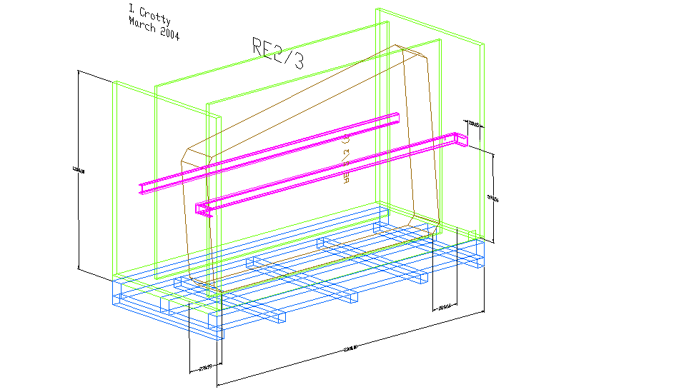

With additional two levels of compression bars which are pre-stressed as shown below. There will be only one size of box to give added flexibility as the boxes move between the different institutes.

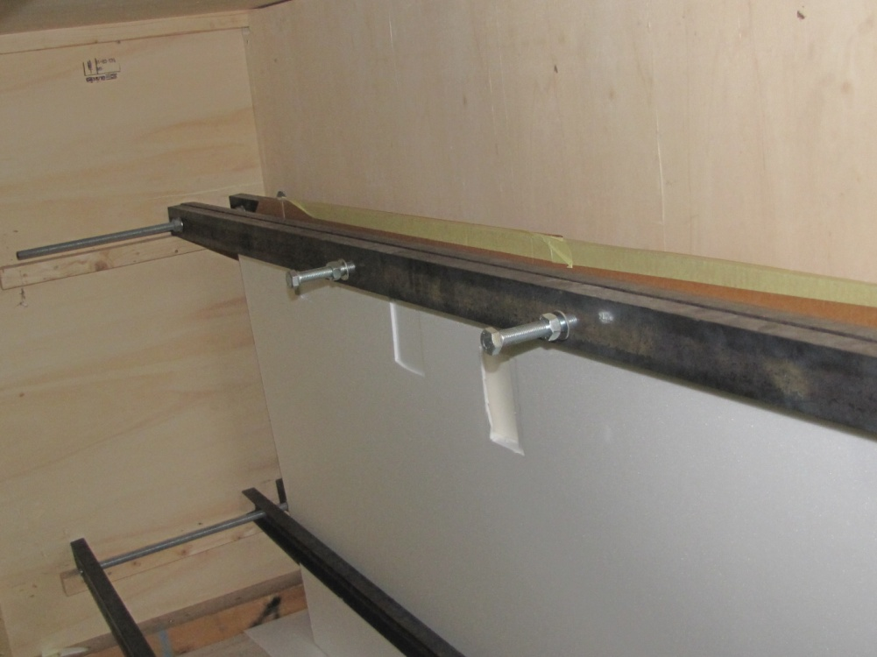

S. Buontempo and I. Crotty 13 April 2011