CMS RPC Upscope Bakelite Specification

CERN, May 2010
- Basic material
High Pressure Laminate using Phenol (resol) and Melamine resin, loaded with kraft and ‘decorative’ papers.

- Pieces
Starting with 660 sheets of Bakelite we request to produce 1800 cut pieces with size, shape and precision as described in point n.5 below.

- Volume (Electrical) Resistivity
The volume resistivity must be maintained between 1-6 x10¹⁰ [Ω.cm] @ 20°C.
- Size, shape and cut precision
Starting from Bakelite sheets of 3.2 x 1.6 m with thickness 2 mm +/- 0.1 mm we ask to cut half of them according to pattern A and half according to pattern B, as described in the attached drawings with tolerance +0, -0.5.

- Resistivity measurement database
For each sheet 8 resistivity measurements will be performed and recorded in a resistivity database delivered with at the end of the production. 3 measurements will be done along the 3.2m sides at 20 cm distance from edge ad at positions 80cm, 160 cm and 240 cm form a corner. 1 measurement will be done at center of 1.6m side at 20 cm from the edge. We reserve the possibility to repeat the resistivity measurements in different positions on the sheet in our laboratories.

- Surface finish
The surface of the bakelite must be ‘brilliant’ without blemishes and deformations. The surface roughness is in the Ra = 0.1μm range.
- Gluing polycarbonate
The Bakelite must be compatible with gluing of polycarbonate components on its surface.
- Linseed oil treatment
The Bakelite must be compatible with uniform wetting of full sheet surface with diluted linseed oil
- Graphite treatment
The Bakelite must be compatible with uniform deposit of graphite on its surface.
- Quality Controls
The quality control shall be done in house of the manufacturer with the supervision of the client . Acceptance of surface damage is at the clients discretion.
- Packing and handling
Packing shall be done to the client’s requirements and needs dependant on the final destination .
- Label and tracability
We request 4 identical labels on each sheet from the original production of 600 sheets, each sheet `s labels are unique. These labels will identify the sheet and must be easy to remove. They will be used to identify the sheet in the resistivity measurement data basing. After sheet cut, 3 of 4 labels will go to each of the 3 pieces coming out of the cut. Fourth label will stay on the residual of the original sheet.
- Rejects
The rejects from the QC are taken back by the supplier. Only sheets passing final QC based on the 9 point jig are charged to the client, CERN.

Cutting Patterns W29 and W30
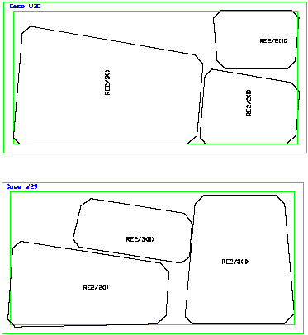

Dimensions of bakelite pieces (not gap) for RE*2 and RE*3 chambers (as verified by Luc and Ian in the ISR 16 March 2010).
Dimensions of HPL (not gap) for RE*/2 and RE*/3 type chambers. These are dimensions as verified by Luc and Ian in the ISR 16 March 2010.

http://project-cms-rpc-endcap.web.cern.ch/project-cms-rpc-endcap/rpc/Production/Oil%20&%20Bakelite/Cutting/20210203/RPChpl030920REtype2.pdf

S. Buontempo and I. Crotty 10 May 2010

