CMS RPC Upscope Bakelite Specification

CERN, April 2011
- Basic material
High Pressure Laminate using Phenol impregnated kraft paper as the bulk and Melamine resin impregnated ‘decorative’ papers on the outer surfaces.

- Pieces
Starting with 660 sheets of Bakelite we request to produce 1980 cut pieces with size, shape and precision as described in point #4 below. In addition from each sheet a ”sample” 300 x 300mm will be cut to be kept in Pavia to track changes in resistivity over the following years.

- Volume (Electrical) Resistivity
    - The volume resistivity must be between 1- 6 x10¹⁰ [Ω.cm] @ 20°C.
    - StDev.ρ/Av.ρ ≤ 0.5
- Size, shape and cut precision
Starting from HPL sheets of 3.2 x 1.6 m with thickness 2 mm +/- 0.1 mm we ask to cut half of them according to pattern W29 and half according to pattern W30, as described in the attached drawings with tolerance +0, -0.5.

- Quality Controls & Resistivity measurement database

First level. For each sheet 8 resistivity measurements will be performed and recorded in a resistivity database delivered at the end of each production batch. Three measurements will be done along the 3.2m sides at 20 cm distance from edge and at positions 80cm, 160 cm and 240 cm form a corner. One measurement will be done at the center of each 1.6m side at 20 cm from the edge.

The second level of resistivity qualification will be done on the 9 point measurement jig in Pavia. The third and final level of measurement will be made within 3 months of the delivery to Pavia. This latter stage defines the panels that will be charged to the client. It is at this point that that the final pass, therefore production yield will be made. The rejected sheets will be removed from the Pavia site.

- Surface finish
The surface of the HPL must be ‘brilliant’ ( as described by the manufactures use of the polished stainless steel “pressing plates” termed “lucido”) without blemishes and deformations. The surface roughness is in the Ra = 0.1μm range.
- Gluing polycarbonate
The HPL must be compatible with gluing of polycarbonate components on its surface.
- Linseed oil treatment
The HPL must be compatible with the uniform wetting of the full surface of the sheet with diluted linseed oil
- Graphite treatment
The Bakelite must be compatible with uniform deposit of graphite on its surface.
- Storage and Transport
The HPL shall be stored on reinforced palettes under cover of rain and direct sunlight. The palettes will have neither additional load placed on top nor be placed on other palettes of smaller dimensions causing the client’s HPL to bend.The HPL will remain flat at all times. For any reason for delay in shipping from Puriceli the client has the prerogative to reject deformed sheets.

- Packing and handling
Packing shall be done to the client’s requirements and needs independent of the final destination .The examples already built (in Italy) and used are to be continued throughout the production run.
- Label and traceability
We request 4 identical labels on each sheet from the original production of 660 sheets, each sheet`s labels are unique. These labels will identify the sheet and must be easy to remove, namely by using standard paper tape applied before the barcode label. They will be used to identify the sheet in the resistivity measurement data basing.
- Rejects
The rejects from the QC are taken back by the supplier. Only sheets passing final QC based on the 9 point jig are charged to the client, CERN.

Cutting Patterns W29 and W30
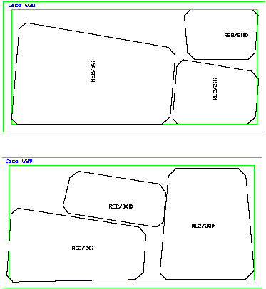

Dimensions of bakelite pieces (not gap) for RE*2 and RE*3 chambers (as verified by Luc and Ian in the ISR 16 March 2010).
Dimensions of HPL (not gap) for RE*/2 and RE*/3 type chambers. These are dimensions as verified by Luc and Ian in the ISR 16 March 2010.

http://project-cms-rpc-endcap.web.cern.ch/project-cms-rpc-endcap/rpc/Production/Oil%20&%20Bakelite/Cutting/20210203/RPChpl030920REtype2.pdf

S. Buontempo and I. Crotty 12 April 2011

