**Introduction**

The end cap region of the muon station in CMS experiment consists of different types of resistive plate chamber (RPC), depending on its location. During the operation of the RPC, there is a few miliwatts of heat energy dissipated into the front end boards, so we need cooling system to be applied to the RPC. Different cooling systems were used for this purpose. In this work we make a comparison of cooling efficiency between various forward CMS RPCs. Also we investigate the effect of the high voltage.

**Description**

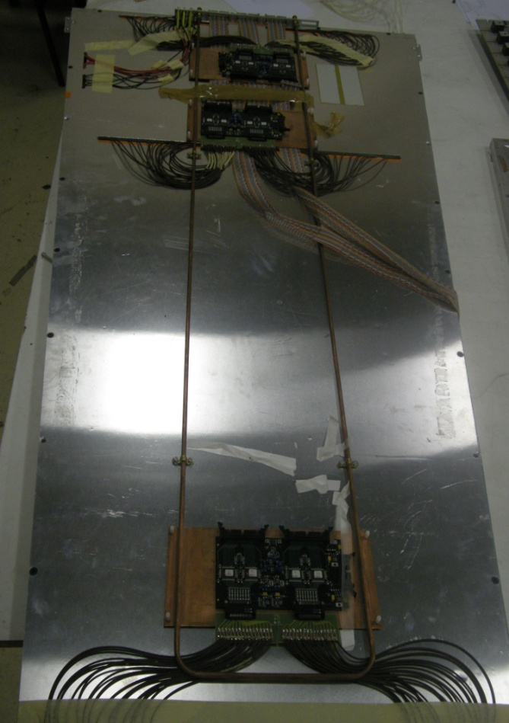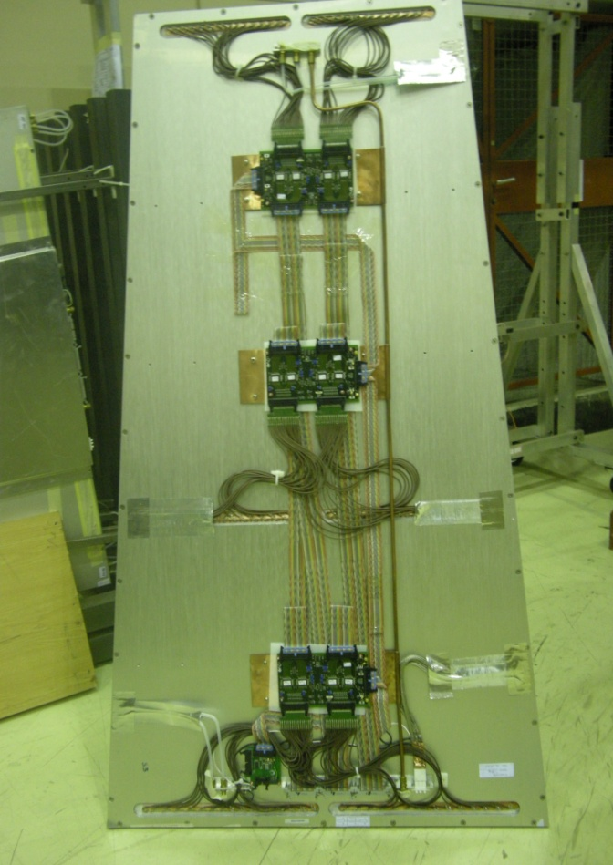

In

Out

Out

In

RE ½ RE 2/2

Figure 1 The cooling system in both RE ½ and RE 2/2.

As shown from Fig 1 the cooling system of RE ½ is simply cooper tube passing from one side of the RPC having U shape and get out from the same side so that the cooling liquid (water) passes through both sides of the front end boards (FEBs). On the other hand, the cooling system of RE 2/2 is just cooper tube enter from one side and out from the other side which mean that the cooling liquid takes the heat from one RPC to the next one.

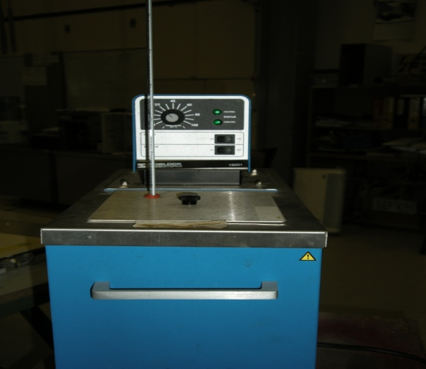 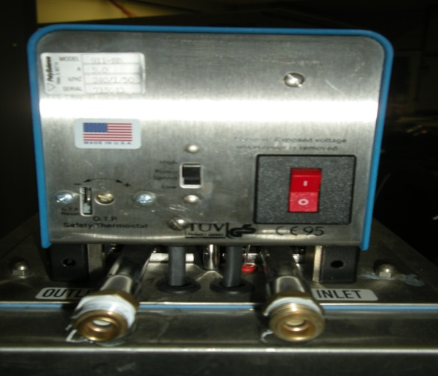  
 a b

Thermometer

Figure 2 Front view (a) and back view (b) of the chiller.

Figure 2a show the front view of the chiller used in cooling in which we can control the temperature of the cooling liquid (water) and monitoring it by using thermometer shown in the same figure. Figure 2b show the inlet of the chiller which supply the water to the RPC and also the outlet which receive the water from the RPC, cooling it and supply again to the RPC.

In this work, the variation of the temperature of the front end boards (FEBs) was recorded by using infrared camera (Varioscan 3021).

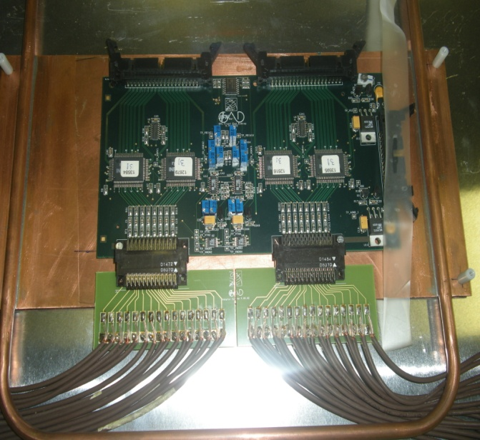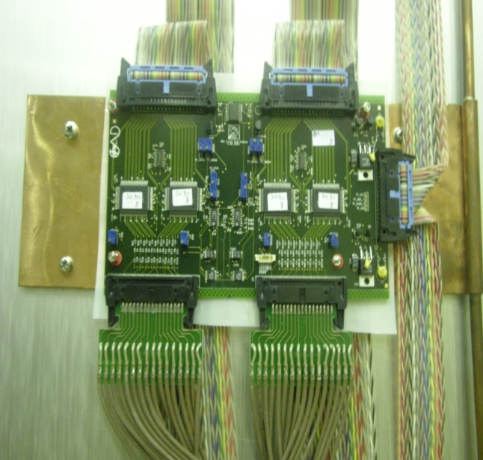   
 a b

Copper plate

Cooling pipe

Copper plate

Cooling pipe

Figure 3. Copper cooling plate and FEB of (a) RE2/2 and (b) RE1/2

Figure 3 show the different cooling system for front end board for both RE 2/2 and Re 1/2. The cooling copper pipe passes through only on side of the copper cooling plate in case of RE 2/2, while in case of RE 1/2 it passes through both sides of the cooling copper pipe.

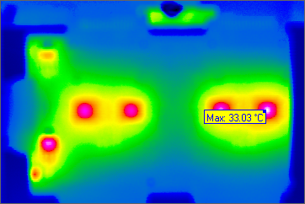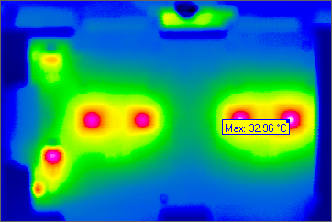

Fig 4 Front end board photos using infrared Camera.

Figure 4 show two photos of the FEB taken by infrared camera. The figure indicates the hot parts of the front end board by the red spots.

**Method**

1- We put the chamber RE 1/2 on the gas for one day and then switch on the front end board (FEB). Record the variation of the FEB temperature with time without cooling. Start cooling at 16 C and also record the variation of temperature with time.

2 Switch on the High Voltage (9 KV) with the FEB on and record the variation of the FEB temperature with time without cooling and then with cooling at 16 C.

3 Put the chamber RE 2/2 on the gas for one day and switch on the FEB. Record the variation of the temperature with time with the cooling (16 C) off and then on.

4 Switch on the High Voltage (9KV for top and 5KV for the bottom) with FEB on. Record the variation of the FEB temperature with time with cooling (16 C) off and then on.

5 Repeat the previous four steps for both chamber RE 1/2 and 2/2 but with cooling at 20 C instead of 16 C.

**Data**

|  |  |  |  |  |  |  |  |
| --- | --- | --- | --- | --- | --- | --- | --- |
| RE1/2 HV off | | RE1/2 HV on | | RE2/2 HV off | | RE2/2 HV on | |
| Time (h) | T (max) | Time (h) | T (max) | Time (h) | T (max) | Time (h) | T (max) |
| 0 | 30.55 | 0 | 30.63 | 0 | 28.39 | 0 | 28.33 |
| 0.25 | 33.95 | 0.25 | 35.27 | 0.25 | 34.5 | 0.25 | 35.03 |
| 0.5 | 34.25 | 0.5 | 35.63 | 0.5 | 34.75 | 0.5 | 35.39 |
| 0.75 | 34.49 | 0.75 | 35.67 | 0.75 | 35.04 | 0.75 | 35.6 |
| 1 | 34.76 | 1 | 35.75 | 1 | 35.37 | 1 | 35.72 |
| 1.25 | 34.85 | 1.25 | 35.77 | 1.25 | 35.51 | 1.25 | 35.81 |
| 1.5 | 34.96 | 1.5 | 35.8 | 1.5 | 35.61 | 1.5 | 35.95 |
| 1.75 | 35.01 | 1.75 | 33.34 | 1.75 | 35.59 | 1.75 | 36.05 |
| 2 | 35.09 | 2 | 33.14 | 2 | 35.56 | 2 | 36.09 |
| 2.5 | 33.03 | 2.5 | 33.08 | 2.25 | 34.28 | 2.25 | 34.59 |
| 3 | 32.96 | 3 | 33.12 | 2.75 | 34.37 | 2.5 | 34.43 |
| 3.5 | 33.02 | 3.5 | 33.05 | 3.25 | 34.41 | 3 | 34.54 |
| 4 | 32.95 | 4 | 33.12 | 3.75 | 34.41 | 3.5 | 34.48 |
| 4.5 | 32.99 | 4.5 | 33.11 | 4.25 | 34.45 | 4 | 34.52 |
| 5 | 32.95 | 5 | 33 | 4.75 | 34.43 | 4.5 | 34.48 |
| 5.5 | 33.02 | 5.5 | 33.05 | 5.25 | 34.34 | 5 | 34.48 |
| 6 | 33.05 |  |  |  |  | 5.25 | 34.6 |

table 1. The variation of the FEB temperature with time for both RE 1/2 and 2/2 with HV on and off and cooling (16 C) off and then on.

|  |  |  |  |  |  |  |  |
| --- | --- | --- | --- | --- | --- | --- | --- |
| RE1/2 HV off | | RE1/2 HV on | | RE2/2 HV off | | RE2/2 HV on | |
| Time (h) | Temp (max) | Time (h) | Temp (max) | Time (h) | Temp (max) | Time (h) | Temp (max) |
| 0.5 | 34.25 | 0.25 | 36.96 | 0.25 | 34.95 | 0.25 | 35.77 |
| 1 | 34.76 | 0.5 | 37.02 | 0.5 | 35.43 | 0.75 | 36.45 |
| 1.5 | 35.85 | 0.75 | 37.2 | 1 | 35.9 | 1.25 | 36.9 |
| 1.75 | 35.27 | 1 | 37.15 | 1.25 | 35.4 | 1.5 | 37 |
| 2 | 35.28 | 1.25 | 37.18 | 1.5 | 35.5 | 1.75 | 37.24 |
| 2.25 | 35.32 | 1.5 | 36.08 | 2 | 35.72 | 2 | 36.49 |
| 2.5 | 35.45 | 2 | 36.21 | 2.5 | 35.84 | 2.25 | 36.49 |
| 3 | 35.72 | 2.75 | 36.17 | 3 | 36 | 2.75 | 36.64 |
| 3.5 | 35.73 | 3.25 | 36.1 | 3.5 | 36.01 | 3.25 | 36.75 |
| 4 | 35.83 | 3.75 | 36 | 4 | 36.07 | 3.75 | 36.76 |
| 4.5 | 35.92 | 4.25 | 36.02 | 5.5 | 36.13 | 4.25 | 36.79 |
| 5 | 35.89 |  |  | 6 | 36.18 | 4.75 | 36.73 |
| 5.5 | 35.98 |  |  |  |  | 5.25 | 36.8 |
| 6 | 35.83 |  |  |  |  |  |  |
| 6.5 | 35.73 |  |  |  |  |  |  |
| 7 | 35.85 |  |  |  |  |  |  |

table 2. The variation of the FEB temperature with time for both RE 1/2 and 2/2 with HV on and off and cooling (20 C) off and then on.



Figure 5. The variation of the FEB temperature with time for both RE 1/2 and 2/2 with HV on and off and cooling (16 C) off at the first part of the graph and on at the second part.



Figure 6. The variation of the FEB temperature with time for both RE 1/2 and 2/2 with HV on and off and cooling (20 C) off at the first part of the graph and on at the second part.

**Discussion**

As shown in figure 5 the temperature of the FEB increases till it reaches plateau1 and when we apply cooling (16 C) it starts to decrease till it reaches also plateau2.

For both RE 1/2 and RE 2/2 the effect of applying the high voltage is to increase the plateau1 temperature and leave the plateau2 temperature nearly the same. One possible reason of this increase in temperature is that when we apply high voltage to the FEB, it works more.

Chamber RE 1/2 reaches lower temperature than RE 2/2 after applying cooling so that the cooling system in RE 1/2 is more efficient than that in RE 2/2

As shown in figure 6, when the cooling is off, the temperature or the FEB increases. As we start cooling (20 C) the temperature decreases and then start to increase again, which mean that this cooling has no effect.

Also we tried to put the aluminum cover of the FEB and record the variation of the FEB temperature with time but the problem is that the camera can see nothing.

**Conclusion**

1 The effect of switch on the HV is to increase the temperature of the front end board

2 The cooling system of the chamber RE ½ is more efficient than that of the chamber RE 2/2.

3 Cooling at 20 C have no effect.

--------------------------------------------------------------------------------------------------------------------------------------

The name of the infrared camera is Varioscan 3021 and manufactured by Jenoptik, Germany.



The configuration of the camera:

Spectral range: (8→12) μm

Detector cooling: LN2

Temperature range: (-40 → 1200) C

Thermal resolution: ±0.03

Geometrical resolution: 1.5 mrad

Number of pixels: 360 $×$ 240

Power supply: 220 V

Chiller was manufactured by