<http://w3.iihe.ac.be/~vanlanck/SM/8x80left.pdf>

<http://w3.iihe.ac.be/~vanlanck/SM/>

There are 20 files

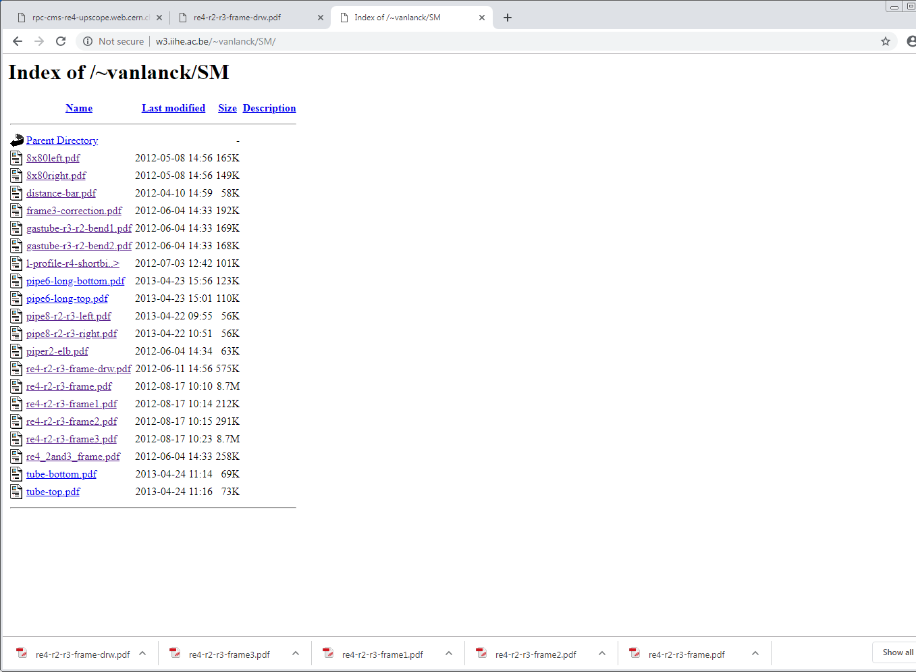

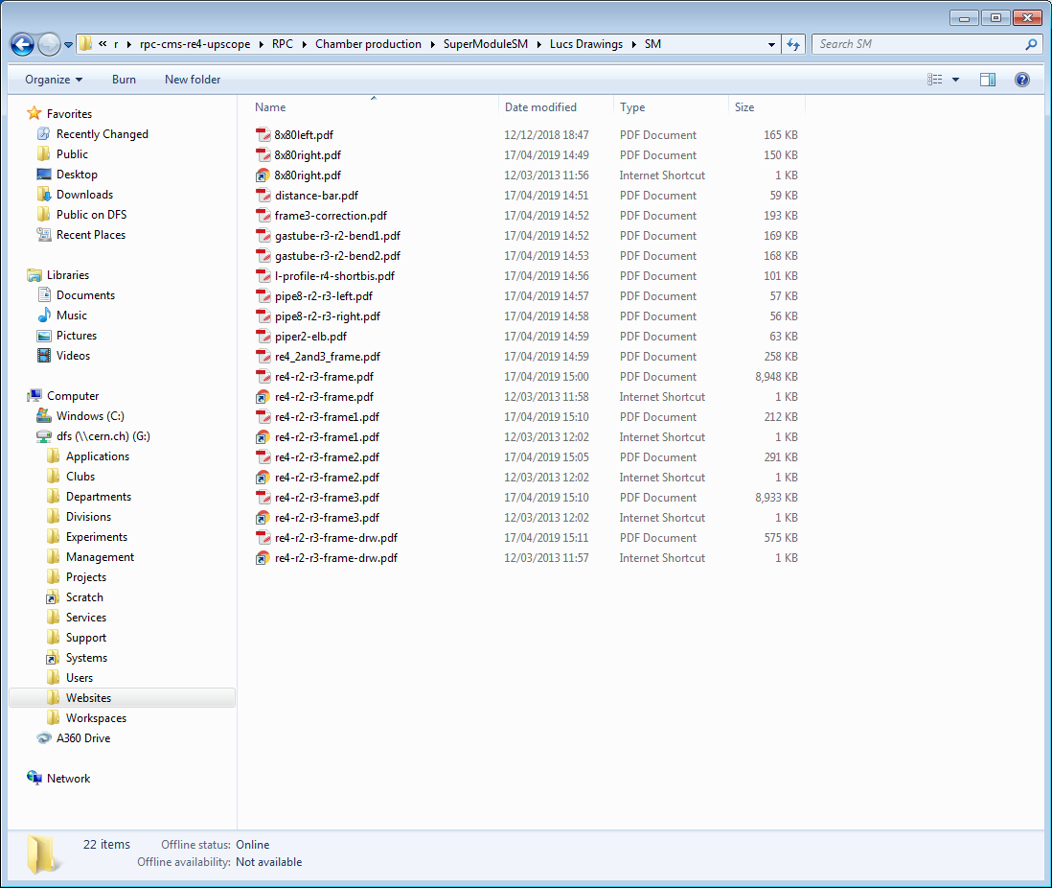

Corrected and completed with 20 files. 17 04 2019

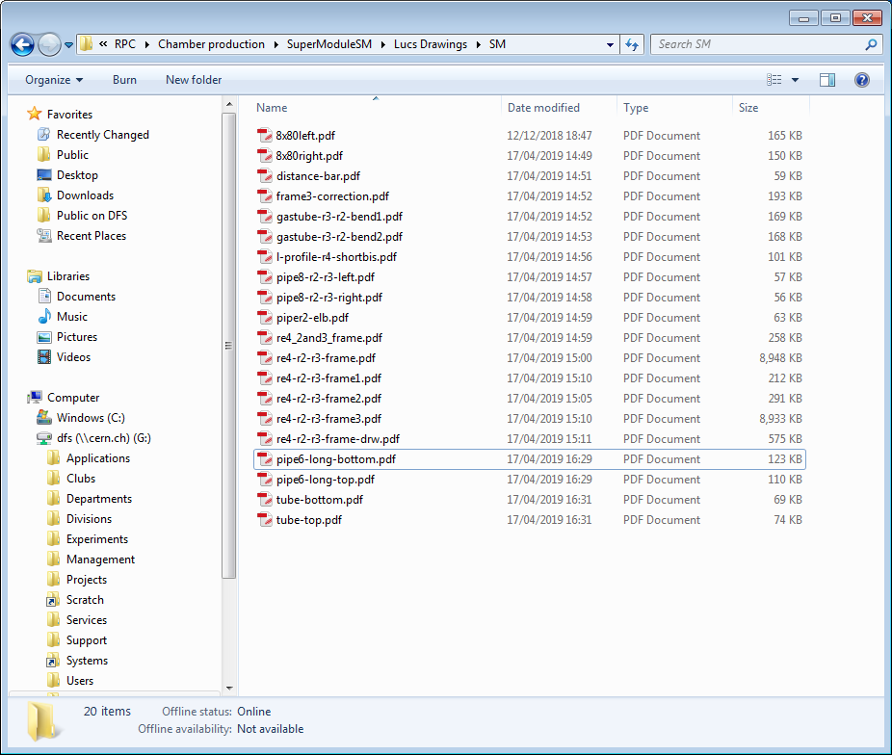

The urls for the cha,mber componentys take from original Pakistani drawaings

<http://w3.iihe.ac.be/~vanlanck/RE4-Ring2/>

<http://w3.iihe.ac.be/~vanlanck/RE4-Ring3/>