Leak rate calculations SM002 May 28 2013

With temp sensor in the gas pipe.

File name for Data;

The system ran for almost 4 days. It was stopped by me reading from another machine ??

This test was done after using H2N2 mix for finding the leak.

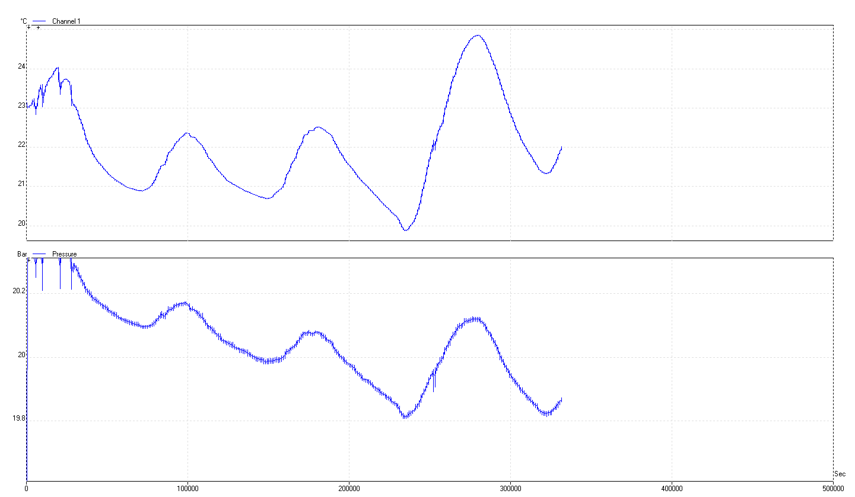

Looking at “by eye “ fit over the 4 days.

Start 20.325 Bar 0sec

Finish 19.852 325000s

dP/dt 0.473/325000 = 1.46 E -06 [bar/s]

= 1.46 E -03 [mbar/s]

Vol = SM vol ; L ~ 8m dia8mm

Extra coil 5m dia8mm

Vol = Pi x r^2 x 1300 [cm^3]

= 653 [cm^3]

= 0.653 [litres]

Leak Rate = 9.5 E -04 [mbar.l/s]

Leak rate calculated at equal temperatures (22degC) on a decreasing temp (& pressure) as shown below.

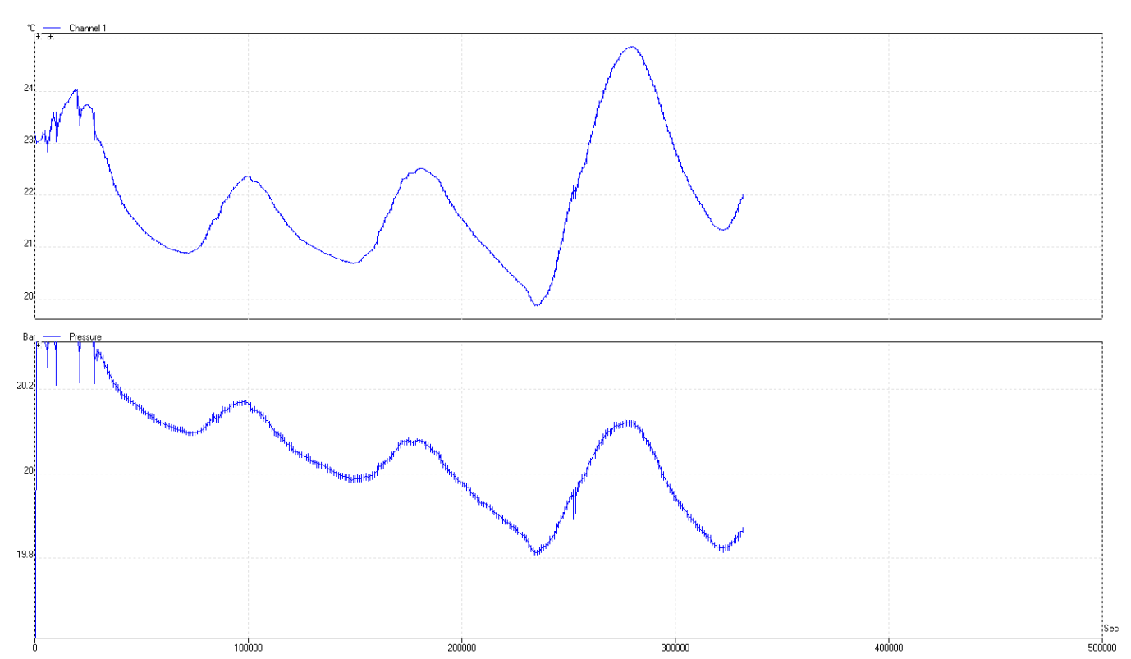

Values obtained at 22degC 39807s 309500s dt= 269693s

20.198Bar 19.880Bar Dp= 0.318Bar

dP/dt = 1.18 E -06 [bar/s]

= 1.18 E -03 [mbar/s]

Leak rate = 7.7 E -04 [mbar.l/s]

Test done before installation of the temp sensor of the BUT with the sensor using picolog attached to the external coil.

Global view of data taken.

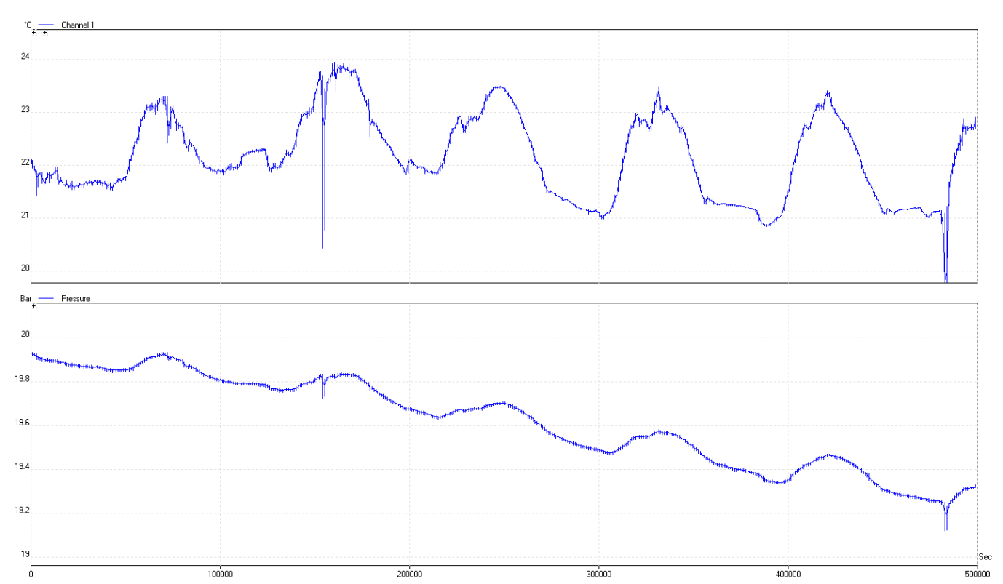

Below is the 20ks to 40ks = 20ks sample time

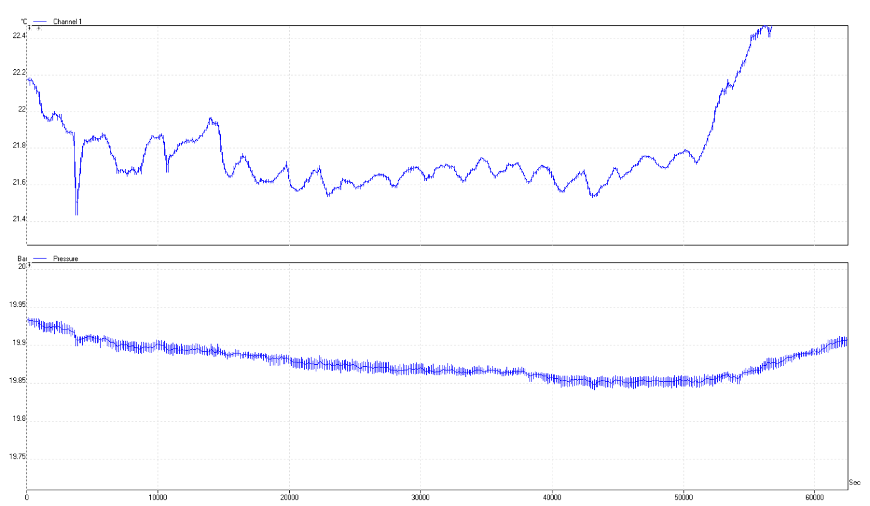

Values obtained by eye from the 20ks sample period.

At 20ks = 19.88Bar

At 40ks = 19.857Bar

dP/dt = 0.023Bar/20ks = 1.15 E -06 [Bar/s]

Vol = 0.653[litres]

Leak Rate = 7.5 E -04 [mbar.l/s]

3rd calc from 40ks to 60ks

Start temp 22.005 Start Pressure 20.198

Finish temp 21.07 Finish Pressure 20.120

dP/dt = 0.078/20ks

3.9E-03 [mbar/s]

Normalisation for temp change

P2 = P1 x T2/T1

= 20.134 [bar]

Pressure drop due to temp drop = 20.198-20.134

= 64mbar

Pressure drop due to leak = 20.134-20.120

= 14mbar

dP/dt = 14/20000 [mbar/s]

= 7E-04 [mbar/s]

Norm. Leak Rate = 3.5E-04 [mbar.l/s]

THEREFORE OK !

