ISIEC – Initial Safety information on Experiments at CERN

purpose of this template
This document shall be completed by the GLIMOS of an experimental collaboration, whenever it intends to bring new experimental apparatus, new test beams or make major modifications to experimental apparatus already operating at CERN.
The purpose of this document is to provide a summary description of the equipment that is to be brought to CERN and the activities that are to be carried out. This document will then allow the PH Safety Office (PH-SO) to perform an initial safety assessment; i.e. identification of the applicable safety requirements, control measures, etc.
This ISIEC document will serve as a basis for the safety information on an experiment. Further documentation may be requested to improve the understanding of safety hazards.
For each experimental apparatus, the following procedure applies:
- The GLIMOS shall fill in chapters 1 to 4.
- The GLIMOS shall submit this document (ISIEC form) to the PH Unit
sps.coordinator@cern.ch and dso-ph@cern.ch
- Recommendations and procedures will follow after the provision of this document. Note that if the experiment is considered to have major safety implications then the CERN HSE unit will become involved and their safety procedures will then be followed.
- A Launch Safety Discussion may be called for by the PH-SO. This will take place on site with representatives of the experiment, PH-SO, the HSE Unit and other CERN Departments.
- A formal ‘Safety Clearance’ of the experiment must be given prior to the experiment being allowed to start operating (for example to receive beam).
Please note that this form must be completed and sent to CERN prior to the arrival of the planned experiment. Work will not be allowed to start until this form, and any requested complementary information on safety hazards, has been completed and handed over as explained above.
Please complete the following:
NAME OF THE EXPERIMENT: CMS RPC GIF++ Ageing
Filled out by: Ian Crotty 164414
Date: 20 March 2015

Introduction
The purpose of this document is to provide a description of the experimental program/test beam to be carried out at CERN; i.e.:
- to identify the equipment brought to CERN;
- to identify activities to be carried out at CERN;
- to identify hazards associated to the equipment and activities and the measures to be implemented in order to eliminate, control or mitigate them.

Please enter the information in the empty cells of the tables below:

Organization of the Collaboration
Role | Name | Phone/e-mail
Spokesperson | Tiziano.Camporesi@cern.ch | 160404
Technical coordinator | Austin Ball | 160408
GLIMOS | Niels du Pont | 165186
SPS Coordinator | Henric Wilkens | 16-3845 spsco@cern.ch
DSO-PH | Mark Hatch | dso-ph@cern.ch
Liaison Physicist | Gabriela Pugliese | 164880
TSO | Michael Jeckel | 164710

Schedule and location of the experimental apparatus or test beam
Start date: | 21 March 2015
Completion date: | October 2015
Building/experimental area | 887 GIF++
Beam line/PPE door | H4 PPE 154
Lab/Counting room/Phone | HNA 487 phone 78905

Description of the experimental apparatus/test beam

General description of the experimental apparatus/test beam
Initial Test Trolley with one RPC shown in yellow. 1.6m x 0.8m x 2.20m in beam line up stream of the source.
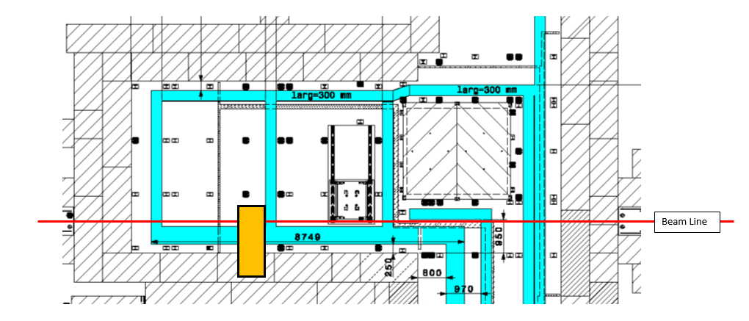

Description of the installation
Complete the cells below and double click on the boxes and check as appropriate.
Equipment | Availability | Design and manufacturing
RPC RE2/2 from CMS | Existing | To be used without any modification  To be modified
RPC RE2/2 from CMS | New | Standard equipment supplied by a manufacturer  CERN/collaboration responsible for the design and/or manufacturing
CAEN main Frame SY1527  LV Module A1513A  HV module A1526N | Existing | To be used without any modification  To be modified
CAEN main Frame SY1527  LV Module A1513A  HV module A1526N | New | Standard equipment supplied by a manufacturer  CERN/collaboration responsible for the design and/or manufacturing
Cabling | Existing | To be used without any modification  To be modified
Cabling | New | Standard equipment supplied by a manufacturer  CERN/collaboration responsible for the design and/or manufacturing

Hazards generated by the experimental apparatus/test beam

Identify the hazards associated to each part of the experiment and the associated equipment that is to be integrated in the experimental apparatus/test beam. Double click on the boxes and check as appropriate. Provide comments or values under the description.
Domain | Hazards/Hazardous Activities |  | Description
Mechanical Safety | Pressure |  | 1-2[mbar]; 6[l]
Mechanical Safety | Vacuum |  | NA
Mechanical Safety | Lifting equipment |  | NA
Mechanical Safety | Machinery / Machine Tools |  | NA
Mechanical Safety | Mechanical energy (moving parts) |  | NA
Mechanical Safety | Mechanical properties (sharp, rough, slippery) |  | Antico frame on Wheels
Mechanical Safety | Industrial Vehicles |  | NA
Mechanical Safety | Hot Work (e.g. welding, grinding) |  | NA
Mechanical Safety | Hot/cold surfaces |  | NA
Mechanical Safety | Vibration |  | NA
Cryogenic Safety | Cryogenic fluid |  | NA
Structural Safety | Shielding Walls |  | NA
Structural Safety | Specific actions/conditions
Electrical and Electro-magnetic Safety | Electrical equipment and installations |  | 7[V], 1.5[A]
Electrical and Electro-magnetic Safety | High Voltage Equipment |  | 10 [kV]
Electrical and Electro-magnetic Safety | Magnetic field |  | [T]
Electrical and Electro-magnetic Safety | Equipment in potentially explosive atmospheres
Chemical Safety | Hazardous chemical agent (HCA)
Chemical Safety | CMR (carcinogens, mutagens and substances toxic to reproduction)
Chemical Safety | Toxic/Harmful |  | [fluid], [quantity]
Chemical Safety | Corrosive |  | [fluid], [quantity]
Chemical Safety | Oxidizing |  | [fluid], [quantity]
Chemical Safety | Flammable |  | [fluid], [quantity]
Chemical Safety | Potentially explosive atmospheres |  | [fluid], [quantity]
Chemical Safety | Irritant |  | [fluid], [quantity]
Chemical Safety | Asphyxiant |  | [fluid], [quantity]
Chemical Safety | Nanomaterial’s
Chemical Safety | Dangerous for the Environment
Chemical Safety | Asbestos
Biological Safety | Legionella
Biological Safety | Biological Agents
Non-ionizing radiation Safety | Laser, class
Non-ionizing radiation Safety | Radiofrequency
Non-ionizing radiation Safety | Microwaves
Non-ionizing radiation Safety | UV light
Non-ionizing radiation Safety | Electromagnetic (Frequency & Field strength) |  | Hz, Vm⁻¹
Workplace | Excessive Noise
Workplace | Temperature constraints (non-comfortable)
Workplace | Insufficient Lighting
Workplace | Indoor Air quality (e.g. clean rooms)
Workplace | Confined space
Workplace | Work at height
Workplace | Obstructions in passageways
Workplace | Lone working
Workplace | Falling objects
Workplace | Internal Traffic (e.g workshops, experiments)
Workplace | Slippery/unstable ground
Workplace | Working outside normal working hours
Environment | Usage/storage of potentially polluting substances (gases, liquids, solids) |  | R134a & SF6
Environment | Emissions of substances into the atmosphere |  | R134a & SF6
Environment | Discharge of effluents to the site drainage (i.e. infiltration water, rain water, cooling water…)
Environment | Discharge of effluents to sewage (i.e. sanitary water…)
Environment | Activated or radioactive soil
Environment | Polluted or contaminated soil
Environment | Emission of noise harmful for the environment
Environment | Vibrations harmful for the environment
Environment | Odours
Environment | Waste generation
Environment | Significant consumption of resources (e.g. water, electricity gas, fuels, ...)
Worksite | Construction & dismantling activities |  | All work done outside bunker
Worksite | Co-activity |  | With other experiments
Fire Safety | Hot works
Fire Safety | Combustible Materials
Fire Safety | Ignition sources
Ionizing Radiation | Target material
Ionizing Radiation | Beam particle type |  | Muons
Ionizing Radiation | Beam intensity |  | 10^4/spill
Ionizing Radiation | Beam energy |  | <100GeV
Ionizing Radiation | Source | X | Cs 137

Table 1 - Hazard identification

Include below a table of any other hazards that may be present – if applicable.

Description of the activities carried out at CERN

Description of installation activities
Roll the trolley into position from the preparation zone and cable/pipe

Description of the operation
Carry out HV scans and establish efficiency plots, log currents as a function of source intensity. All operations are controlled from the control room HNA 487

Description of the maintenance
There should be no maintenance except for gas leak checks

Safety assessment
For the key identified hazards of an experimental apparatus and activity, measures shall be taken in order to eliminate, control or mitigate them. The table below shall contain the list of the key hazards and the measures that are to be implemented.
Key hazards identified | Location | Measures to be implemented
HV | On Trolley | Ground of chamber and trolley
 |  | PS limit is 1mA, set well below.
ODH on gas return | Gas Racks | Measure gas return flow rate

Roles and responsabilities

GLIMOS
According to the § 5.4 of the Safety Policy at CERN (SAPOCO): “For Safety matters, an experiment or test is represented by a Group Leader in Matters of Safety (GLIMOS), who is responsible for Safety, with the necessary authority, from the design stage and subsequently throughout the development, construction, and operational stages of the equipment until it is finally dismantled and correctly disposed of”.
In the absence of an appointed GLIMOS, all his duties and responsibilities fall automatically on the Technical Coordinator or, if one does not exist, to the Spokesperson.

HSE Unit
According to the § IV of the Mandate of the Occupational Health & Safety and Environmental Protection Unit (HSE):
“The HSE Unit provides Safety clearance for activities, special equipment, installations, experiments and projects with major Safety implications prior to design, operation or dismantling activities”.
For experiments less than 3 weeks duration, and if there are no major safety implications, then the PH-SO procedure will be followed (the ISIEC form and formal safety clearance by PH-SO).

TSO
According to the Safety Guide for experiments at CERN the task of Territorial Safety Officers is to watch over the safety of and in the region or building(s) under their responsibility, thereby ensuring that no part of the CERN site(s) escapes safety surveillance. However, the character of the various regions differs considerably, and consequently also the roles of the TSOs. We shall in this guide limit the considerations to those TSOs that are responsible for either experiment areas or buildings housing experiment support labs/workshops.

SAFETY Clearance
The procedure for the safety clearance will depend on the type and duration of the experiment and whether or not there are major safety implications. In all cases a formal safety clearance is a requirement before an experiment can start operating

PS/SPS PHYSICS COORDINATOR
The PS/SPS physics coordinator establishes the AD/PS/SPS user schedules, represents the users at the different scientific and technical committees, being the contact person for both the accelerator groups and the experimental users. He also reports to the CERN management.
*** ***

ANNEX

 | Terms and abbreviations in English
CSHS | Special Health and Safety Committee
CSO | Cryogenic Safety Officer
CSOC | Cryogenic Safety Officers' Committee
DSO | Departmental Safety Officer
DSOC | Departmental Safety Officers' Committee
FGSO | Flammable Gas Safety Officer
FGSOC | Flammable Gas Safety Officers' Committee
GLIMOS  HSE  PH-SO | Group Leader In Matters Of Safety  Occupational Health & Safety and Environmental Protection Unit  Physics Department Safety Office
RSO | Radiation Safety Officer
SAPOCO | SAfety POlicy COmmittee
SLIMOS  TSO | Shift Leader In Matters Of Safety  Territorial Safety Officer

