Interference of Detectors and their supports

with GIF++ Infrastructure

Gas Panel next to Beam Entry point Up-stream hinders horizontal translation of detectors

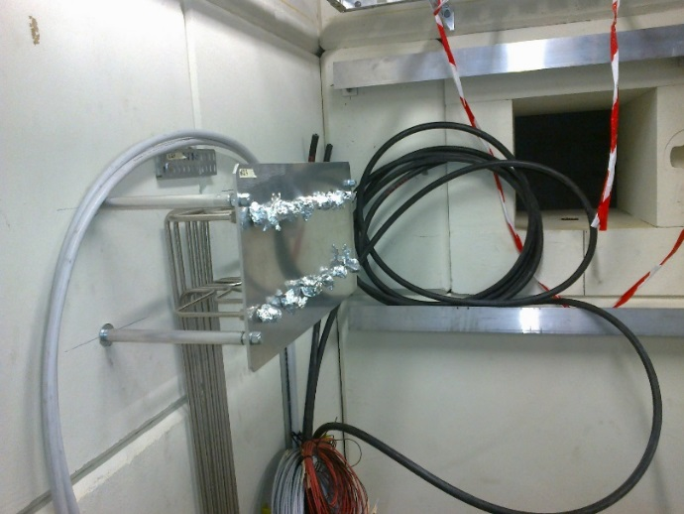

Moving down-stream the alcove can be used

However there are Cable trays and Lighting blocking access just 40cm above the beam line.

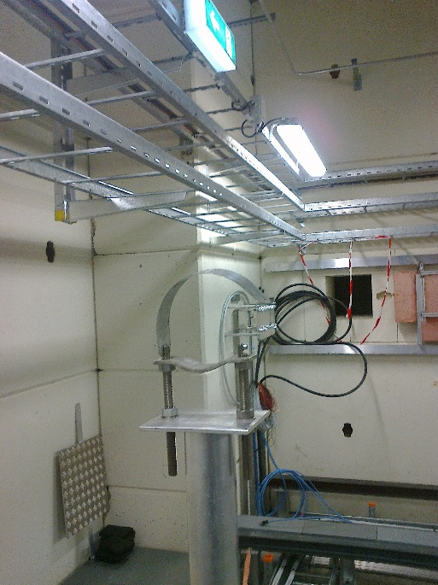 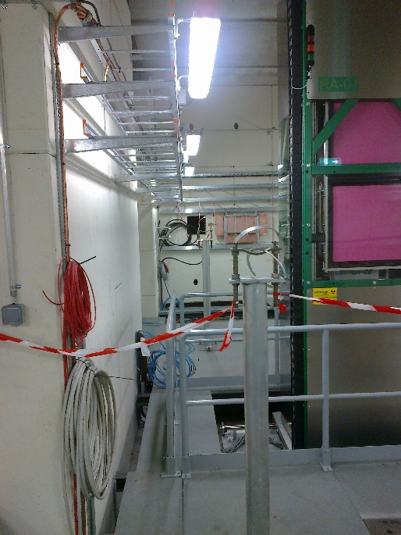

If the cable trays are put higher up or flush against the wall then the horizontal translation distance goes from 30cm to 1.6m.

Ian Crotty 20 Feb 2015

Please see following page.

X section of beam line and cabling infrastructure

Cable Trays @ 2m

Horizontal scan is possible.

Vertical scan is NOT possible

80cm

RPC and Support

Bunker Floor

Alcove 80cm

Beam Line

Beam Line

RPC and Support

Bunker Floor

Bunker wall