VERY approximate Cable length estimate for worst case up stream V01 (Done with a guess on Rack position) Ian Crotty 10 April 2014

L = 35m approx (includes 3m height at each end) 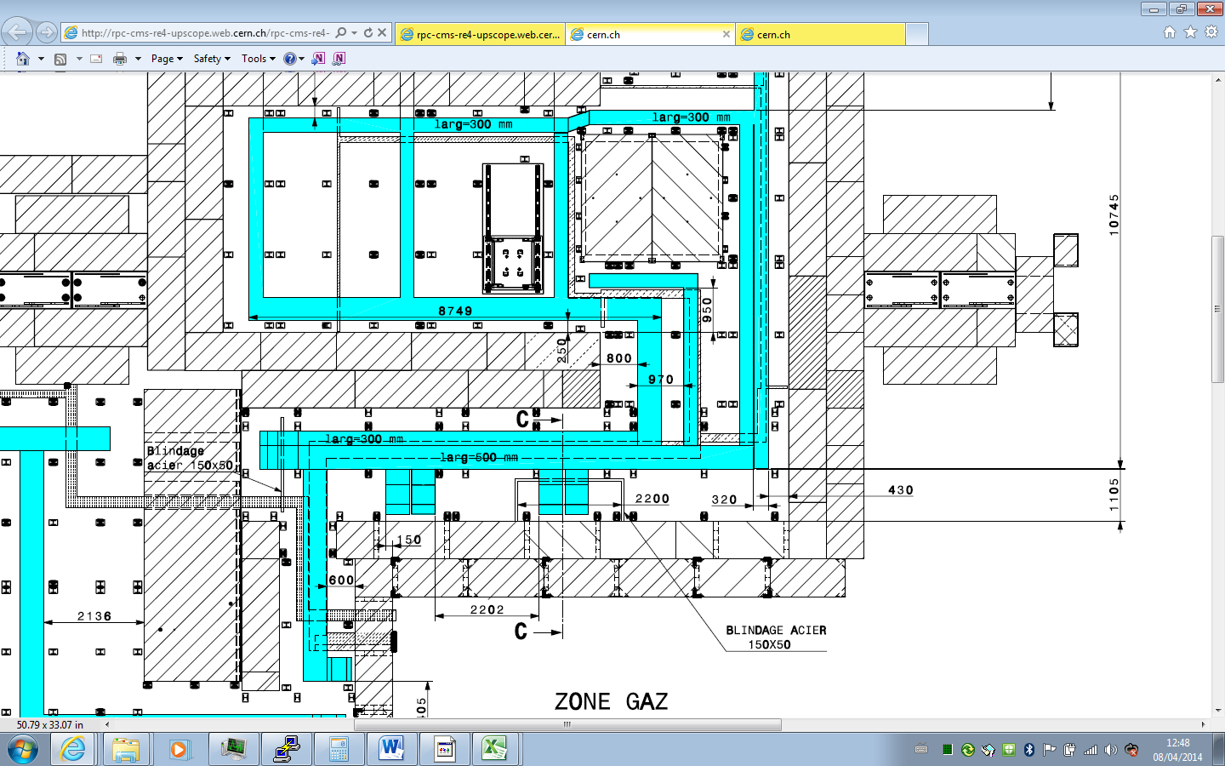

Rack Zone

An intermediate case L = 24m Approx(includes 3m height at each end)



Rack Zone

A down stream case L = 21 m Approx(includes 3m height at each end)



Rack Zone