Cable lengths in the GIF++ area for RPC upgrade V2 Ian Crotty 22 May 2014

To the upstream area L = 33m Approx(includes 3m height at each end) In reality we measured 36m 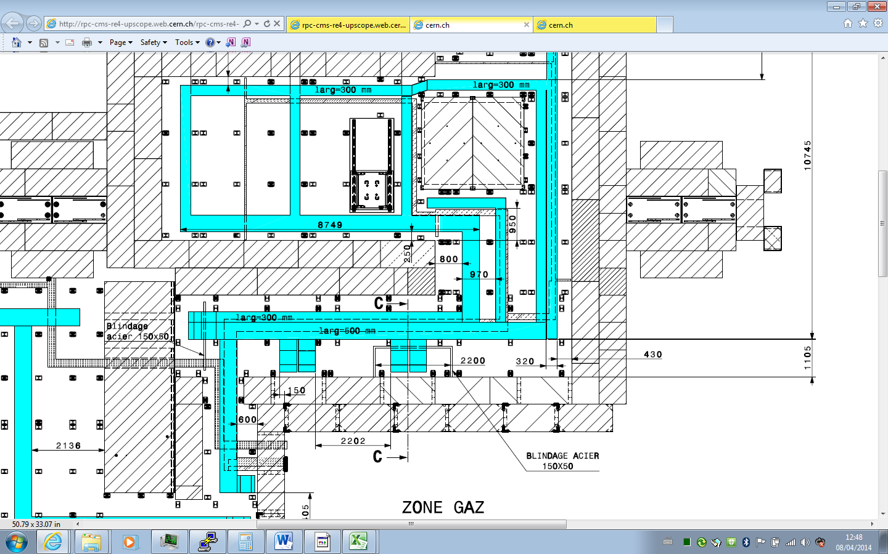

Rack Zone

To downs stream area L = 27m Approx(includes 3m height at each end) ) In reality we measured 28.5m



Rack Zone

Cable length to the preparation area L = 35m Approx(includes 3m height at each end) ) In reality we measured 32m but without position definition



Rack Zone