Cable lengths in the GIF++ area for RPC upgrade V3 Ian Crotty 30 June 2014

To the upstream area L = 35m Approx(includes 3m height at each end) 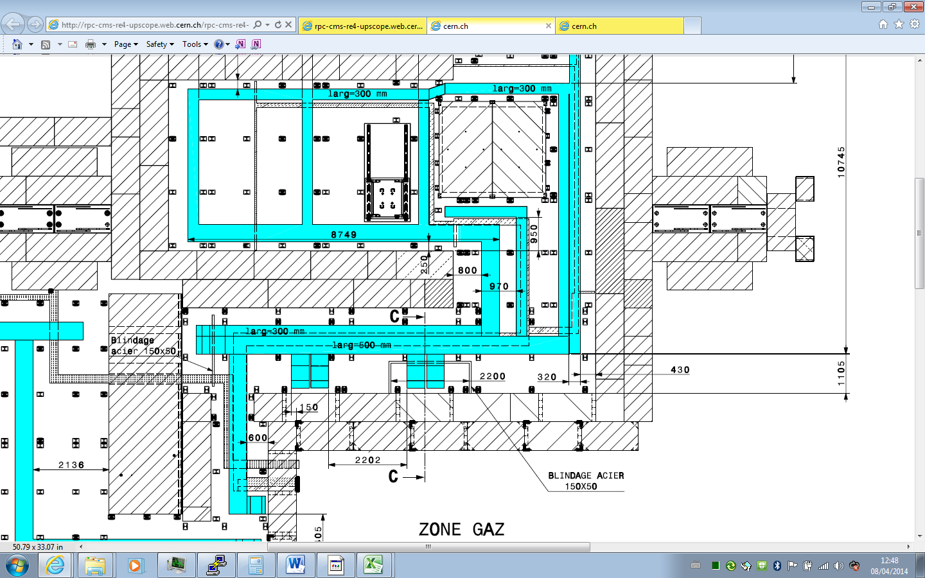

Rack Zone

To downs stream area L = 27m Approx(includes 3m height at each end)



Rack Zone

Cable length to the preparation area L = 35m Approx(includes 3m height at each end)



Rack Zone