EUROPEAN ORGANIZATION FOR NUCLEAR RESEARCH
COMPACT MUON SOLENOID COLLABORATION
URL : http://cmsdoc.cern.ch/cms.html

Up-scope of the CMS forward RPC low η system
Technical Design Report

Ghent University, Ghent, BELGIUM

Vrije Universiteit Brussel, BELGIUM

Peking University, Beijing, CHINA

Lappeenranta University of Technology, Lappeenranta, FINLAND

Bhabha Atomic Research Centre, Mumbai, INDIA

Panjab University, Chandigarh, INDIA

KODEL, Korea University, Seoul, KOREA

National Centre for Physics, Islamabad, PAKISTAN

Institute of Experimental, Physics Warsaw, POLAND

Soltan Institute for Nuclear Studies, Warsaw, POLAND

CERN

INFN

1. Introduction

1.1 The CMS muon trigger system

At the LHC, the bunch crossing frequency will be 40 MHz, which, at the nominal luminosity of 10³⁴cm⁻²s¹, leads to about 800 million proton-proton collisions per second.
The Compact Muon Solenoid (CMS) experiment has put emphasis on the detection and identification of muons. Every 25 ns some 1000 particles emerge from the interaction point into the CMS spectrometer. In less than 3 μs a first level trigger has to reduce this rate to 100 kHz without losing potentially interesting collisions requiring further analysis.
The CMS muon system described in the CMS Muon Technical Design Report [CERN/LHCC 97-32] contains two complementary components:

- detectors that track the muons through the iron yoke and return field: Drift Tubes (DT) in the barrel part; Cathode Strip Chambers (CSC) in the end caps. In both cases, four layers are embedded in the yoke;

- detectors that determine precisely the time of passage of the muons: Resistive Plate Chambers (RPC) not only determine the beam crossing from which the muons emerged, but also their transverse momentum.

1.2 Physics motivation for the forward up-scope (Piet, Salvatore T)

The CMS first level muon trigger relies on RPCs. Six concentric layers of chambers are used in the barrel part, while four layers have been foreseen in total for the end caps to cover a rapidity up to h=2.1.

The Memorandum Of Understanding (MOU) commitment for the forward RPC system was with the Islamabad (Pakistan), Peking (China) and Seoul (Korea) Institutions. Due to insufficient funding availability, only 3 layers per end cap were built with a limited rapidity coverage up to η=1.6 as shown in Figure 1.1.
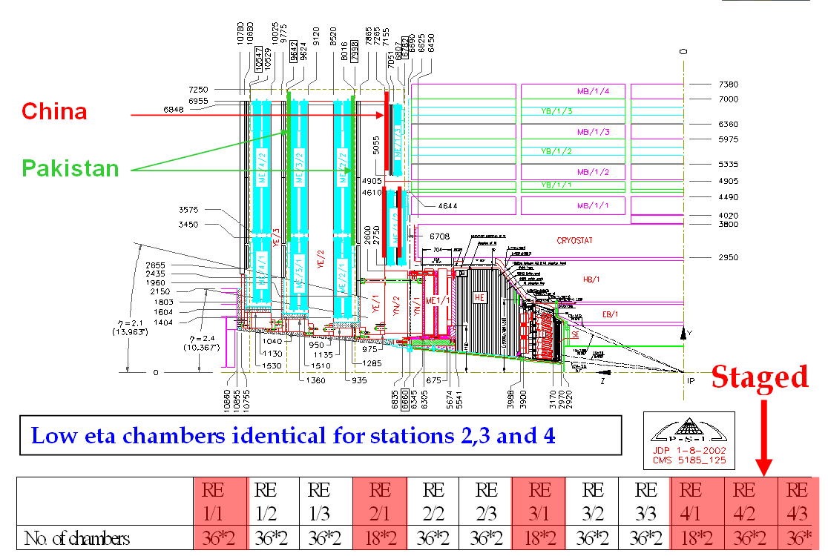

Figure 1.1: layout and rapidity coverage of the initial forward CMS RPC system.

The remaining chambers were staged until the LHC design luminosity is achieved. In Figure 1.2 the simulated actual trigger efficiency as function of the η region is shown for different intrinsic RPC efficiency. A depletion in the forward part can be clearly noted. At low luminosity this will not constitute a handicap to CMS since the CSC detectors can provide an efficient first level muon trigger.

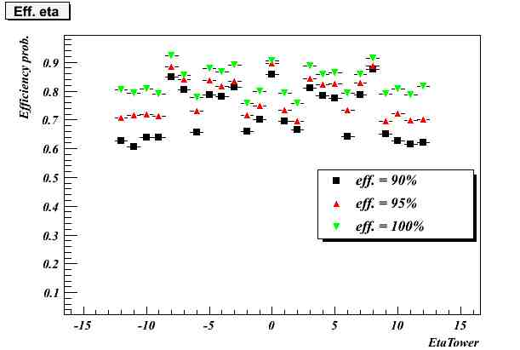
Figure 1.2: simulated trigger efficiency vs. the η region

Simulations of the trigger algorithm studies have however shown that, at design luminosity, at least four forward RPC layers will be required to provide an efficient muon trigger as shown in Figure 1.3.

New figure Piet , Salvatore T., Karol

Figure 1.3: …………………………………..

The completion of the forward RPC system to 4 layers per end cap and covering rapidity up to η =2.1 is therefore a priority. However CMS has decided to split the up-scope project into two distinct phases:

- phase 1: completion of the low η part (η < 1.6);
- phase 2: completion of the high η part (1.6< η <2.1).

This present document will be focused on the restoration of a full low η system to allow efficient and robust trigger operation at the LHC design luminosity. The involved groups from Pakistan, China and Korea have already committed themselves to this completion. In addition Belgium and India, Egypt, have confirmed their involvement in the project while negotiation with Italy are on the way to assure the off detector electronics. Other countries, although have not committed any financial contribution, will however be involved with their expertise on important aspects of the project (Filand, Poland). Recently interest has been expressed from Iran and Colombia and negotiations have started to define possible contribution and area of involvement.

2. Detector design and layout

2.1 Description of the detector geometry (Walter , Salvatore B.)

The forward stations are wedge shaped detectors with a double gap RPC. A schematic layout is shown in Figure 2.1a. The actual system consists of 432 chambers mounted in a staggered way in three concentric rings on the end cap disks as to cover its surface (~ 150 m² per disk) as illustrated in Figure 2.1b. The RPC third layer on the +z end cap is shown Figure 2.2.
The completion of the forward RPC system for the η ≤ 1.6 region will require an additional layer, in the following named RE4 composed by 144 new chambers.

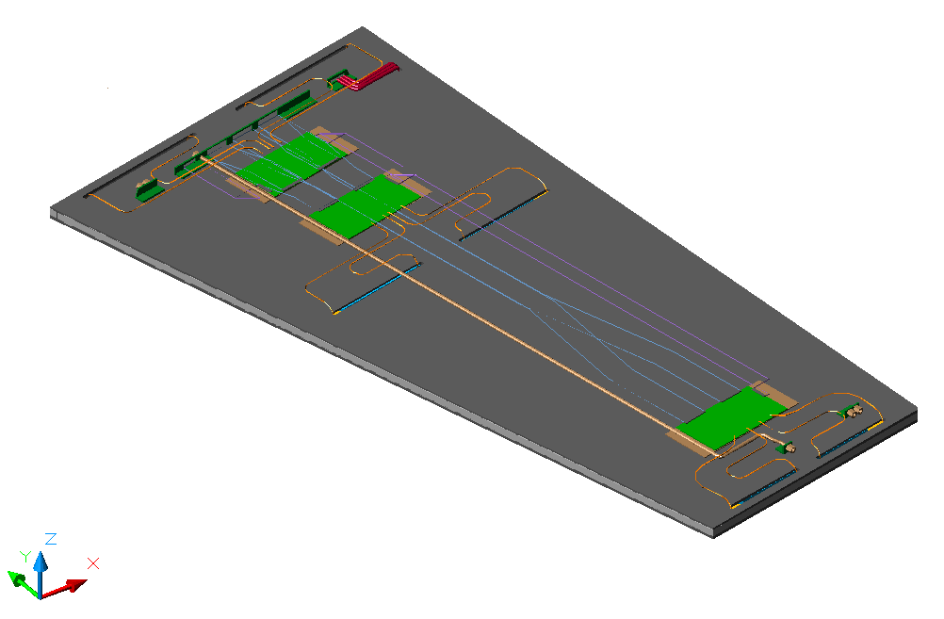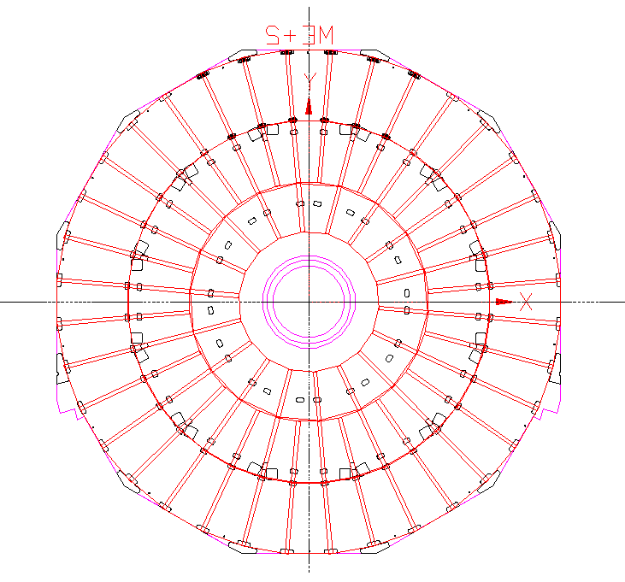
Figure 2.1: a)schematic layout of a forward double gap RPC; b) layout of the an RPC layer on the yoke disk

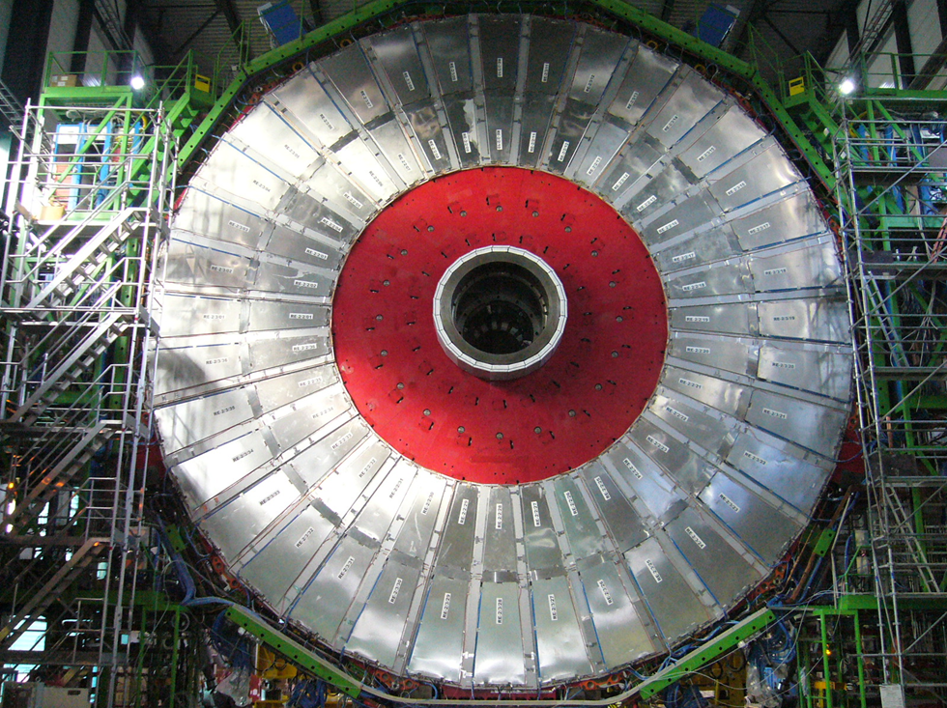

Figure 2.2: RPC third layer on the +z end cap.

2.2 RE4 geometry (Walter , Salvatore B.)

The new RE4 layer will be composed of two concentric rings (RE4/2 and RE4/3) of RPC. Each ring is therefore composed of 36 chambers. There will be 144 chambers, 72 per end cap. The

RPCs chambers will be of the standard CMS forward design.

2.4 Integration of station RE4 (Walter , Salvatore B.)

The new RE4 station will be installed on the back of the YE3 yoke. The near yoke detectors will be mounted on an aluminum interface frame mounted off the threaded M16 holes at the extremity of the CSC mounting posts as illustrated in Figure 2.6. The far detector can then be mounted using a similar frame. This solution decouples the installation of RE 4 from the existence of the YE4 shielding wall. The nominal clearance to the shielding wall will be 9 mm provided the interface frames have a thickness of 8 mm.

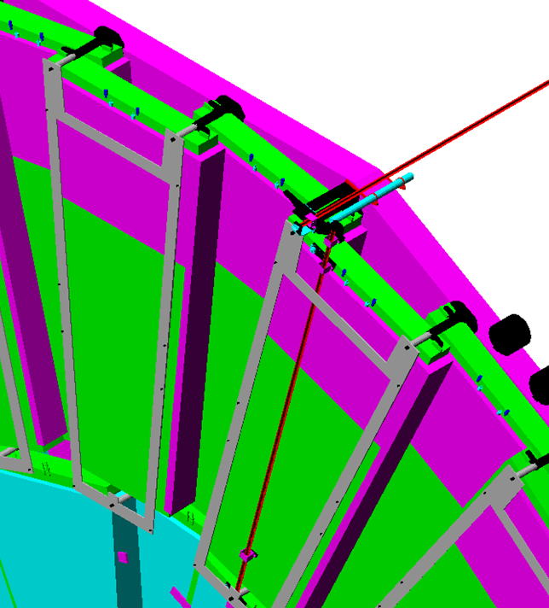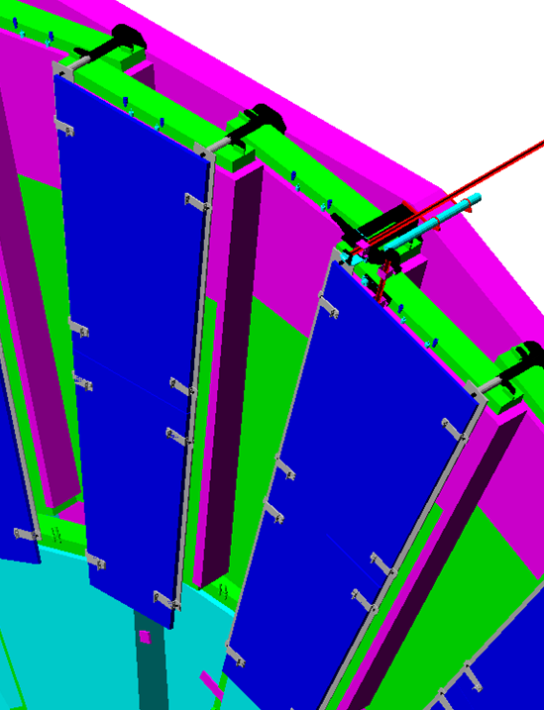

Figure 2.6: mounting of RE 4 stations with the interface frame attached to the CSC posts.

The services to RE4 will be housed on the YE3 yoke where the infrastructure already exists. However no services to RE4 have as yet been installed since they were part of the staging scenario. The infrastructure services to be added to YE3 are:

- a gas distribution rack with 72 channels and the necessary pipe work to the adequate bulkheads;
- the pipe work for the distribution of the cooling fluid;
- the LV cabling to the power supply system in the YE3 towers;
- the HV cabling to the YE1 Patch Panel;
- the necessary link boxes and related cables and fibers.

As a consequence the end cap main cable chains will have to be opened to install the missing umbilical links to the SX5 cavern. Adequate space for this completion has been reserved in the main- and mini cable chains.

3 Electronics (Flavio , Waqar)

3.1 Front end board

The same RPC Front End Board (FEB) developed in the past and mounted on the chambers in operation will be employed. It contains four 8-channel ASIC Front End Chips (FEC) consisting of amplifier, discriminator, monostable and differential LVDS line driver. The VLSI are available from the past production and from some recent production done for the PHOENIX experiment. The baseline option considered for the FEB mass production is the procurement in Pakistan.
Figure 3.1 shows a picture of one 32 channel FEB. About 1000 new boards will be necessary to instrument the new RE4 layer.

Few words about distribution board………..

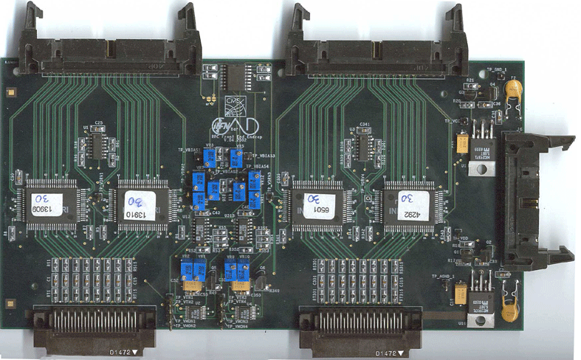

Fig. 3.1: Front End Board

3.3 Off detector electronics ( Pigi, Maciek)

The output of the FEBs will be sent to the Link Board system (LB) where the synchronization with the LHC clock, the optical conversion and the transmission to the Trigger Electronics are performed. The new layer 4 has to be equipped with a complete new sub set of LBs. Table 3.1 gives the number of additional components needed to complete the LB system on the detector side, while table 3.2 shows the other trigger components due to be installed in UCS.

 |  | RE4/3, RE4/2 on YE3
 |  | needed | spare | total
 | LB mechanics | 12 | 2 | 14
 | LB Back Plane | 12 | 2 | 14
 | MLB | 48 | 10 | 58
 | SLB | 96 | 10 | 106
 | CB | 24 | 6 | 30
 | FP | 24 | 6 | 30
 | OP | 12 | 2 | 14

Table 3.1: list of LB system components needed for the restoration
 |  | Trigger system in USC
 |  | needed | spare | total
 | Trigger Boards | 10 |  | 10
 | TCB | 0 |  | 0
 | TCBPIB | 0 |  | 0
 | Splitter board | 12 |  | 12
 | PAC30 | 120 |  | 120
 | PAC60 | 20 |  | 20
 | RMB | 30 |  | 30
 | VME | 30 |  | 30
 | Sorter | 30 |  | 30
Table 3.2: list of trigger components needed for the restoration

4 Services

4.1 Gas system ( Salvatore, Roberto)

At present no work has been done for the fourth layer besides the necessary piping for the control of the intended gas rack. The supply and return piping to RE3 chambers have been sized to allow also RE4 chambers to be tagged on. It will be necessary to find the space for an additional gas rack. Space is available next to the RE3 gas rack while space above is slightly obstructed with RE3 piping.

4.2 Cooling ( Salvatore)

The cooling system will be drained independently of all other sub-detectors. The flexible section of the piping may have to be replaced or modified but once the chamber patch panels are reached only the inter chamber connexions will have to be re-done. We suggest to use Sagana double ferrule unions that are metric, cheap in the brass version and easy to connect.
The cooling loads design parameters on the present system already foresees the addition of RE4 chambers. However since the plan was to build a cooling manifold onto the YE4 disk, there are no take-offs for the RE4 cooling on the YE3 manifolds. The option of adding takeoffs for RE4 on the YE3 manifolds is being considered.
Given the low heat loads of 700 Watts for the entire RE4 over a vertical surface and the adjacent cooled CSCs , there should be no problem for either party.

4.3 Signal read out (Ian, )

Additional 504 signal and DCS cables between the Link Board crates and the RE4 chambers will have to be procured, connectorised, labelled, tested, installed and the system commissioned.

4.4 High voltage ( Saleh)

For the new RE4 layer, power supply modules (6 x CAEN A3512s) will be required in the USC. All cabling has been done to the installed Easy Crates. The fan out crates are planned and will be available this year. The large diameter multi conductor cables are in place in the main cable chains and into the HV USC racks but have not been connectorised in the USC. They are assembled and connectorised into the PP in UXC. However the cabling from the PP up to level 4, to go through the Mini cable chains to YE3, is not available. Both, procurement, connectorising, testing, installation and commissioning will be required. Space has been planned and reserved in the mini-cable chains.

4.5 Low voltage ( Saleh)

New cables from the CAEN A3009 power supplies to the RE4 chambers will have to be procured, connectorised, tested, and installed. No more AC/DC converters will be needed to power the fourth layer; however six more A3009s on each end cap are needed and will require space to be shared in the adjacent Trigger Easy crate.

4.6 T/RH sensors ( Salvatore, Stefano)

..........................................

5. Production facilities

In the following the main aspects relevant to the chamber production will be briefly reviewed. All the numbers quoted below refer to the production of 200 new chambers, out of which 144 will be needed for the RE4 station and the remaining 56 will be kept as spares for the RE2/RE3/RE4 forward system.

5.1 HPL production ( Ian , Salvatore B)

Production of HPL electrodes will follow the same procedure already established in the past. The main steps are: production of the HPL foils, quality check for resistivity measurement and surface quality, cuts of the foils to the required size and finally surface cleaning of the obtained components.
Raw material production will take place at the ............ industry near Pavia. This company has the necessary expertise and experience to produce low resistive (1-2 .10¹⁰ Ω cm) HPL as required. Recently a small production with the same CMS specifications has been successfully achieved, ensuring that the proper production set parameters can be reproduced.
About four hundreds 1600 x 3200 mm² foils for a total of 2000 m² are necessary. A preliminary planning draft discussed with the producer shows that about 4-5 months are required for the production assuming a one month cycle for the production and quality control of 200 foils at the time.
Quality check will be pursued at the Pavia INFN site. Here the resistivity measurement table already used in the past will be re-commissioned and made available for operation. The Pavia group will assure consulting for the running of the device while measurement operations will be under forward community responsibility.
Successive cutting and surface cleaning procedures will follow according to the scheme already established in the past respectively at RIVA (Milano) and General Tecnica (Frosinone)

5.2 Gap production (Pino , Sung)

The gas gaps for the forward upgrade RPC chambers will be produced by KODEL at Korea University. KODEL will use the same technology as developed for the production of the initial 432 forward RPC chambers. A total of about 600 gaps are needed for the low η restoration. However, based on previous experience, about 30% additional production should be planned for a total of 900 pieces. The general production procedures can be divided into several sequential steps.

Initially HPLs will be inspected for defects in color, scratch on the surface and any mechanical damages on the edges and corners. The surfaces of all selected HPLs are cleaned with IPA. After the HPLs are cleaned, the surface is graphite coated. The next step is to insulate the graphite surface with PET film. PET film is glued to the graphite surface by the machine shown in Figure. 5.1a. The gaps are then assembled and placed under a pressing machine (Figure 5.1b) for 24 hours for glue hardening.

All assembled gas gap are treated with linseed oil mixed with heptane. The rate of linseed oil administration into the gas gap placed in its vertical position is 100 cm/hour. After the completion of the linseed oil administration, a small compressor is used to immediately remove the remaining oil in the gas gap. Then, dry air at 40 °C is circulated over the oiled surfaces of the gaps. The flow rate of air is from 60 to 100 liters/hour. And the period of the air circulation is from 48 to 72 hours.

A check of the mechanical and electrical quality of the gas gap is finally performed. The criteria for accepting the gas gap are very strict. For the mechanical test, no pop-up spacer should be found when the gas gap is pressurized with +20 hPa for 10 minutes. In addition, the rate of leakage of the gas gap should be less than 0.2 hPa for 10 minutes. For the electrical test of the gas gaps, high voltage is applied to the gas gap and the amount of current drawn is recorded. First a voltage of 8.5 kV is applied for 12 hours, then a voltage 9.4 kV is applied for 96 hours. The current limit for accepting large gaps is 3.0 µA.

For the gas gaps which pass the tests, transportation is arranged. Wooden boxes are specially designed for safe transportations. The gaps inside the wooden box are stored vertically and are clamped by using partially pre-stressed bars.

The transportations are normally done via air-carrier for the safety reason. All gas inlet and outlet pipes of the gas gap should be open for sudden change of the atmospheric pressure during the transportation.

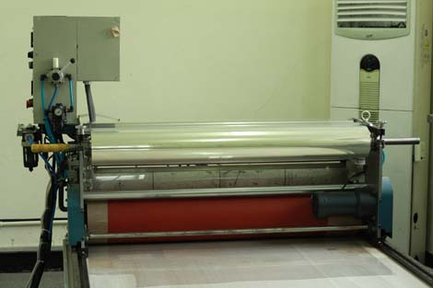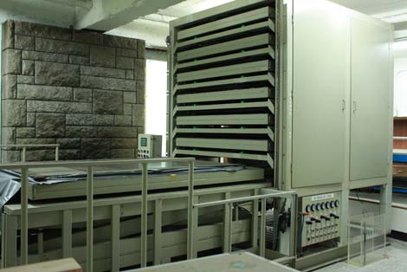

Fig. 5.1: a) electrode insulation machine;
b) gap assembly machine.

Gas gap production schedule has two components. The first three months from July till September are needed for preparation. Mass production will take place in the following 12 months. During each three months period, about 300 gas gaps will be completed and shipped to chamber assembly sites. One scenario is to start with RE 2/2 positive side for the first period. During the second period, RE 2/2 negative side will be completed. RE 2/3 positive and negative side will be completed and shipped during the third and fourth period respectively.

5.3 Chamber mechanics ( Luc , Yong)
The chamber mechanics is composed by several components:

- honeycomb box;
- auxiliary parts;
- cooling circuit, FEB support and screen box;
- readout strips plane.

Honeycomb box
The box is made of aluminium top and bottom honeycomb plates and four edge bars. The honeycomb plate is 6 mm thick, composed of 0.5 mm thick top and bottom Al covers sheets, and 5 mm thick Al honeycomb core; at the four edges and few other positions (where slots or threaded holes will be located) 5 mm thick solid Al plates will be inserted in the honeycomb core. The cross section of the edge bar is 16 x 16 mm². Figure 5.2 shows the layout of a typical RE honeycomb plate.
Production of honeycomb plate proceed as following: the 0.5 mm thick Al sheets are cut to shape and the surfaces are oxidized; additional 5 mm thick Al plates and the Al honeycomb cores are glued at the edges and in the middle; the assembled plates are heated at 120º temperature to cure the glue; finally the slots and holes are machined. We plan to use a CNC machine to make all parts inter-changeable.
Figure 5.2: layout of a typical RE honeycomb plate
New figure from Luc, Yong

Auxiliary parts
These parts include the front patch panel, the joint pieces for mounting the chamber in the yoke, the inside chamber fixation pieces etc.

Cooling circuit, FEB support and screen box
This part is made of copper pipe soldered onto three copper plates, where the FEB will be mounted. The screen box made of 1 mm thick Al sheets will cover all cooling and FEB system.

Readout strips plane
The readout strip planes are divided into three sections as shown in Figure 5.3, the gapbetween the strips is 2 mm.

Figure 5.3: layout of a typical RE strips
New figure from Luc, Yong
The plane is 0.3 mm thick, with a 0.035 mm thick copper cladding. Strips are produced by etching method. By request, the factory could heat-cover the strips plane with a 0.15 mm thick Mylar sheets for protection and insulation. The honeycomb boxes and auxiliary parts will be produced in “Beijing Axicomb Technology co., Ltd” (China) and the readout strips will be produced in “Beijing Gaonengkedi SGT co., Ltd” (China). We have a long term collaboration with both companies since they have already successfully provided good quality mechanics for the RE station built and installed in CMS. For the 144 RE4 chambers, the companies could complete the production of the mechanics within three months after signing the contract. Considering the time needed for the transportation, ordering the mechanics six months before the chamber assembly is recommended.

5.4 Chamber assembly and test sites

The 200 new RE2 chambers will be assembled and tested at different sites according to the following Table 5.1:

Type of chamber | # chambers | Assembly site
RE4/2 | 40 | Mumbai-BARC
RE4/2 | 60 | CERN - 904
RE4/3 | 40 | Ghent
RE4/3 | 60 | CERN - 904

Table 5.1: chamber assembly sites

5.4.1 CERN 904 site (Archana)

On the 904 premises at CERN, an assembly and test laboratory will be set up for the production of the RPC chambers. This facility will includes the assembly tables and tooling facilities for gas gaps QC/QA as leak tightness, popped spacers, HV behaviour. A cosmic hodoscope will also available to test up to 10 detectors at once and determine all physical working chamber parameters.
The manpower to run this facility will be provided by the respective institutes when their detectors are being tested.

Figure 5.4: RPC assembly and test infrastructure at the CERN ISR

5.4.2 Belgium ( Walter, Michael)

The chamber construction will be the main effort of the University of Gent. At this institutes a chamber assembly and test facility is presently being setup. It is foreseen that in Gent 36x2 new RE4/3 chambers will be assembled to instrument an entire new RE4 outer ring station.
To simplify logistics most of the fabrication of assembly tools, small mechanical detector pieces, signal cables for signal readout, storage racks, etc. will be handled by the mechanical workshop in Gent. All commercially available components, e.g. cooling lines, gas tubes, connectors, foils etc. that are required for the chamber assembly will be purchased in common orders with other sites for all sites to ensure a uniform chamber construction.
The gas gaps will undergo a basic quality control before the assembly. The test procedures will be similar to those performed in the previous construction phase at the CERN ISR test facility. All gas gaps will be tested for unglued spacers and gas tightness using Argon. High voltage behaviour will also be tested with a gas mixture of Freon and Iso-butane (no SF6). Once the chambers are assembled, a complete test with a cosmic hodoscope will be performed before the transportation to CERN.

5.4.3 India ( Lalit)

Under India-CMS-RPC collaboration, RPC assembly and testing would be the main effort of Nuclear Physics Division-Bhabha Atomic Research Centre (NPD-BARC) at Mumbai. Panjab University at Chandigarh will contribute with the preparation of component and providing expertise for the assembly and test phase.
The RPC Lab at NPD-BARC, Mumbai, is fully operational and basic quality control procedures have been set up for assembly and testing. Recently ten RPCs which have been assembled and tested there, in collaboration with Panjab University and Delhi University, are at CERN. Figure 5.5 shows assembly and testing infrastructure at BARC.

……………………………

Fig. 5.5 : RPC assembly and test infrastructure at NPD-BARC, Mumbai

The lab has an associated storage area and is backed by a robust workshop for handling all the relevant mechanical jobs. The HV, LV, 4 channel gas mixing unit, 8 channel gas flow system and gas recovery unit are fully operational. The cosmic ray stand can handle eight RPCs of RE4/2 type at a time. Scintillators of the relevant sizes are under fabrication at BARC, Centre for Design and Manufacture and accordingly the cosmic hodoscope would be set up to study the chamber performance. Efforts are underway to have an independent air conditioning system for controlling the relative humidity at 45-50% level round the clock. Electronics and DAQ have to be upgraded to handle more chambers simultaneously. Expertise from CERN would be required for setting up the cosmic hodoscope to test up to 8 detectors together and determine all RPCs physical working parameters.

5.4.4 Pakistan ( Waqar, Hafeez)

Pakistan will be responsible for FEB mass production in Pakistan. Fifty FEBs will be produced at the end of October. After complete validation of FEBs , mass production will be started at the beginning of 2011. We required 600 FEBs including 10 % of contingency. Required time is approximately three months which include the time of procuring of components, developing of PCBs, stuffing of components and testing of final FEBs.

Before shipment to CERN, validation tests will be performed in Pakistan such voltage threshold setting (VTH), voltage biasing setting (VBIAS), voltage monitoring (VMON) and I2C for quality assurance.

6 Project organization (Pino, Walter)

6.1 Responsibilities assignment

Restoration of the low η RPC forward system will involve a large community of physicists around the world. Besides the major responsibilities already discussed in this document for the chamber production, other relevant responsibilities related to important detector components or to infrastructure services should be acknowledged. Table 6.1 gives a complete overview of the responsibilities for all the items related to the RE re-scope.

Item | BL | CH | CN | IN | IT | KL | FI | PK | PL
HPL prod.
HPL QA

Gap prod.
Chamber. mech
Chamber assem.
Front-end design
Front-end prod.
HV/LV system
LB design
LB prod.

Infrastructure

Table 6.1: overview of the tasks responsibilities (legend: BL=Belgium, CH=CERN, CN=China, IN=India, KL=Korea, FI=Finland, PK=Pakistan, PL=Poland).

As already mentioned some of these responsibilities will be related to deliverables and appropriate funding commitment of the funding agencies. In other cases they refer to the coordination of some relevant parts of the projects based on existing expertise and competence already available from the group involved in the design and construction of the initial system.

HPL production and certification
CERN will coordinate the logistic for the HPL production and quality assurance. In this context INFN Pavia will make available the proper tooling for the QA and some expertise will be available for its maintenance during 2009.

Gap production
KODEL has the primary responsibility for gap production, certification and delivery to the chamber assembly sites. In case part of the production is moved to General Tecnica, CERN will take over the coordination of the relative fraction.

Front-end board
Design of the extended AND/OR board and front-end QA will be coordinated by INFN Bari. For the production, which will be a shared responsibility among the main funding agencies contributing to the chamber delivery, various option are being considered. The preferable one is to ensure the production at Matrix s.r.l (Bari) which manufactured the front-end boards for the initial system. Also India and Pakistan are enquiring local electronics manufactures to understand the feasibility and cost of production in these countries.

Off detector electronics
Again, the groups already involved in the Link Board and trigger board production will coordinate the upgrade design (Warsaw) and the production certification (Lappeenranta).
Lappeenranta could also take some responsibility in the production, although a share among other Institutions is foreseen. The preferable scenario for mass production is the involvement of the company where the past production for the initial system took place.

HV/LV system
The power system is an obvious extension of the one already installed in CMS, produced by CAEN (Italy). The procurement responsibility will be shared among the Institutions mainly contributing to the chambers delivery. CERN may play a role by centrally coordinating the procurement procedures.

Infrastructure
CERN will have a major role in the infrastructure definition and assessment such as cooling, signal cabling, HV/LV cabling. It will also have the responsibility of the 904 test site running and maintenance.

6.3 Schedule

The possible schedule for the RE up-scope project is quantized since chamber installation can only proceed during a long shutdown period. The most aggressive scenario would lead to an installation of the phase I detectors during the 2011-2012 winter break (figure 6.1). The schedule given below assumes this option but it should be understood that the overall CMS maintenance may have different priorities during this first long shut down. In this case the phase I deployment will only be possible during a subsequent shutdown. Milestones are indicated in Italic.

…………………………………… new figure

Figure 6.1: tentative schedule for chamber installation in the 2011-2012 shutdown. Milestones are indicated in Italic.

Major milestones for 2010 are:
- start up of the HPL production in summer;
- start up of the gap production in fall;
- preparation of the assembly sites in December.

6.4 Cost (Pino, Walter)

The estimated cost of the phase I up-scope is shown in the Table 6.2 where it is broken down into the major categories of expenditures.

ITEM | TOT  (kCHF)
Detector components
Front-end electronics

Off detector electronics
HV LV systems
Services/ infrastructure
Cable
Logistic CERN
Assembly & installation
Monitoring

Table 6.2: cost subdivided into the major categories of expenditures.
The cost per ring is also given.

.

