Safety tour am 20 April 2014.

Upon Niel’s request, an attempt to list ECB ( Empty card boxes) and SECB (semi empty card boxes)

Below is a view of packaging that may or may not be necessary underground. I do not pretend to be the judge.

A very full bin of card boxes near the Cryo filter jig.

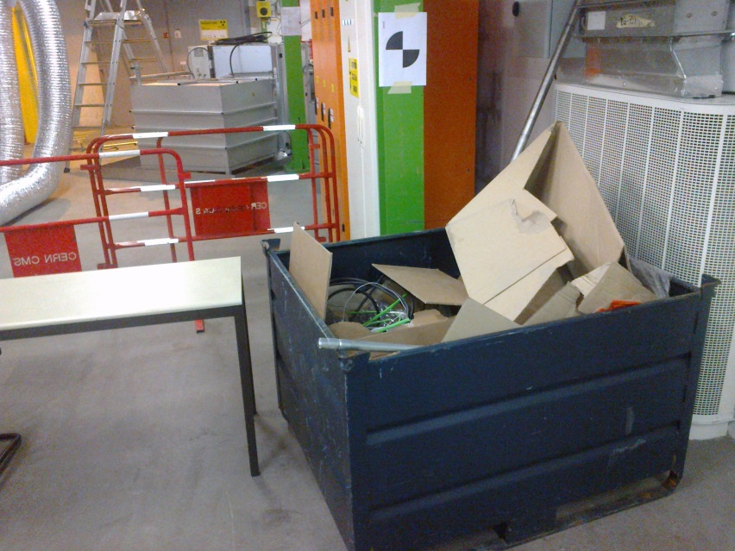

In the cryo area

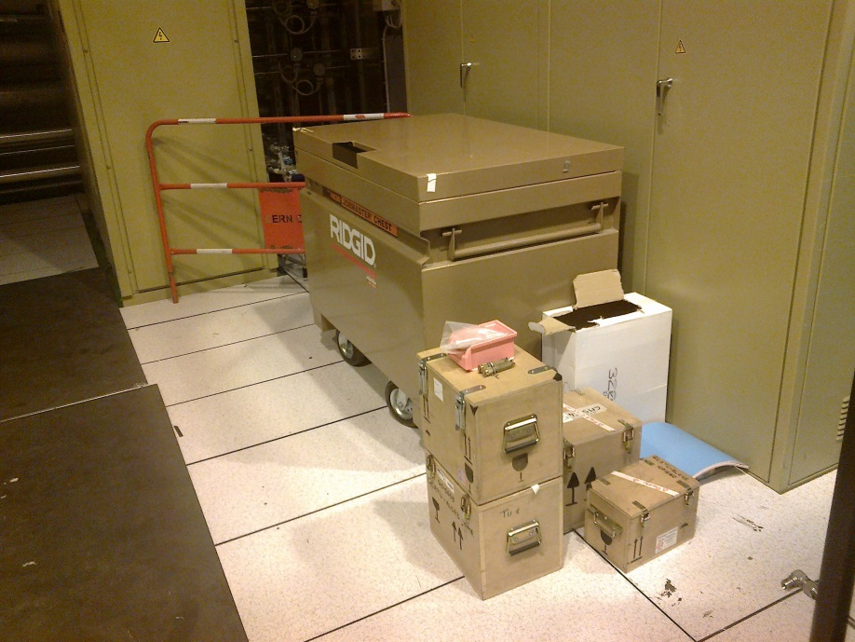

Two more photos of SECBs in the cryo area.

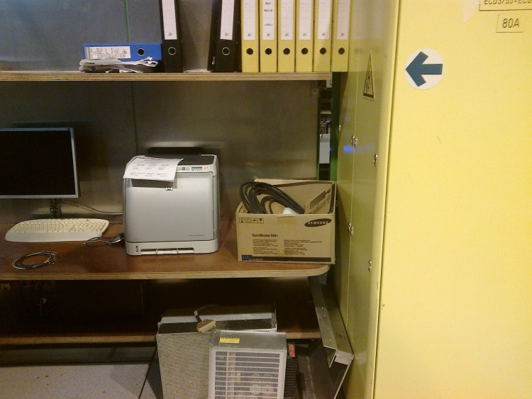

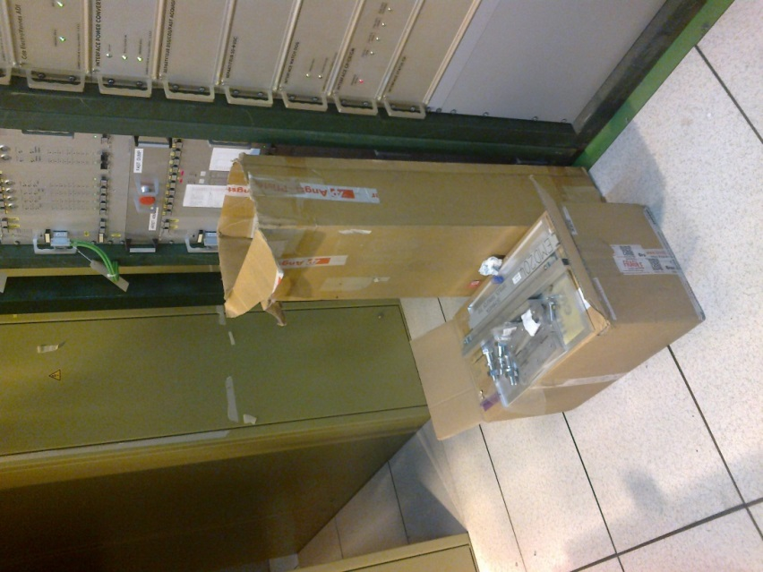

Packaging of rack doors ? -1

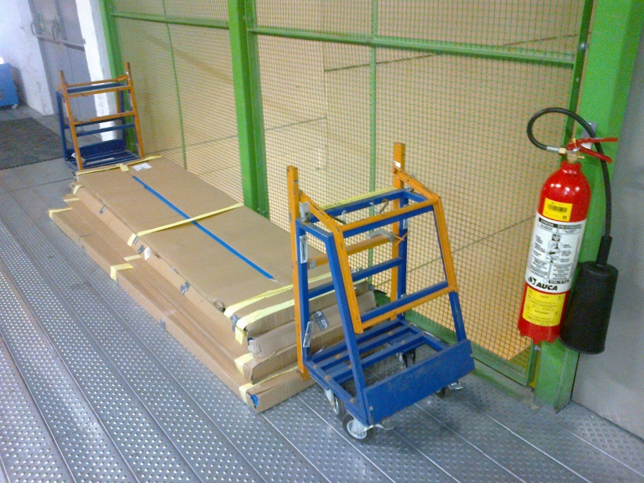

SECB behind S2A02 and S2b02

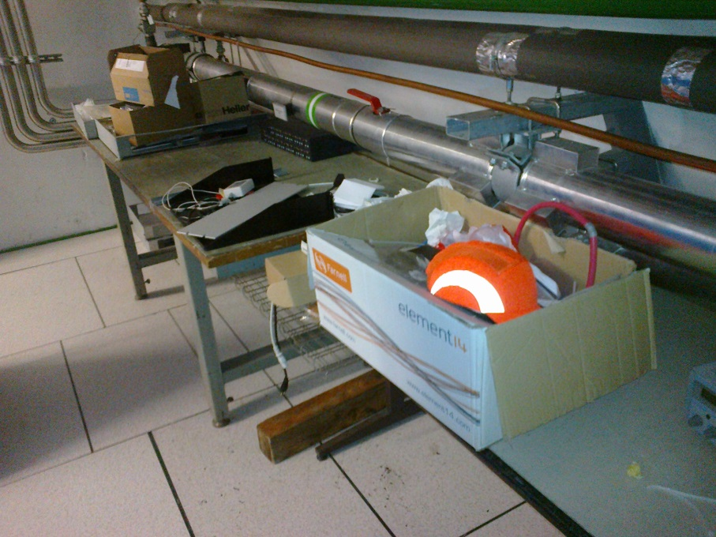

UCR

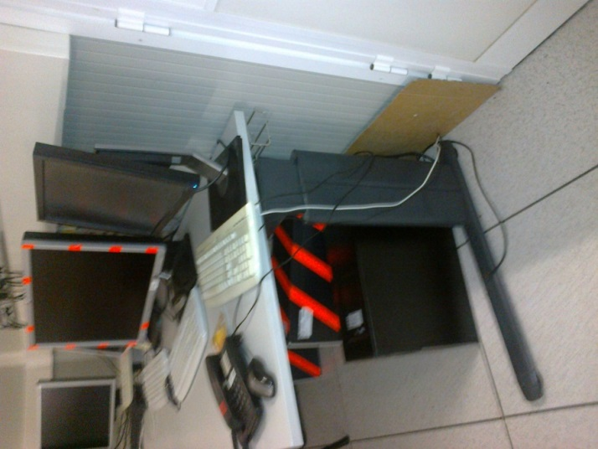

UCR

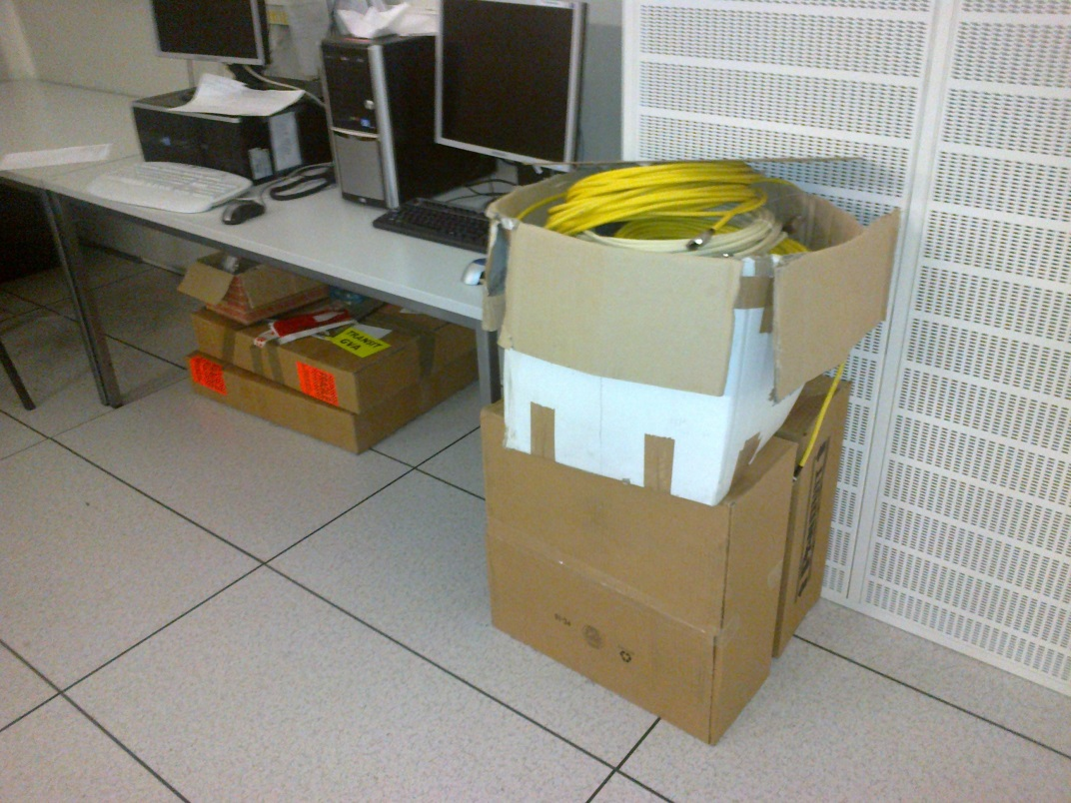

UCR, 2 card tubes.

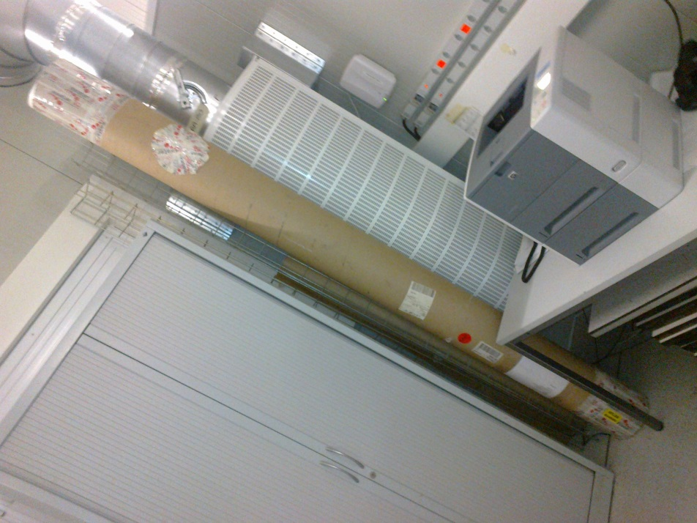

UCR stuff

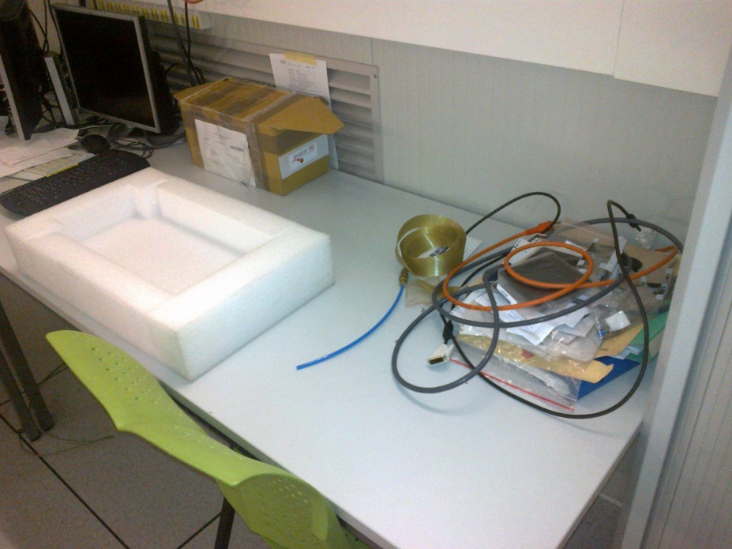

Above laser room, our RPC stuff !

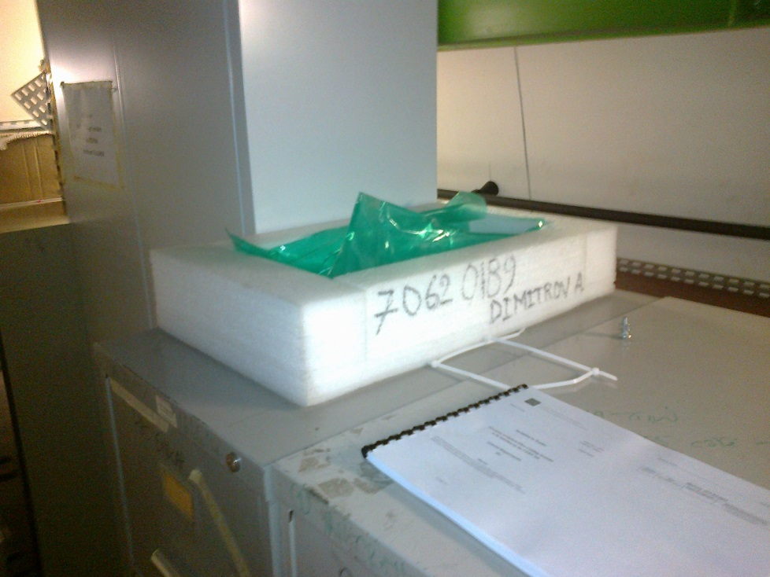

Near laser room

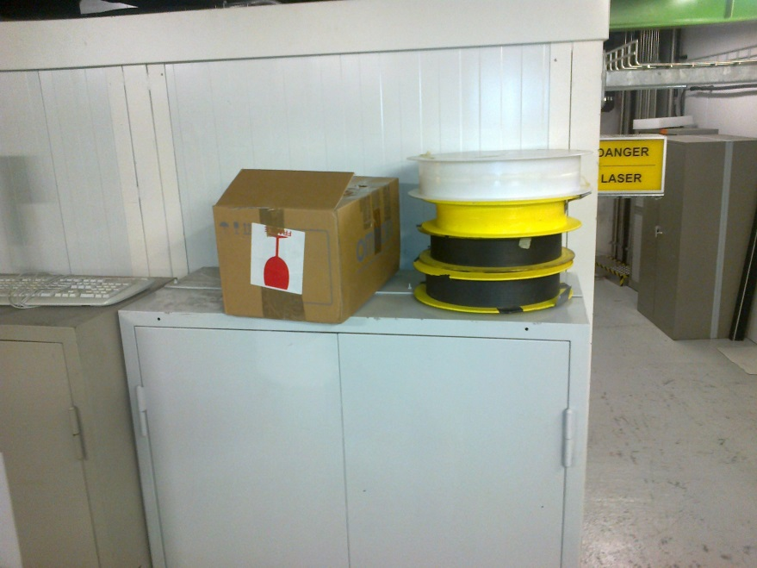

Near laser room

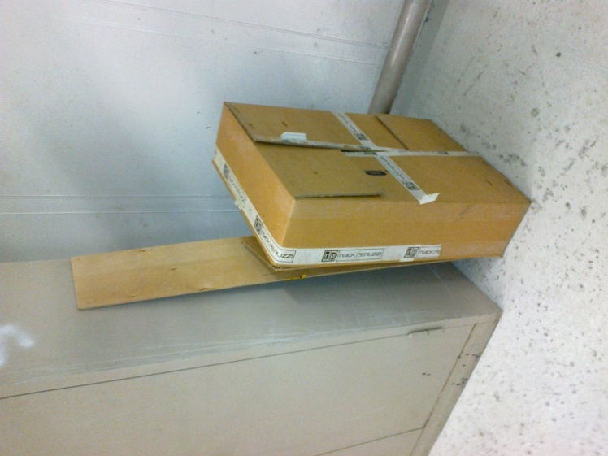

UGX, empty cable drum

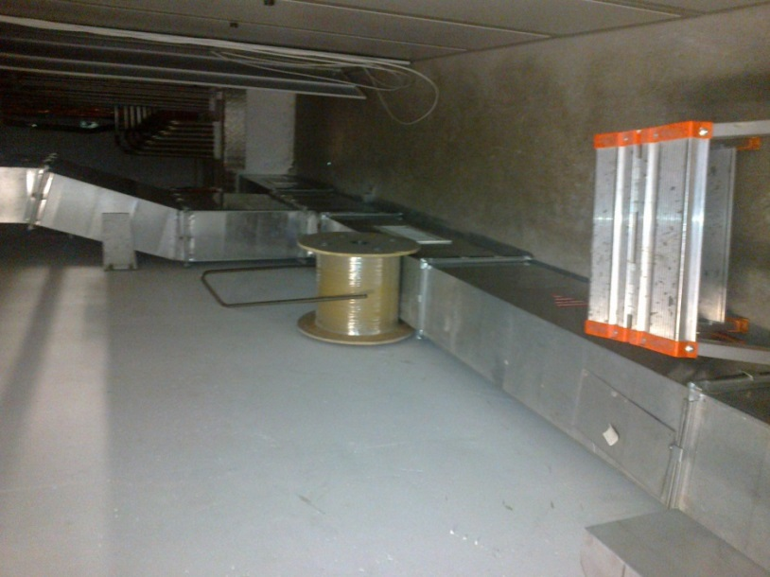

UGX, hard board and PMM/PC

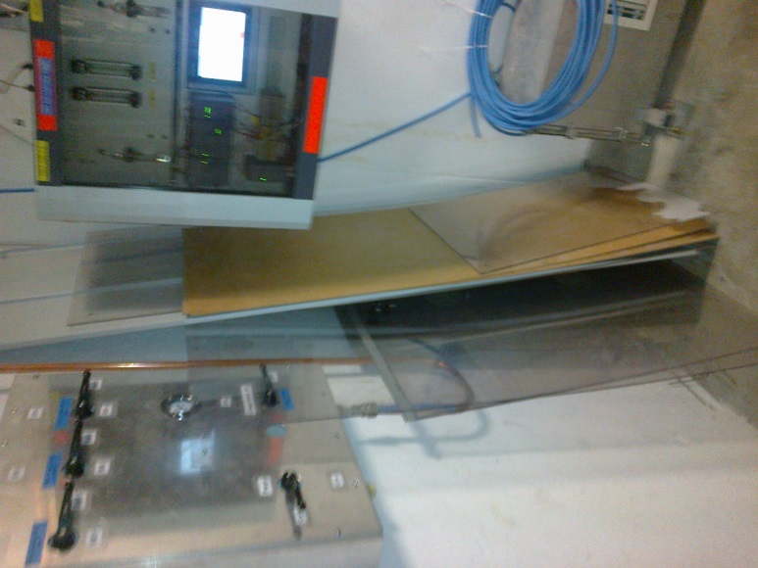

UGX

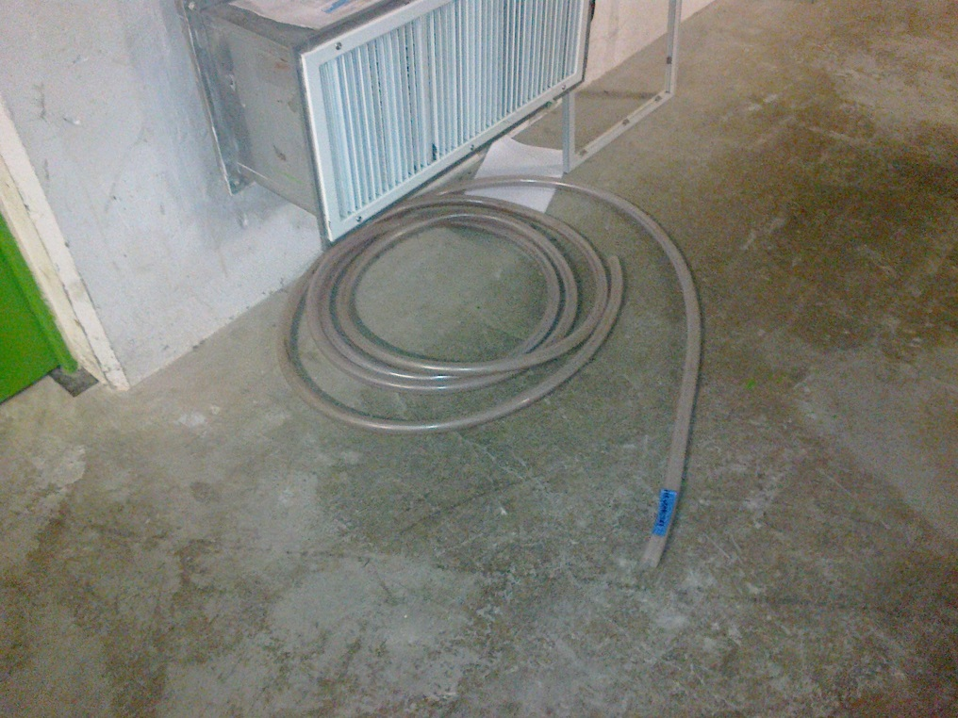

Under the HV RPC racks an ECB can be seen, in the photos below.

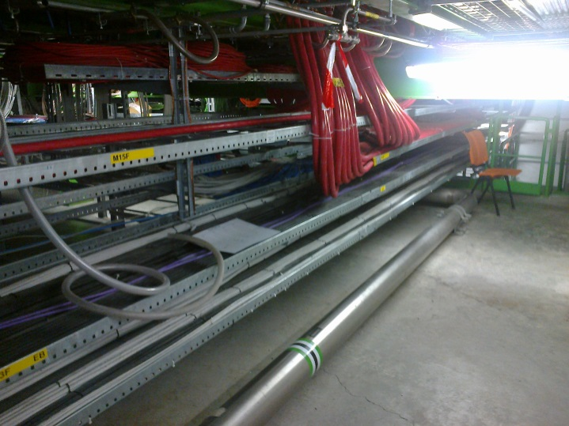

I estimate it is under S1E09

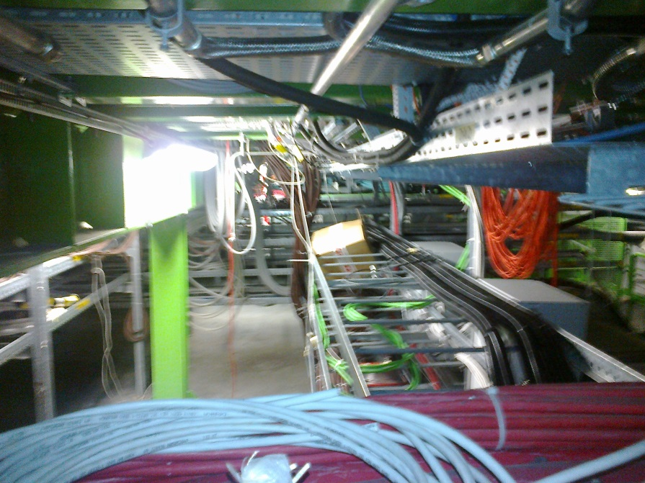

Opposite S1G11 near HV RPC

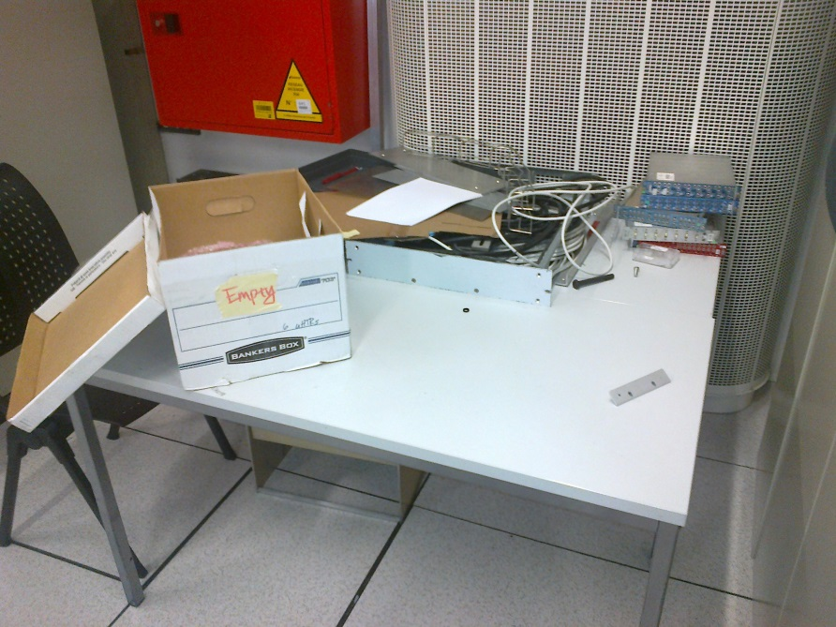

And underneath

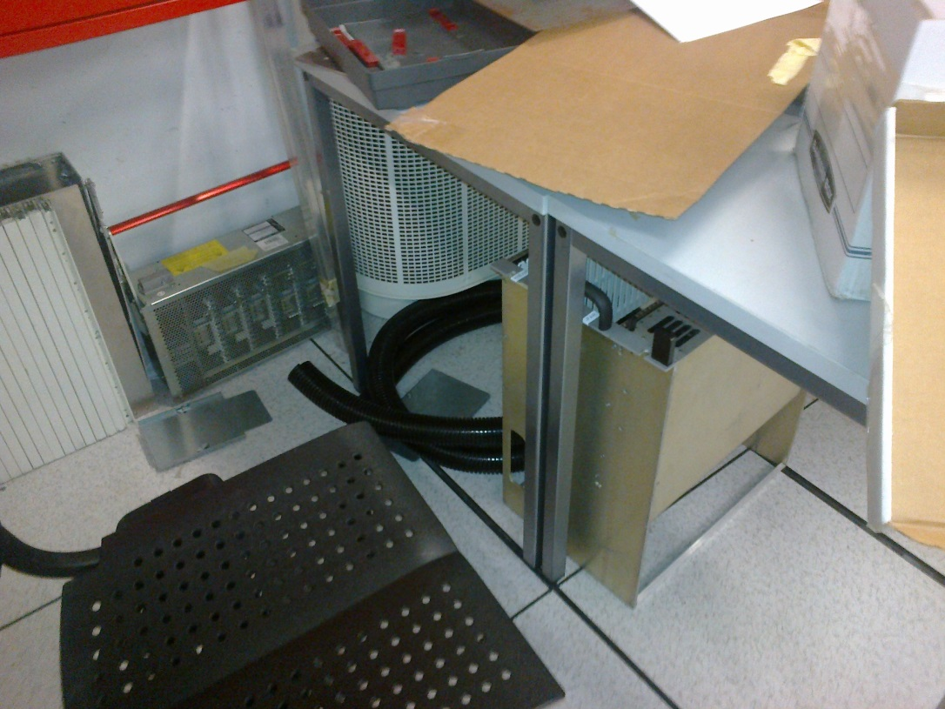

A pipe to fall over on behind RPC HV racks.

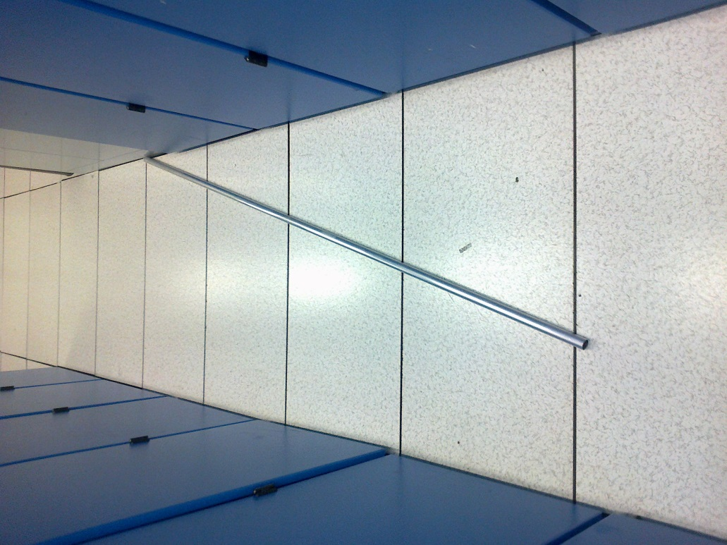

Further along the racks a 220v plus that should not be left for out.

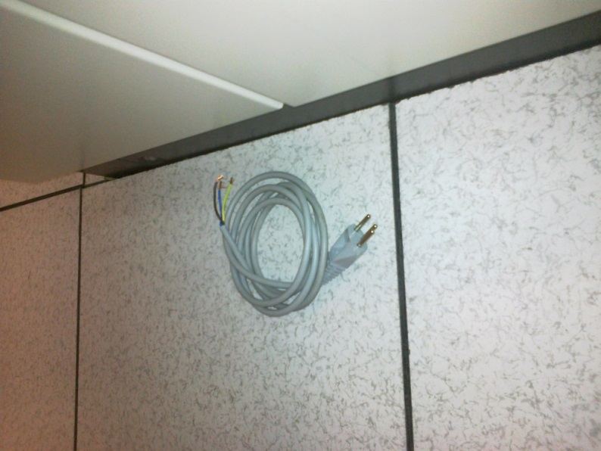

Under ground Wc area

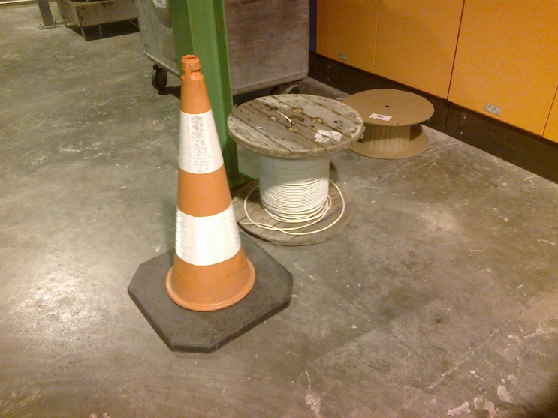

U WC drums ?

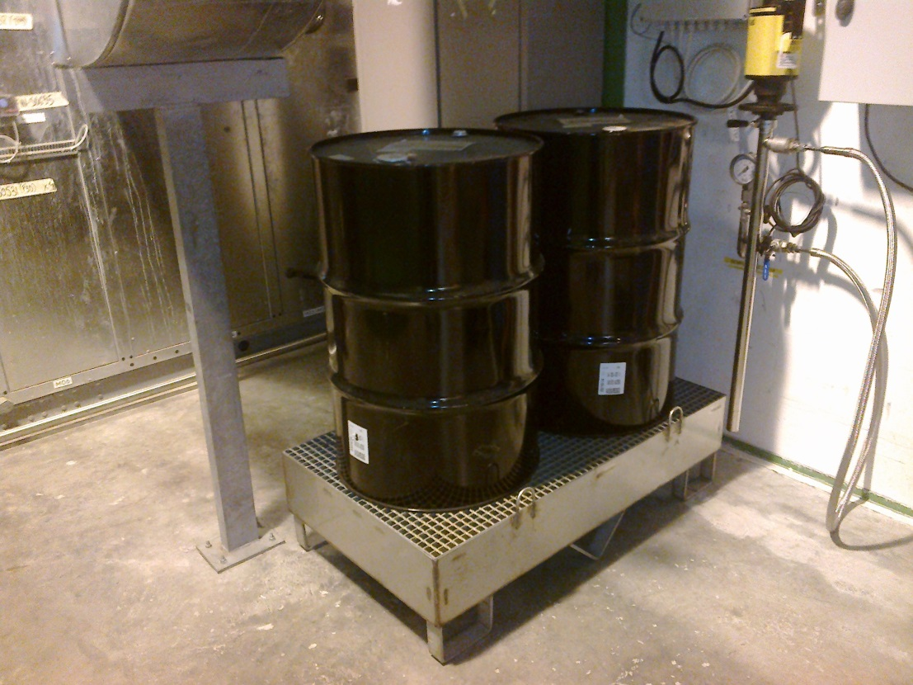

U WC near AC unit, old PVC pipe.

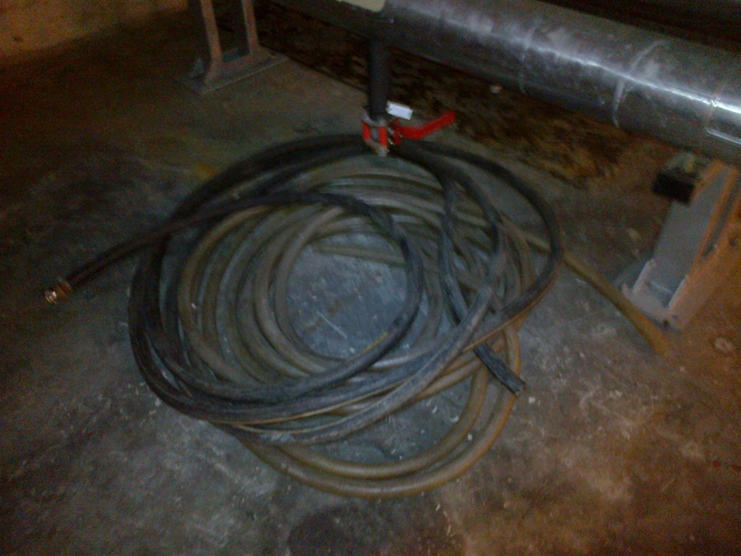

In the TX area there is large quantity of ear plugs. True they are readily accessible.

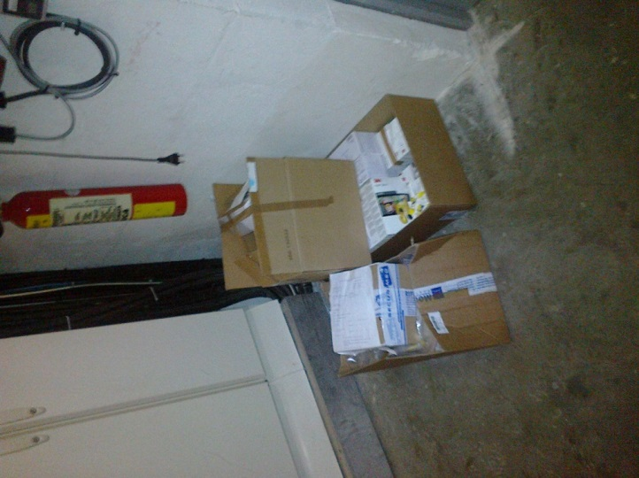

In the TX,

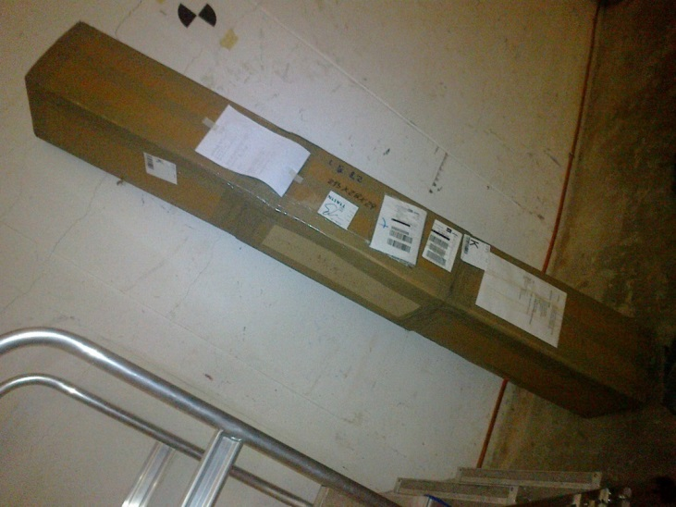

In the coffee area next to the SCR there is a full palette of Coffee machine/coffee ??

No photo.

3562 C. Farm

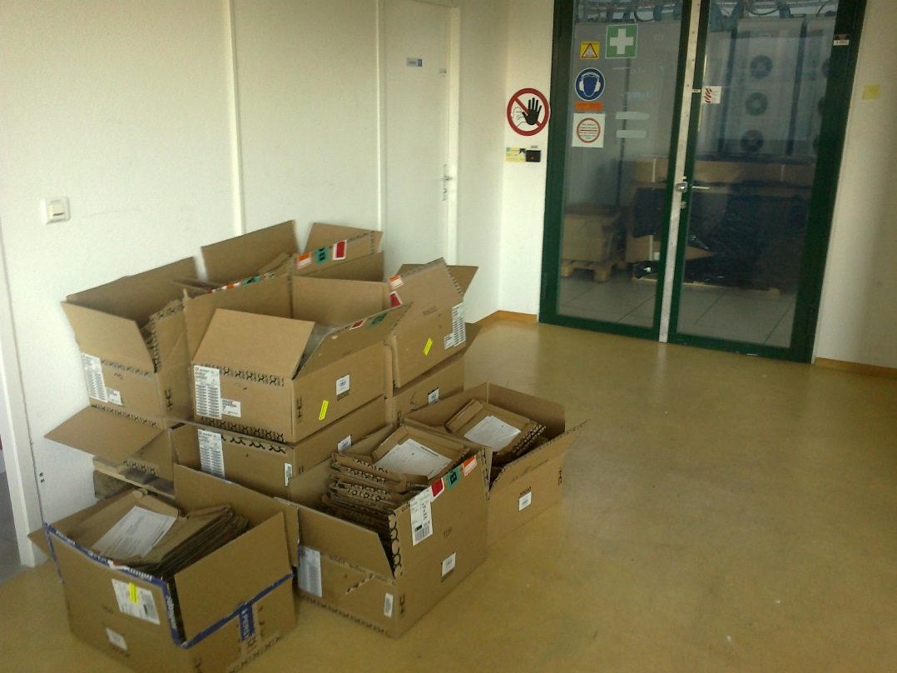

And inside.

