Foam Genereator charcteristics

Kidi in CMS

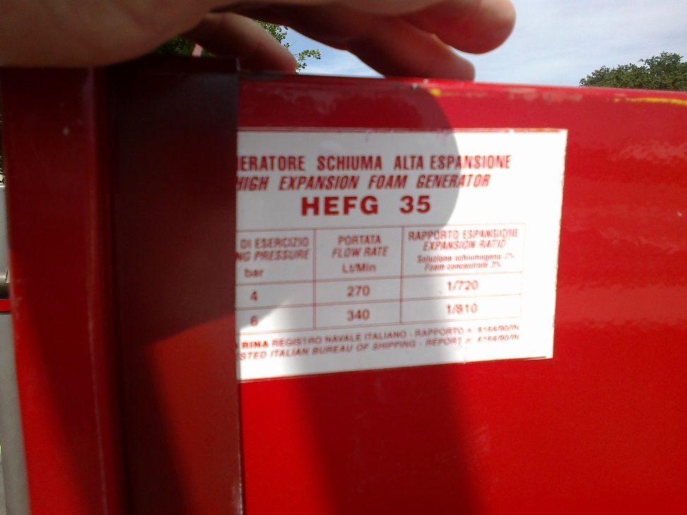

Bar Flow Rate Exp Ratio

4 270 720

6 340 810

SKUM Products.

<http://www.skum.com/pages/products/products.asp>

<http://www.skum.com/pages/Products/datasheets/HotFoam%20systems/1022-50%20HG%20ENG.pdf>

http://www.skum.com/HTML/PDF_Files/Hi-ex%20systems/SKUM%20HG%20HiEx%20foam%20generator_FDS14315%200214%20LR.pdf

An Example HG-15

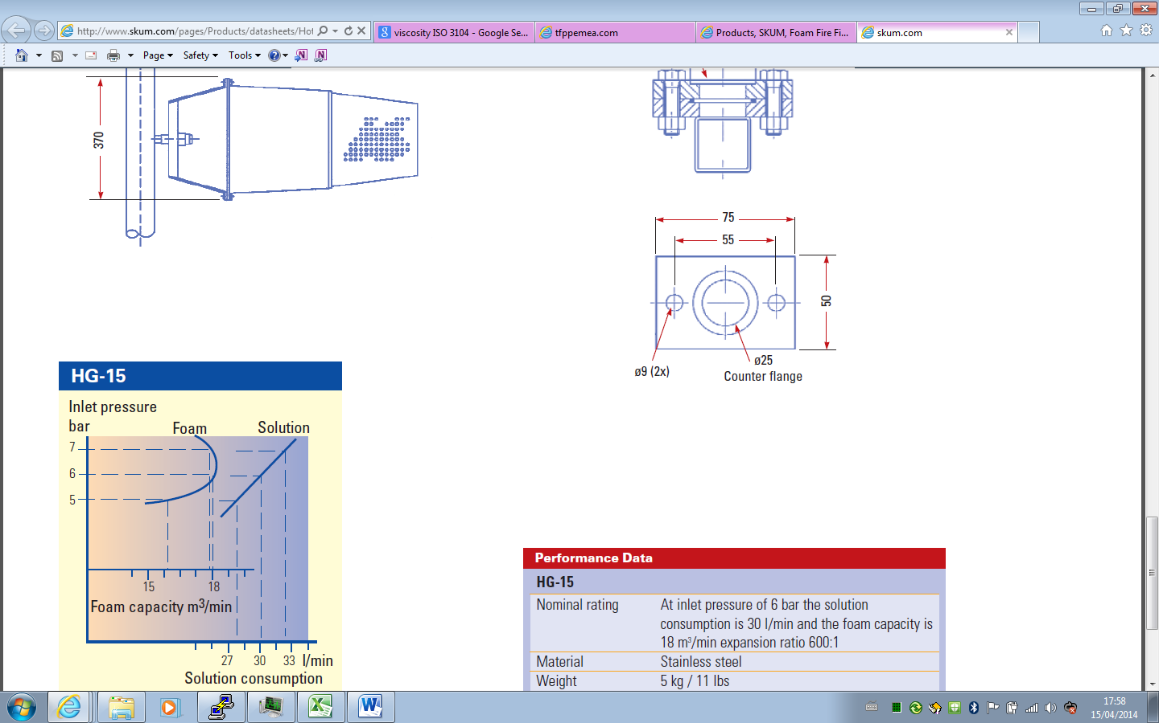



Other manufactures