Foam test Madrid
3-9 July 2016 Ian Crotty
GUADALAJARA, near Madrid

Mr. Oscar OTERO
Fortem
Polígono Industrial La LLave, Calle del Cobre, 41 - 42, 19170
El Casar, Guadalajara, Spain
Phone:+34 949 29 27 23
N40.705512, W3.422602.

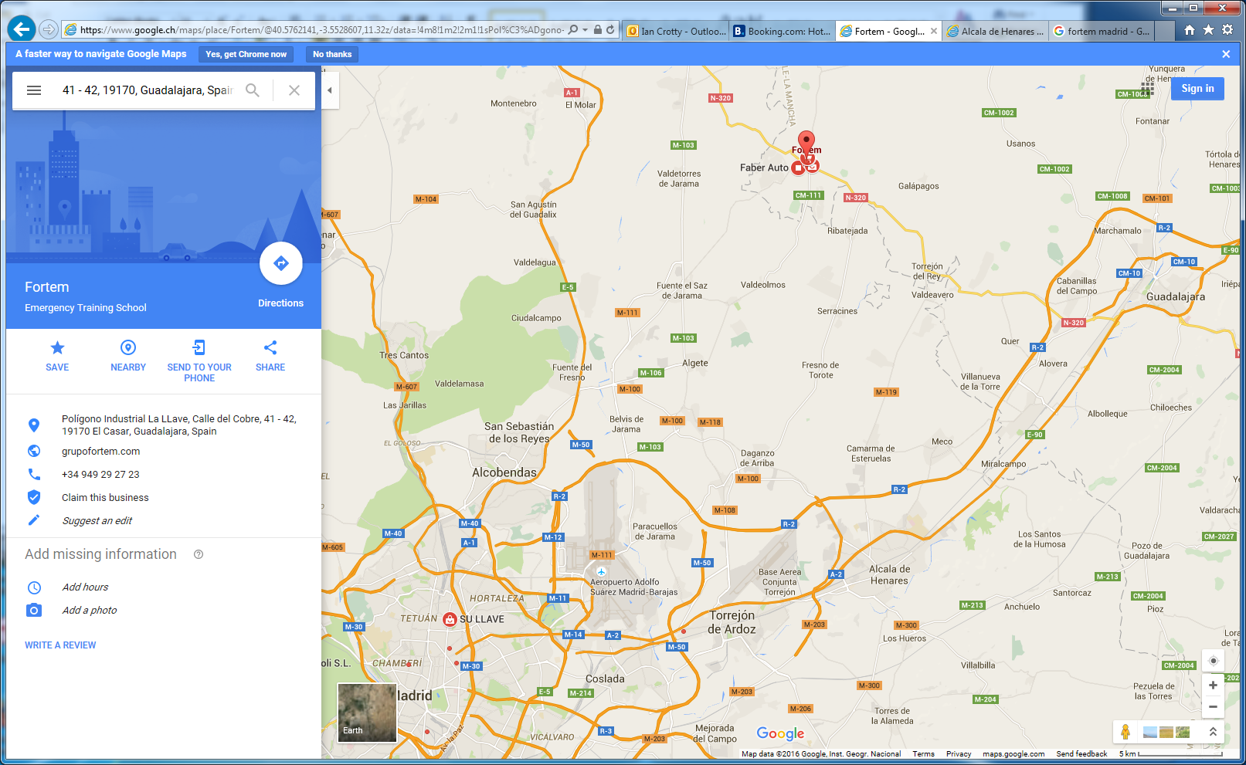

Fortem
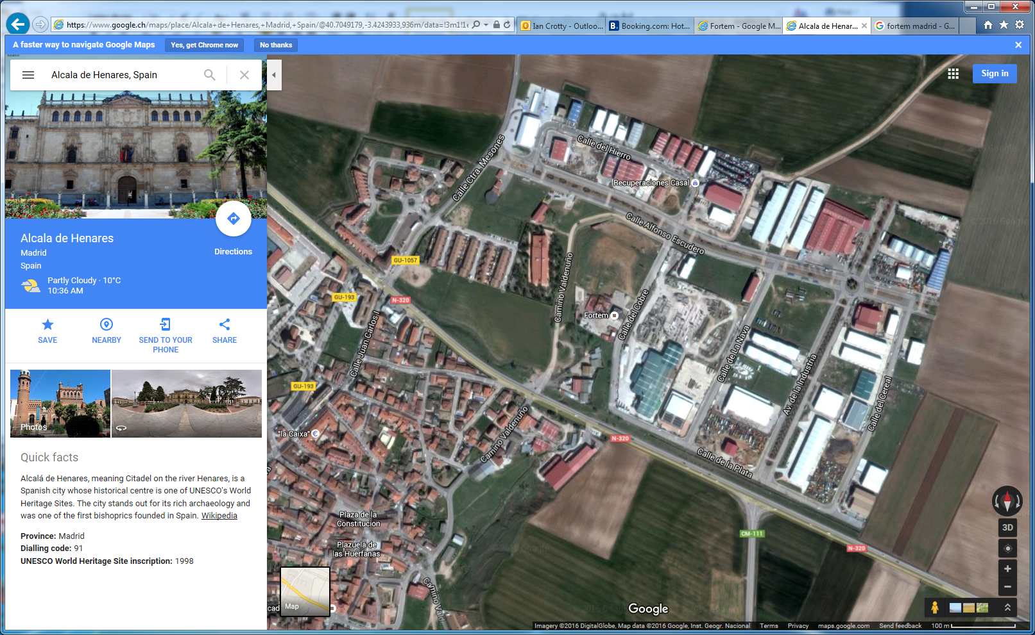

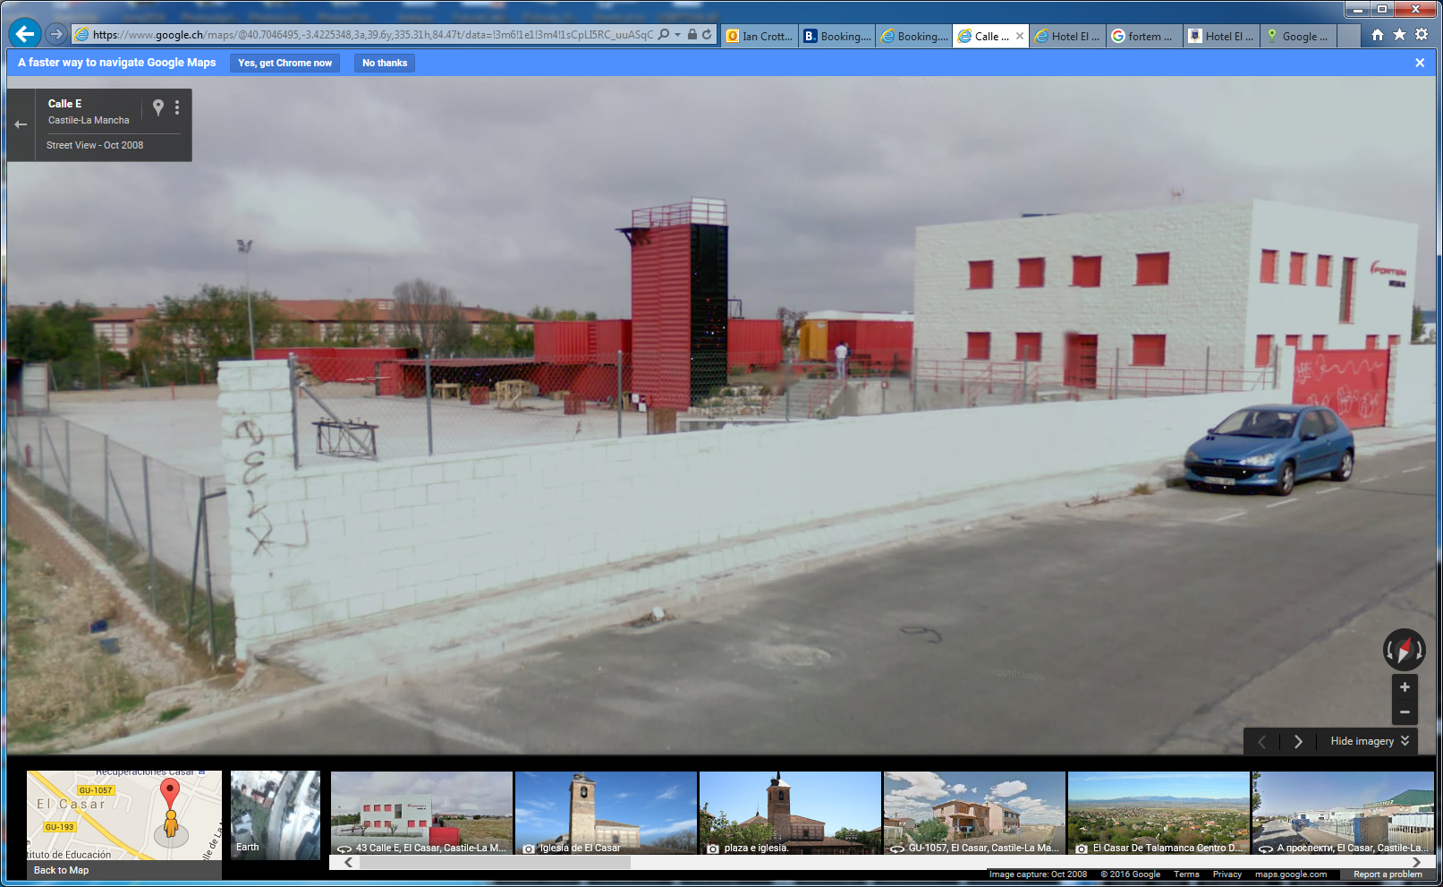

Accomadation
Alcalá de Henares
Hotel El Bedel
Plaza San Diego, 8, 28801 Alcalá de Henares, España
Phone:+34 918 88 67 26
N40.483061, W3.363609.
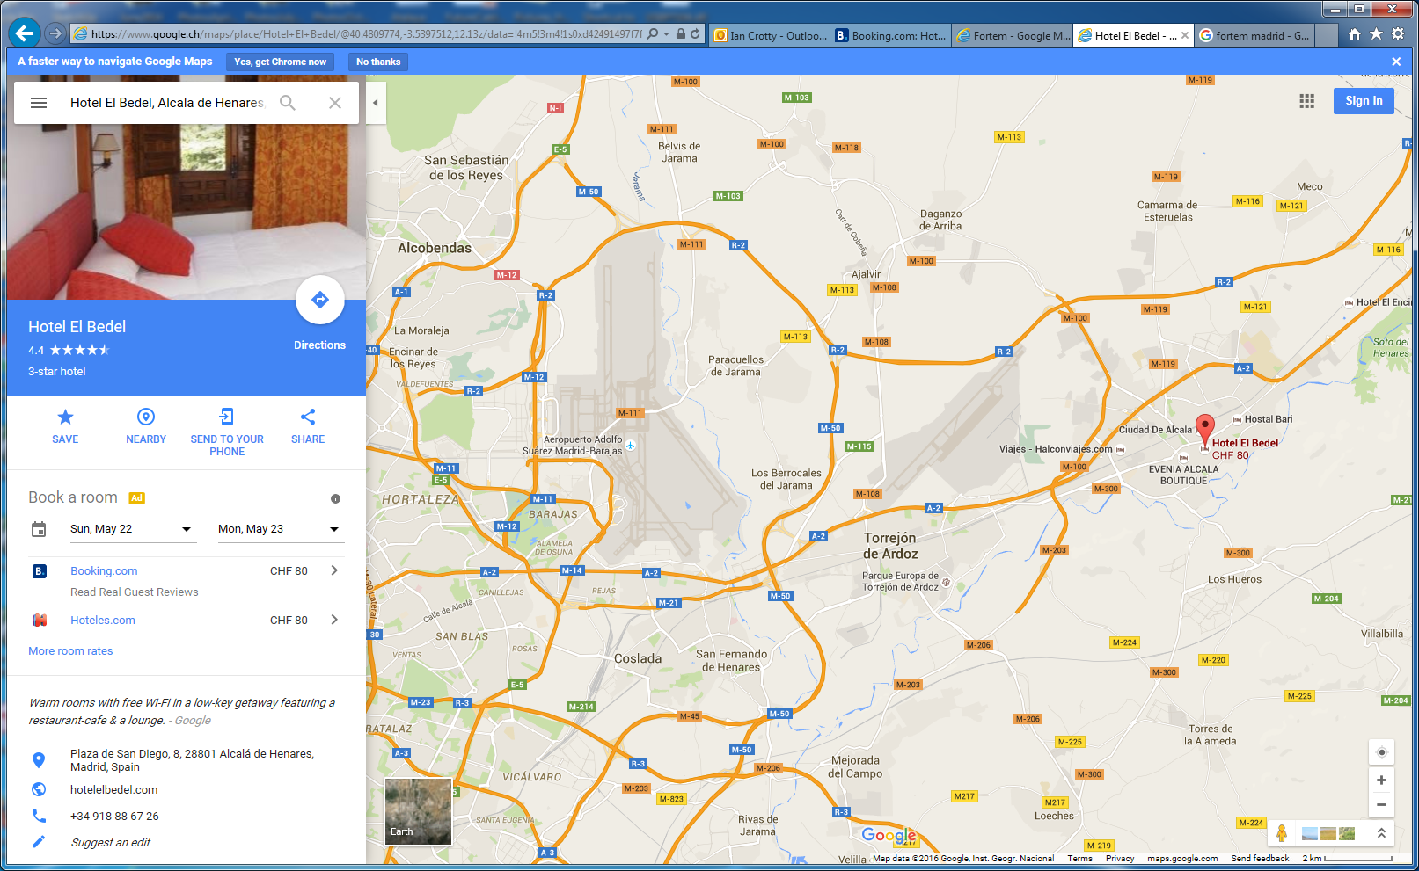

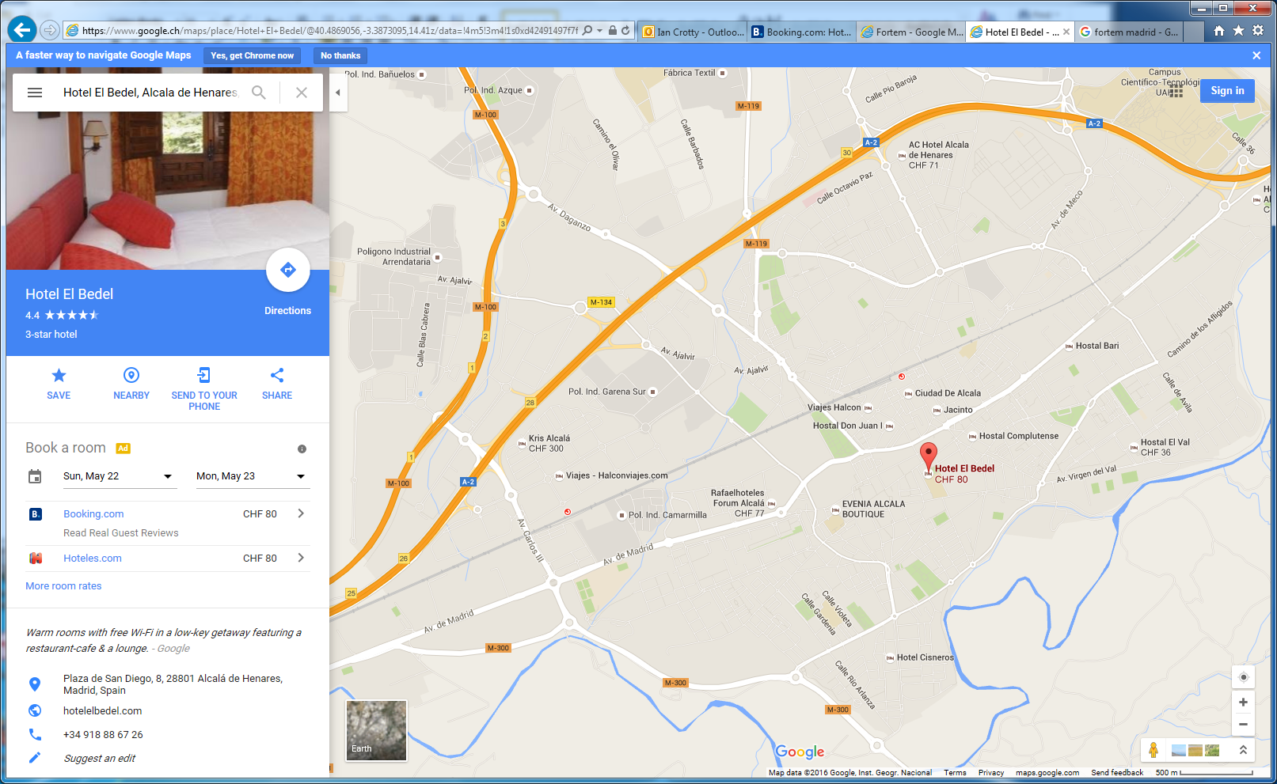

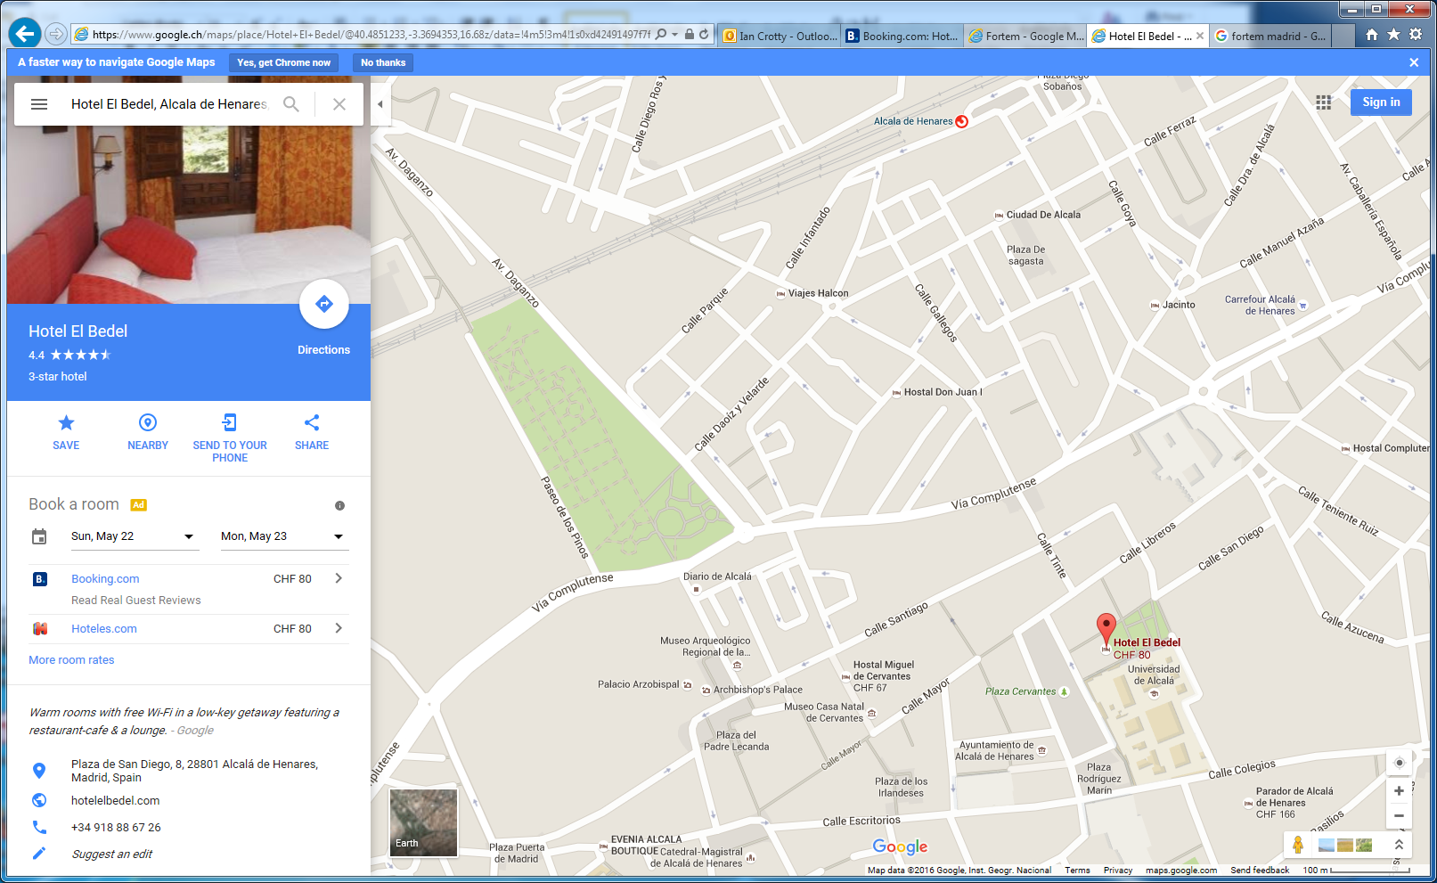
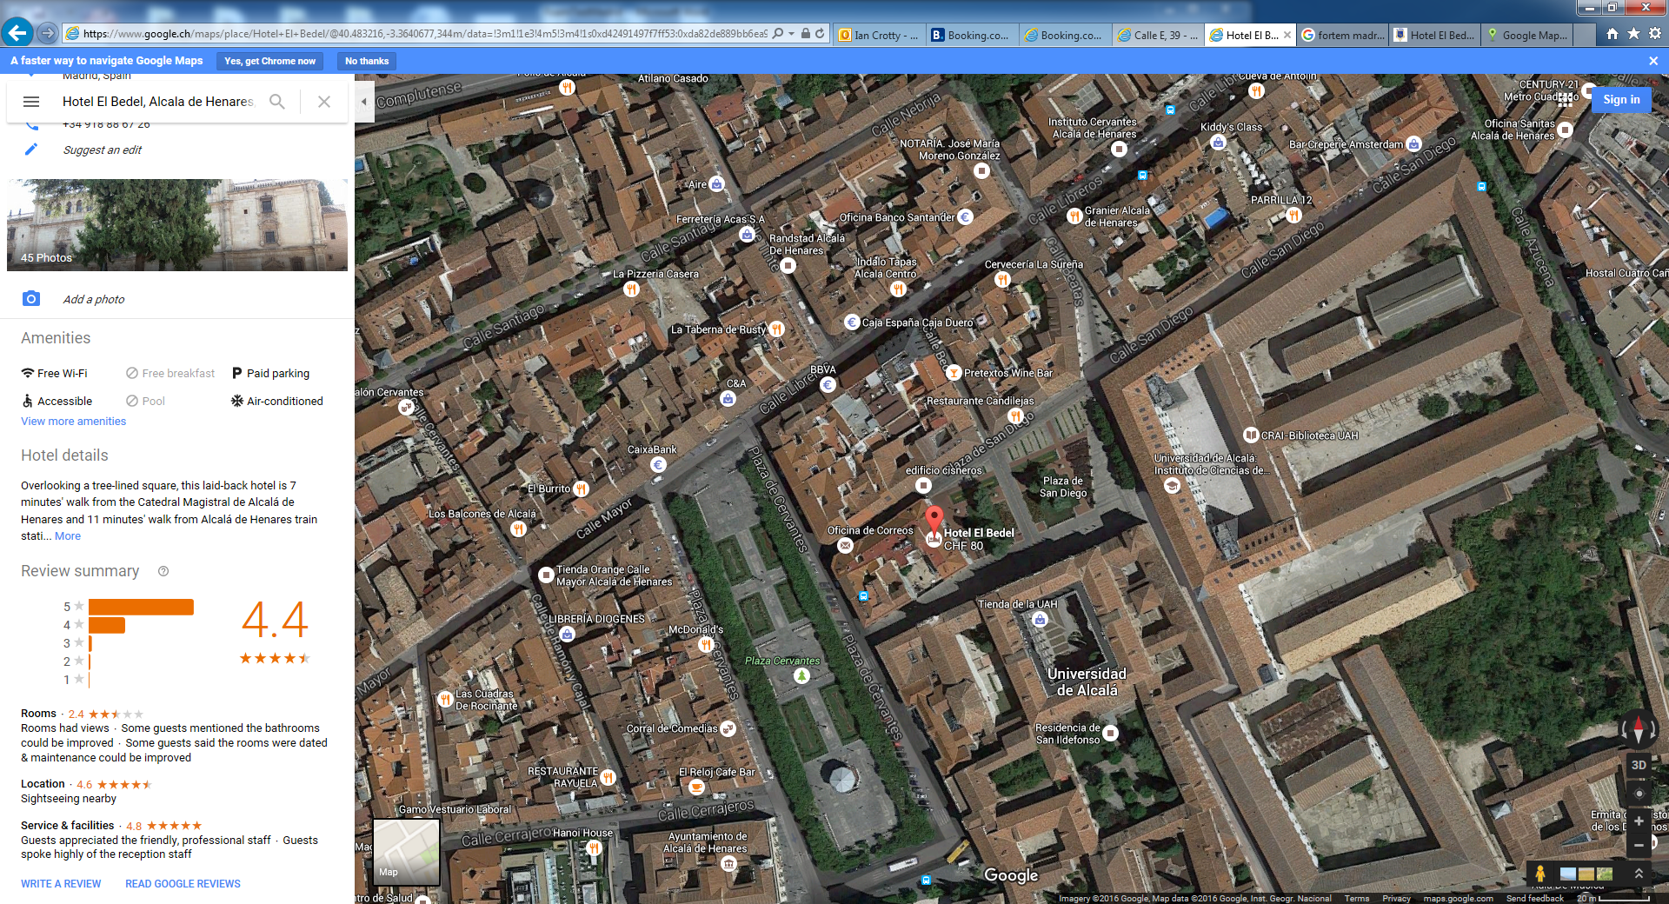

Directions
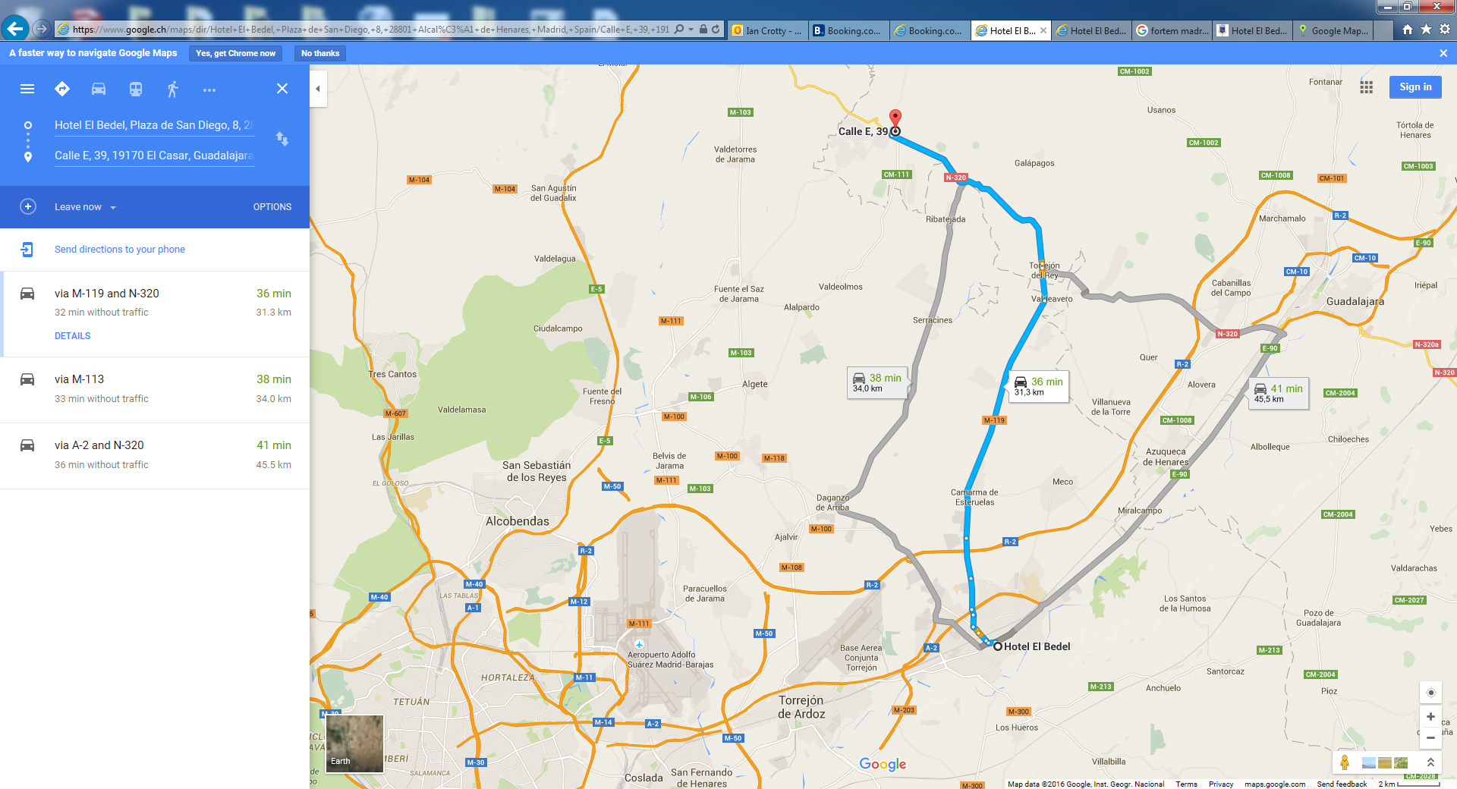

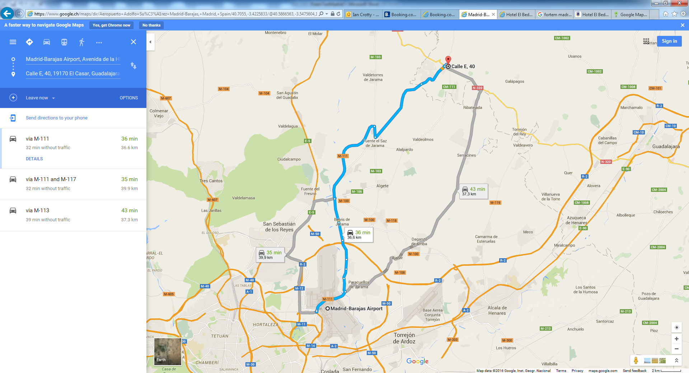

EDH Shipping
https://edh.cern.ch/Document/SupplyChain/SHIP/6351044

