Foam Trials, Raw Pictorial log (No editing) 4 May 2016

Trials were done in the chemical treatment plant Bat 676.
This was the second trial in this building.

Gantry and Digital spring balance (also the “Raspberry Pi” for DAQ)
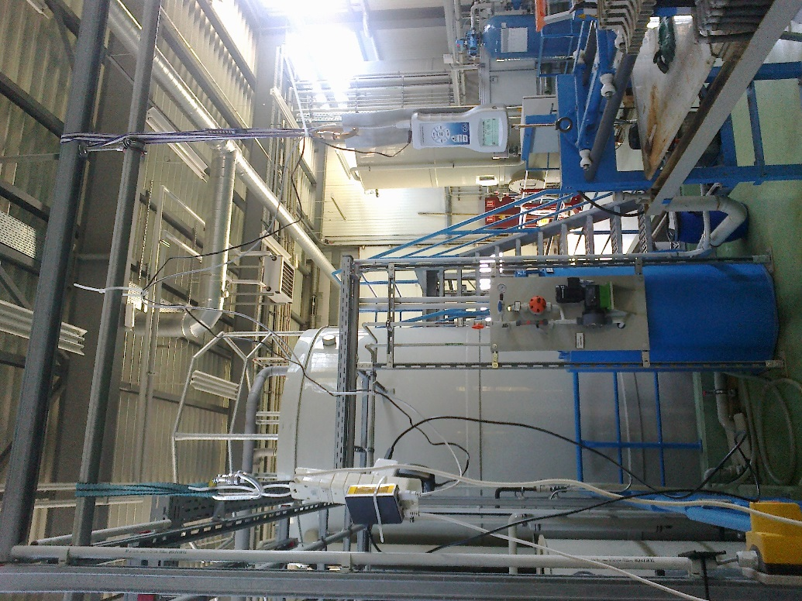

The digital spring Balance with readout
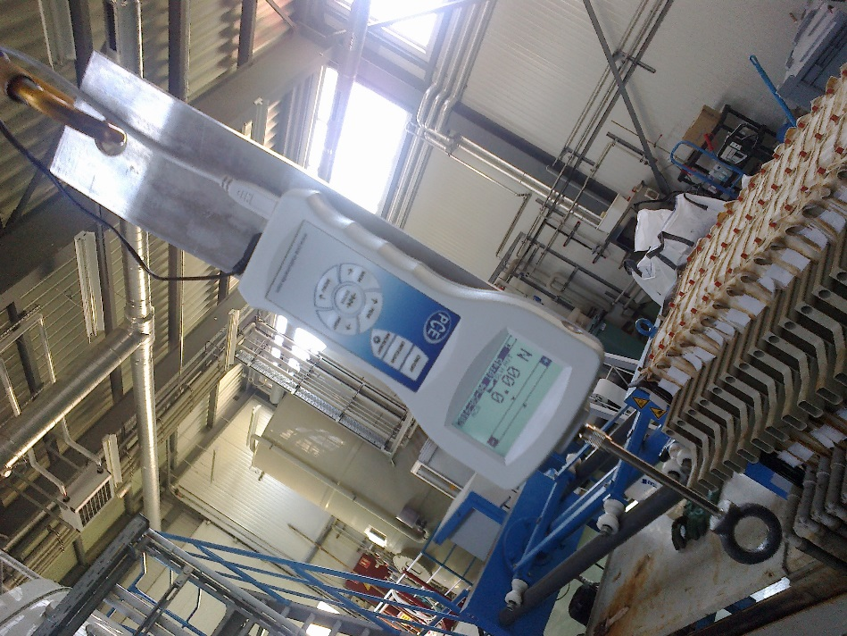
DAQ
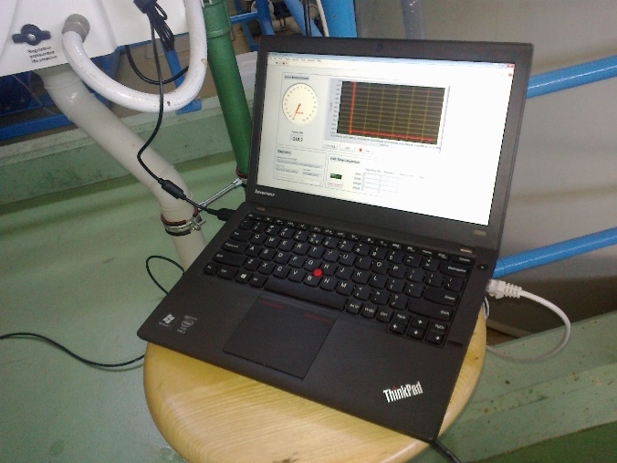
Solution 2% (not observed) and pump
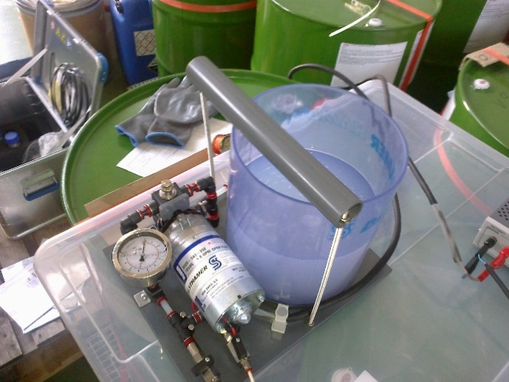

Nozzle , the biggest of the 3. Pressure were taken and recorded here unless otherwise stated. At the bottom of the picture is the controller for the fan speed. Shown at approx. 50%
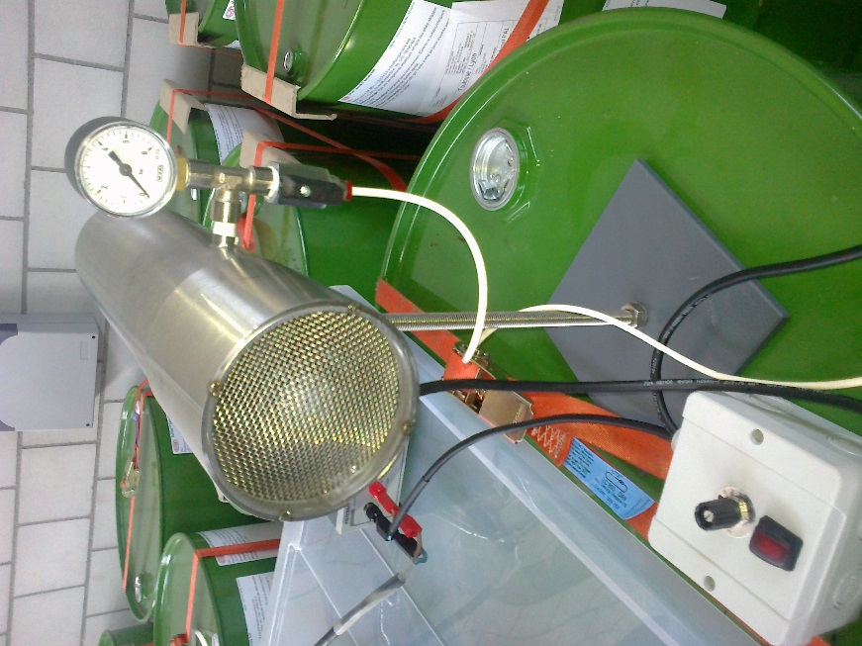
Power Supply for the pump.
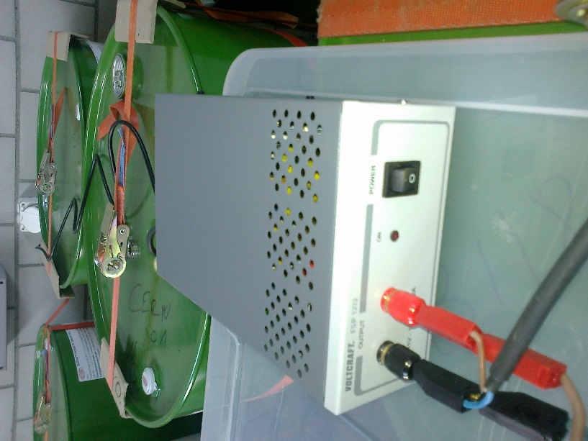
First attempt at filling cylindrical vessel. The tare was not taken. Need check list !
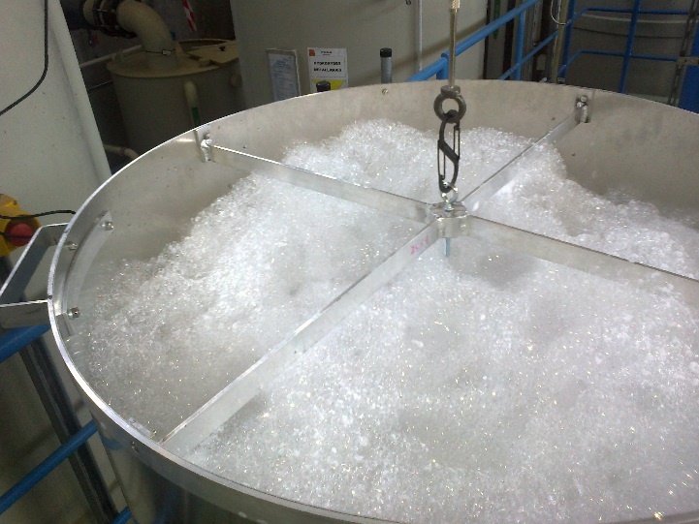
White decay products sitting on top of the foam
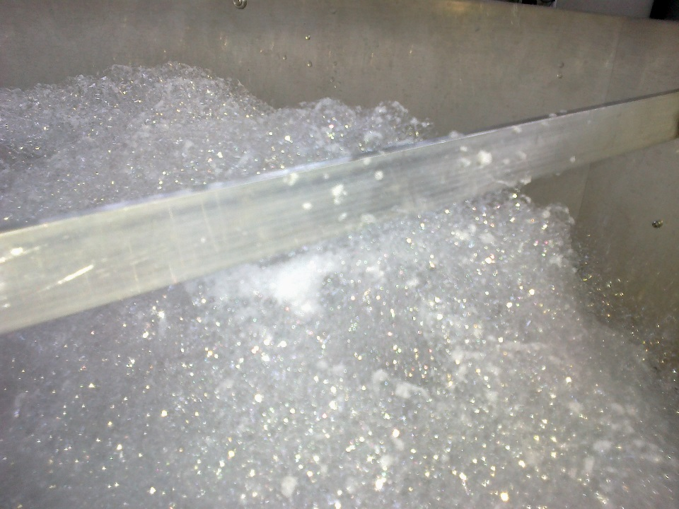

Destroying foam
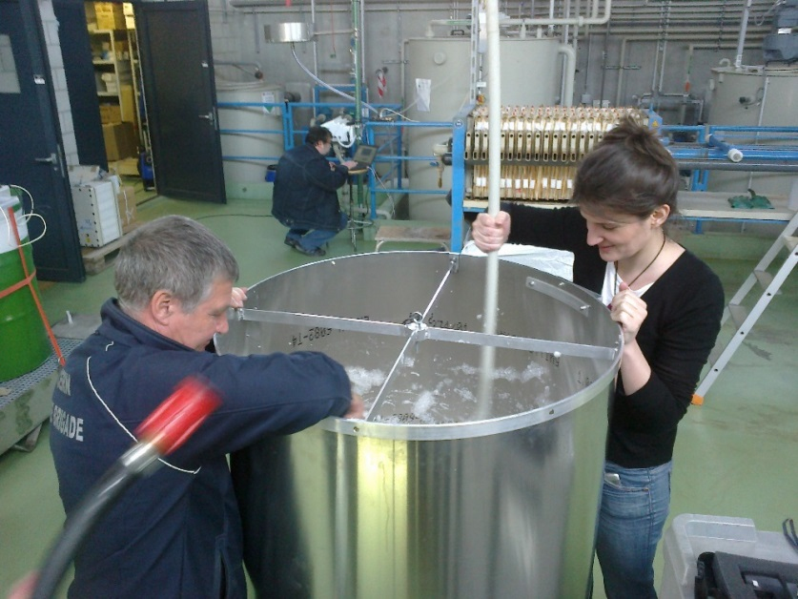
Destroying Foam
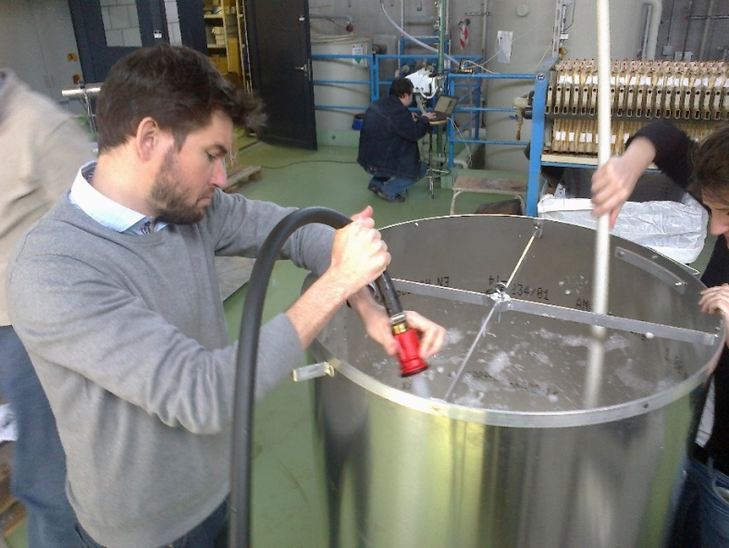
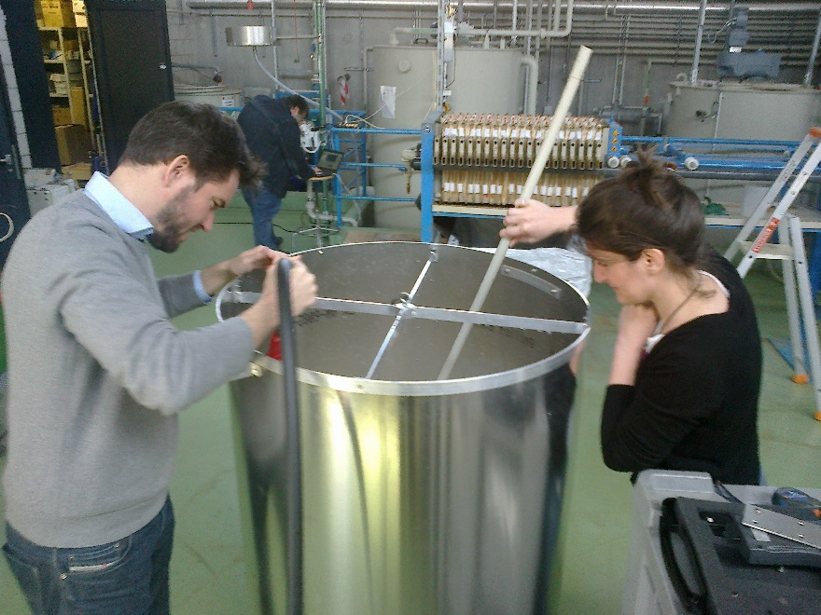
Pouring out what was left
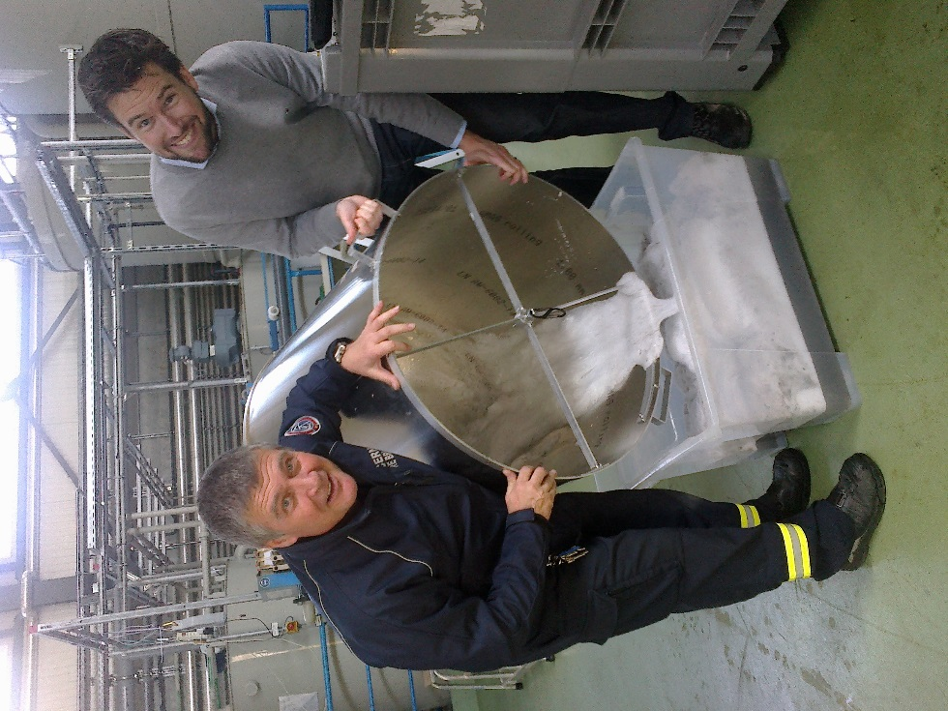
And rinsing
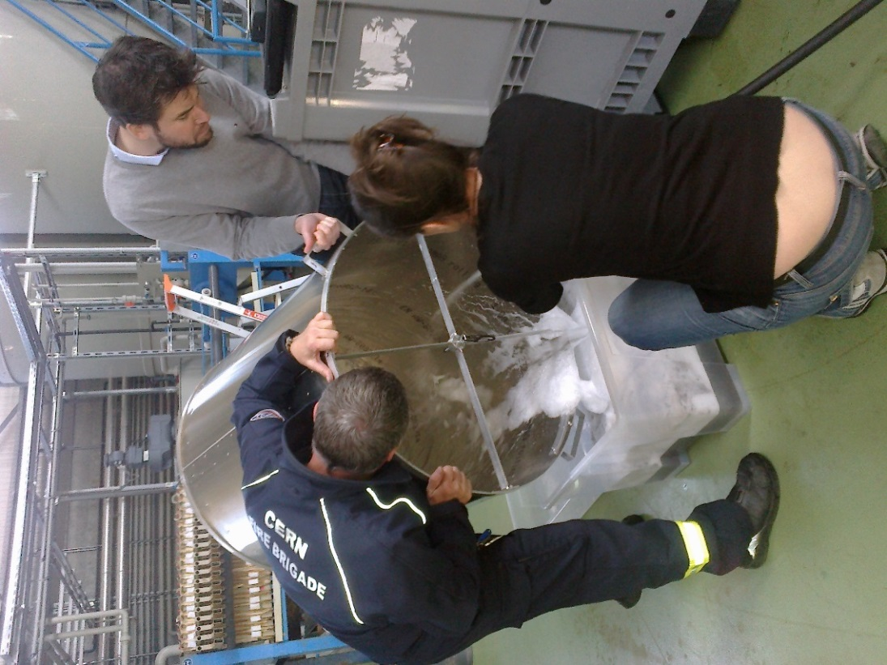

Residual foam after destruction using water spray.
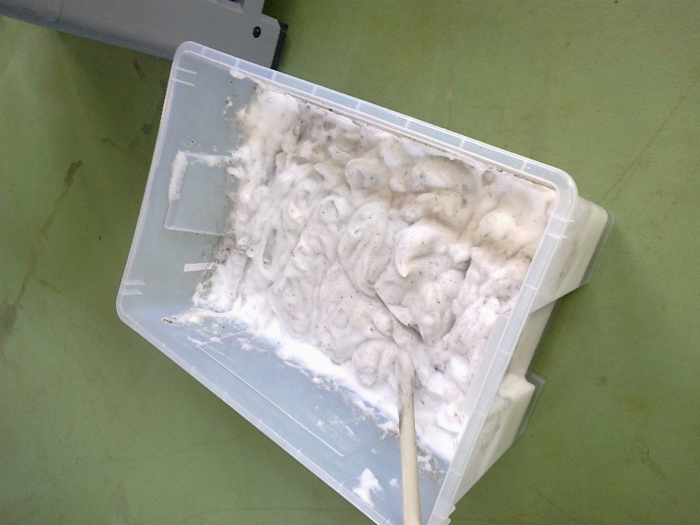

Test # 2
The first effective test with useful DAQ. Start at 10.20am
Pressure at nozzle 1.2 – 1.3[Bar] (~2.6[bar] on the pump) temp measured in side building was 17[degC] but may be cooler with the doors open at both ends of the building. Temp taken with Fire Service IR imager.
Fan speed put back from 70% to 50%.
Initial weight was 117.55[N] AFTER filling off the gantry. The vessel was weighed in P5 at 11.4[kg] (Ian)
Quantity of liquid used was XXXXX [ml] (Grams !!)
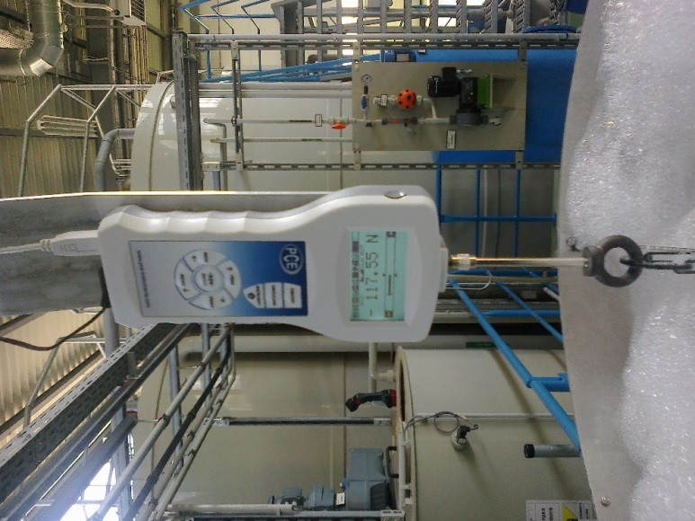
Solution dropping out of the cylindrical vessel.
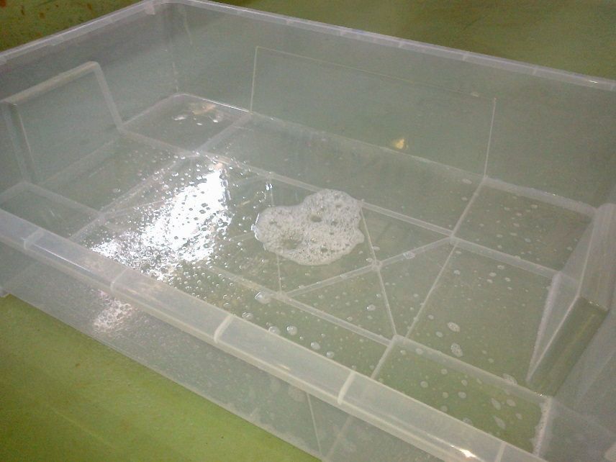
DAQ is running
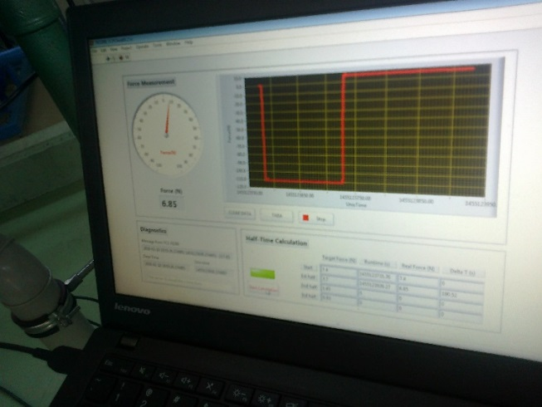

Drainage is recorded , reading 116.70[N]
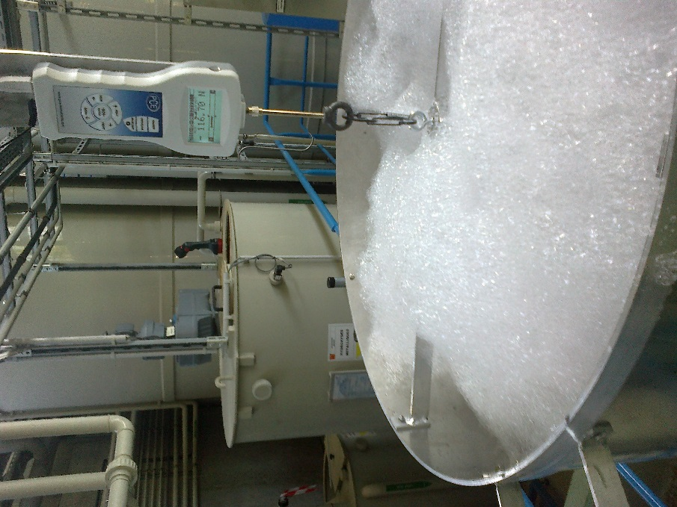

Still further reduction 110.25[N]

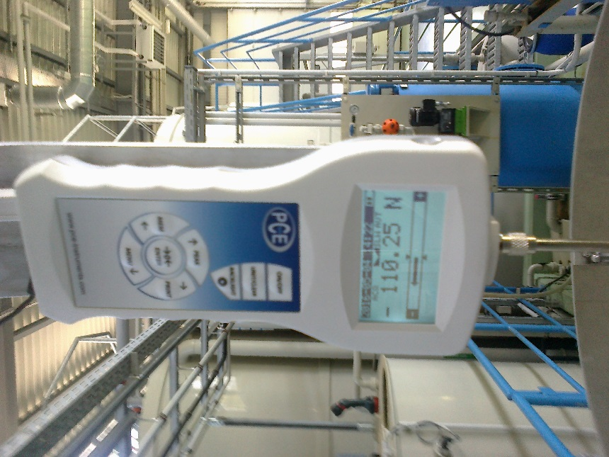

Decaying Foam with white deposit on top
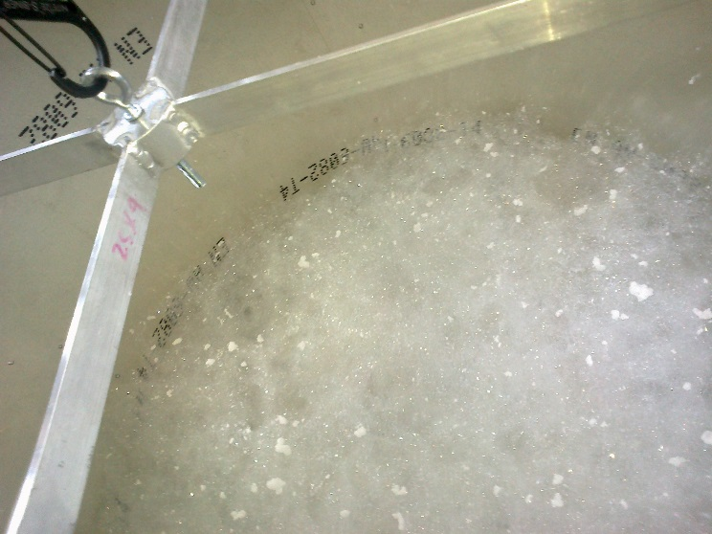
Results test #2
Expansion ratio was 670 ? OR was it 670[ml] with solution of 2% (?)
Expansion ration = 480[litres]/0.67[litres] = 716.
Half time was 1303secs @ 3.65[N]
Half of half time (T/4) 2421s @ 1.85[N]
Stopped DAQ at 3829s @ 0.9(0.92)[N]
The foam level has not really changed. Down by 10cm.
Should we be measuring the solution falling from the vessel.
Removal and cleaning
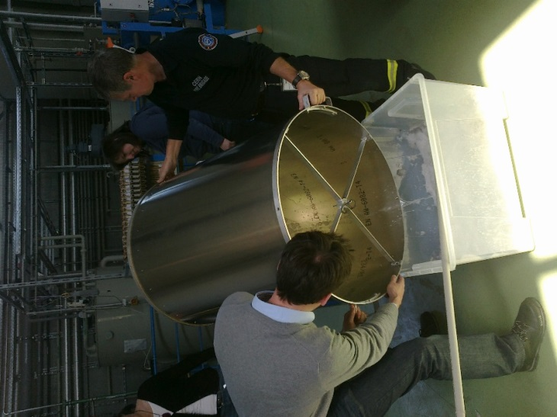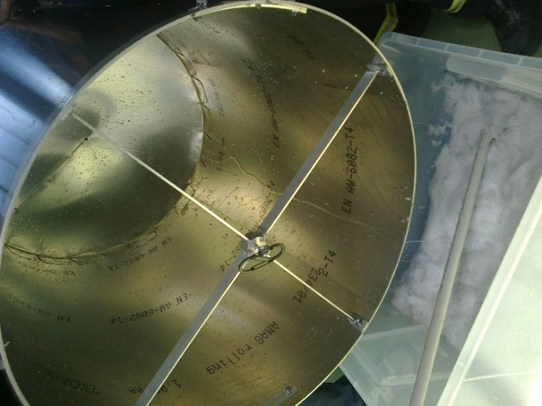
All clean and time for coffe. At 1045 ?
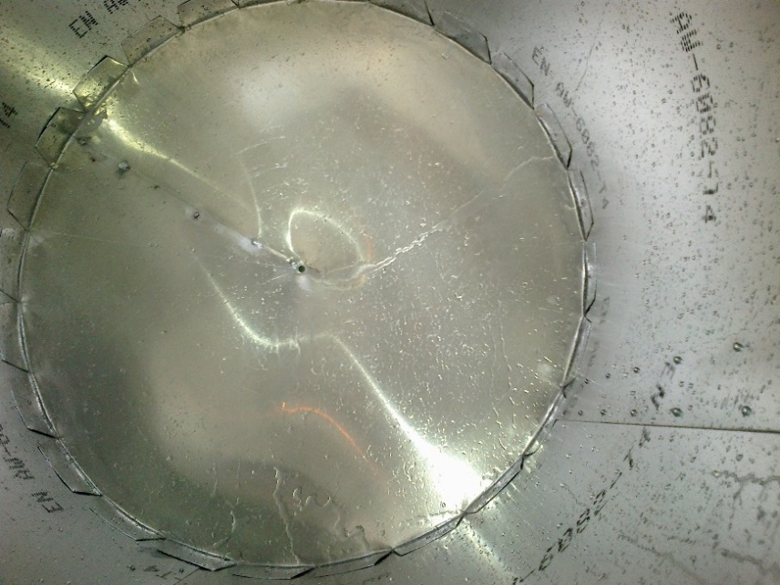
Test #3
Filling the vessel this time starting on the gantry with DAQ running to obtain a real T0
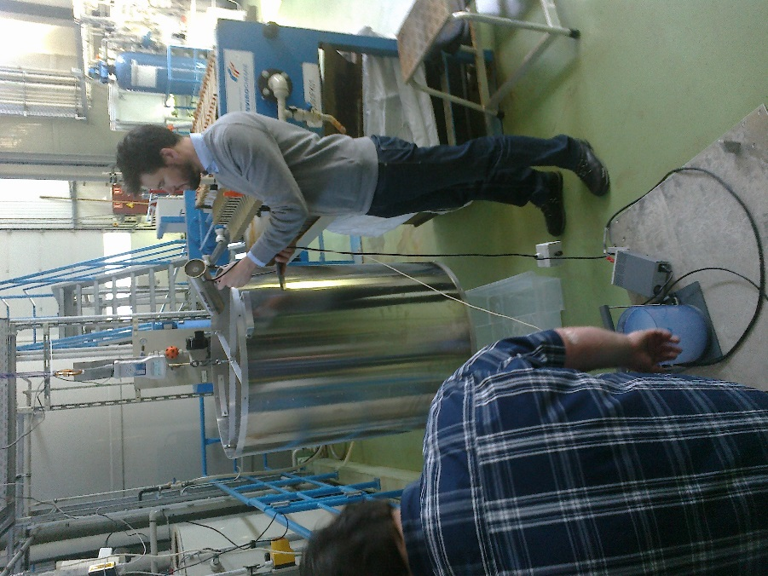
Do not touch the vessel !
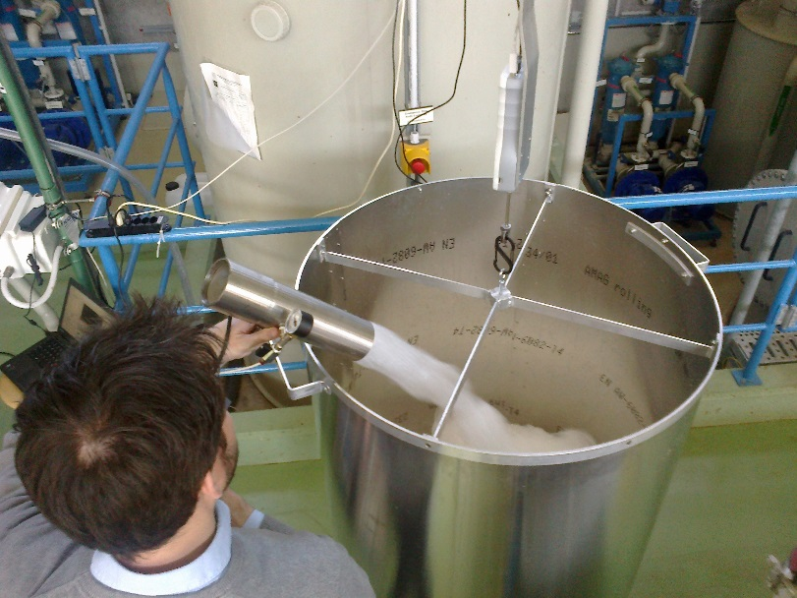
Start at 1138am
Temperature has increased. ? 1.15[bar] on Nozzle and 2.5[Bar] at the pump
Tare with residual water inside = 110.60[N]
Solution used ; 2900 – 2200ml =700[ml]
Expansion ratio 480/0.7 = 685 with “weight” = 117.90[N]
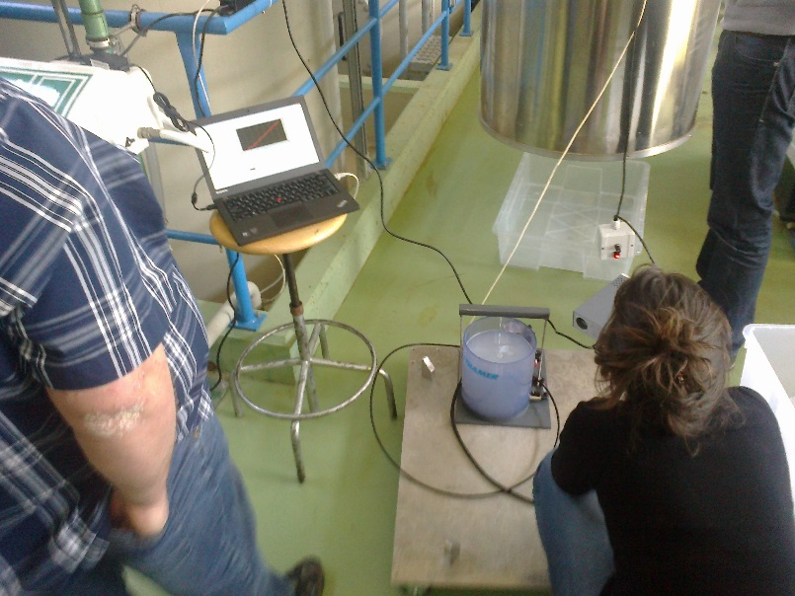
Full, but perhaps not around the rear ….
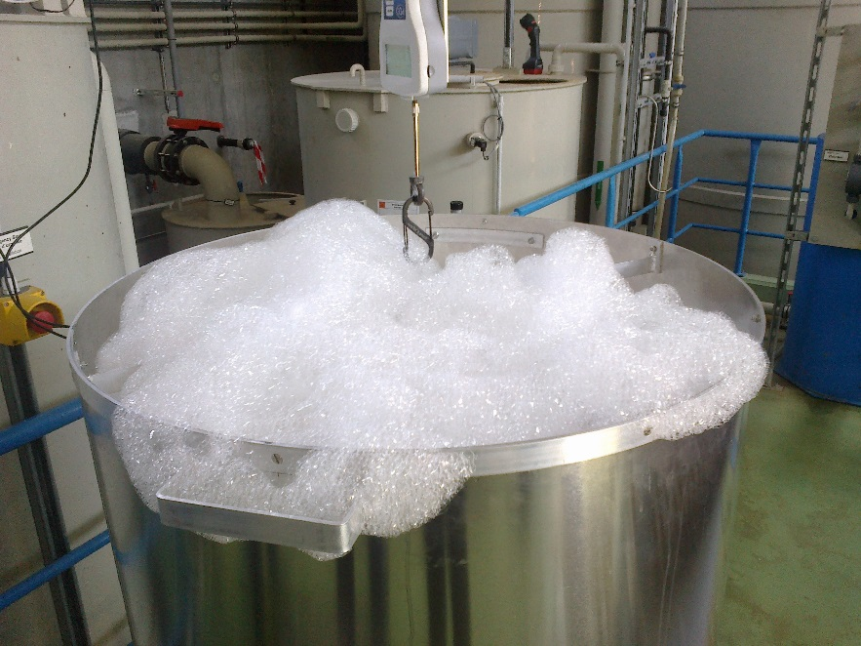

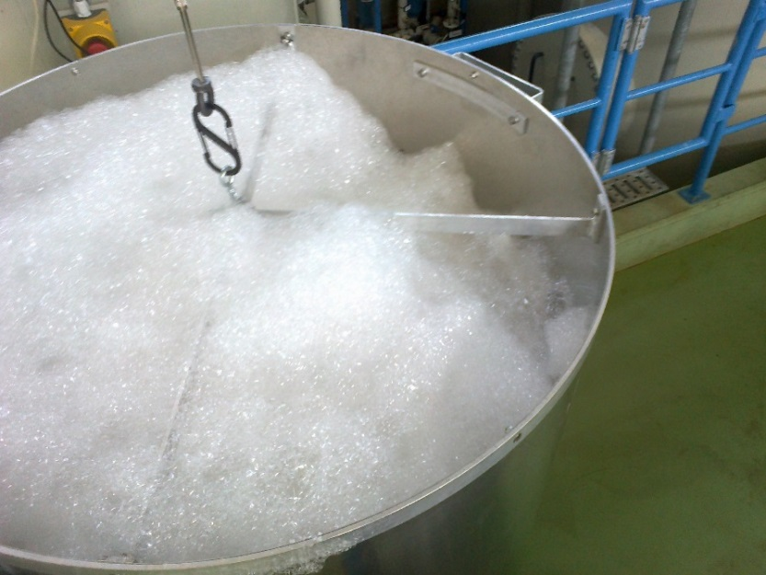

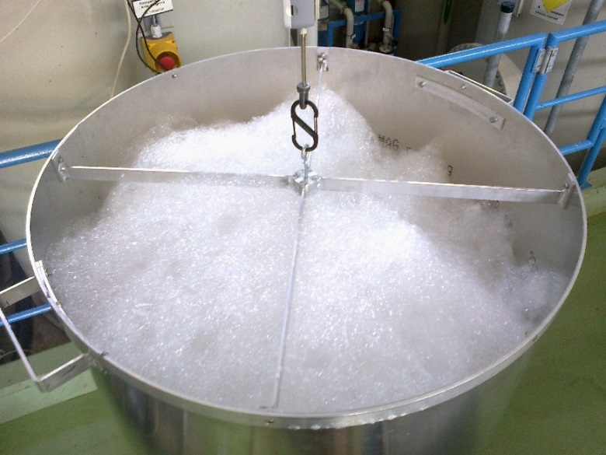
Left over lunch. At 1353 the foam level is ~45cm down, there is no liquid left (110.25N). The remaining foam is readily destroyed.
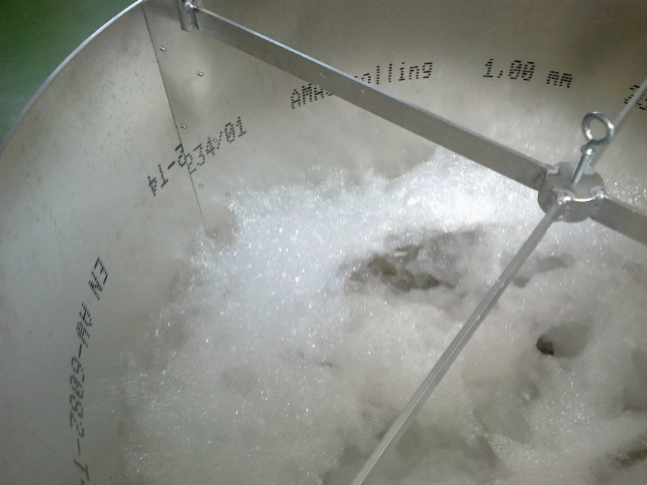

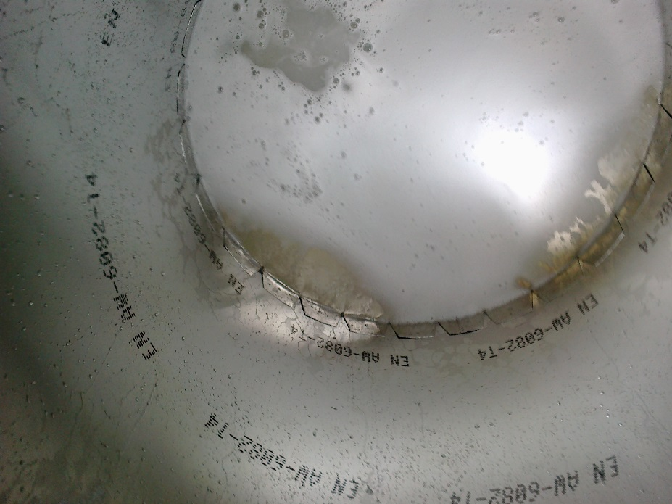

Results for Test #3
0s 7.4N 1138am
1248s 3.7N
2399s 1.8N 1219pm
3608s 0.93N Foam 20cm down from top
Lunch
PC still running ! -0.35N Foam down ~45cm @ 110.25N (1353pm)

Clean and draining
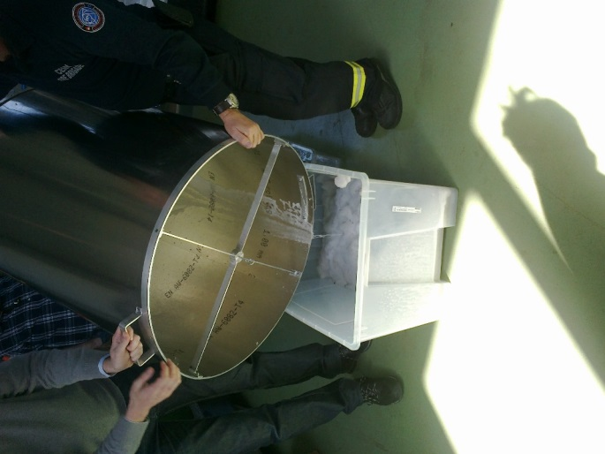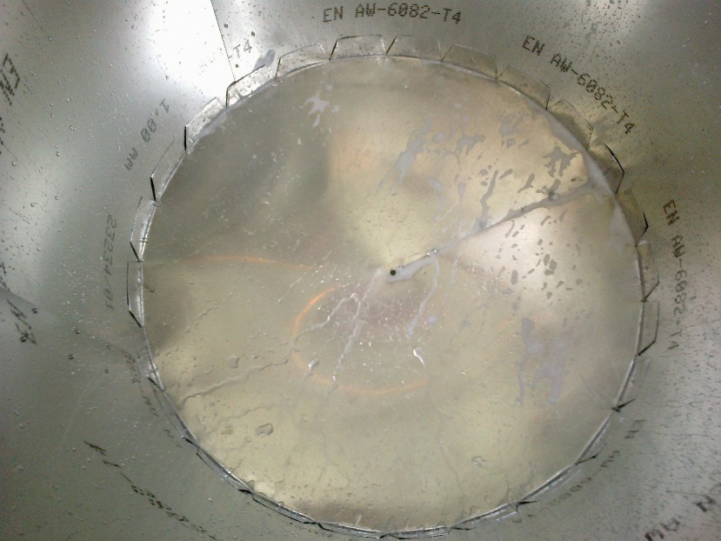
Residual water

Team Work
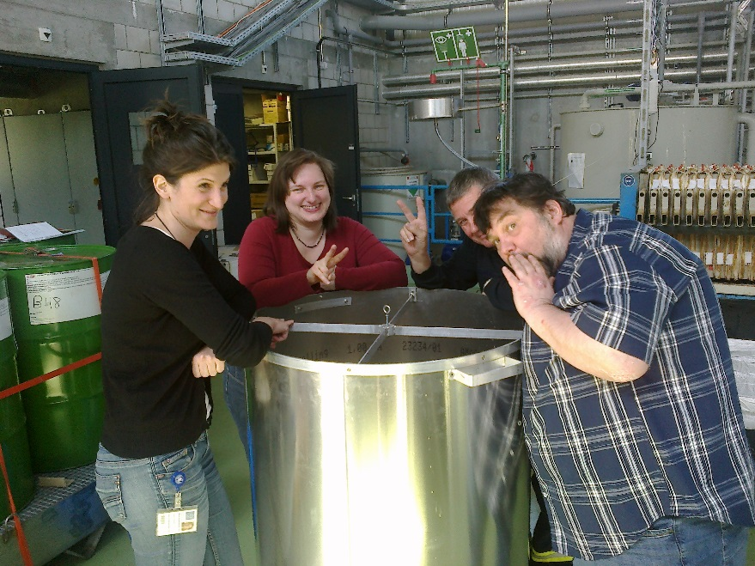

Who did we loose in there ?

Test #4
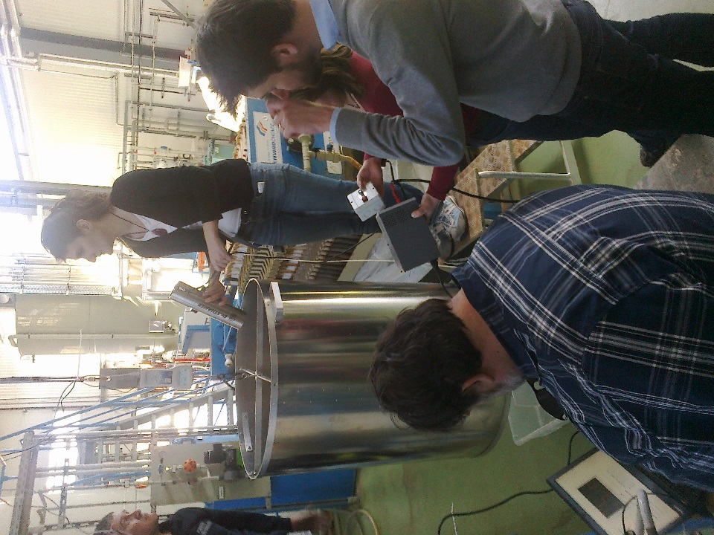

Start 1404pm
Remake solution
100[ml]ml of Sthamer FX15 and 5 litres of tap water from building supply (see auxillary photos for water quality.
Use 250ml flacon graduated to 10[ml].
Mixed into pump reservoir and 4950 – 4300ml = 650ml used for test
Expansion ratio 480[l]/0.65[l] = 739
Tare = 110.20[N]
At 1408pm full with foam 116.20[N] = 5.95[N] “of foam”
Again filling with vessel suspended from gantry so obtaing a real T0.
Attempts were made to ensure complete filling, is the foam having sufficient structure to create voids and so full filling is not achieved ?

Fan speed check
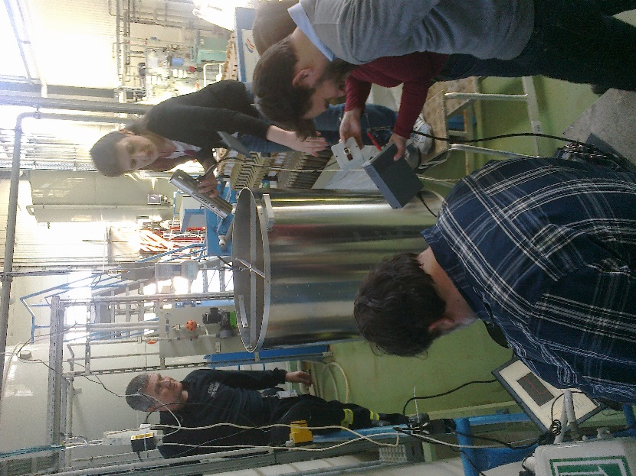
Filling check
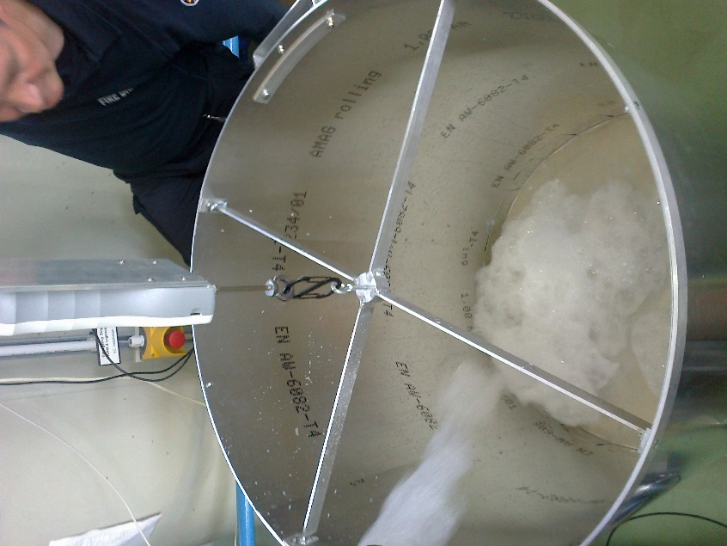
A good jet at 50% fan speed, as for the other tests
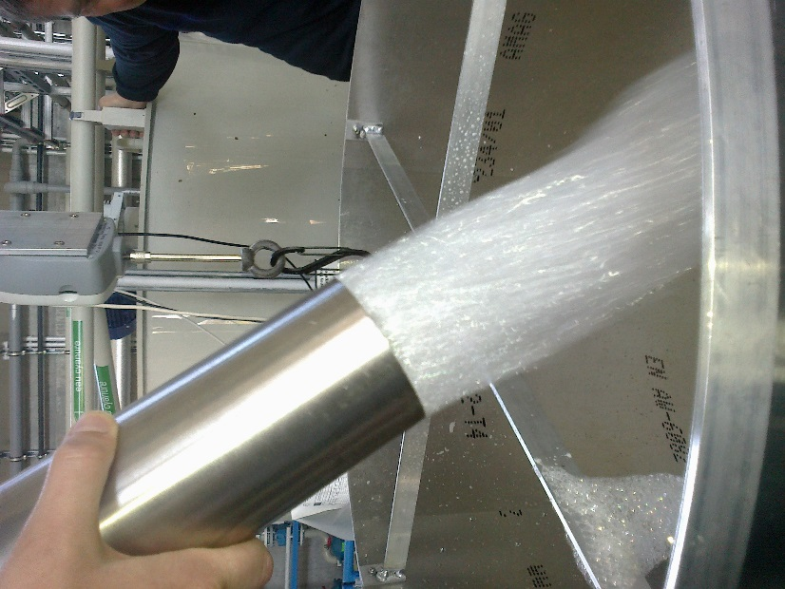
It is really full this time. Do not touch !
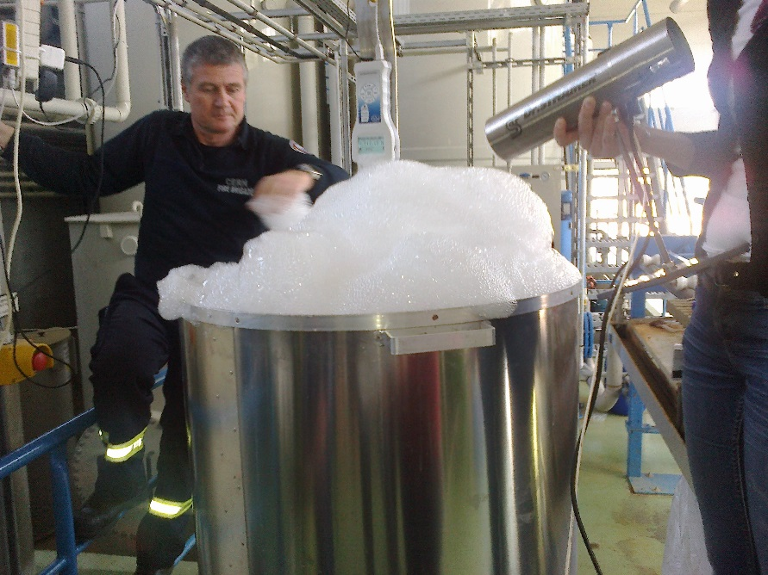
Decaying Foam
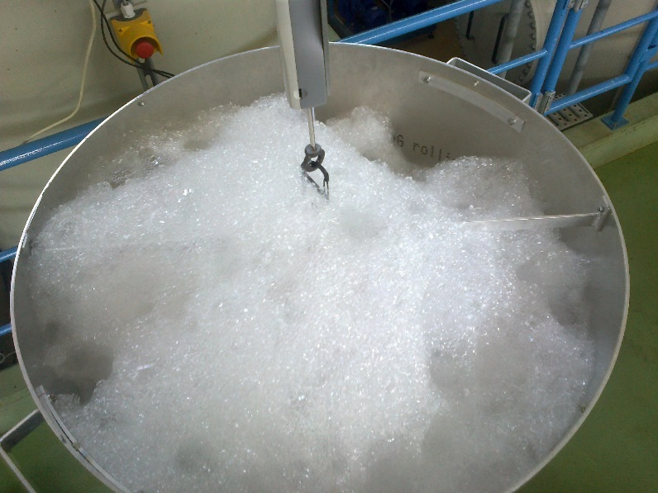

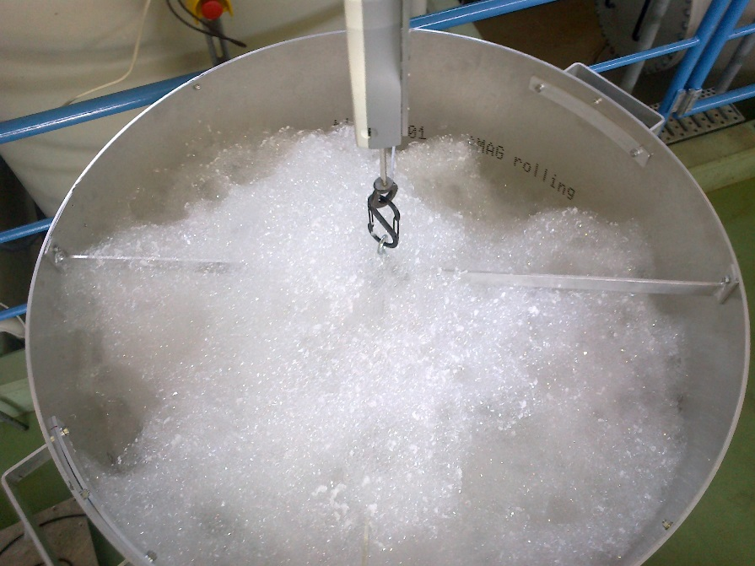

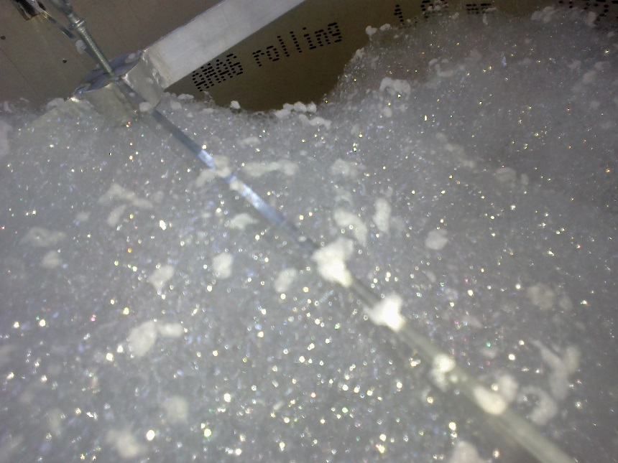

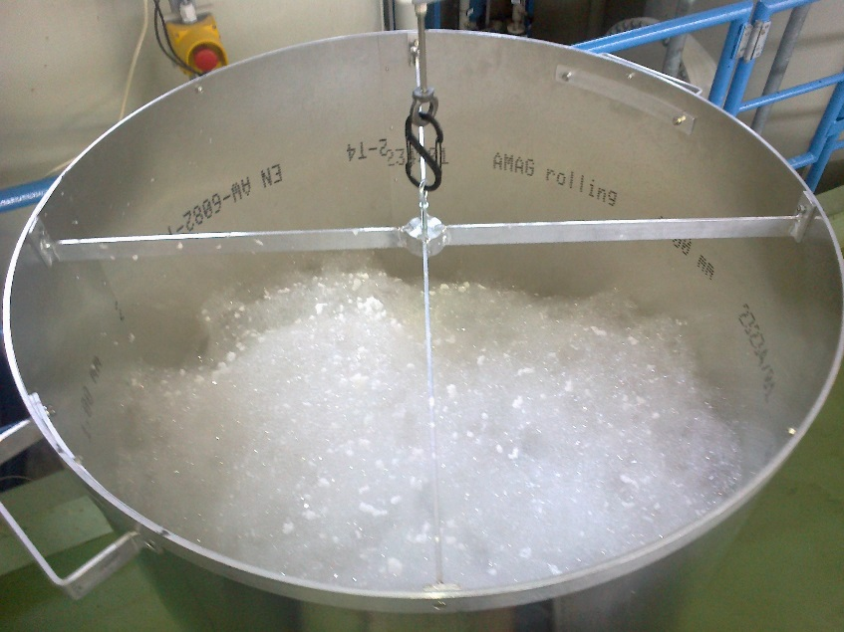
Bubble size “printed” on alu sheet panel/cylinder. See many photos by Naomi.


Zoom of bubble “print”


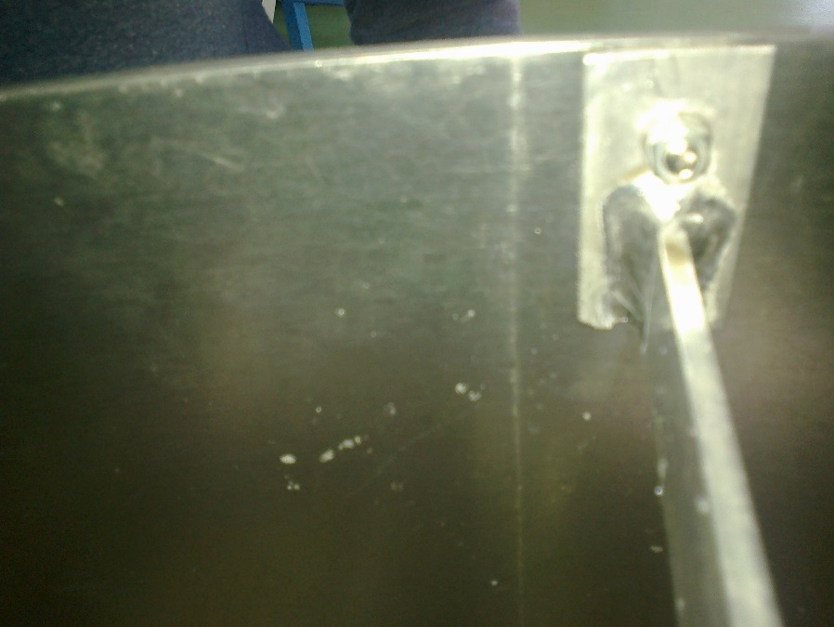
Results of Test #4

0s 5.95[N] xxxxpm
1567s 3.0[N] 1437pm
2992s 1.45[N] 1502pm
4997s 0.7[N] 1527pm

Temperature has increased but no measurement !

From the installation in the building;
Eau brute ph = 8.03 @ 25[degC]

Test #5

This time the method is changed to attempt to reproduce the earlier, morning results, by starting with the vessel on the ground and only when it is hung up on the gantry will the DAQ be started.

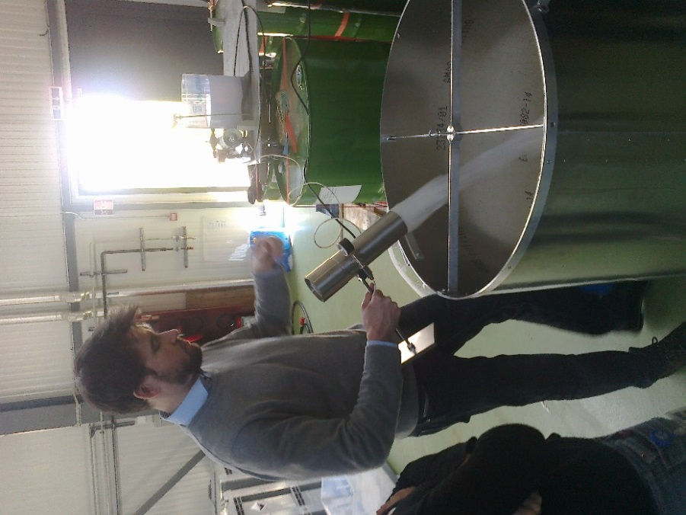

Start at 1535
Still less weight than in the morning.

0s 6.95[N] 1539pm
1514s 3.45[N] xxxxpm
2835s 1.7[N] xxxxpm
4172s 0.85[N] 1654pm (photo)
1556pm photos at 1075 secs Foam down.
114.45[N] @ 1170s
Video @ 2600s you can see the foam collapsing (see refs)
Temperature is recovering OR reducing, look at the bump in the plot (Zoltan)
Taking the tare BEFORE filling with foam ! 110.50[N]
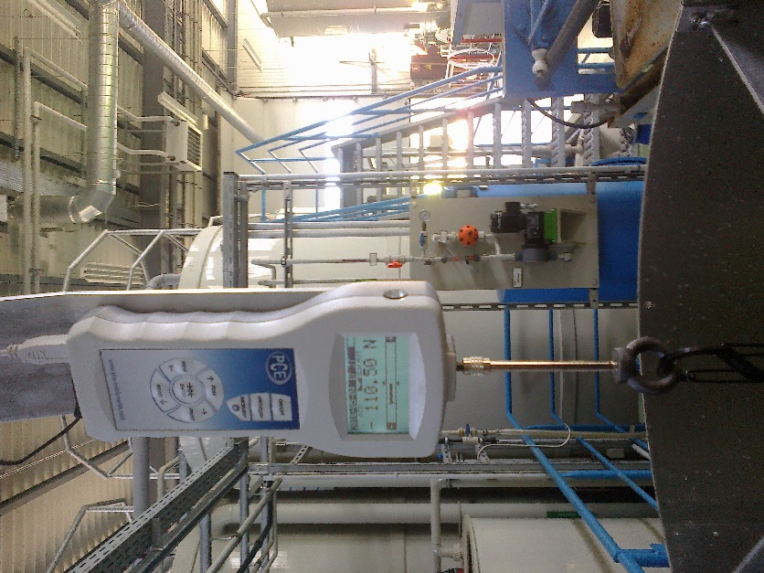
Observer crew checking operator accuracy
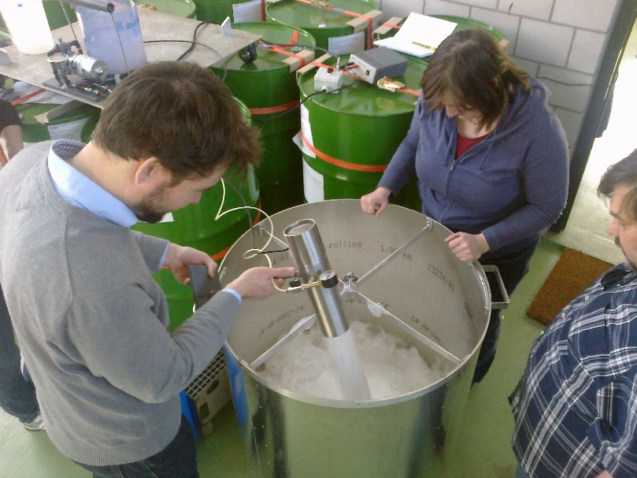
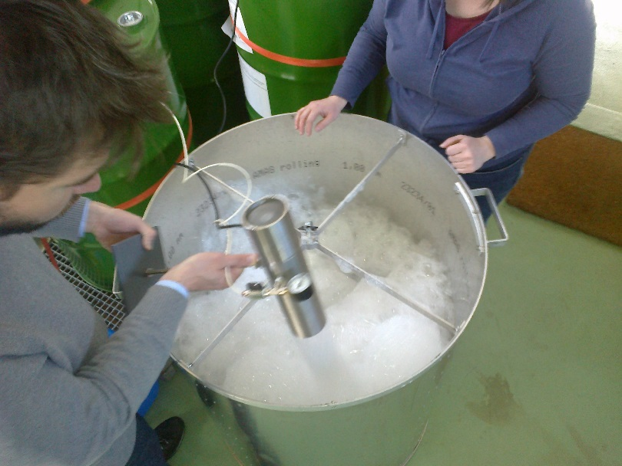
Hung up and Full
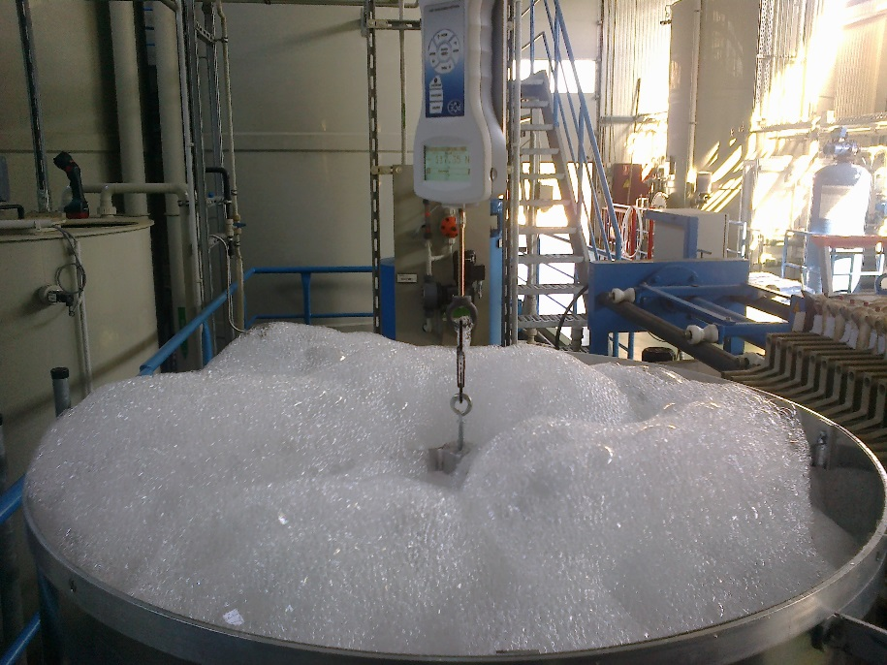
117.25[N]
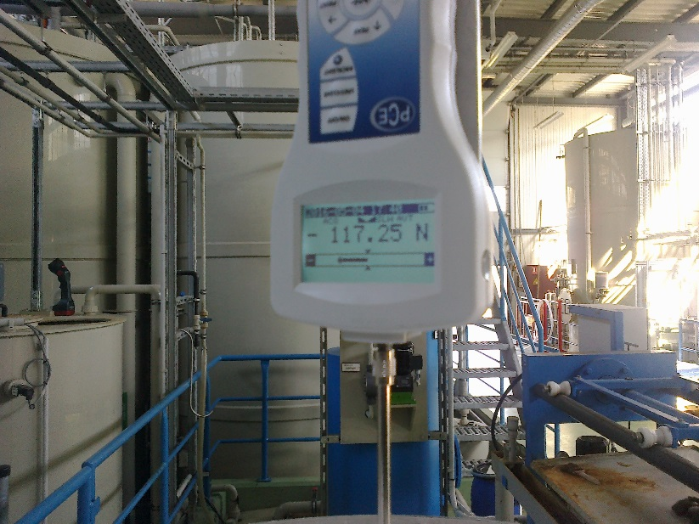
Test #6
Start at 1706pm
Quantity of solution was not well established. False start, people are becoming tired.
3600[ml] but on slope = 3650[ml]n – 2700[ml] = 950[ml] could be 10% error ??
Continue with previous method i.e. starting off the gantry/scale
Tare 110. Xxx[N]
6.85N 0s
Ian left around 1730 ? I requested Zoltan to take a few notes of essential points.

Record ends here.

Results are available here;

http://rpc-cms-re4-upscope.web.cern.ch/rpc-cms-re4-upscope/RPC/Safety/CMS%20Foam/Tests/Trials4May2016/Results4May2016.xlsx

This document is available here;
http://rpc-cms-re4-upscope.web.cern.ch/rpc-cms-re4-upscope/RPC/Safety/CMS%20Foam/Tests/Trials4May2016/FoamTrials4May2016.pdf

Alternative nozzles.
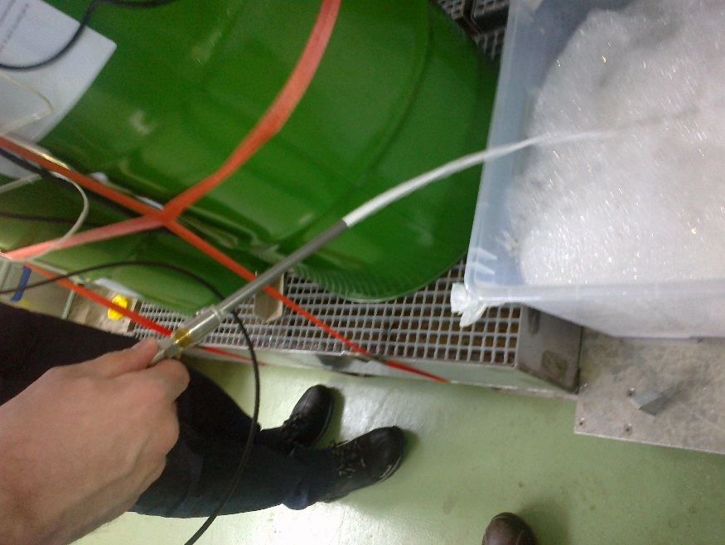
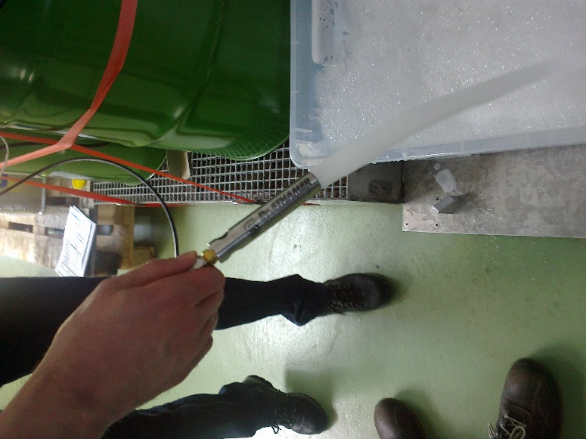

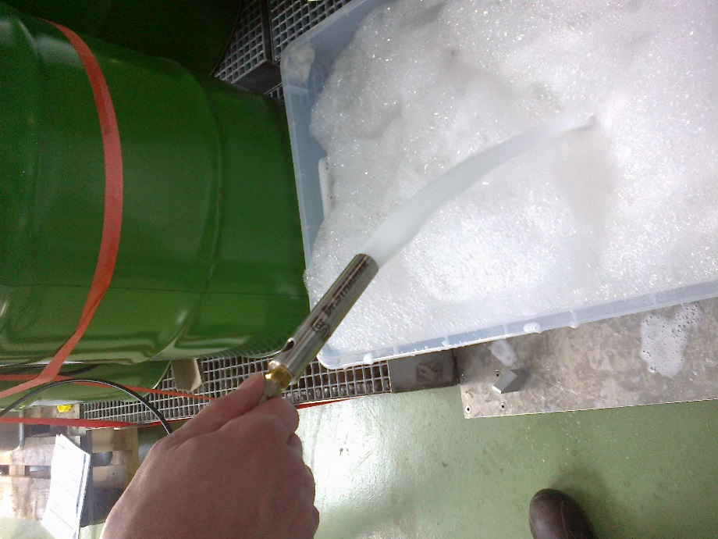

References;

3 video referenced here;
http://rpc-cms-re4-upscope.web.cern.ch/rpc-cms-re4-upscope/RPC/Safety/CMS%20Foam/Tests/PhotoTrials4May2016/Photos10April2016V2/
Files;
04052016.mp4, 04052016001.mp4 and 04052016002.mp4

One drop of water
50-60 micro grammes
Dimineralised water plant

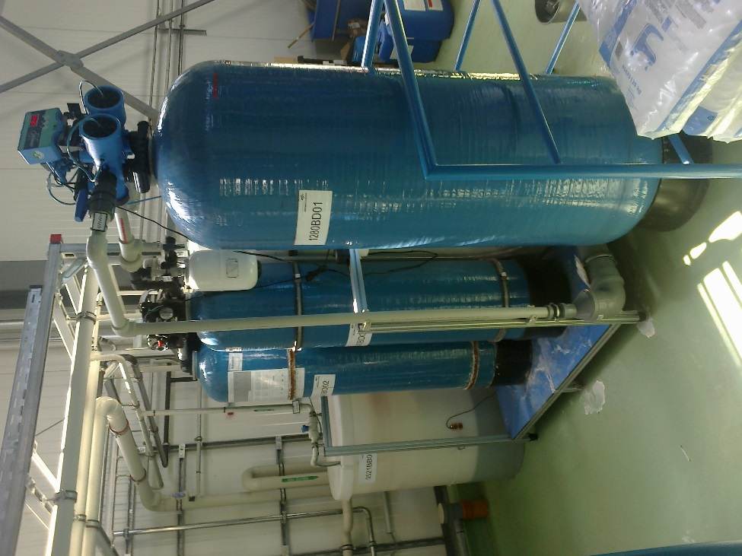

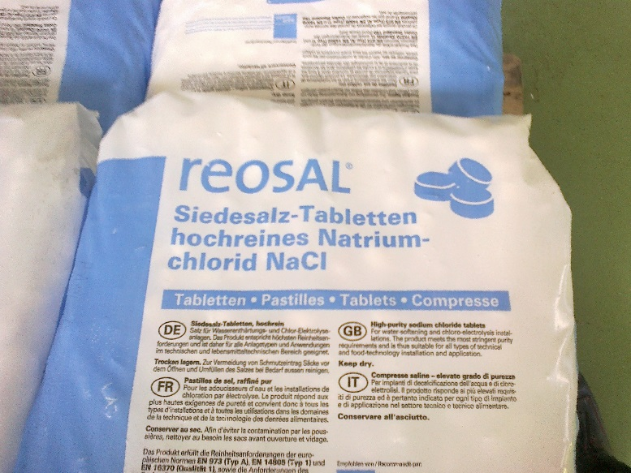

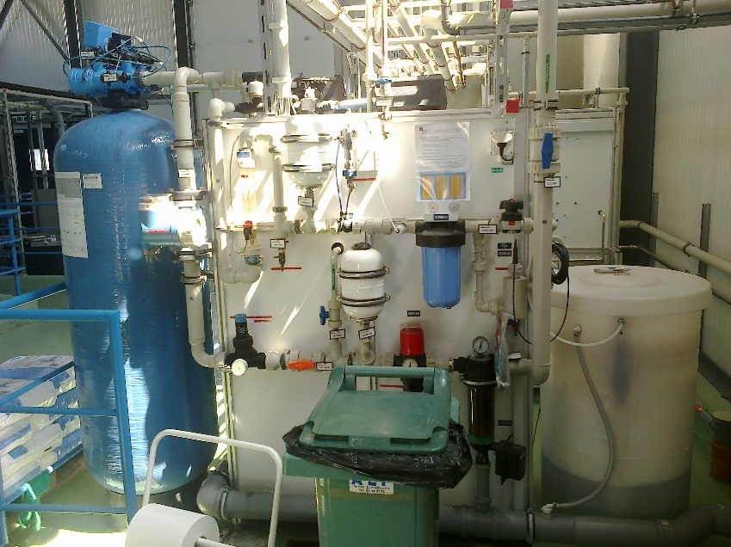

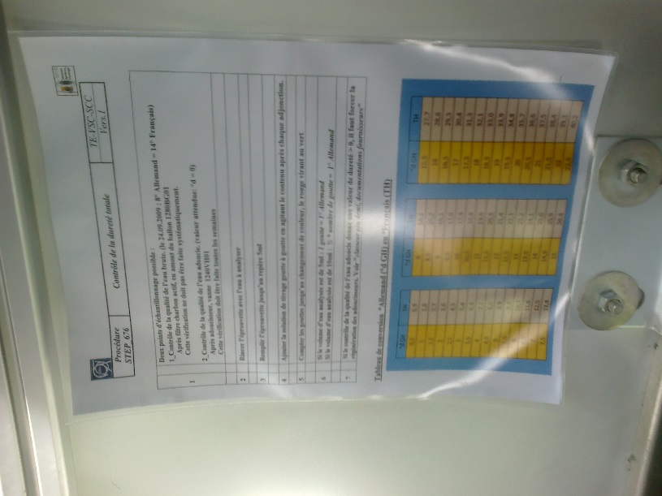

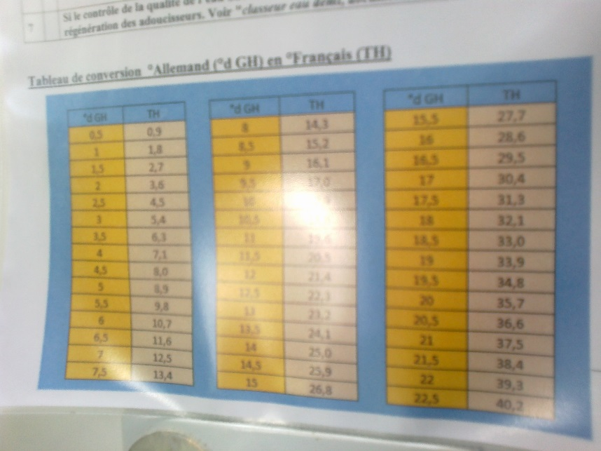

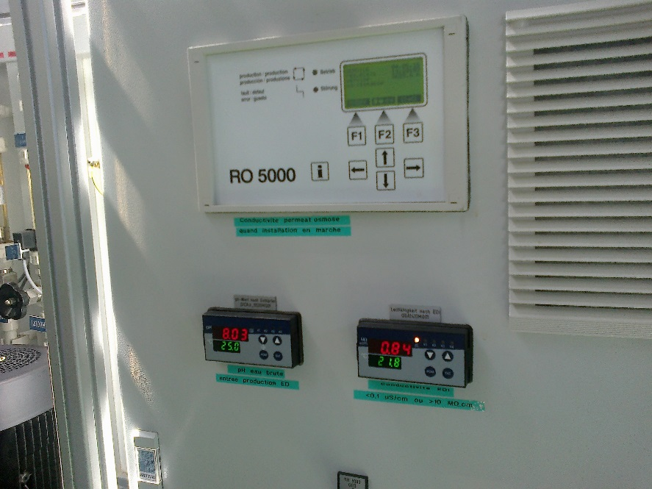

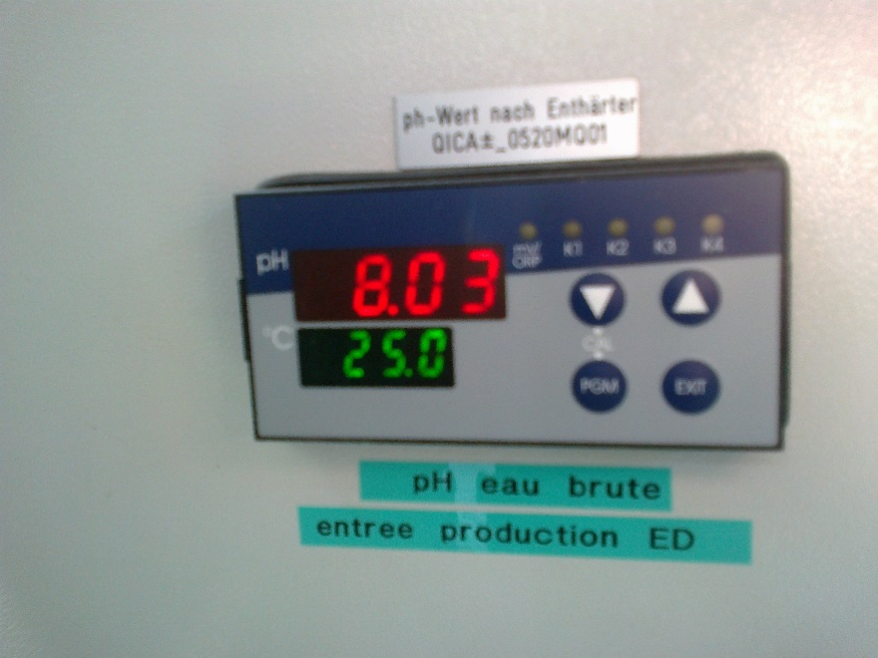

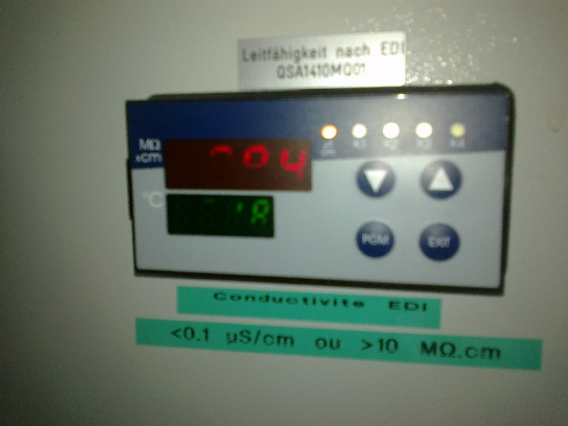

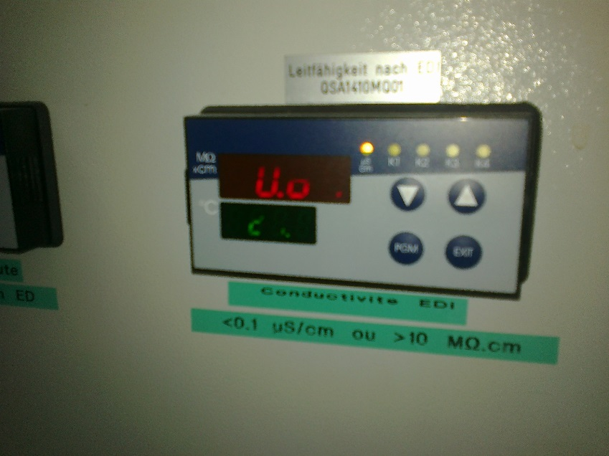

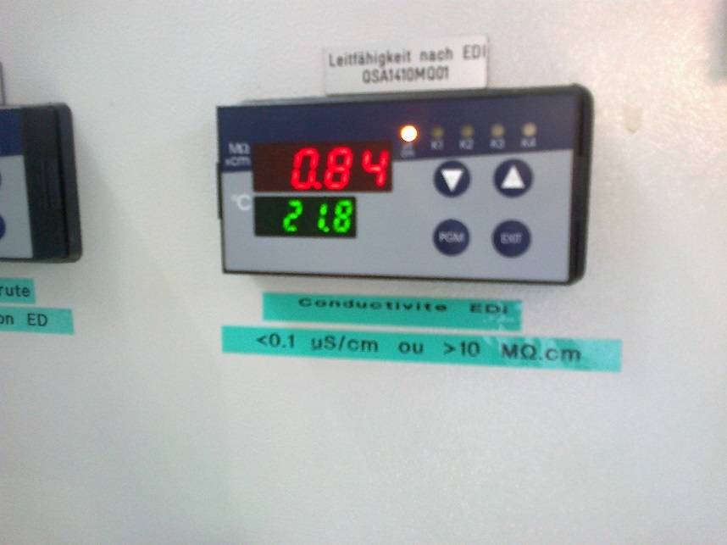

The general plant

