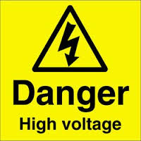 Danger

High Voltage Tests

RPC RE-4

Tel; Anton 162692

Tel; Ian 164414

Danger