Foam Test Volume for Foam Quality Verification
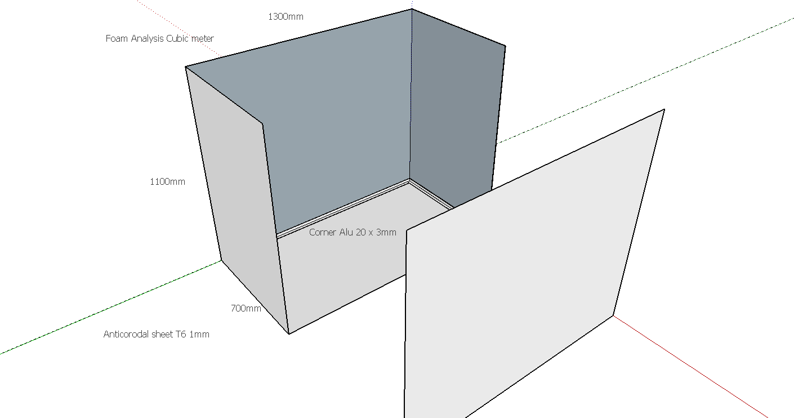
Ian Crotty 10 June 2014

