Foam tank for Tests in Spain July 2016 Ian Crotty
6 April 2016
(x 3-4) Vessel dia 800 mm
Height = 1000mm
Max weight of 15kg
Cone at Base
Handles x2 at top
Lifting hook at top.
Dia 800mm

Height = 1100mm

100mm

Drainage Hole dia 10mm

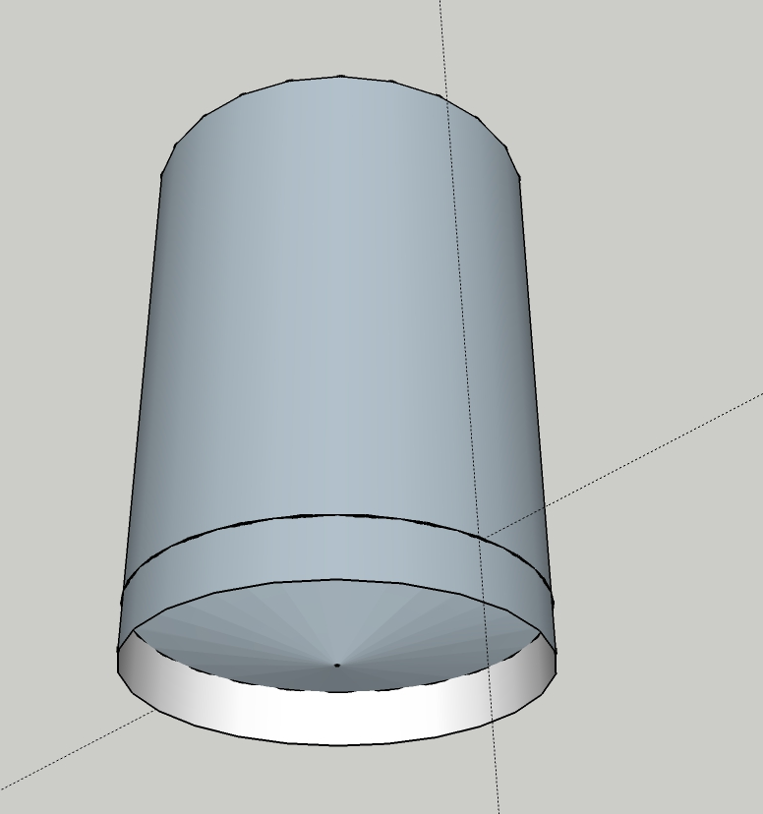

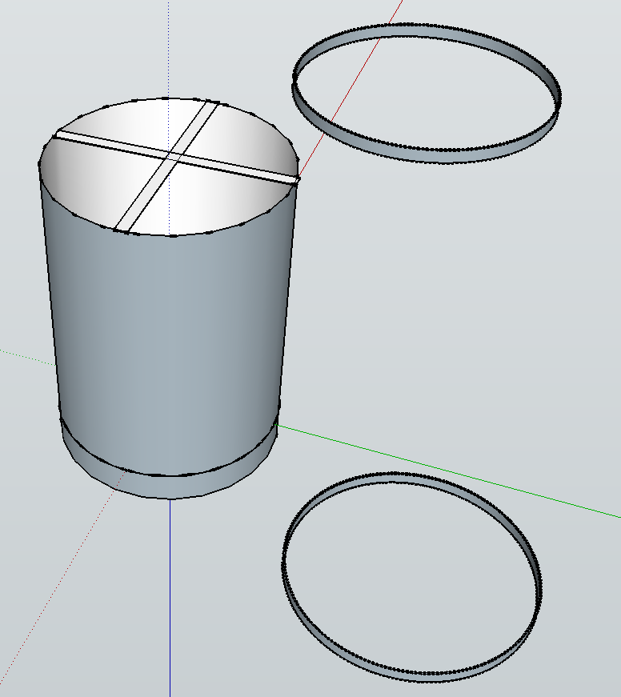

Calculate cone
http://craig-russell.co.uk/demos/cone_calculator/
