Foam tank for Tests in Spain July 2016 Ian Crotty
20 April 2016
(x 4) Vessel dia intern 800 mm
Height = 1000mm
Max weight of 15kg
Cone at Base
Handles x2 at top
Lifting hook at top.
Dia 800mm

Height = 1100mm

120mm

Drainage Hole dia 10mm
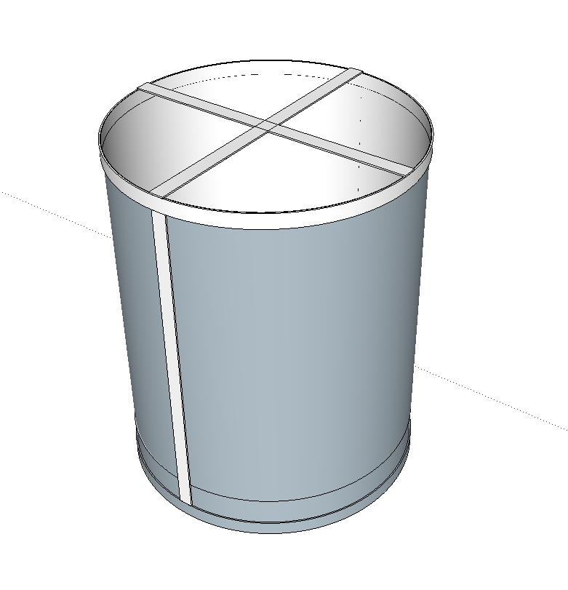
2x handles at top
Hole dia. 8.4
Suspension
Bars 4 x 40
Hoops 4 x 40
Bar Antico 4 x 40
Antico
Cylinder 1mm

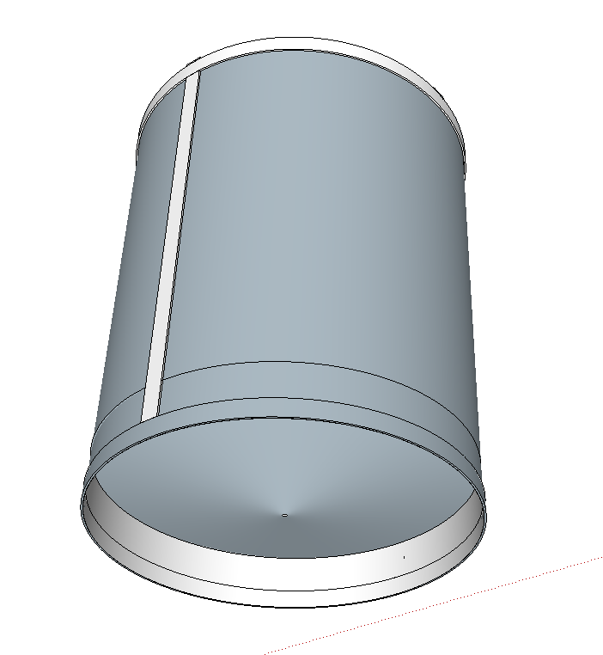
Ian Crotty 20 April 2016
Cone Antico 1mm
Height 100. Drain hole dia 10mm

Calculate cone
http://craig-russell.co.uk/demos/cone_calculator/
