Foam Disruction ideas

A-L Fameau, S Lam and O D Velev, Chem. Sci., 2013, DOI: 10.1039/c3sc51774h
http://www.rsc.org/chemistryworld/2013/08/destroy-stable-foam-demand

http://www.dowcorning.com/content/publishedlit/26-1231-01_Foam_Control_Aq_Coatings_WP.pdf

http://www.google.com/patents/US2346928

Sound Methods of Breaking Foam
Fourth Year Project Report- Engineering Science, Finals Part II, 2007
James Winterburn, Pembroke College
Supervised by Dr P. Martin
http://personalpages.manchester.ac.uk/staff/p.martin/publications/Sound_methods_of_breaking_foam.pdf

http://www.ncbi.nlm.nih.gov/pubmed/15491178

The Science of Defoaming: Theory, Experiment and Applications
By Peter R. Garrett 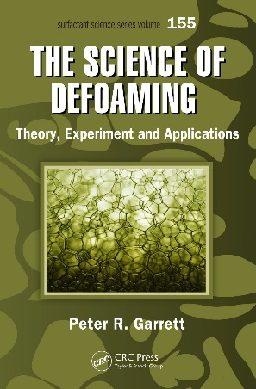
120GBP
https://books.google.ch/books?id=rV7MBQAAQBAJ&pg=PA544&lpg=PA544&dq=destroying+foam&source=bl&ots=qCeuMz8bWw&sig=KzukLyqeYo9rUV_w7x-D8rTkV0g&hl=en&sa=X&ei=sB7JVMrqBsLpaI65gNgP&ved=0CCwQ6AEwAjgK#v=onepage&q=destroying%20foam&f=false

Biosurfactants: Production and Utilization—Processes, Technologies, and ...
edited by Naim Kosaric, Fazilet Vardar Sukan

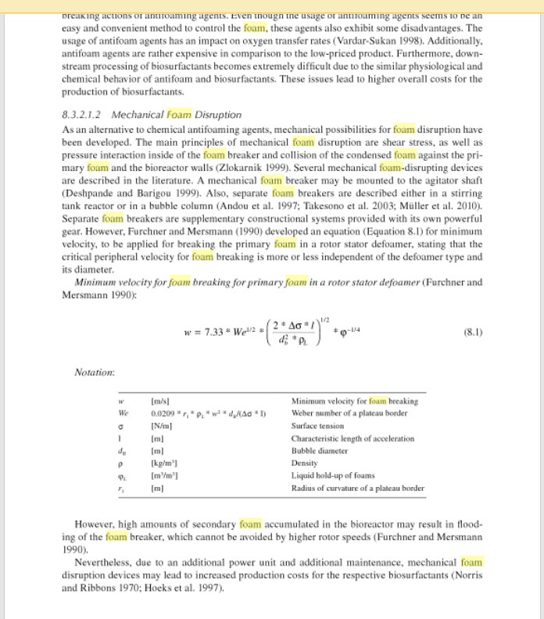

http://www.dailymail.co.uk/femail/article-2131761/Are-paint-stripper-chemicals-shampoo-destroying-hair.html

Power Ultrasonics: Applications of High-Intensity Ultrasound
edited by Juan A Gallego-Juárez, Karl F Graff 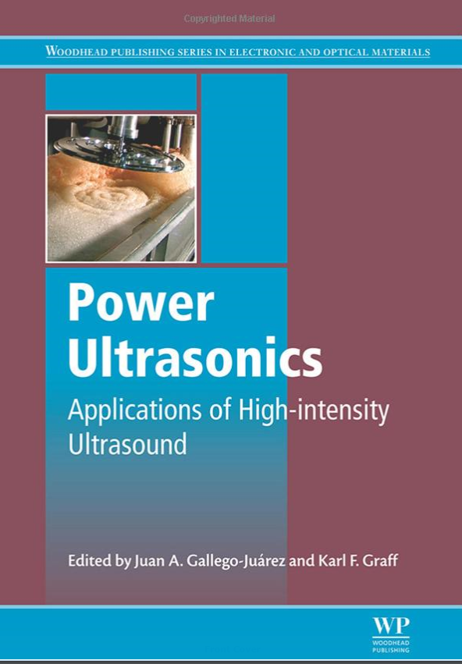

https://books.google.ch/books?id=vpeuAwAAQBAJ&pg=PA801&lpg=PA801&dq=destroying+foam&source=bl&ots=14gHjSc2Gl&sig=HQb5YTnYAYH89Zx7BUE-DMxMSI8&hl=en&sa=X&ei=sB7JVMrqBsLpaI65gNgP&ved=0CD0Q6AEwBjgK#v=onepage&q=destroying%20foam&f=false
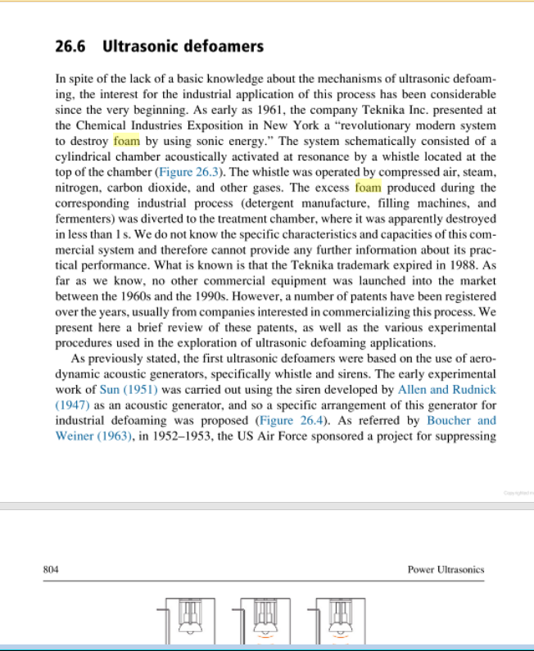
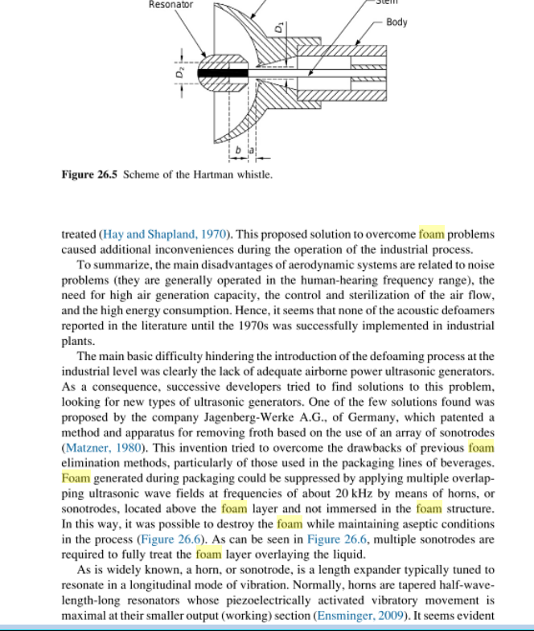

Foam Supplier
http://www.fomtec.com/fluorine-free/category38.html

