Foam Drainage or decay

Transport Processes in Bubbles, Drops and Particles
By Daniel DeKee

https://books.google.ch/books?id=7saRlQeNSwYC&pg=PA160&lpg=PA160&dq=free+drainage+of+aqueous+foams&source=bl&ots=CO8bqkokV_&sig=D0nT_B8iTU5Edld06p-GXhZkQA8&hl=en&sa=X&ved=0ahUKEwjt2deWjafNAhWInBoKHU7mBNQQ6AEIZjAN#v=onepage&q=free%20drainage%20of%20aqueous%20foams&f=false
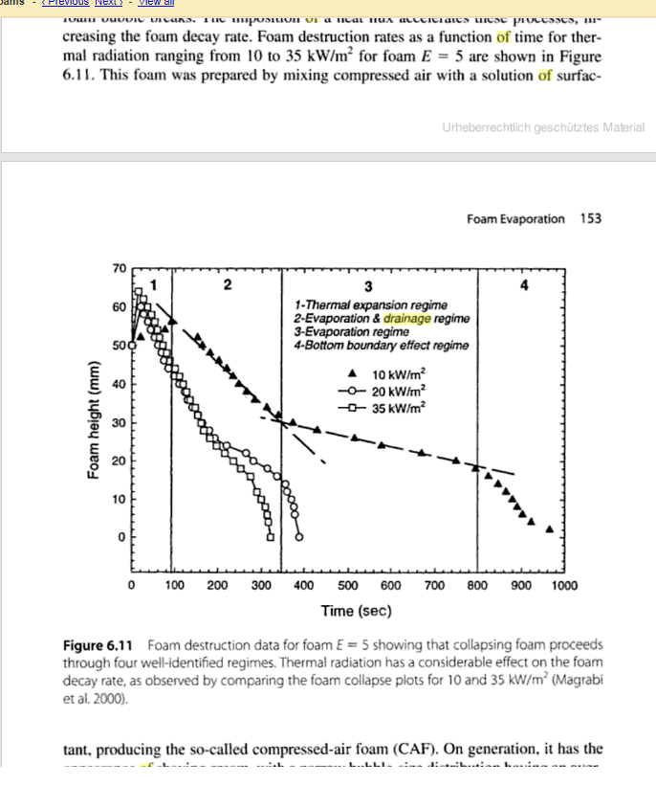

Quote from
A note on the effects of liquid viscoelasticity and wall
slip on foam drainage
V Bertola
http://iopscience.iop.org/article/10.1088/0953-8984/19/24/246105/pdf

“This work was motivated by some recent experimental observations on tetradecyltrimethylammonium
bromide/dodecanol (TTAB/DOH) aqueous foams, showing that tiny amounts of
polyethylene oxide (PEO) dissolved into the liquid cause a faster displacement of the front
between wet foam and dry foam in the forced drainage experiment [25, 26]. Independent experiments
[27] on commercial aqueous film forming foams (AFFFs) showed that the addition
of PEO significantly increased the foam lifetime, from which a reduction of the drainage rate
was suggested.”

Foam density
Measurement of Foam Density Profiles using AC capacitance.
http://iopscience.iop.org/article/10.1209/0295-5075/31/8/013/pdf

