Cooling connexions to be made from the RE4 Chambers to the manifolds

Ian Crotty 31 May 2013
Tools
Components
Methods, Push-Lok Hose
Tightening unions
Swaging of Cu pipe.
Checks and commissioning
References

Introduction

The RE4 chambers will be water cooled, as are all the other RPCs in CMS, to remove on-board heat and maintain temperatures within the RPC operating window.
The chambers are assembled into 20deg sectors called super Modules(SM) then the cooling will be also.

Tooling
Below are the tools necessary to assemble the Cu pipe and union
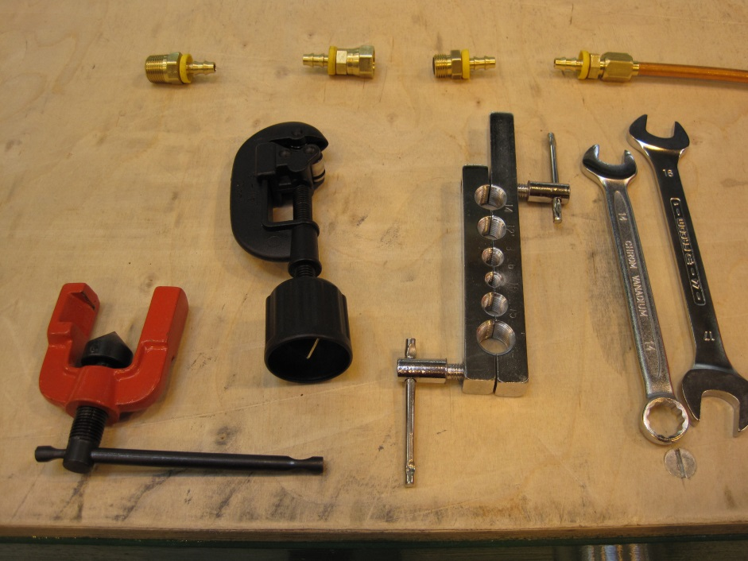

Below are the tools for assembly of the Push-Lok hose
Push-Lok Cut-Off & Assembly Tool
Model No. 881540
This unique tool combines a hose cutter with a toggle-action that presses the fitting into the hose. Designed to handle. Push-Lok hose from 1/4" through 3/4", this tool makes the job
easier whether you are making one assembly or a hundred. Overall length: 16" Weight: Approximately 4 pounds

Full list of tools
Spanner 14.2mm = 9/16inch
Spanner 15.9mm = 5/8inch
Spanner 17.45mm = 11/16inch
Push-Lok tool
Swaging tools
Pipe cutter
Locktite 567

http://www.youtube.com/watch?v=Da5auYDiJ9s

Schematic of cooling Circuit by Dan Wenman
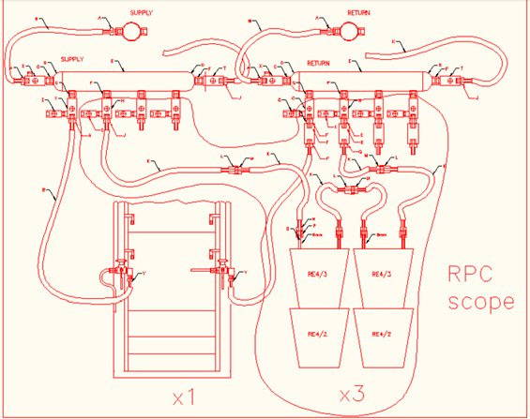

Components;

Hose ¼ inch internal dia.
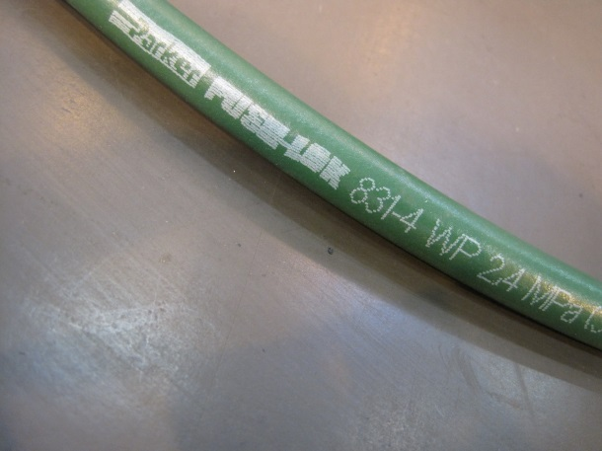

Copper pipe to Unions
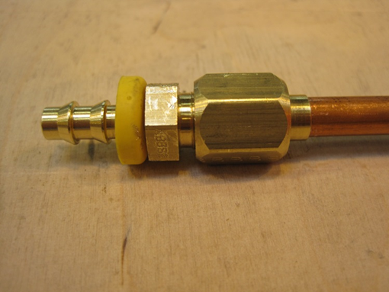

“O” Ring unions
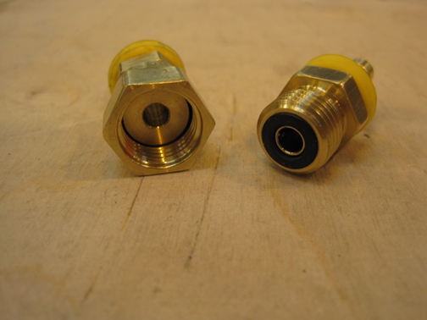

3/8 inch union to manifold

Photo

Swaged assembly to 8mm Copper pipe from the chamber
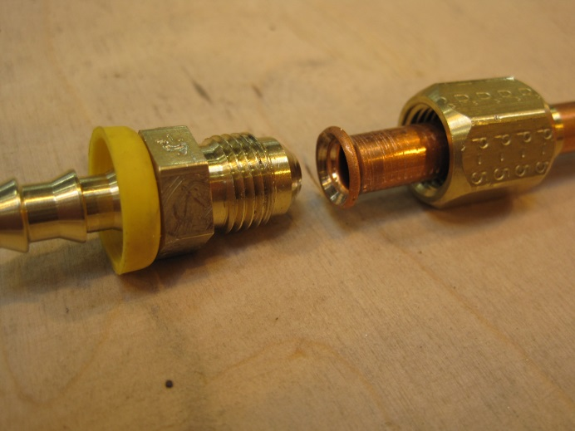
Smooth finish on inside facings showing full contact
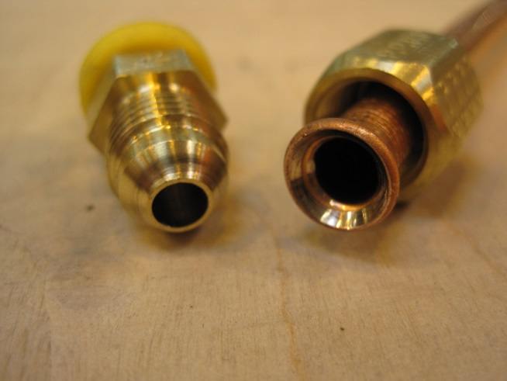

Flexible assembly.
The flexible must be pushed onto the union all the way so that the end is well hidden by the yellow collaret. This is done using the specific tool illustrated above, or similar.
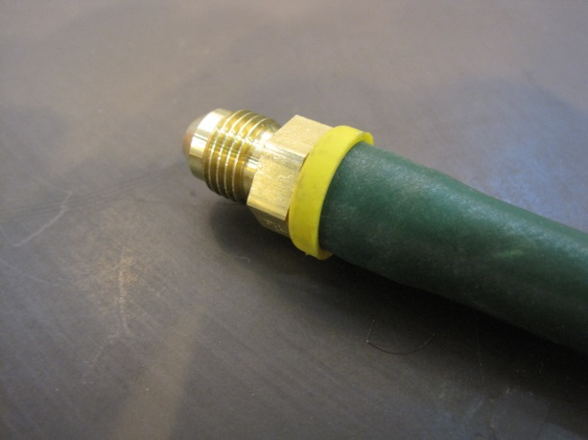

The final result.
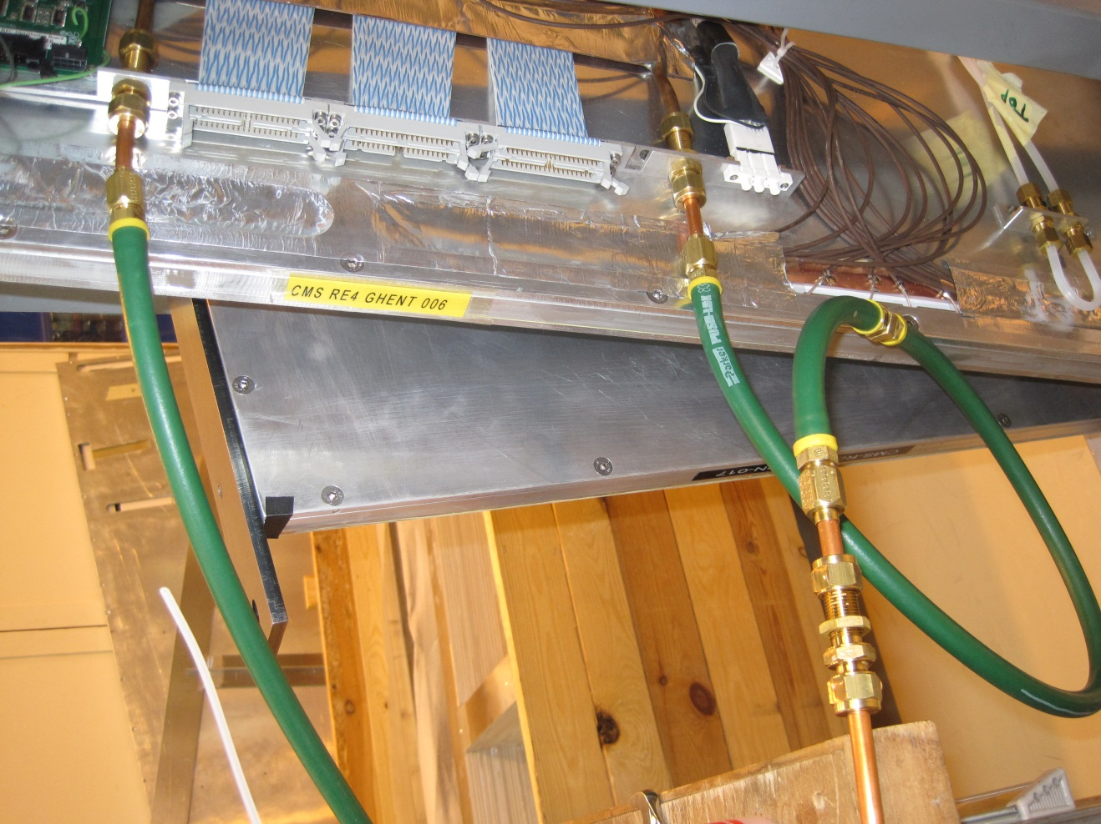

Details & difficulties in swaging the flared fittings;
The flare must be coaxial and single line contact as seen below.
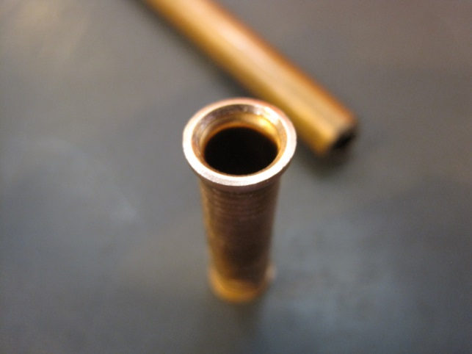

Shown below is a cheap version of the swaging tool. Not centering the tool over the copper pipe
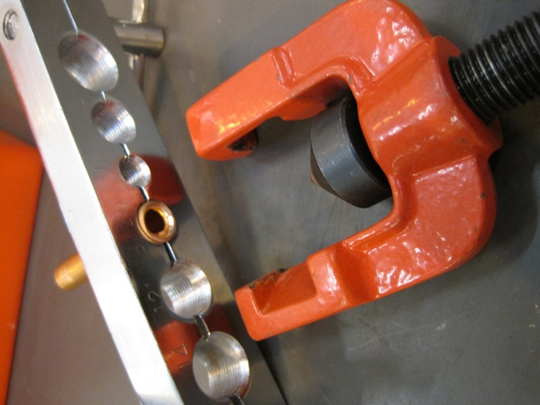
will produce poor results, below, with an offset and non-continuous contact zones. The diameter of the flare (or tulip) will be XXmm with a tolerance of XXmm
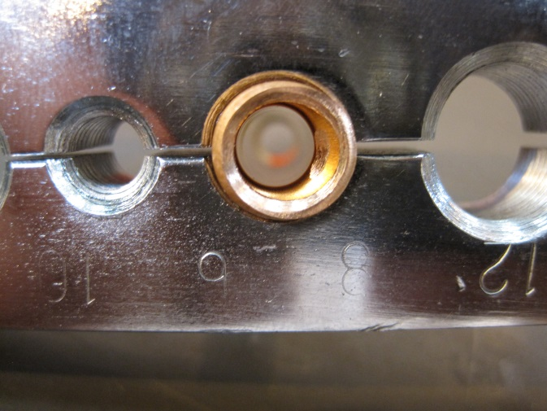
By forcing the male onto the flared pipe during assembly an apparent improvement can be made but the sealing is not good.
Damaged pipe due to forcing the union.
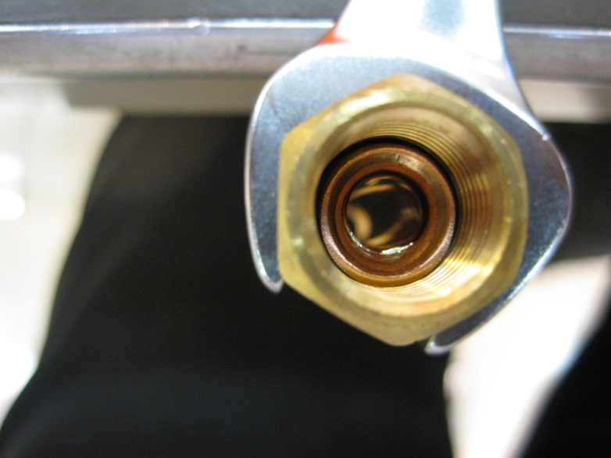

Tightening of the unions.

The “O” ring fitting will seal under light applied torques, however a further torque is applied to ensure they do not come loose. Approx XX Nm will be used.
The flared fitting will be torqued to XX Nm if the swaging was done correctly further plastic deformation will be obtained at XXNm

Commissioning of the system.
The 20deg sectors will be tested at 20 bar or Nitrogen. The flexible is quite capable of sustaining this high pressure. The rated pressure is 24 MPa = 24 Bar.
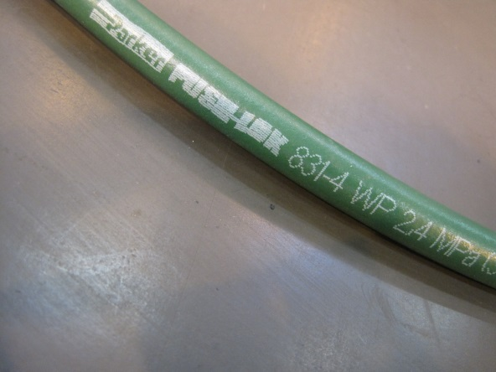
The volume of the system from manifold to 20deg sector and back varies from XX litres to XX litres.

A leak rate of 5 x E-04 [mbar.l/s] should be found.

When using the N2H2 only very low pressures (1-2Bar) are required.

References

http://www.technical-controls.com/product.asp?prodid=36520

http://www.parker.com/literature/Hose%20Products%20Division/4281_B1.pdf

http://www.instrumentassociates.com/literature/Parker/Bul%204281-B1%20A00.pdf

http://www.hydraulichouse.com/pdf_files/HPD-4400/D1.pdf
http://www.youtube.com/watch?v=uTw17jQ0hzQ

