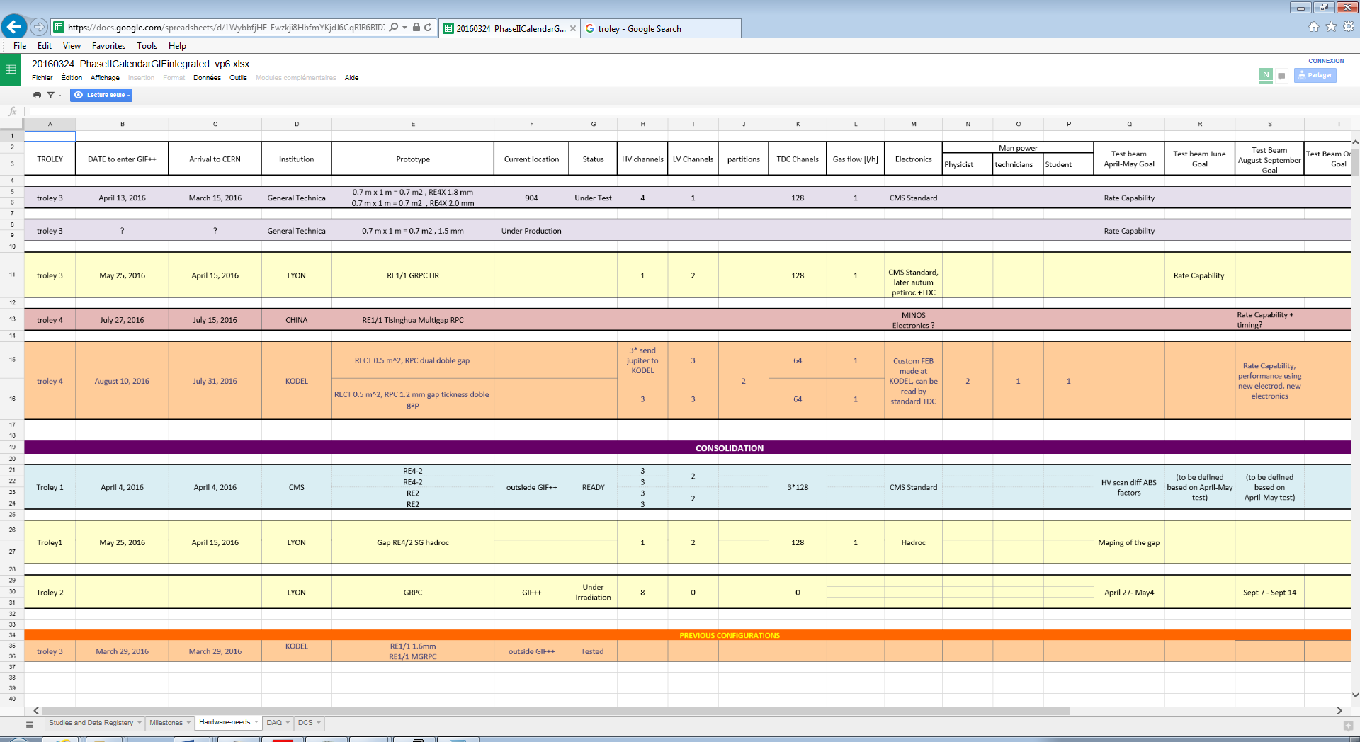
https://docs.google.com/spreadsheets/d/1WybbfjHF-Ewzkji8HbfmYKjdJ6CqRIR6BID7jugEcpI/edit?pref=2&pli=1#gid=1091581956

