TDC cable adapter as made for the Cosmic stand in 904 QC3
3M x2 IDC 34c male connectors, 1 continuous twitsed flat cable 3M & 1 68pin Robinsen Nugent (ref; P50E-068S).
Available from CAEN; http://www.caen.it/csite/CaenProd.jsp?parent=52&idmod=412
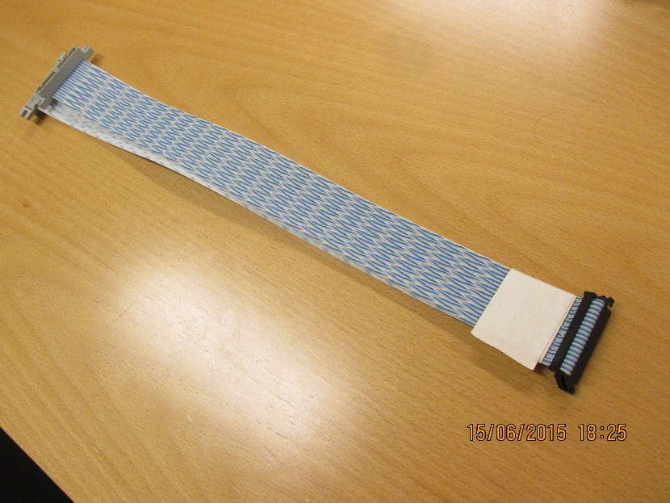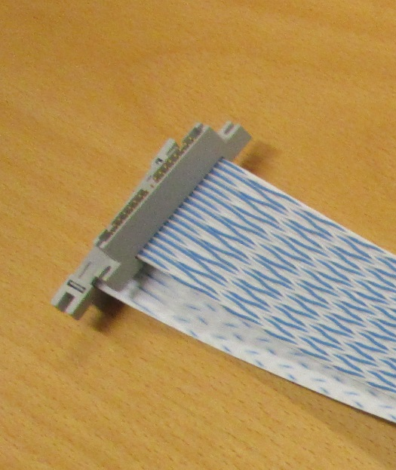

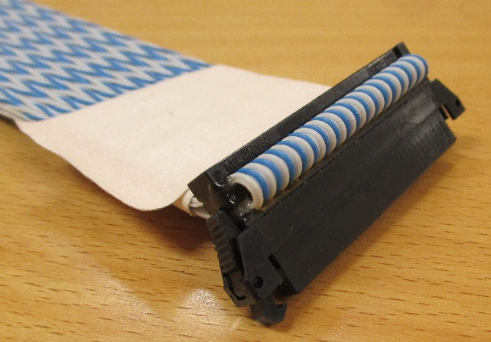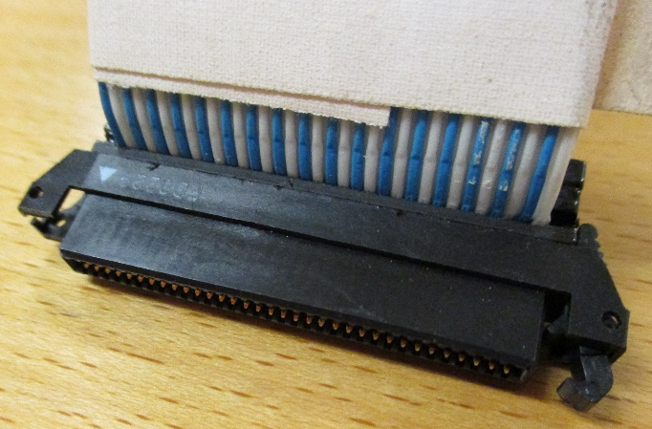
Continuous cable loop !
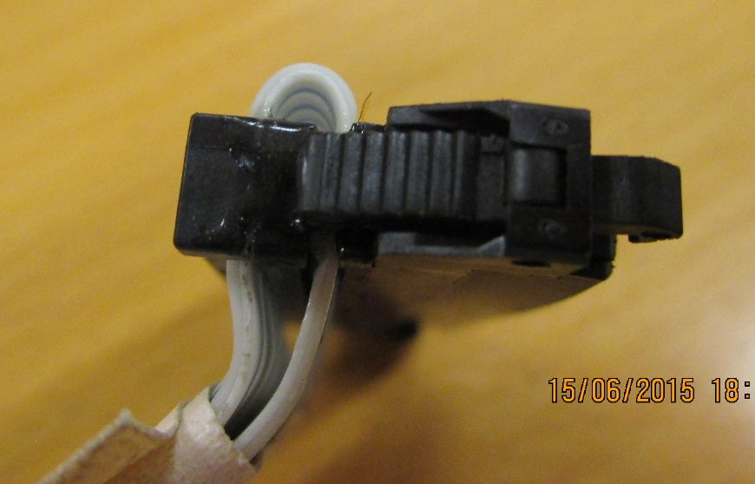

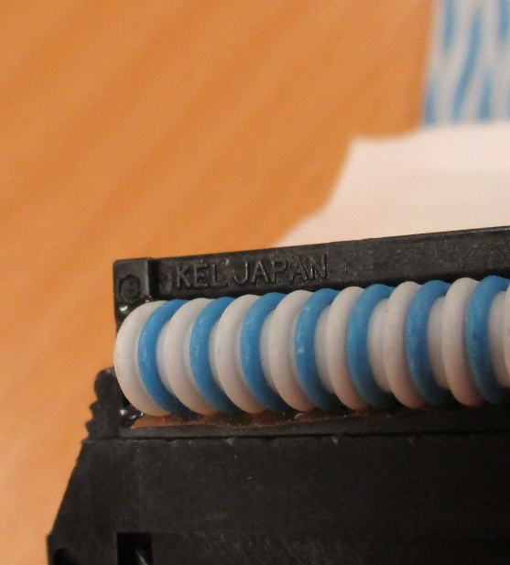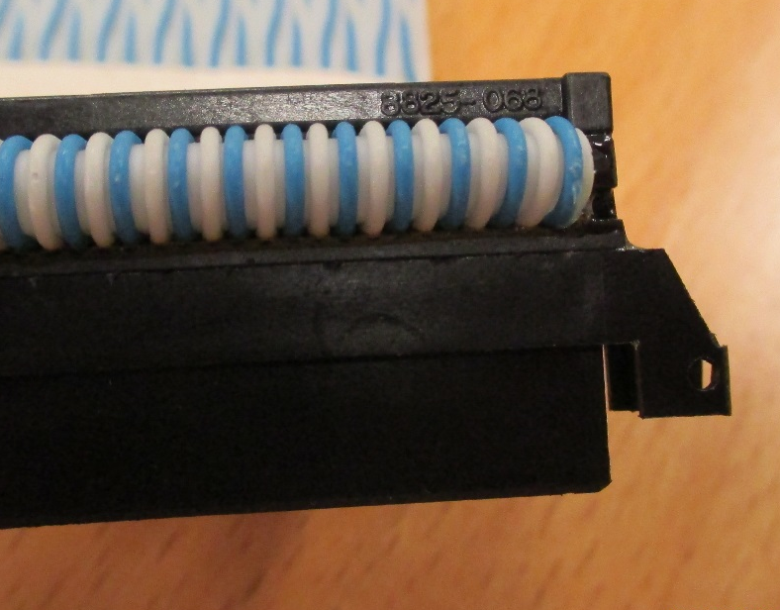

You can read “ KEL Japan” and “ 8825-068”

http://multimedia.3m.com/mws/media/441604O/3mtm-interconnect-mating-table.pdf
Page 41 of 45 or page 48 in pdf doc.
3M ref
P50E-068S-EA
TS 1143
3M Part-Number was 80-0009-0484-9
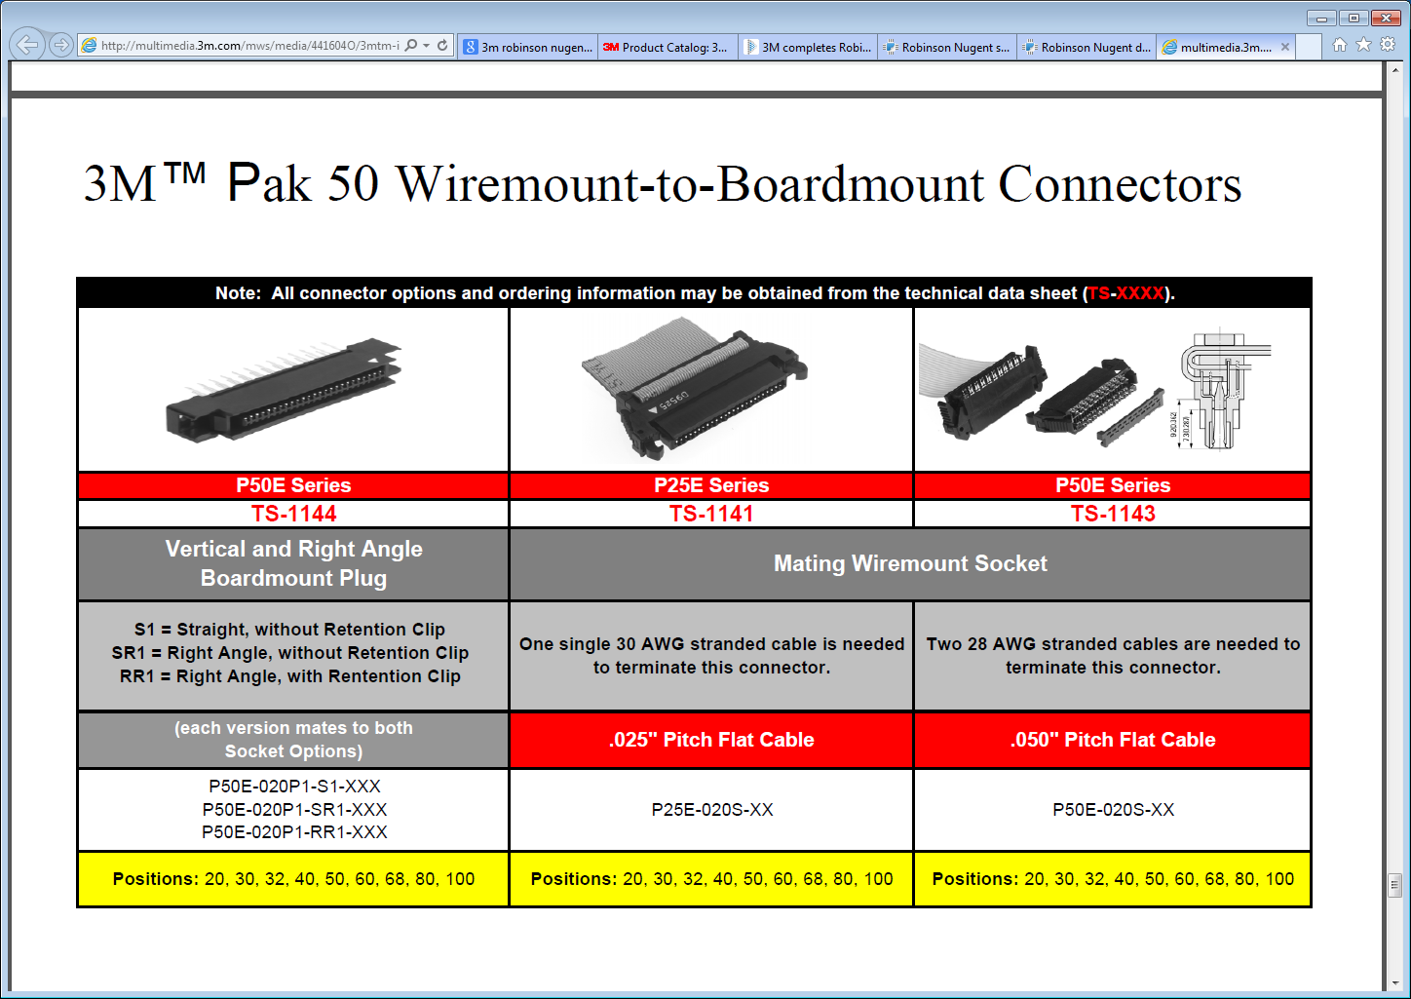

This appears to be the wide version, is it the latest release that is easier to assemble. ?

http://solutions.3m.com/wps/portal/3M/en_US/Interconnect/Home/Products/ProductCat?N=4890+3293471877&rt=rud
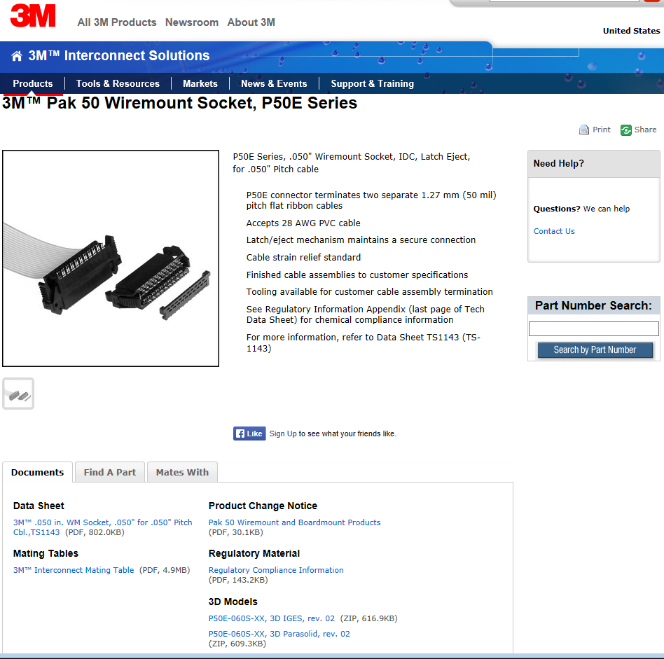

http://multimedia.3m.com/mws/media/218537O/3mtm-050-in-wm-socket-050-for-050-pitch-cbl-ts1143.pdf
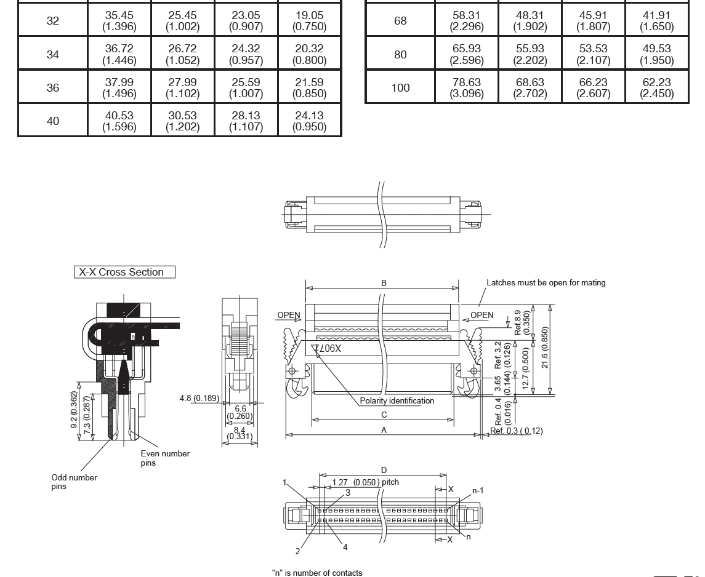

KEL Corporation supplies this;
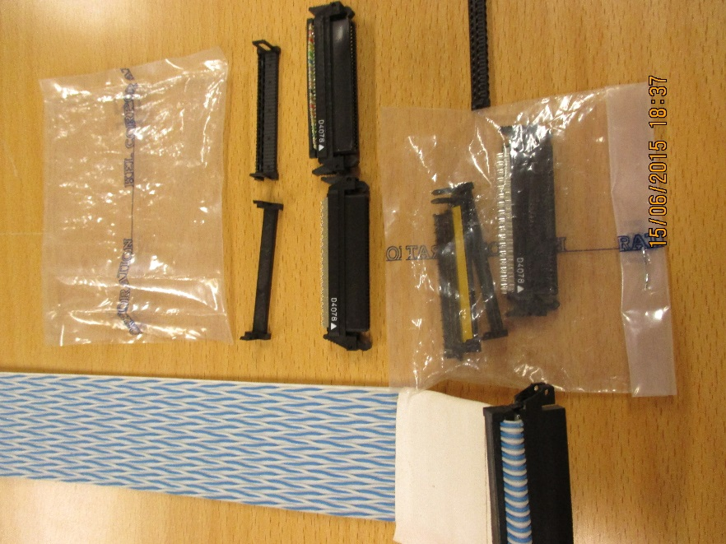
Which is thicker than the one used in the cable above !
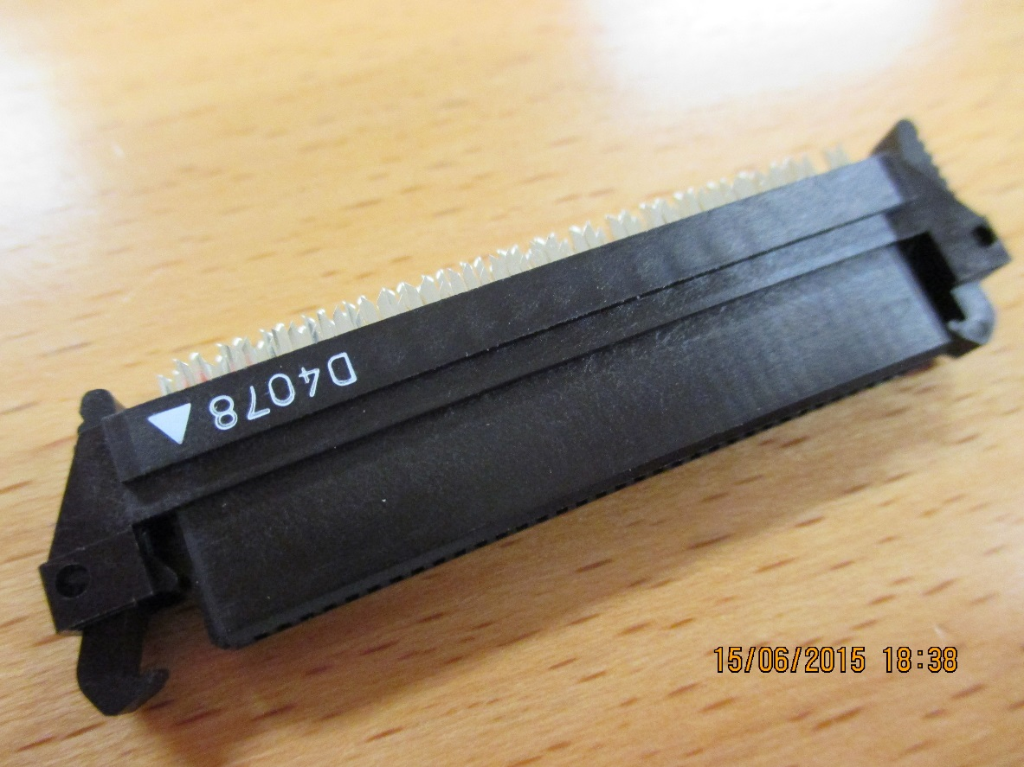

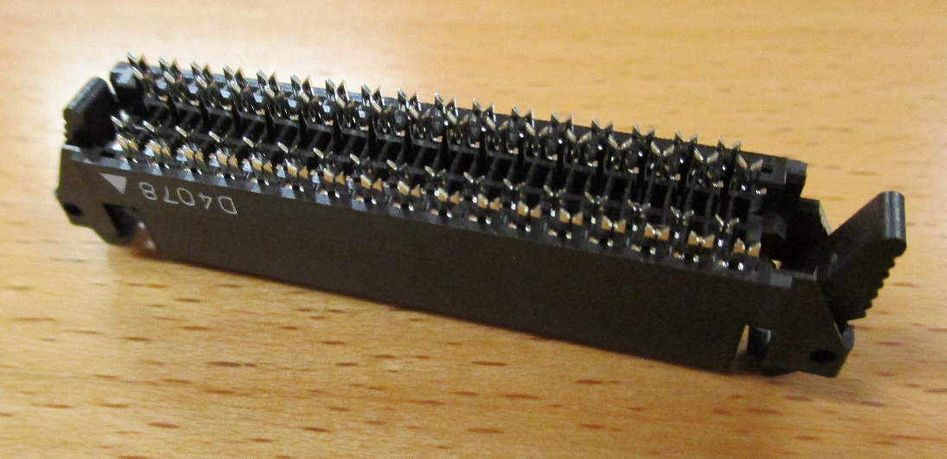

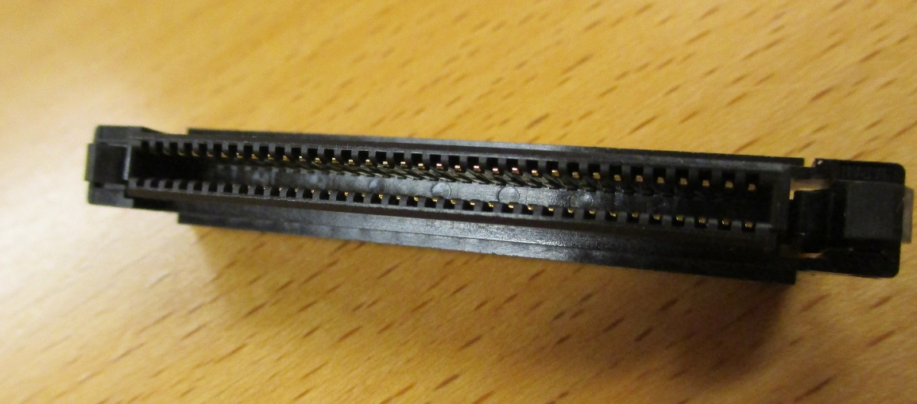
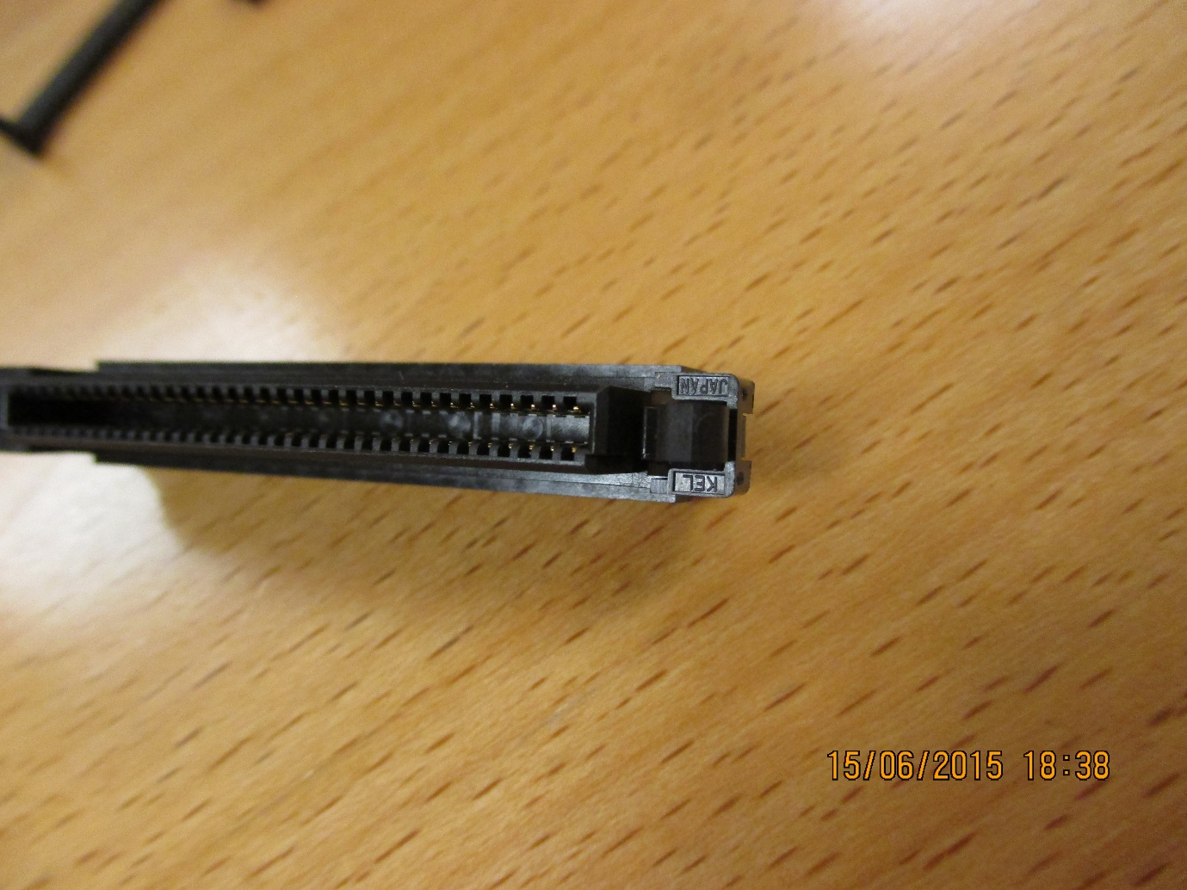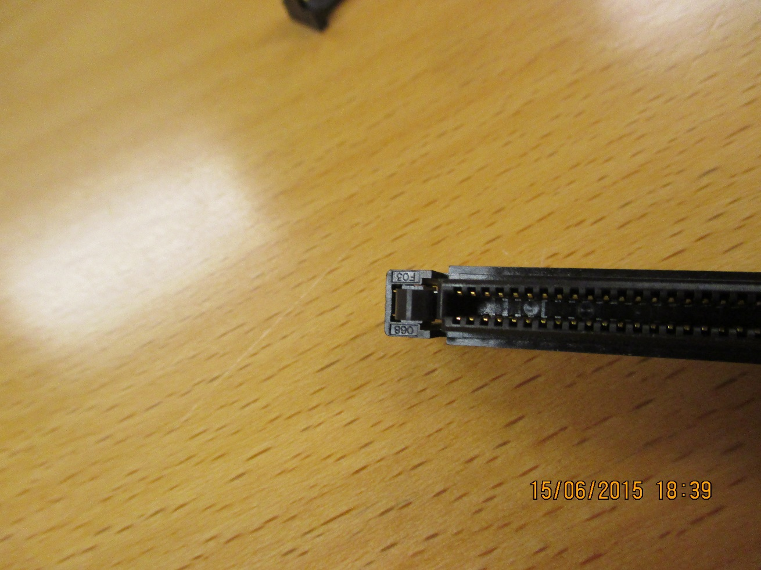
You can read “KEL Japan” and “068 F03”
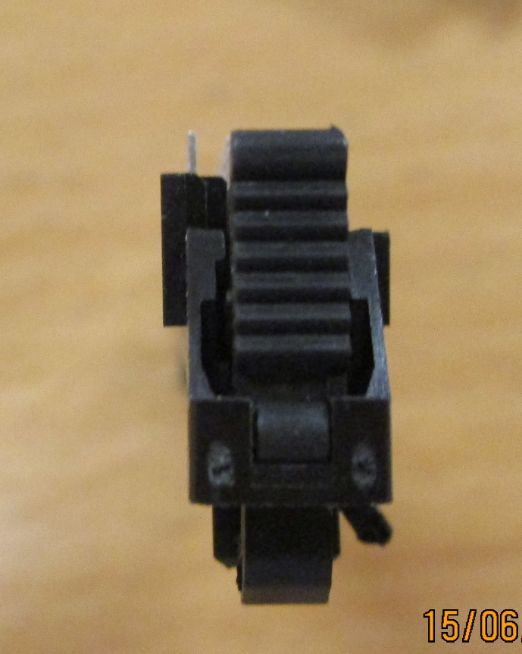

CAEN Data Sheet
http://www.caen.it/csite/CaenProd.jsp?parent=52&idmod=412

DO NOT use the rigid thick twisted pair cable from CERN stores (SCEM 04.21.22.434.8) as it is very difficult to work. Better to use the thinner cable from CERN stores (SCEM 04.21.22.334.?) that is NOT twisted pair as shown in the CAEN document. Unfortunately it is NO longer in CERN stores. It is or was Fileca P34 QOHF 28-07.

http://eu.mouser.com/search/ProductDetail.aspx?3M-Electronic-Solutions-Division%2fP50E-068S-EA%2f&qs=1Dv50y8t490WWWSxqFoGcQ%3d%3d
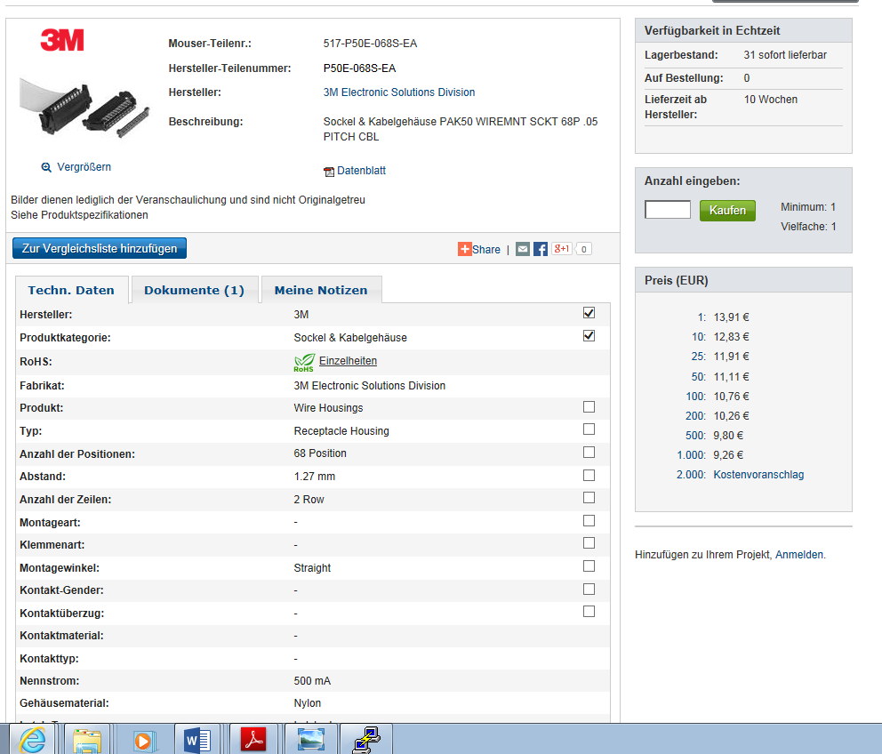
Only 31 left on 25 Aug 2015.
EDH made out ;
https://edh.cern.ch/Document/SupplyChain/DAI/6126251

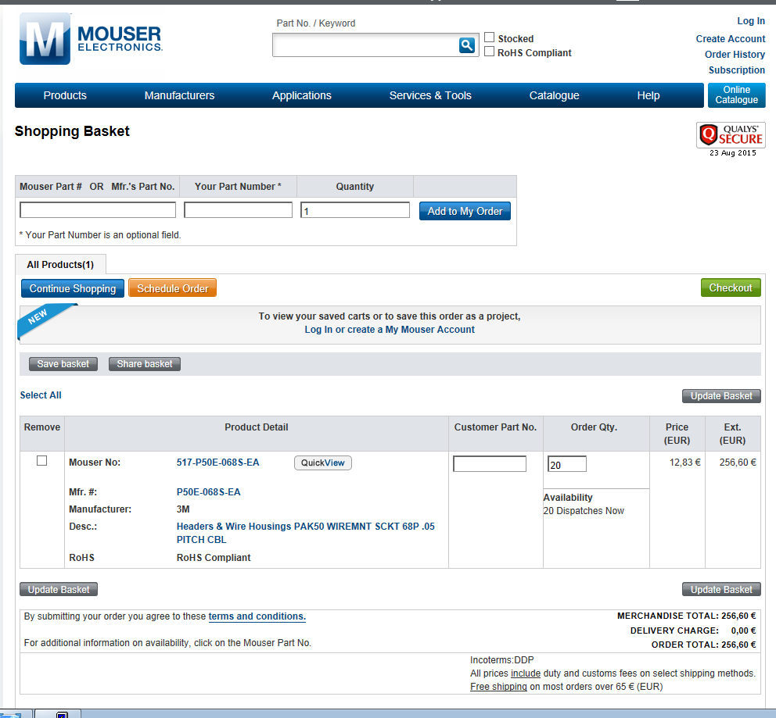

http://www.digikey.com/product-detail/en/P50E-068S-EA/P50E-068S-EA-ND/2340964

Similar products available from Radio Sapres
http://int.rsdelivers.com/product/3m/p50e-100s-ea/mil-idc-socket-100-contacts/8280475.aspx
But not 68 contacts !!
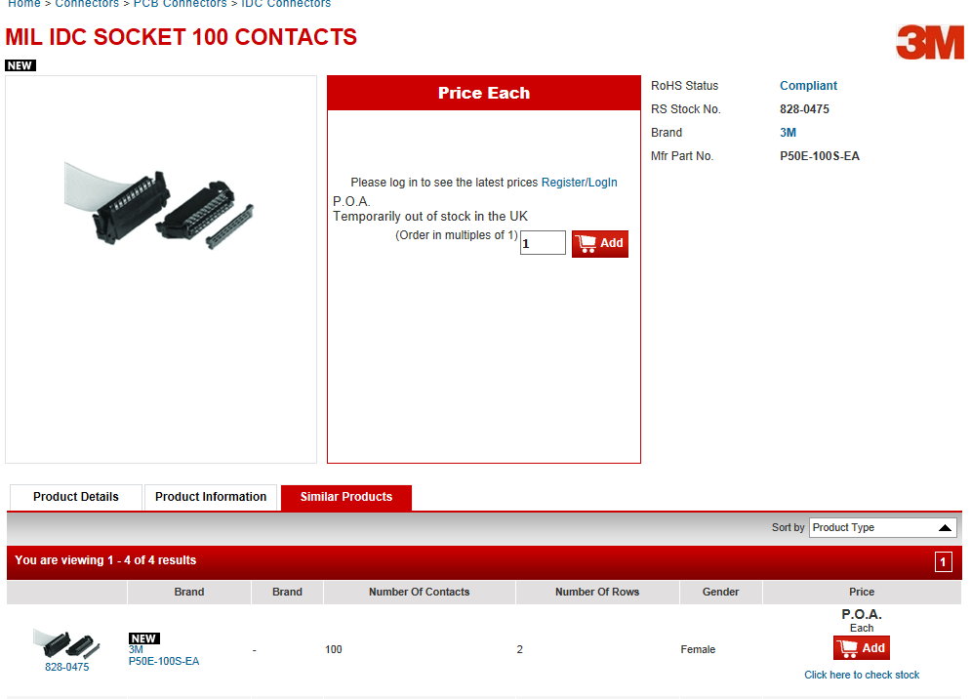

The flat Cable Fileca
The original SCEM in 40c was 04.21.22.340.3
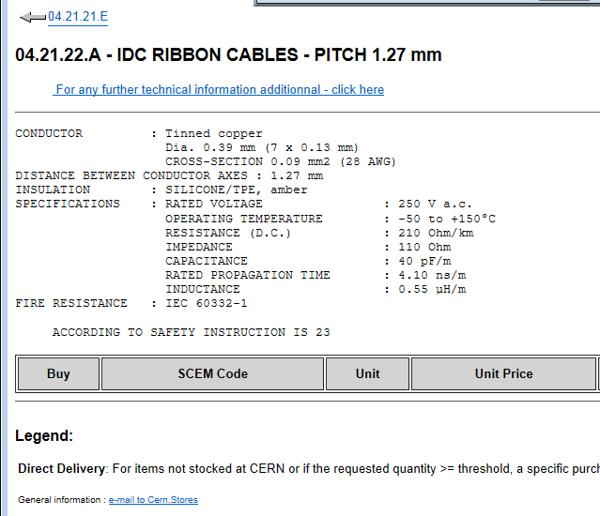
Email sent to Manuel Sanchez in Bat 73 asking help to find this silicone cable, rather than PVC as it is more flexible and perhaps thinner (?)

NOTA non connected( in fact non used) conductors.
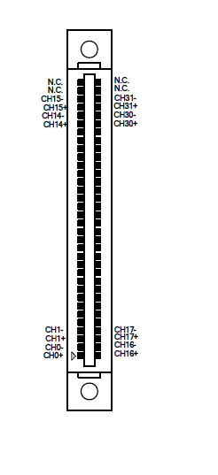
Ian Crotty
15 June 2015
Other photos here;
http://rpc-cms-re4-upscope.web.cern.ch/rpc-cms-re4-upscope/RPC/GIFPlusPlus/Services/SignalTDCAdaptor/PhotosTDCCableJune2015/

And this document here;

http://rpc-cms-re4-upscope.web.cern.ch/rpc-cms-re4-upscope/RPC/GIFPlusPlus/Services/SignalTDCAdaptor/TDC CableAdapter.pdf

