Quality Certification of Forward RPCs for the CMS Experiment at CERN

Yasser Assran
For the CMS RPC Collaboration
Abstract

The production of Resistive Plate Chambers (RPCs) for the first Endcap station (RE) of CMS experiment at Large Hadron Collider (LHC) was completed at CERN over last few years. For good performance of CMS muon and trigger systems these chambers have been assembled in accordance with strict QC (quality control) and QA (quality assurance) procedures during various assembly steps. Over 500 chambers have been constructed and have been tested with cosmic rays. The chambers are assembled with the sensitive volumes (namely gas gaps) which were manufactured in Korea and all relevant mechanical parts were made in China. The experience we have accumulated during the assembly and quality certification will be described.

Introduction

A typical RPC ⁽¹⁾ used in CMS experiment is double gap. Each gap consists of two parallel plates, made out of resistive material (with resistivity 10⁹ – 10¹² Ωcm). The plates are separated by a gas gap of two mm thickness. The outer surfaces of the resistive material are coated with graphite paint to form the HV and ground electrodes. The readout is done by copper cathode strips sandwiched between the two gaps. The RPC chamber operated in avalanche mode, whose design considerations have been proven successfully in several tests ⁽²⁾. In this work we compare the two cooling schemes used in RE1 and RE2 and investigate the effect of applying high voltage. In the quality assurance testes, we have investigated parameters like dark current, strip occupancy, cluster size and efficiency of 36 RPCs.

1 . Cooling test
The end cap region of the muon station in CMS experiment consists of different types of resistive plate chamber (RPC), depending on its location. During the operation of the RPC, there are a few watts of heat energy dissipated into the front end boards, so we need cooling system to be applied to the RPC. Different cooling schemes were used for this purpose. In this work we make a comparison of cooling efficiency between various forward CMS RPCs. Also we investigate the effect of applying the high voltage. .

Description
As shown from Fig 1 the cooling system of RE ½ is simply cooper tube passing from one side of the RPC having U shape and get out from the same side so that the cooling liquid (water) passes through both sides of the front end boards (FEBs). On the other hand, the cooling system of RE 2/2 is just cooper tube enter from one side and out from the other side which mean that the cooling liquid takes the heat from one RPC to the next one.

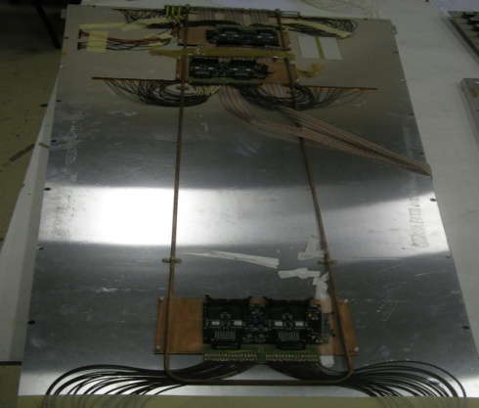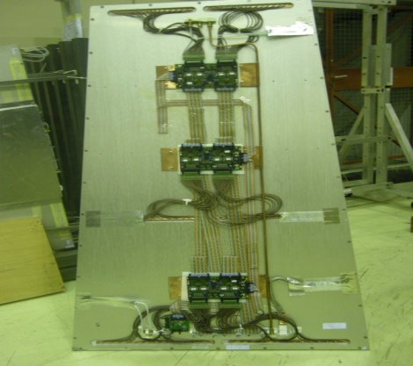
RE1/2 RE2/2
Figure 1 The cooling system in both RE 1/2 and RE 2/2.

In this work, the variation of the temperature of the front end boards (FEBs) was recorded by using infrared camera (Varioscan 3021).

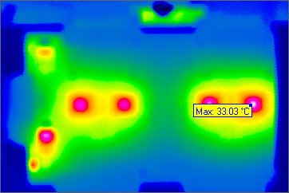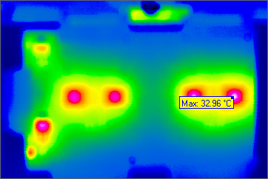

Fig 2 Front end board photos using infrared Camera.

Method
1- We put the chamber RE 1/2 on the gas for one day and then switch on the front end board (FEB). Record the variation of the FEB temperature with time without cooling. Start cooling at 16 C and also record the variation of temperature with time.

2- Switch on the High Voltage (9 KV) with the FEB on and record the variation of the FEB temperature with time without cooling and then with cooling at 16 C.

3 Put the chamber RE 2/2 on the gas for one day and switch on the FEB. Record the variation of the temperature with time with the cooling (16 C) off and then on.

4 Switch on the High Voltage (9KV for top and 5KV for the bottom) with FEB on. Record the variation of the FEB temperature with time with cooling (16 C) off and then on.

- Repeat the previous four steps for both chamber RE 1/2 and 2/2 but with cooling at 20 C.

Results.

As shown in figure3, the temperature of the FEB increases till it reaches plateau1 and when we apply cooling (16 C) it starts to decrease till it reaches also plateau2.
For both RE 1/2 and RE 2/2 the effect of applying the high voltage is to increase the plateau1 temperature and leave the plateau2 temperature nearly the same. One possible reason of this increase in temperature is that when we apply high voltage to the chamber, there is a gas gain so it works more.
Chamber RE 1/2 reaches lower temperature than RE 2/2 after applying cooling so that the cooling system in RE 1/2 is more efficient than that in RE 2/2. By comparing the results shown in fig 3 and 4 we found that the cooling at 20 ºC is not efficient since at the end of the curve the temperature start to increase again in spite of the presence of cooling

Figure 3. The variation of the FEB temperature with time for both RE 1/2 and 2/2 with HV on and off and cooling (16 C) off at the first part of the graph and on at the second part.

Figure 4. The variation of the FEB temperature with time for both RE 1/2 and 2/2 with HV on and off and cooling (20 ºC) off at the first part of the graph and on at the second part.

Quality control test.

The completed chambers are put in cosmic stand for quality control tests using muons from cosmic rays. The cosmic stand consists of two rows of scintillators, one at the top of the stand and one at the bottom, used for triggering purposes . The gas system was based on mass flow meters and controllers. The gas mixture was composed on 96.5% C2H2F4, 3.5% iC4H10 and 0.3% SF6 and was applied in parallel to all chamber in the cosmic stand. The high voltage power supply distribution was based on the Universal Multichannel CAEN/SY1527 unit which has the internal processor and internal network connection. The DAQ system consists of two VME crates housing 15 TDC modules sampled by40 MHZ clock. Each TDC process the LVDS signal after amplification and discrimination. By cosmic stand we measure the efficiency and the cluster size of the chamber. We can also monitor the current in both top and bottom gaps; also we can measure the noise.

2.1 Efficiency.

Efficiency is defined as the ratio between the number of chamber signals in a fixed time window and the number of triggers. Chamber efficiency is obtained with the “coincidence” method by evaluating the ratio between the number of events in which RPC has at least one fired strip in the trigger window (100 ns) and the total number of recorded
events, with correction for spurious hits ⁽³⁾.
The efficiency is given by ⁽⁴⁾.
$ε=\frac{\left[\left(N_{ob }/N_{t}\right)-P_{s}\right]}{1- P_{s}}$

where Nob is the number of observed events, Nt is the number of total events and Ps is the probability of the spurious hits. We measure the efficiency of 36 chambers at 9.4 kV, only one give low value. This low value because there is 24 dead strip in that chamber. Fig 5 show the efficiency of the36 chambers, from the figure we see that the efficiency of 90% of the tested chambers exceed 96% which agree with the requirements of CMS. In the left we see efficiency scan through the applied voltage of chamber RE12/o38.

Figure 5 the efficiency of 36 chambers at 9.4kv (left), efficiency scan of RE12/038 (right).

2.2 cluster size.

The Cluster size is defined as the number of contiguous hit strips of the chamber. A cluster size should be small in order to achieve good momentum resolution. The number of strips in a cluster should be less than three for efficient performance of RPCs and this number corresponds to the CMS criteria regarding cluster size The average value of cluster size for all 36 tested Chambers is 2 which is agree with the requirements of CMS endcap RPC. It has been shown from figure that all tested chambers are in agree with the requirements of CMS, in the lift we see the cluster size scan over the applied voltage, the cluster size at 9.4Kv is 2.5.

Figure 6 the cluster size as a function of chamber number of 36 chambers (left). The cluster size scan of 36 chamber through the applied voltage (right).

2.3. Dark Current

Dark current is defined as the current recorded by the gap in the absence of charged particle passing through it. For good gas gap, the current should be stable with respect to the time and less than 5 µA. from the 36 tested chambers, only four gaps give current more than 5 µA. in figure 7 we introduce one example of bad chamber (left) in which the current is not stable with time and also it exceed the value 5 µA, and an example of accepted chamber in which the current is stable and small.

Figure 7 current stability for chamber RE23/021 (left) and chamber RE12/038 (right).

2.4. Strip occupancy

Strip response profiles are created and they serve two main purposes: first, to ensure that the chamber is connected properly to the DAQ system and second, to ensure all readout strips are active and working properly as they are supposed to. Improper soldering of connections can lead to strips that appear to be dead in the strip response profile. Each RPC contains a total number of 96 readout strips and each of them is supposed to be in proper working condition. There can be some noisy strips, which show large number of hits and there can be some dead strips also, which show no signal or hit. A hit is defined as a signal recorded on a single readout strip within the 25 ns time window. All the strips of RPC were checked and faulty strips were observed. If a chamber had more than 2 noisy or dead strips, then the chamber was rejected. A rejected chamber was reassembled to remove those noisy and/or dead strips so that it can fulfill the CMS requirement. In figure 8 we introduce the strip profile of chamber RE12/038 which has two dead strips (strip 49 and strip 65), so that this chamber is accepted.

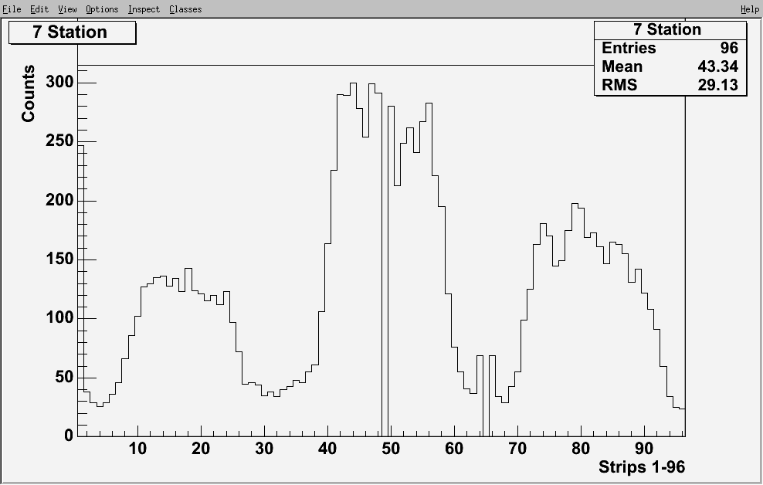

Figure 8 the strip response profile of chamber RE12/038

Conclusion

The cooling scheme used in RE1 is more effective than that used in RE2,3. Switching on HV increase the temperature of the FEB by 1 degree Celsius and Cooling at 20 ºC is not effective in both RE1 and RE2,3. For current stability, four chambers are rejected and 32 chambers are accepted. For efficiency, only one chamber gives low value and we found that the reason is it has 24 dead strips. Four cluster size all chambers give a value less than 3 so that all chambers are accepted. for strip occupancy only one chamber was rejected because it had 24 strips gives no signal.

Acknowledgments
References
1. Recent results and Developments on Double Gap RPC For CMS, A.Calaleo, CMS CR/1997- 013.
2. Test beam Results of the forward RPC Prototype Chamber for CMS Muon Detector, CMS NOTE 2001/014.
3. M. Maggi, “Preliminary Results on Double-gap RPC in a High Background Environment”, Scient. Acta 13
(1998) 139.
4. R. Santonico and R. Cardarelli, Nucl. Instr. and Meth. A187 (1981) 377.

