Stycast 2651-40W1 et Catalyst LV 23
Henekel
http://www.globalhenkelelectronics.com/distributor_search/locator/

Abovo

Abovo AG Locations
 | Abovo AG  Selzacherstrasse 32  Selzach, 2545  Switzerland | (41) 326 533 380  http://www.abovo.ch/

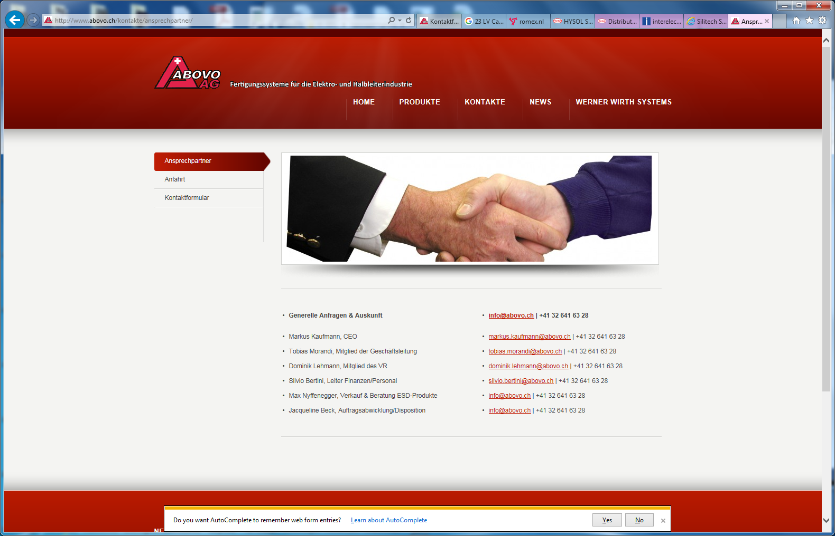

Interelec
http://www.interelec.ch/de/kontakt.html
Interelec Electronics AG
Sihleggstrasse 23
CH - 8832 Wollerau
Switzerland

T +41 (0)44 704 50 50
F +41 (0)44 704 50 69
inel@interelec.ch
BUT ALSO HERE according to Henkel

Interelec Electronics AG Locations
 | Interelec Electronics AG  Alemannenweg 6  Rüschlikon, Cedex 8803  Switzerland | (41) 447 045 050  http://www.interelec.ch/index.html

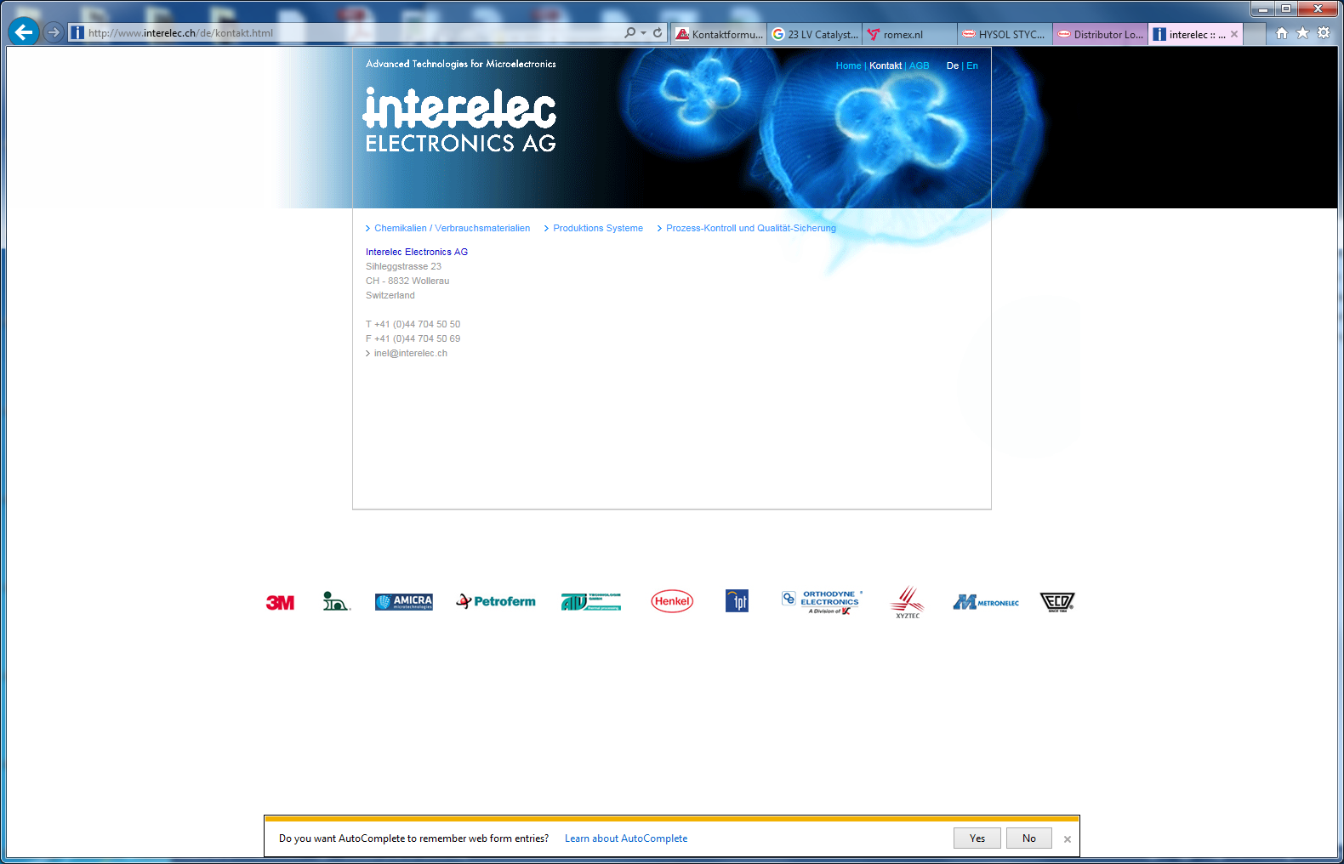

Silitech

Silitech AG Locations
 | Silitech AG  Worberstrasse 173  Gümlingen, CH-3073  Switzerland | (41) 3139 850 70  http://www.silitech.ch/d/index.asp
Email; info@silitech.ch

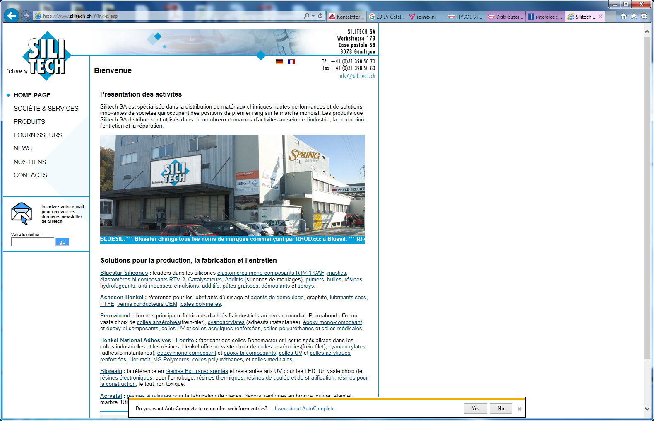

Perhaps not the best either as they are shut here and in Crisser before 4pm Friday …….

