Extra cable to CPE Oct 2013

EDH doc made out on the 17 Oct 2013 to move 2km of HV cable
https://edh.cern.ch/Document/SupplyChain/SHIP/5455395
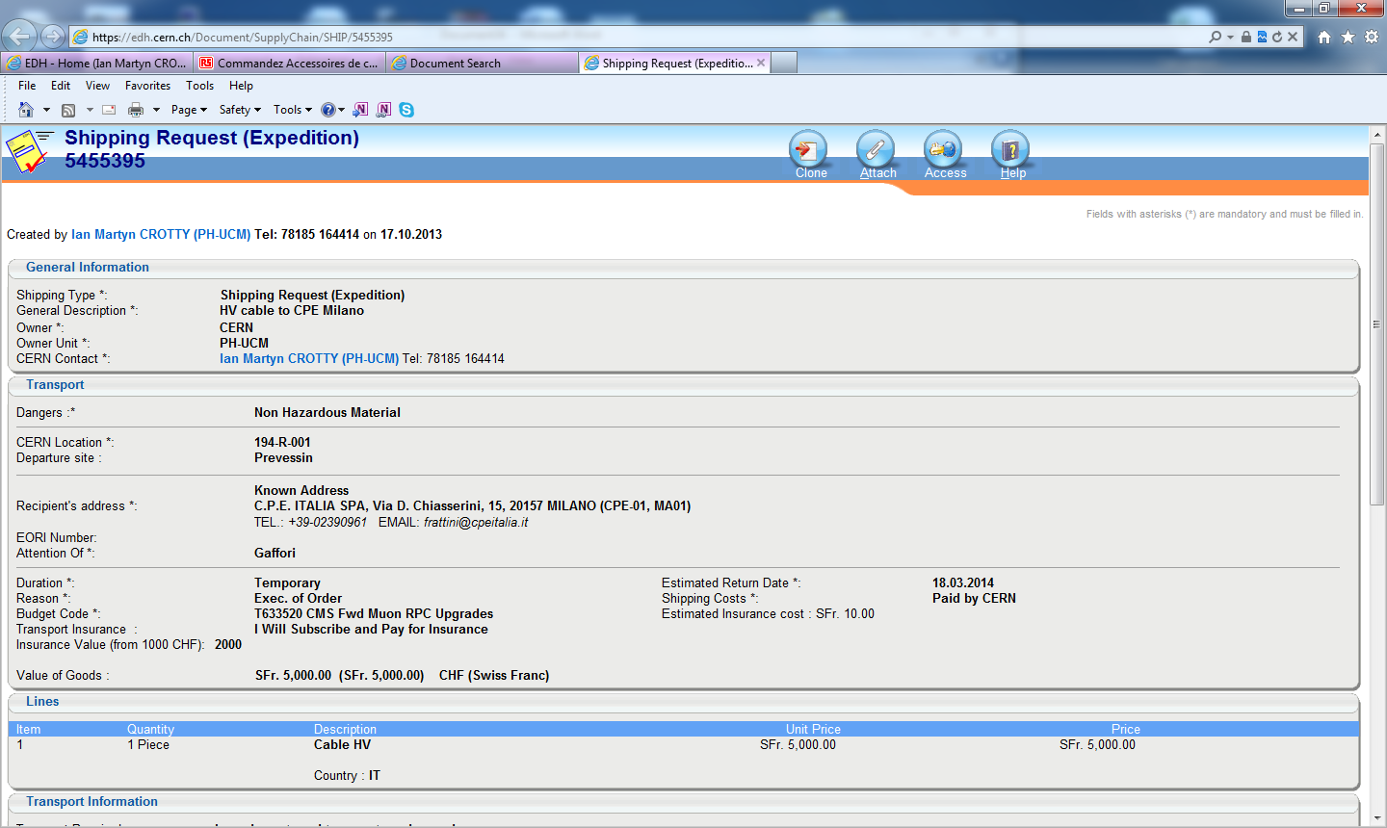
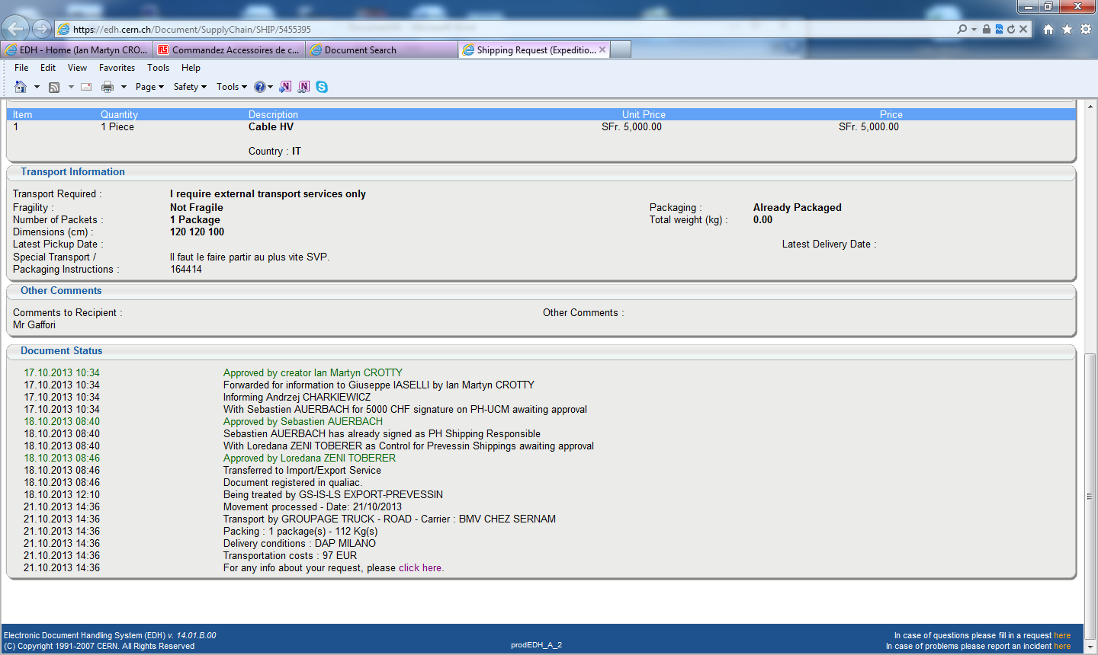

Delivery notice was stamped by CPE on the 23 Oct 2013. See below
They should have the drum that is 1.2m in diameter and weight 112kg !

Ian Crotty
21 Jan 2014

