Jupiter Hv Connector Assembly to 40mm Umbilcal cable

Intial trials done on 23 April 2015, those present
Imtiaz
Pino Main actor
Franco
Alexandre
Notes & Photos by Ian
All operations will be made optimising Safety. Namely the use of sharp tools and ventilation of the immediate work area through the use of forced ventilation. See the one used in 904.

Tools
Soldering Iron
Hot Air Gun
Knife ( safe type)
Wire insulator stripper
Crimping tool (Ref Red Line 58 59)
Cable Specification
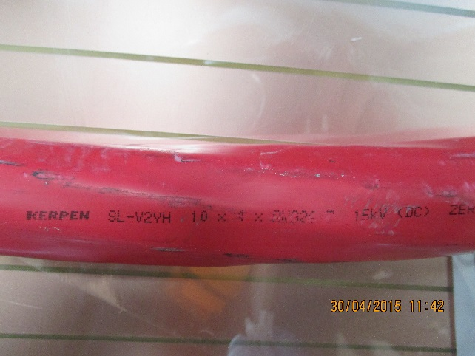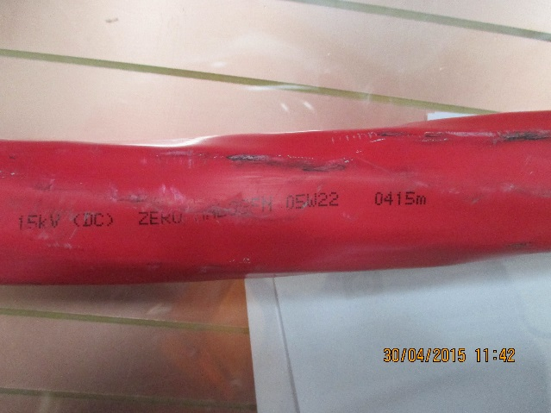

Connector Specification
C.P.E.
edttjhytkj

Remove the sheath to the desired length as a function of the application, here it is 250mm. For multiple chambers it should be approx. 1.5m as each chamber requires 3 channels of the 20 available.
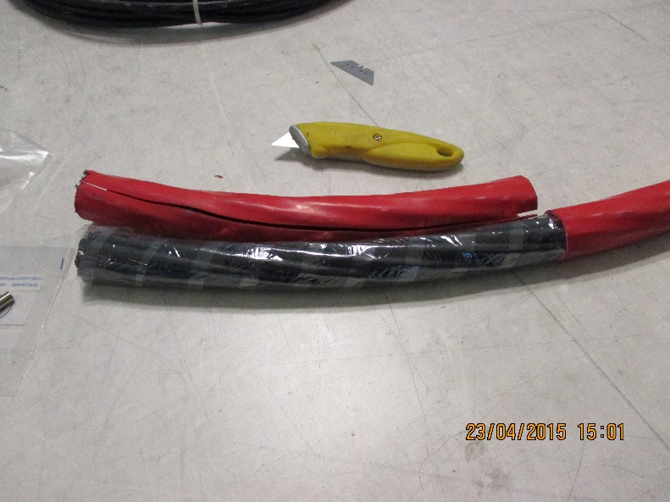
Replace this photo
Remove the unused internal components of the cable, packing and transparent mylar.
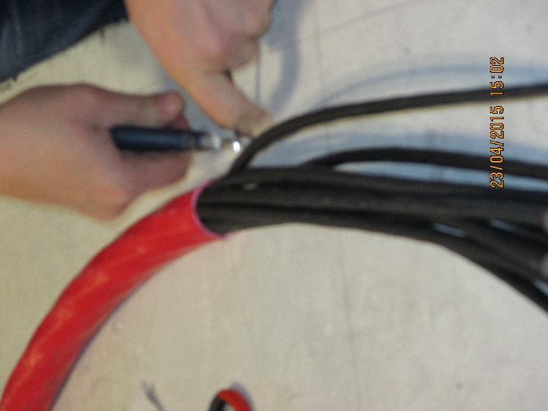
Use a stripper of this type.
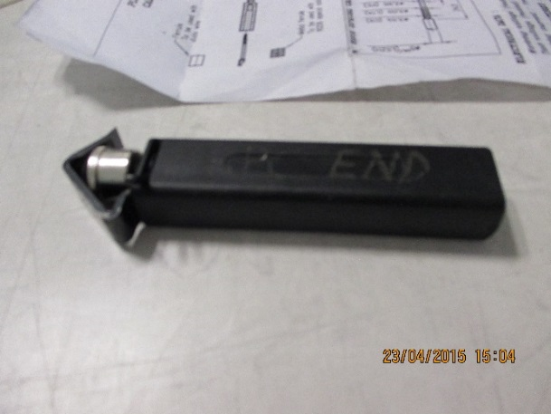
Remove the black insulator over a length 250mm.
Remove the shield braid. Take care not to damage the inner wires and their insulator.
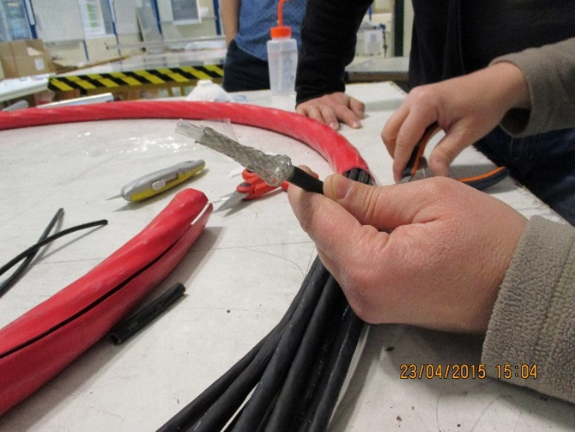
The four white insulated conductors are revealed. If using these instructions for the four conductor red 10mm dia cable it is vital to distinguish the different diameters of the conductors. The very slightly bigger diameters are for the HV and the smaller ones for 0V return.
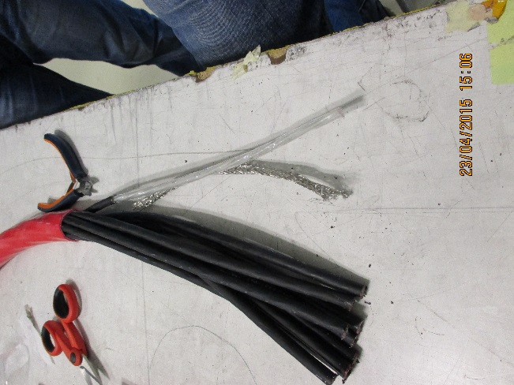
These conductors are numbered 1 to 4. Pairs are separated into 1 (inner) & 3 and 2 (inner) & 4.
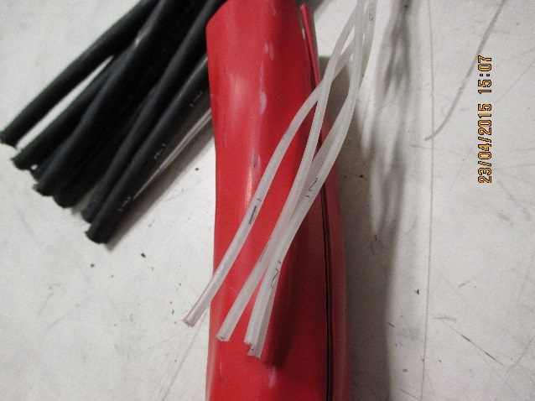
Two diameters of Heat shrink, with glue, are required cut to different lengths.
9mm dia length is 50mm less than the length of the exposed black insulator
12mm dia length is ~90mm. These will be in installed at this stage.

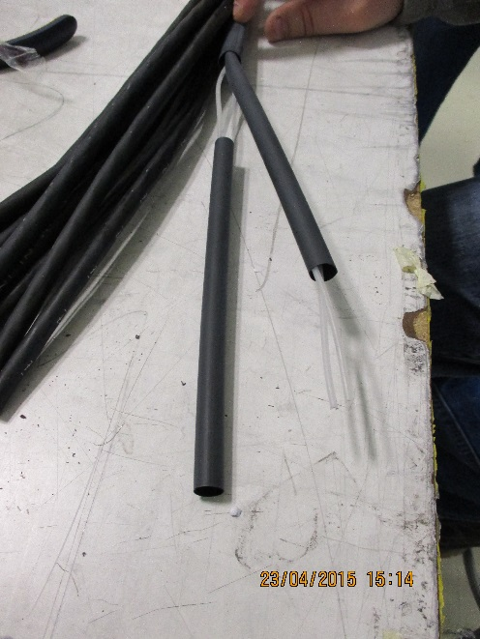

Strip the individual conductors over a length of 4mm with the tool shown choosing the correct slot for the conductor size. Slot NO xxxx
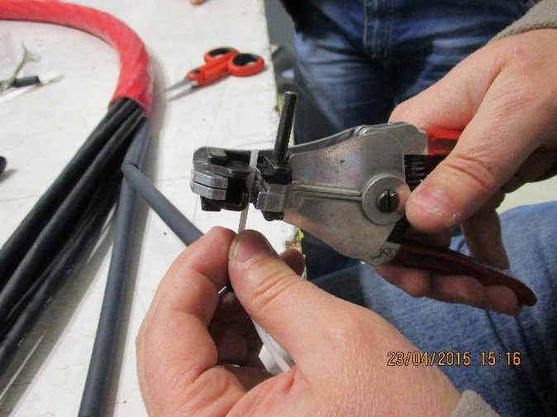

The same tool can also be used to hold the pin (male) for soldering. Another tool can be used but the heat should not be conducted into the tool otherwise the solder will deteriorate (oxidise) with the longer time necessary to melt the solder.
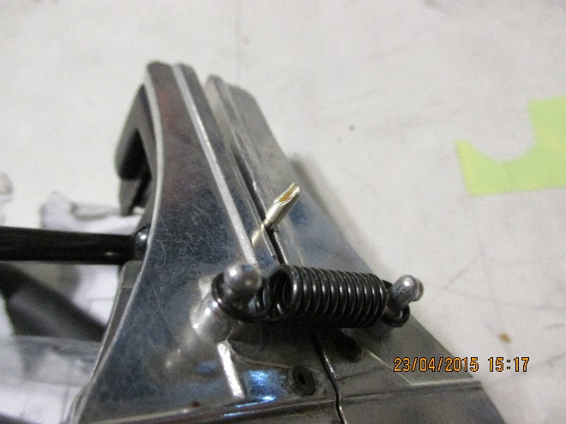
Pre tin/solder the pin using the solder iron set to 350degC for PbXX/SnXX solder. It is good to use the version with 2% Ag.
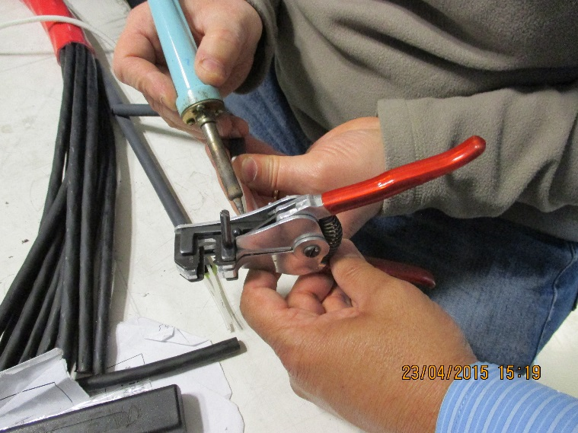

Pre-tin the white conductors
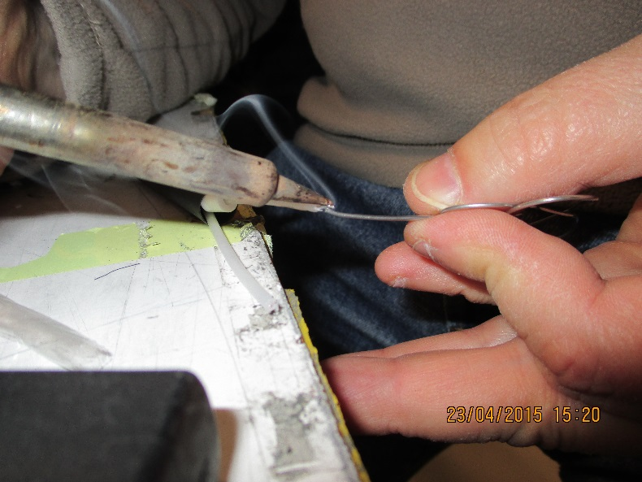
Slide on the white collar
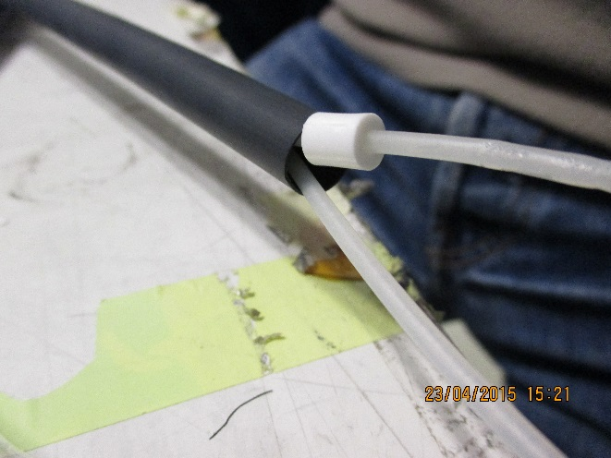
Using a similar tool again avoiding sinking out the heat, to solder the pin to the conductor.
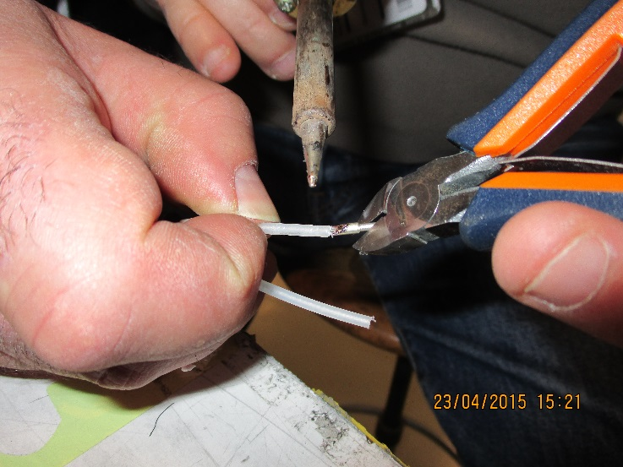
Great care must be taken to ensure that the insulator is from the good quality production batch. Defects included pin holes in the injection point.
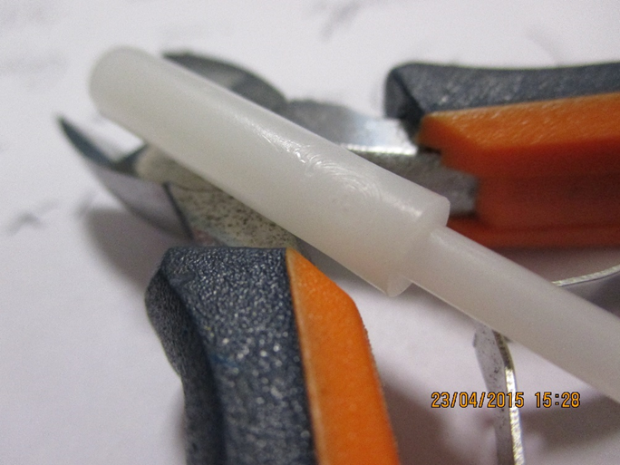
Here the injection point is shown and is a good example.
Slide on the narrow connector insulator (for female pins)
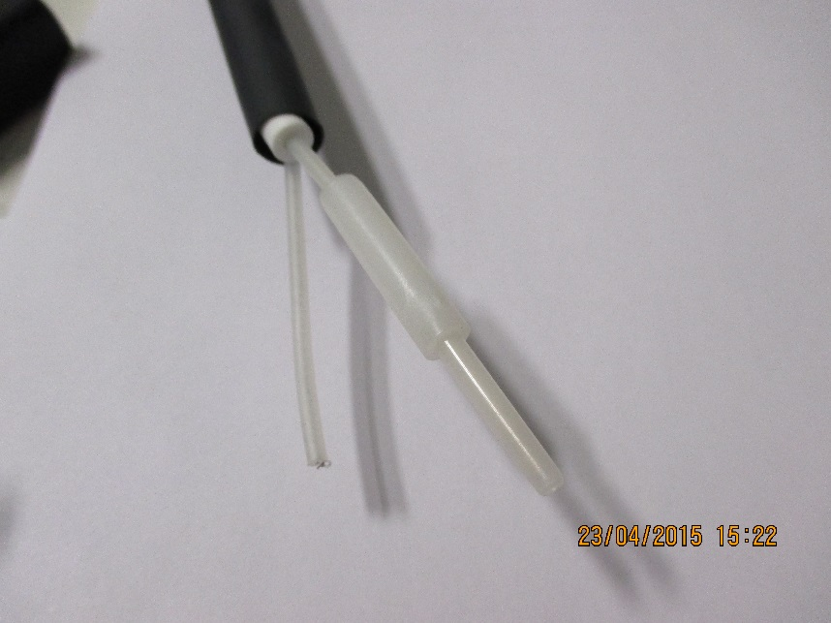
The pin should be inserted almost up until the end of the insulator. Here the pin is <2mm below the tip of the insulator.
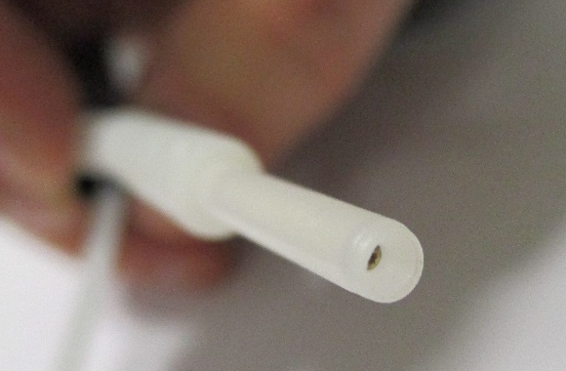
There are two methods to make the 0V connection, the first is shown below without using any flux.
It is essential that the connector insulator is not exposed to heat from the soldering iron or hot air gun that will damage it.
The connector casing is gently supported with a cutter or similar tool reducing heat loss to the tool .
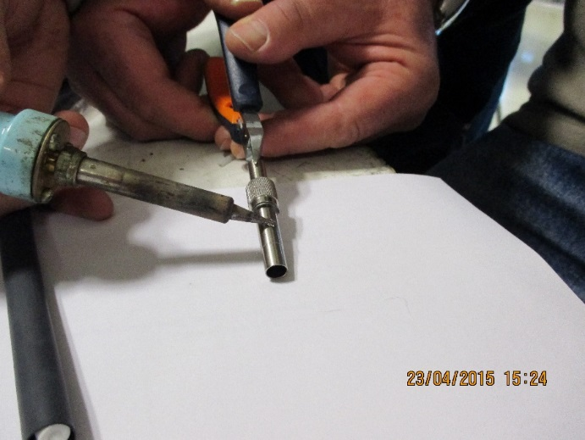
The solder iron will be reset to 400degC and is held on the casing for quite some time and so becomes hot ! This is continued until the solder ”wets” the casing . The casing can be abraide with a file or abrasive paper.
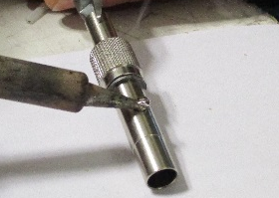
The 0v wire is soldered to the pre-tinned area after the length odf the conductor has been adjusted so that the insulator lies in the casing with its end flush with the far end. The cable end must have sufficient space to allow the short white collar fully inserted.
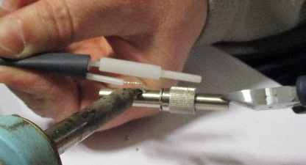

The result should be relatively low and smooth.
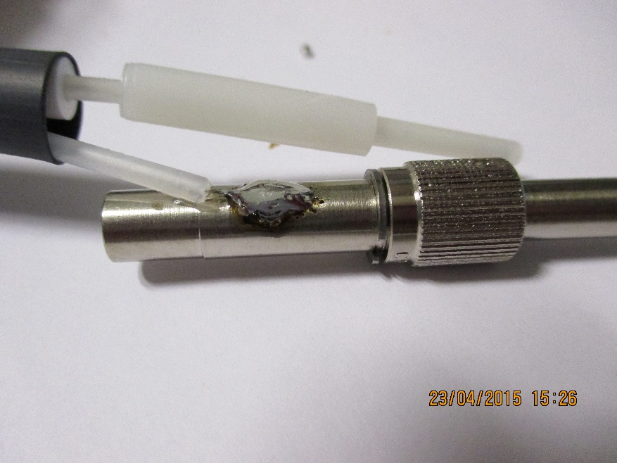

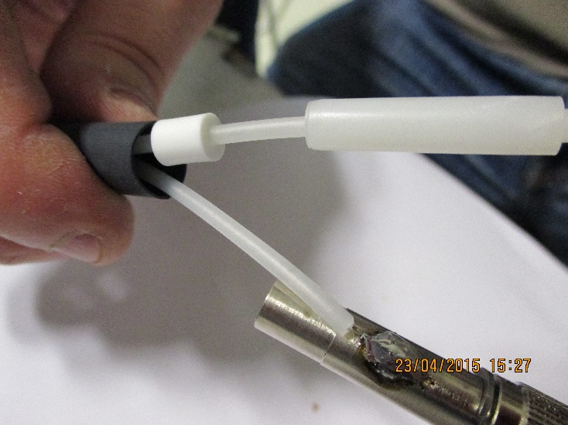

Alternative method suggested by Imtiaz. Pre tin the connector casing using flux SCEM XXXXXXXXX and solder the wire onto the casing once the insulator/pin assembly has been inserted. There are at present no photos of this method.

Continuing with the initial method.
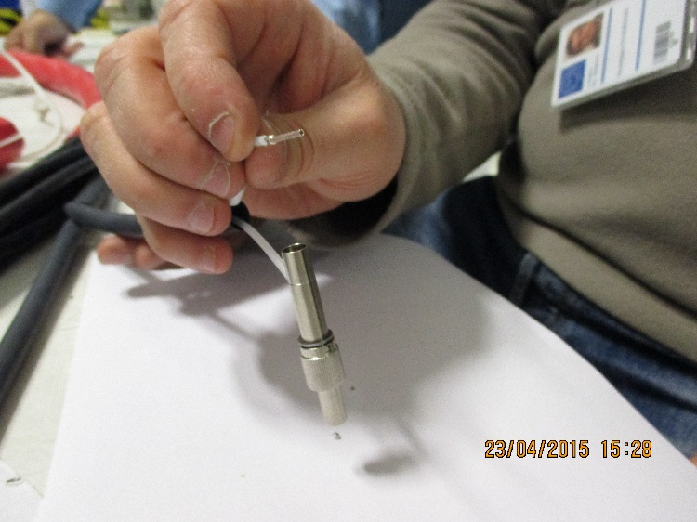
The result.
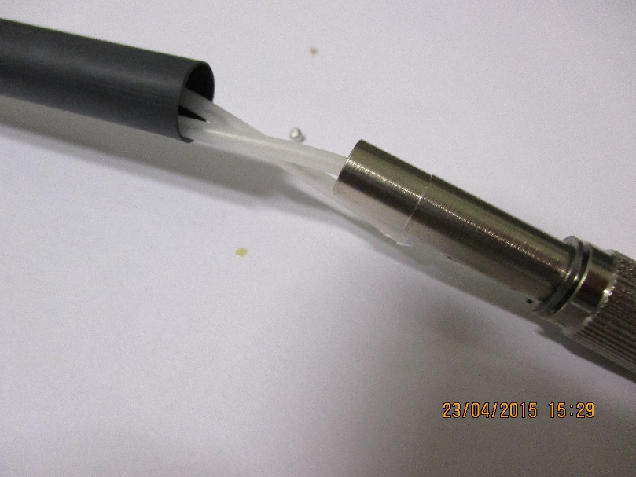
Using crimp tool XXX with extensions very slowly crimp the casing to secure the internal elements
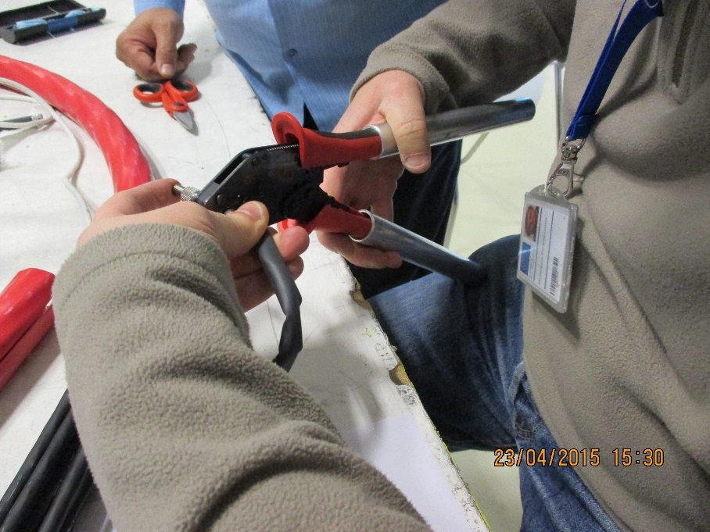
It is essential to ensure the white collar is fully inserted and apply the necessary force VERY slowly otherwise the casing will split/crack.
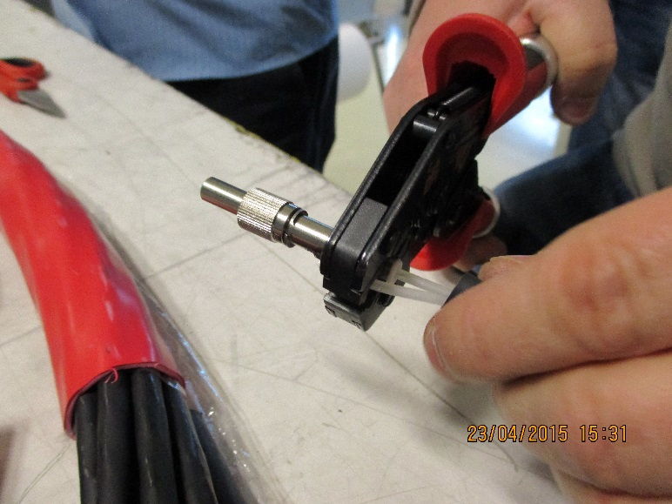
A zoom shows the collar protruding very slightly (<1mm) from the casing.
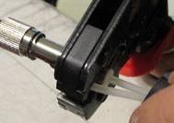
A well crimped casing that has left some 1mm or so untouched by the tool.
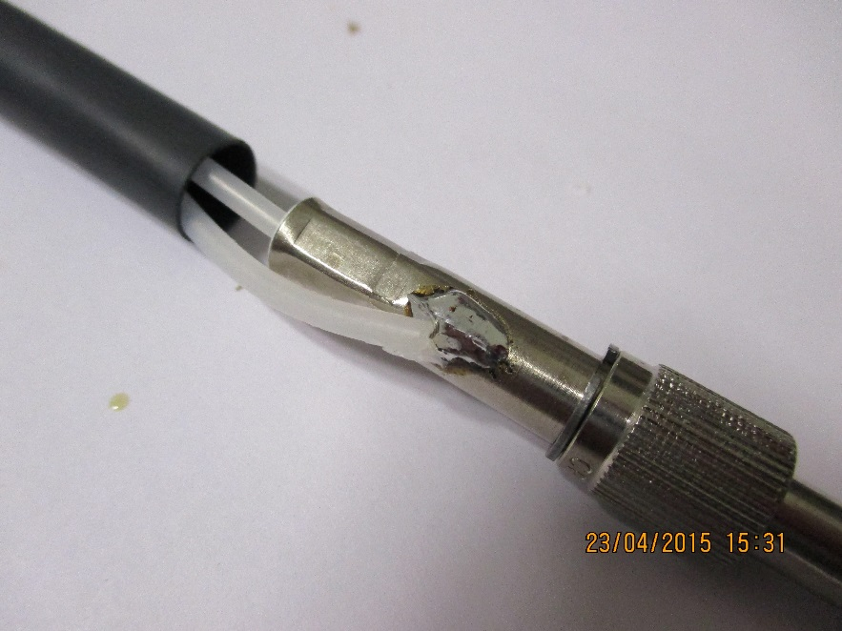
The far end result.
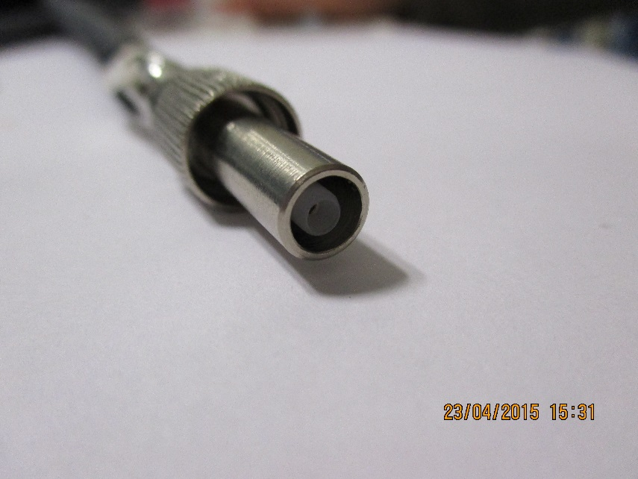
Now slide the small dia HS up to the shoulder of the connector.
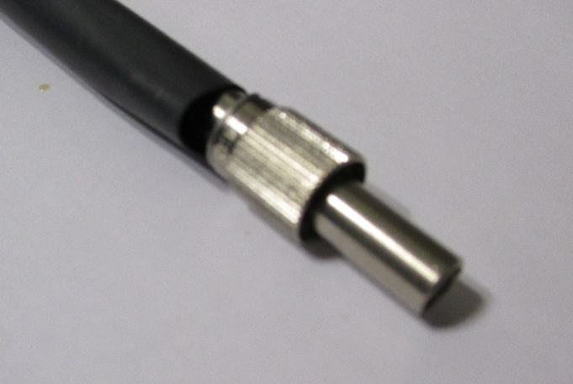
Using setting #7 on the hot air gun shown SCEM XXX shrink the small dia HS.
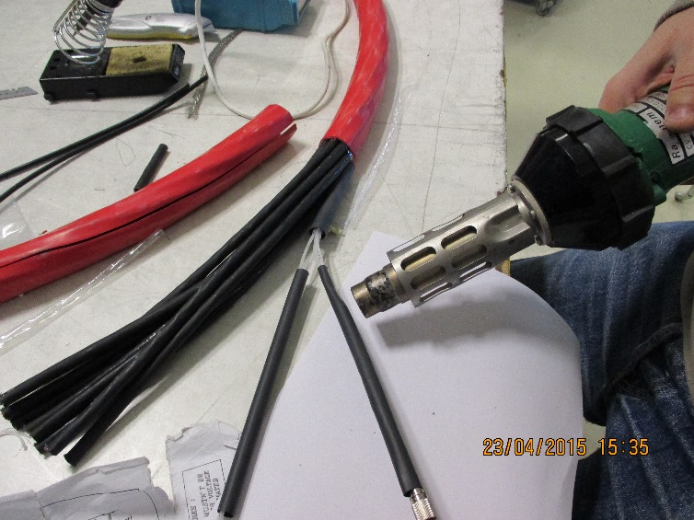
Proceed to reduce the large HS once it has been slide approx. 10mm over the smaller dia ones.
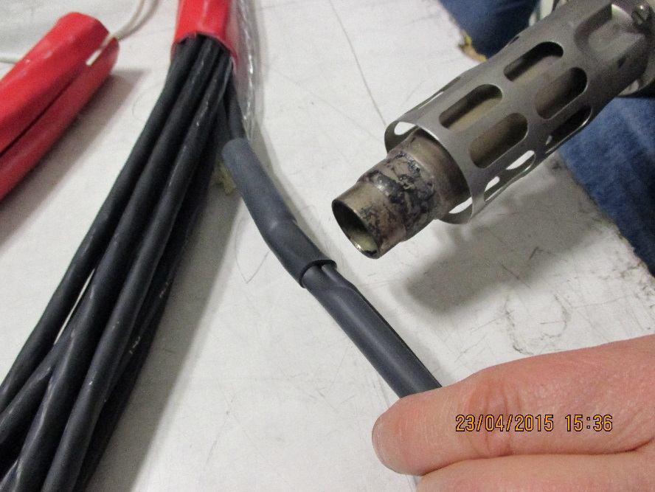
To make the final part of the cable just before the connector more rigid an additional piece of HS dia XXmm and L= 70mm can be added.

The team .
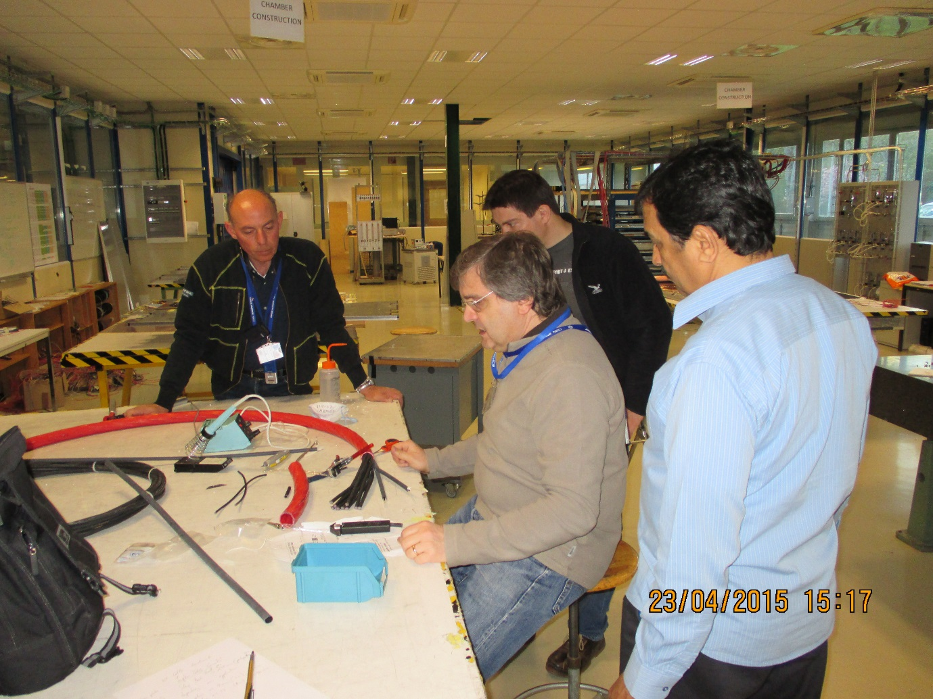

Tool specification
Hot air Gun
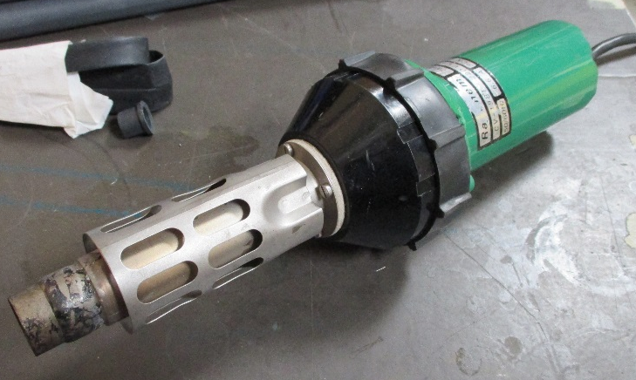

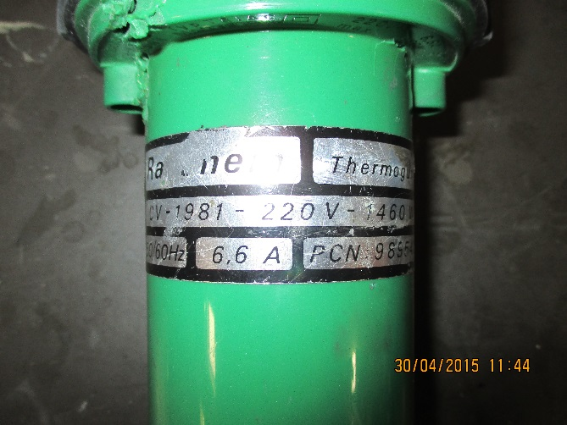
The preferred gun
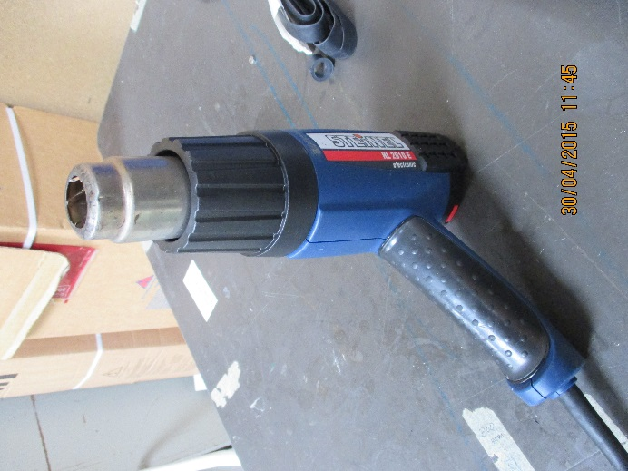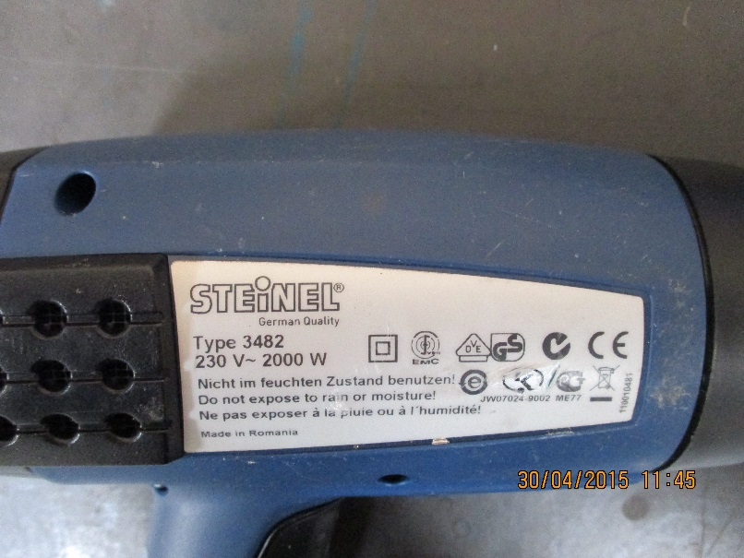

The stripper
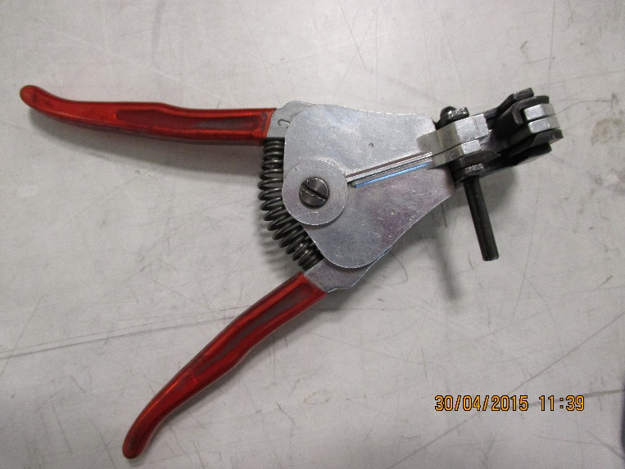

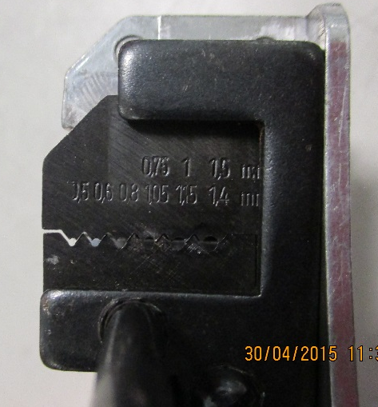

The sheath remover
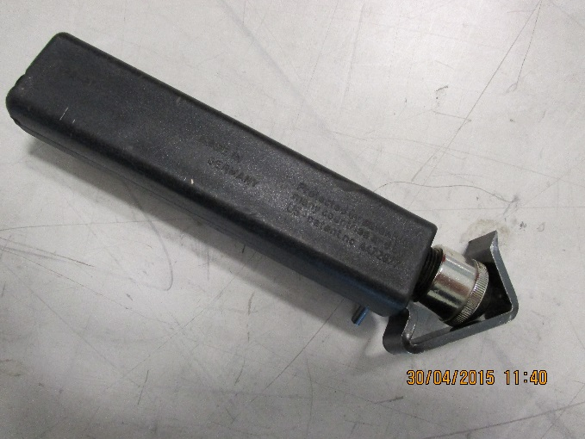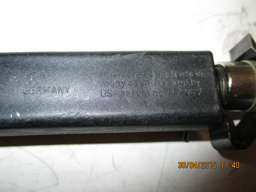

Crimping tool
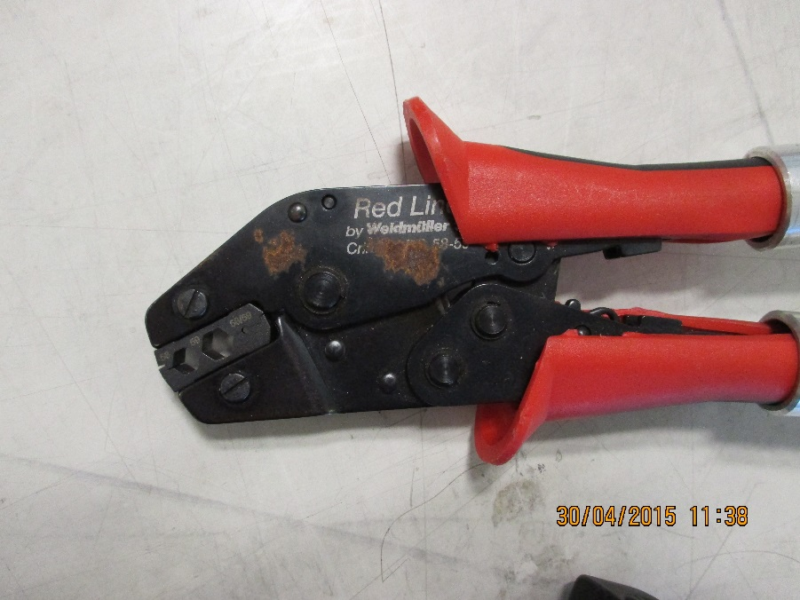
With extended arms
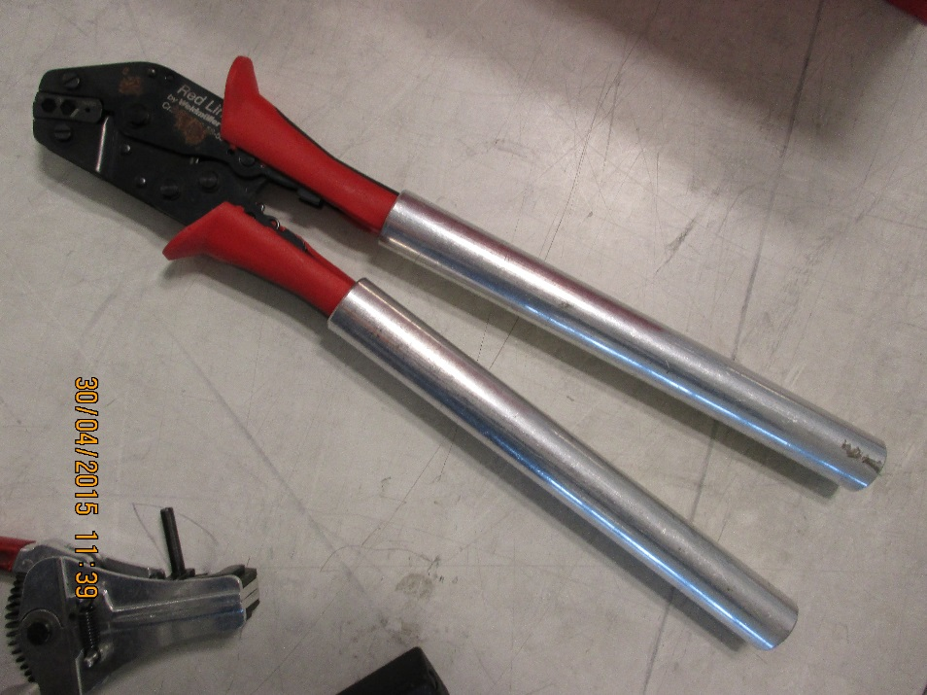

Soldering iron
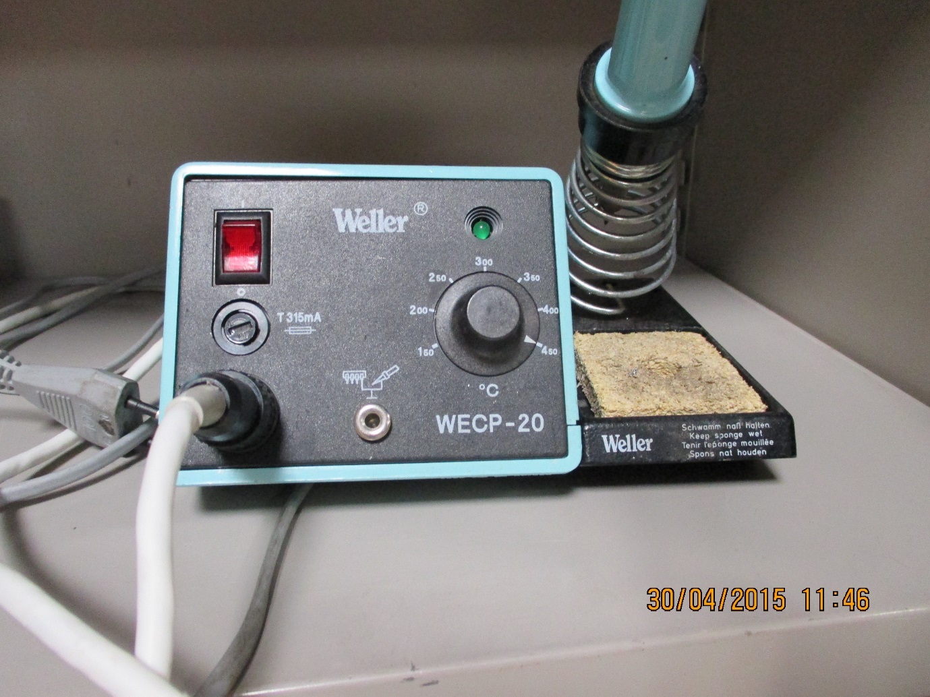

Specification
Power
With tip cleaner

