info@novacavi.it
http://www.novacavi.it/eng/contatti.htm


- Home
- About Novacavi
- Quality
- Materials
- Products
- Contact us
- Share with us your special requirements
 |  | 
 |  | Contact us  Novacavi  via Martiri di Cefalonia 1  20068 Peschiera Borromeo  (Milan) Italy  For more information:  Tel. +39 02.5538321  Fax: +39 02.5472354  info@novacavi.it  How to reach us:  5 Km South East from Milan  Tangenziale Est Linate exit - Km. 2  2 Km from Linate Airport  70 Km from Malpensa Airport  G.P.S:  N 45° 25’ 57,8’’  E 9° 17’ 17,7’’ | 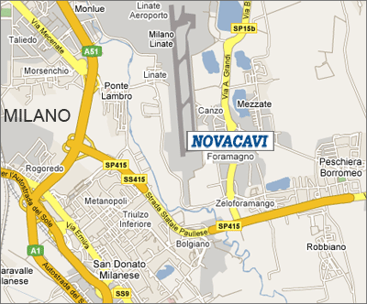
© 2013 Novacavi Srl - Peschiera Borromeo (MI) - P.I. 02353450154 - Company details - Web design

